MRARegress: From Setup to Fun in a Snap !
1/ Requirements
R version 4.3.2 (2023-10-31 ucrt)
RStudio 2023.06.0 Build 421.
Modules required by "MRARegress":
Package | Version
BiocManager | 1.30.22
CVXR | 1.0-12
devtools | 2.4.5
dplyr | 1.1.4
glmnet | 4.1-8
magrittr | 2.0.3
minet | 3.58.0
randomForest | 4.7-1.1
RCy3 | 2.20.2
rootSolve | 1.8.2.4
stats | 4.3.2
stringr | 1.5.1
testthat | 3.2.1
upstartr | 0.1.2
utils | 4.3.2
"minet" requires the package "Biocmanager". Then, BiocManager::install("minet").
The software "Cytoscape" (version >= 3.6.1 required -- our version is 3.10.2) must be installed and running before using "DrawGraph", a module of "MRARegress" used to draw network graphs.
2/ Installation
- Check the installed versions of R and RStudio. Update them if necessary.
- Check that the required modules (see previous paragraph) are installed and that the versions match, otherwise install and/or update them.
- Install the "MRARegress" package: devtools::install_github("J-P-Borg/MRARegress").
- Check that there is no error message. There may be warnings about replacing the previous import of certain objects.
- The "MRARegress" package should now appear in RStudio's package list (at the bottom right of the screen).
3/ Basic testing
library("MRARegress")
library("testthat")
1st example :
MatExp <- matrix(c(1:12), nrow=3)
MRARegress(MatExp)$r

The following results matrix should be displayed:
Q1 Q2 Q3
N1 -1.0000000 2.954545 -2.0454545
N2 0.3021978 -1.000000 0.7417582
N3 -0.3703704 1.296296 -1.0000000
2nd example :
Run "Cytoscape"

MatExp <- matrix(c(1,2,3, 11,21,31, 12,22,32, 13,23,33),nrow=3)
Ret <- MRARegress (MatExp, Relative=FALSE)
RetDG <- DrawGraph (Ret)
test_that("Simple network", {
expect_equal (RetDG$Variables[[2]], 3, tolerance=1E-4) # 3 nodes (DrawGraph succeeded)
})

The following line should be displayed:
Test passed

When entering "Ret$r", the following connectivity matrix should appear:
> Ret$r
Q1 Q2 Q3
N1 -1.0 2 -1.0
N2 0.5 -1 0.5
N3 -1.0 2 -1.0

When opening "Cytoscape", one must see:
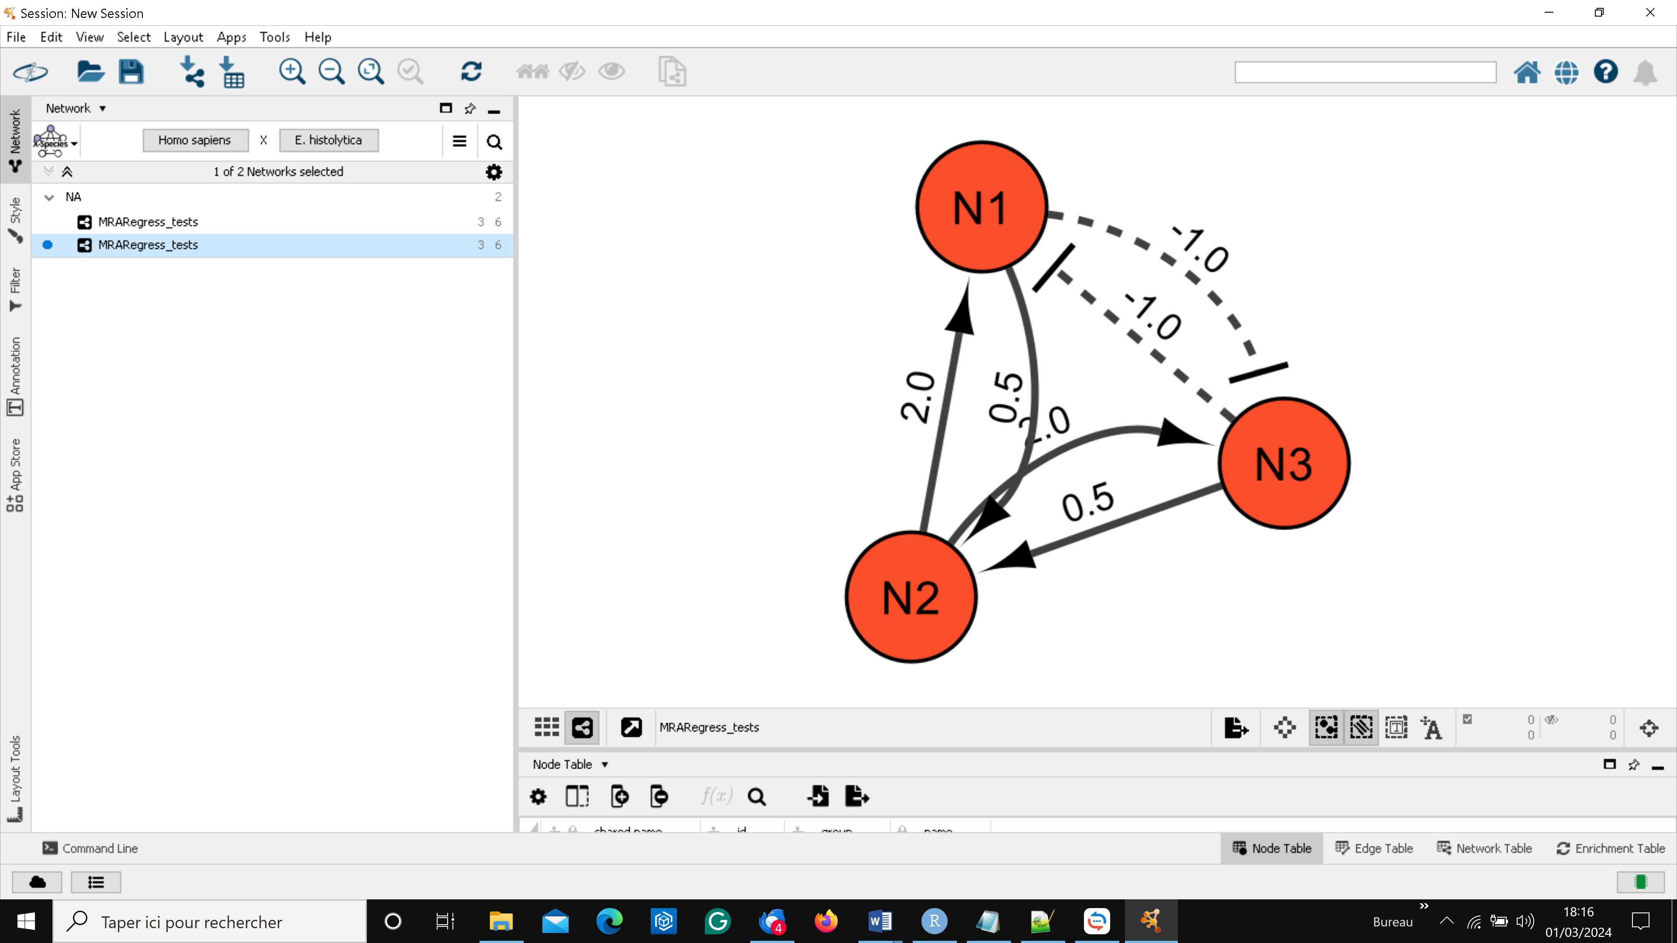
Connectivity matrix values are graphically represented.
In Cytoscape, users can manipulate nodes and arcs to enhance diagram clarity: click on a node to select it, then move it with the mouse. Select an arc by holding down the "alt" key. A red square is drawn next to this arc. Move this square to distort the arc. See "Cytoscape" documentation.
4/ Results displayed
Various outputs are available, including, for example, the "Connectivity Matrix", ANOVA results, 95% Confidence Interval of the estimated coefficients, a "heat map" of these coefficients, a network description in "GraphML" format, and automatic network drawing valued by connectivity coefficients using Cytoscape. In this depiction, nodes with unsatisfactory linear models are highlighted.
Two methods of connectivity coefficient classification are proposed (threshold-based or quantile-based). Multiple classes, including digitization {0, 1}, can be defined. Several comparison scores are suggested to assess exact and approximate connectivity matrices, including 'Confusion Matrix', 'Precision', 'Recall', 'F1 score', 'Sensitivity', 'Specificity', and 'Distance to Diagonal'. Additionally, a network drawing displaying discovered edges, false positives, and false negatives is available.
Upon loading, users can access user manuals for each module comprising the "MRARegress package":
- MRARegress: the main module performing most of calculations (connectivity matrix, ANOVA …).
- rCI: computation of $r_{i,j}$confidence intervals.
- DrawHeat: "heat map" drawing.
- DrawGraph: valued network drawing.
- DrawGraphM: network description in 'GraphML' format.
- Classify: discretization of connectivity coefficients.
- Score: computation of various scores.
- DrawDiscr : network drawing, with actual edges discovered, false positives and false negatives.
These modules leverage many input parameters, described in the on line documentation. Most of them have a default value corresponding to most common use cases.
It's up to you now. Fasten your seatbelt and have fun !!!

