Module #8 – Capstone Project: U.S. Organization

Jeff M. Paul
Colorado State University Global
MIS581: Capstone – Business Intelligence and Data Analytics
Dr. Kimberly A. Ford
11/01/20

Forecasting Quarterly Revenue Using Macro-Economic Indicators
Abstract
Two critical issues facing large businesses today are operating with limited resources and their slower responsiveness to market conditions. Large corporations do not have enough time, personnel, equipment and capital to achieve every profitable initiative on their agenda. In addition, their large size increases the difficulty to rapidly change to market demands. Other large entities, such as Federal and State Governments, use macro-economic indicators to forecast events such that they can maximize their limited resources and provide as much time to respond to upcoming events. To determine if a large corporation could benefit from the same approach, eleven macro-economic indicators were selected to ascertain whether they could forecast a specific company’s quarterly revenue. Data was obtained from 2009 to 2020 and it was tested using distribution analysis, correlation analysis and regression analysis. The correlation analysis identified the Personal Consumption indicator as having the highest correlation with the quarterly revenue data. To eliminate multi-collinearity, only the Personal Consumption indicator was used in the regression analysis. The regression analysis generated a forecasting model that explained approximately 80% of the quarterly revenue. Due to the positive results that were achieved, it would be beneficial for additional studies to be conducted in this area.
Introduction
When organizations are pressured to cut expenses, one of the first areas they look to reduce is personnel. In today’s economy, this reflexive action causes long-term problems for two reasons. The first is that many companies have adopted a lean staffing model and any reduction in staff is quickly felt within the organization. The second is the difficulty of hiring, training and retaining employees with specialized skillsets. Excessive staff cuts made today will result in lost business and clients tomorrow.
To avoid making erroneous staffing decisions, companies need an evidence-based model to identify the level of staffing they will need in the quarters ahead. One way to determine staffing is by accurately forecasting quarterly revenue. For example, if the average revenue per employee is $100,000 and there are 10 employees, a company can expect to meet a demand of producing $1,000,000 of goods and/or services. However, if revenues are forecasted to be $2,000,000, then the company would need to increase staff to 20.
While there are different ways to forecast quarterly revenue, one method may be found hidden within the phrase – “a rising tide lifts all the boats” (Lazare, n.d., para 2). When policymakers apply this phrase to the economy, it is interpreted to mean that as the general economy improves each entity operating within the economy also improves. If this phrase is true, then the rising and falling of a company’s financials should be correlated to larger macro-economic data. It is with this background that a model will be built to accurately forecast the quarterly revenue of a publicly traded company using macro-economic data.
History
The First American Financial Corporation (FAF) is a financial services company that provides title insurance and related services to the real estate industry. FAF traces its history back to 1889, when the two companies that eventually merged to become FAF, began to offer title services in the newly created Orange County, California. To better service its clients, FAF began expanding its operations throughout California and across the United States. By 2020, FAF is operating throughout the United States, in six major international Countries and in several developing nations.

Services and Products
FAF’s flagship products and services have centered around providing title insurance and title settlement services. By preparing title searches, property reports, title insurance and real estate analytics services, FAF is able to resolve the property issues that would prevent an efficient transfer of real estate (First American Title Insurance Company, 2020). Its clients include home buyers and sellers, mortgage lenders, commercial property professionals and real estate developers.

Headquarters and Statistics
The executive offices of the First American Title insurance company are located in Santa Ana, California. As of 2019, FAF employed 18,412 personnel and achieved an annual revenue of $6.2 Billion dollars (First American Title Insurance Company, 2020). Currently, FAF is the second largest Title Insurance company within the United States (First American Title Insurance Company, 2020).

Organization Selection
There are three main reasons why FAF was selected for this study. First, the author has 15 years of experience within FAF. This tenure enables him to identify the areas that will benefit FAF the most. Second, having access to the resources and personnel within FAF can provide assistance when obstacles with the project are encountered. Lastly, strengthening FAF’s capabilities by better aligning its resources will ultimately benefit its customers, employees and its investors.
Literature Review
Throughout history, society has sought ways to gain insights into the future. Ancient civilizations often looked to the heavens to divine issues such as when crops should be planted and whether military campaigns should be waged. By understanding the future and taking the appropriate actions beforehand, society can position itself to capitalize on whatever fate may present them.
Fast-forward to present day and it will be seen that today’s policymakers also have similar needs in understanding future economic conditions. To effectively navigate the complicated waters ahead, actions can be taken now that will lessen or potentially avert the upcoming impact (Chinn & Kucko, 2015). For example, when a slowing economy has been forecasted, policymakers have injected additional monetary funds into the economy months before the expected economic fallout (Joseph et al., 2014).
Policymakers have numerous tools to help them better understand the future. In many cases, the tools they rely upon are leading macro-economic indicators (Joseph et al. 2014). These indicators include 3-month Treasury Bills, Consumer Confidence (sentiment), Industrial Production, Housing Starts, Vehicle Registrations, Retail Sales and Personal Disposable Income (Krystalogianni et al., 2004). By having numerous tools to use, policymakers have an increased ability to confirm future projections from different sources.
Although many experts failed to predict the financial crisis of 2007 – 2009, there were analysts that accurately predicted this event using macro-economic data. By applying regression and neural network models towards 3-Month Treasury Bill and the Interest Rates Spread data, these analysts understood that a difficult economic climate was approaching (Joseph et al., 2014). The success of their methods has led research to use 3-Month Treasury Bill data to forecast other areas such as Real Business Sales (Joseph et al., 2014).
U.S. Housing Starts data is a second macro-economic factor has been utilized to accurately forecast sales data. In 2012, a research team utilized regression and neural network modeling to predict U.S. Retail Sales based upon U.S. Housing Starts data (Joseph & Larrain, 2012). In addition, a 2015 study using regression analysis, accurately forecasted U.S. Motor Vehicle Sales based upon the U.S. Housing Starts data (Homareau, 2015). The ability of using US Housing Start data to forecast events in different areas alludes to the power of this macro-economic tool.
Macro-economic data has also been used towards predicting sales results at an organizational level. Companies operating within emerging economies are particularly susceptible to the fluctuations of the macro-economic forces (Adeola, 2016). For these companies to succeed, the sales and marketing teams must closely track the macro-economic data and adjust their plans accordingly (Adeola, 2016).
Most of the literature produced to this date has successfully demonstrated the forecasting power of macro-economic data upon broad categories such as Vehicle Sales and Retail Sales. However, there is research indicating that the forecasting power can also be applied to individual companies (Adeola, 2016). If macro data can help companies with their own forecasts, then it is important for additional studies to be performed.
Research Hypothesis
The business question being researched is whether a large publicly-traded company can forecast their quarterly revenue using macro-economic data. With this question in mind, the hypothesis being tested is as follows:
Null hypothesis (H₀) - the regression coefficients between the dependent variable (quarterly revenue) and each of the independent macro-economic variables are equal to zero.
H₀: Β₁=0, B₂=0,…,Bᵢ=0.
Alternate hypothesis (H₁) - the regression coefficients between the dependent variable (quarterly revenue) and each of the independent macro-economic variables are not equal to zero.
H₁: Β₁≠0, B₂≠0,…,Bᵢ≠0.
Should the analysis result in the null hypothesis being rejected, then it can be stated that a company’s quarterly revenue can be forecasted using macro-economic data.
Objectives
The research objectives are as follows:
- To collect U.S. based macro-economic data as well as quarterly revenue data from a publicly listed company.
- To determine the distribution of each independent and dependent variable.
- To transform variable(s) that have failed the normality test such that they pass normality test using log normal, inverse, inverse square root and/or square root transformations.
- To determine whether correlation exists between each macro-economic variable and the quarterly revenue of a publicly listed company using either parametric or non-parametric testing.
- To identify whether correlations exist between each macro-economic variable using either parametric or non-parametric testing.
- To develop a regression model between the macro-economic variable(s) and the quarterly revenue such that the p-value of the F-test is lower than an alpha of .05 and the model demonstrates an R² value greater than .70.
Research Design
Based upon the studies outlined in the literature review, a total of 11 macro-economic variables were selected to study. The datasets for each of these variables are maintained by the Federal Reserve Bank of St. Louis and quarterly data was obtained beginning from 1/1/2009 (FRED Economic Research, 2020). The following variables are being utilized: Housing Starts: Total: New Privately Owned Housing Units Started, 3-Month Treasury Bill: Secondary Market Rate, University of Michigan: Customer Sentiment - Total Vehicle Sales, Personal Consumption Expenditures, Real Disposable Personal Income, Industrial Production: Total Index, Wilshire U.S. Real Estate Investment Trust Total Market Index, Real Estate Investment Trusts; Total Mortgages; Asset - Level, Real Gross Domestic Product, Total Consumer Credit Owned and Securitized – Outstanding and Real Disposable Personal Income.
For FAF, the quarterly revenue data was obtained from the U.S. Securities and Exchange Commission website (U.S. Securities and Exchange Commission, 2020). Since this a publicly traded company, it is required by law to submit quarterly reporting that outlines the results. The 10-Q report filed by the company contains the 3-month result as well as prior years 3-month result. Finally, this data set began 1/1/2009 as this was the first quarter that the company went public.
Since the data contained within each of these datasets were continuous, a quantitative approach was selected. Using SAS statistical software, the variables were analyzed using descriptive statistical analysis, distribution analysis, correlation analysis and linear regression (Least Squares Method) modeling. The data set was split into a training data set (34 observations) and testing data set (12 observations).

Data Benefits
By studying macro-economic data, FAF can create a predictive model to forecast quarterly revenues. This, in turn, will enable FAF to identify the correct amount of resources it will need to fulfill these expected revenues (Homareau, 2015). Resource allocation is a critical strategic issue within FAF, as it operates in a highly competitive industry, utilizes a lean staffing model and administers an extended training period of its risk assessment staff.
Analytical Tools
The primary analytical and visualization tools will be SAS, SAS Enterprise and Tableau. SAS and SAS Enterprise were selected based upon the personal experience level with each of these tools, the ease of use and their data capabilities. One of the main benefits of including SAS Enterprise is that it will display the process flow of the code being used in this project (De Ville, 1998). Although SAS has visualization tools, Tableau was selected for its advanced graphical capabilities and its user-friendliness.
Data Variables
The macro-economic and revenue data being analyzed are reported in either dollars, percentages, number of units or in a numerical index format. Due to this, all of the data can be treated as continuous. Although data presented in a scale format is normally associated with ordinal data, it can also be treated as a continuous variable when the data is numeric and the data doesn’t need to be kept as discrete integers.
Data Dictionary
Overall, there are eleven variables within the study. As illustrated in figure 1, the data dictionary provides an overview of the data structure of each variable. By adhering to this structure, data users, analysts and developers can avoid data inconsistencies and ensure a reliability in the collection and use of the data (Navathe & Kershberg, 1986).
Figure 1.
Data Dictionary
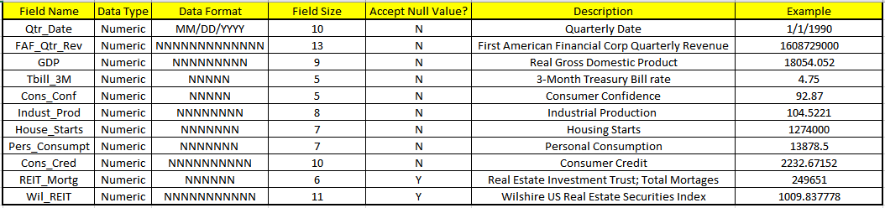
Data Potential
Each data variable within the project was selected for its potential of providing FAF insight into the company’s future. For example, as interest rates fall and borrowers refinance their existing mortgage(s), FAF should expect to see an increase in the number of loan policies being purchased. By studying macro-economic variables, FAF can accurately forecast upcoming demand. This, in turn, can help FAF to ensure that the proper amount of trained personnel are available to service their clients.
Data Privacy
Each data set, except for one, provides aggregated data of a specific area withing the United States economy. Therefore, there are no concerns regarding Personally Identifiable Information or Protected Health Information being released. The one exception is the quarterly revenue data attributable to FAF. Since this information is submitted to the SEC it is considered public data and is expected to be used for analysis purposes (U.S. Securities and Exchange Commission, 2020). Due to these factors and for this project’s purpose, there are no data privacy issues to be resolved.
Data Security
To resolve the unauthorized access risks, the data has been downloaded to a single and secured laptop. This laptop is protected with a firewall, virus and malware protection features, password protection and is physically located within a secured facility. With regards to the analytical tools being used, the SAS, SAS Enterprise Miner and Tableau packages each have their own credible security measures in place. Finally, as the data sets are also available on U.S. government websites, back-up copies can be easily obtained. With these features implemented, there is a very low risk of unauthorized access or data corruption.
Data Ethics
One potential area of concern is whether or not FAF would want their company being used as the focus of this project – especially if the results of this project were made available to the general public. Due to this ethical concern, certain steps such as anonymity should be implemented before displaying this data in a public forum.
Coding
The following coding was executed during the research project.
### Importing dataset and assigning variable names
Data FAF;
infile "/folders/myfolders/sasuser.v94/CombinedData1.csv" firstobs=2 delimiter=",";
input Qtr_Num Qtr_Date $ FAF_Qtr_Rev GDP Tbill_3M Cons_Conf Indust_Prod House_Starts Pers_Consump Cons_Credit REIT_Mortg Wil_REIT Veh_Sales Disp_Pers_Inc ;
Run;
### Code for obtaining summary statistics
ods noproctitle;
ods graphics / imagemap=on;
proc means data=WORK.FAF chartype mean std min max n vardef=df;
var FAF_Qtr_Rev GDP Tbill_3M Cons_Conf Indust_Prod House_Starts Pers_Consump Cons_Credit REIT_Mortg Wil_REIT Veh_Sales Disp_Pers_Inc;
run;
### Code for distribution analysis
ods noproctitle;
ods graphics / imagemap=on;
proc univariate data=WORK.FAF;
ods select Histogram GoodnessOfFit;
var FAF_Qtr_Rev GDP Tbill_3M Cons_Conf Indust_Prod House_Starts Pers_Consump Cons_Credit REIT_Mortg Wil_REIT Veh_Sales Disp_Pers_Inc;
/* Checking for normality */
histogram FAF_Qtr_Rev GDP Tbill_3M Cons_Conf Indust_Prod House_Starts
Pers_Consump Cons_Credit REIT_Mortg Wil_REIT Veh_Sales Disp_Pers_Inc /
normal(mu=est sigma=est);
run;
###Since results from the distribution analysis determined that several variables did not have a ###normal distribution, a transform data procedure needs to be applied.
### Code to transform variables Tbill_3M, Housing Start and REIT_Mortg data using natural ###log.
data work.transform;
set WORK.FAF;
log_Tbill_3M=log(Tbill_3M);
log_House_Starts=log(House_Starts);
log_REIT_Mortg=log(REIT_Mortg);
run;
#### Code to perform distribution analysis on log_Tbill_3M, log_House_Starts and log_REIT_Mortg
ods noproctitle;
ods graphics / imagemap=on;
proc univariate data=WORK.TRANSFORM;
ods select Histogram GoodnessOfFit;
var log_Tbill_3M log_House_Starts log_REIT_Mortg;
/* Checking for normality */
histogram log_Tbill_3M log_House_Starts log_REIT_Mortg / normal(mu=est
sigma=est);
run;
###Since transformation using nat log did not normalize distribution,
### transformed Tbill_3M, Housing Start and REIT_Mortg data using inverse function.
data work.transform;
set WORK.FAF;
inv_Tbill_3M=1 / Tbill_3M;
inv_House_Starts=1 / House_Starts;
inv_REIT_Mortg=1 / REIT_Mortg;
run;
#### Code to perform distribution analysis on inv_Tbill_3M, inv_House_Starts and ###inv_REIT_Mortg
ods noproctitle;
ods graphics / imagemap=on;
proc univariate data=WORK.TRANSFORM;
ods select Histogram GoodnessOfFit;
var inv_Tbill_3M inv_House_Starts inv_REIT_Mortg;
/* Checking for normality */
histogram inv_Tbill_3M inv_House_Starts inv_REIT_Mortg / normal(mu=est
sigma=est);
run;
###Since transformation using Inverse function did not normalize distribution,
###transformed Tbill_3M, Housing Start and REIT_Mortg data using inverse square ###function.
data work.transform;
set WORK.FAF;
inv2_Tbill_3M=1 / Tbill_3M**2;
inv2_House_Starts=1 / House_Starts**2;
inv2_REIT_Mortg=1 / REIT_Mortg**2;
run;
#### Code to perform distribution analysis on inv2_Tbill_3M, inv2_House_Starts and ###inv2_REIT_Mortg
ods noproctitle;
ods graphics / imagemap=on;
proc univariate data=WORK.TRANSFORM;
ods select Histogram GoodnessOfFit;
var inv2_Tbill_3M inv2_House_Starts inv2_REIT_Mortg;
/* Checking for normality */
histogram inv2_Tbill_3M inv2_House_Starts inv2_REIT_Mortg / normal(mu=est
sigma=est);
run;
###Since transformation using inverse square function did not normalize distribution,
###transformed Tbill_3M, Housing Start and REIT_Mortg data using square root function.
data work.transform;
set WORK.FAF;
sqrt_Tbill_3M=sqrt(Tbill_3M);
sqrt_House_Starts=sqrt(House_Starts);
sqrt_REIT_Mortg=sqrt(REIT_Mortg);
run;
#### Code to perform distribution analysis on sqrt_Tbill_3M, sqrt_House_Starts and ###sqrt_REIT_Mortg
ods noproctitle;
ods graphics / imagemap=on;
proc univariate data=WORK.TRANSFORM;
ods select Histogram GoodnessOfFit;
var sqrt_Tbill_3M sqrt_House_Starts sqrt_REIT_Mortg;
/* Checking for normality */
histogram sqrt_Tbill_3M sqrt_House_Starts sqrt_REIT_Mortg / normal(mu=est
sigma=est);
run;
###Transformation using Square Root function did not normalize distribution.
###Repeated the above tests for the Veh_Sales and Disp_Pers_Inc variables
###Veh_Sales data remained not normalized. Disp_Pers_Inc was normalized with Nat Log ###transformation.
###Due to non-parametric data, Spearman's Correlation Coefficient analysis was utilized.
### Code to perform Spearman's Correlation Coefficient analysis
ods noproctitle;
ods graphics / imagemap=on;
proc corr data=WORK.FAF pearson spearman nosimple rank plots=none;
var FAF_Qtr_Rev GDP Tbill_3M Cons_Conf Indust_Prod House_Starts Pers_Consump
Cons_Credit REIT_Mortg Wil_REIT Veh_Sales Disp_Pers_Inc;
run;
###Results from Spearman's Correlation Analysis identified Pers_Consump as the variable
### with the highest association with the dependent variable FAF_Qtr_Rev. Pers_Consump was ### also moderately-to-strongly associated with each of the remaining independent variables. ###Due to the multi-collinearity issue, only Pers_Consump would ###be used in the Regression ###analysis.
### Code for Linear Regression Analysis
ods noproctitle;
ods graphics / imagemap=on;
proc reg data=WORK.FAF alpha=0.05 plots(only)=(diagnostics residuals fitplot
observedbypredicted);
model FAF_Qtr_Rev=Pers_Consump /;
run;
quit;
###Due to success of Linear Regression analysis, proceeded to engage a Predictive ###Regression analysis. During this process, 20% of the data set was partitioned to be run
###as test data.
###Code for Predictive Regression Analysis
ods noproctitle;
ods graphics / imagemap=on;
proc glmselect data=WORK.FAF outdesign(addinputvars)=Work.Glmselect_Design;
partition fraction(test=0.2);
model FAF_Qtr_Rev=Pers_Consump / selection=none;
run;
proc reg data=Work.Glmselect_Design plots(only)=(diagnostics
observedbypredicted);
ods select DiagnosticsPanel ObservedByPredicted;
model FAF_Qtr_Rev=&_GLSMOD /;
run;
quit;
GitHub
To view the coding, documentation and data within GitHub, access the following link https://github.com/J-P251/MIS581-1.
Findings
The quarterly revenue of the First American Financial Corporation (FAF) is a critical reference point. Using Tableau, a line chart demonstrating the quarterly revenue from 2009 to date has been illustrated in figure 2. As seen in this chart, the first quarterly revenue was approximately $925,000 and it eventually peaked at $1.725 million in 2020 (U.S. Securities and Exchange Commission, 2020) . Interestingly, the average quarterly revenue was relatively flat from 2009 until the second quarter of 2012. After this time, the quarterly revenue began to trend higher.
Figure 2
FAF Quarterly Revenue
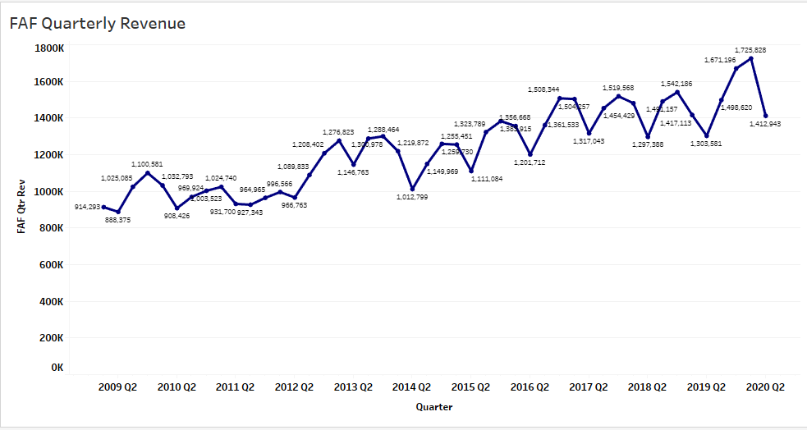
A second way to understand quarterly revenue is through the use of a Box plot. In figure 3, the quarterly revenue results for each quarter are displayed. This information is important as it provides a history of the revenues that have been experienced within each quarter. It also allows a comparison of the revenues between each quarter.
Figure 3
Boxplot of FAF Quarterly revenue
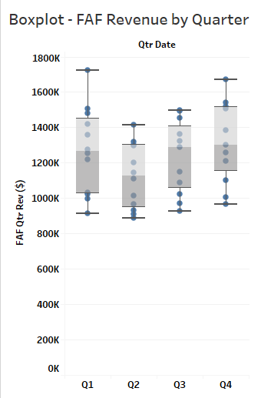
When the distribution analysis was conducted within SAS, several of the variables were identified as not having normal distributions. A few of these variables were U.S. Housing Starts, 3-Month Treasury Bill rates and Vehicle Sales. When data transformation techniques such as Natural Log, Square Root, Inverse Square and Inverse Square Root were applied to these variables, all variables (except Disposable Personal Income) demonstrated distributions that were nonparametric. This insight is important as it dictates the need for nonparametric correlation testing (Jafarpanah & Rezaei, 2014). As an example, figure 4 illustrates the results of the distribution analysis being conducted upon the Natural Log transformation of the U.S. Housing Start data.
Figure 4
Natural Log Transformation of U.S. Housing data
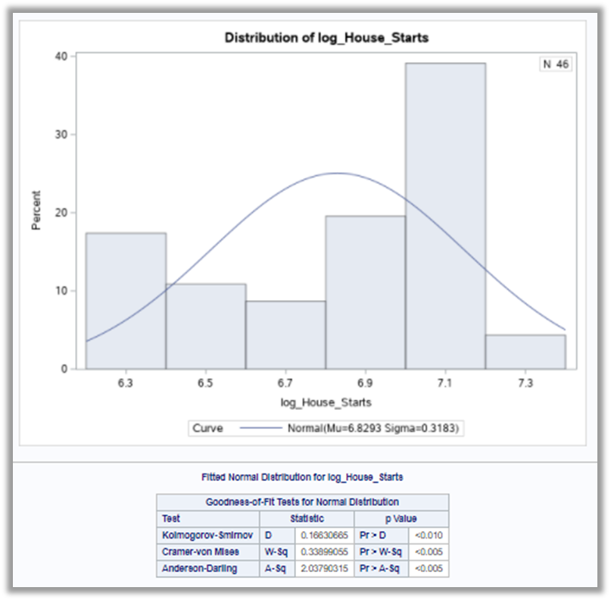
When the correlation analysis was conducted, two key findings were identified. First, the macro-economic indicator Personal Consumption returned the highest Spearman’s Correlation Coefficient when paired with dependent variable Quarterly Revenue. As noted in figure 5, this test indicated a correlation coefficient value of 0.89171 with a p-value of <.0001.
Figure 5
Spearman’s Correlation Analysis
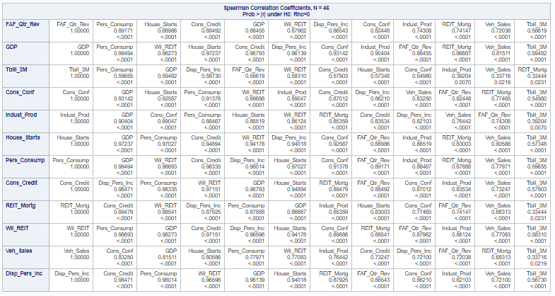
Second, Personal Consumption was moderately-to-strongly correlated with each of the remaining independent variables (Jaadi, 2019). The lowest Spearman’s correlation value with Personal Consumption involved the 3-month Treasury Bill rate which returned a value of 0.59655 with a p-value of <.0001. To avoid the negative impact of multi-collinearity, only Personal Consumption data would be used in the regression modeling (Sadahiro & Wang, 2018).
As indicated in figure 6, when a predictive linear regression model was utilized to predict the quarterly revenue, the F-test returned a p-value of <.0001 and the R² value was 0.7954.

Figure 6
Predictive Linear Regression results
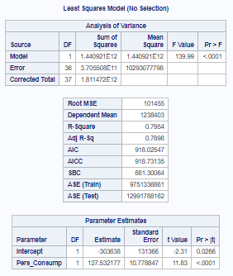
In addition, the Personal Consumption variable returned a p-value of <.001. Using this p-value, the null hypothesis stating that the regression coefficient is equal to zero can be rejected and the alternate hypothesis can be accepted (Page & Satake, 2017). The linear regression model can be written as:
Quarterly Revenue = -303,638 + (127.532) * Personal Consumption.
Conclusion
To prepare their organization for success, business leaders must have accurate forecasts of upcoming quarterly revenues. It is through the understanding the future revenues, that leaders can adjust their resources before these revenues are predicted to occur. While much research has used macro-economic data to forecast larger economic events, relatively few studies have been conducted to demonstrate the forecasting ability of macro-economic data upon individual companies. Using regression analysis, it was discovered that the macro-economic variable (Personal Consumption), could explain approximately 80% of quarterly revenue of First American Financial Corporation. By applying this knowledge, the company now has an evidence-based model to help it determine the resources it will need to properly service its customers, shareholders and employees.
Recommendations
Three main areas need to be further investigated. First, since the results apply to a single publicly traded company, a generalization should not be made that the findings hold true for all publicly traded companies. Second, research should also be conducted to see if the addition or substitution of other macro-economic variables can improve the R² value of the regression model that was developed. Lastly, in addition to utilizing a regression model, other models should be tested for their forecasting ability.
References
Adeola, O. (2016). The impact of macroeconomic conditions on sales performance in Nigeria. The Journal of Developing Areas. Vol 50, Issue 6, pgs. 31-41. Retrieved from http://eds.a.ebscohost.com.csuglobal.idm.oclc.org/eds/pdfviewer/pdfviewer?vid=5&sid=3d5199e1-fb5c-4176-89f1-35c81dd403e5%40sessionmgr4008
Chinn, M., & Kucko, K. (2015). The predictive power of the Yield Curve across countries and time. International Finance. Summer 2015, Vol. 18, Issue 2, pgs. 129-156. http://eds.b.ebscohost.com.csuglobal.idm.oclc.org/eds/detail/detail?vid=1&sid=e5c68f15-8b9e-4e83-902b-15cec11e0a7c%40pdc-v-sessmgr03&bdata=JnNpdGU9ZWRzLWxpdmU%3d#AN=edsgcl.426795044&db=edsgao
FRED Economic Research. (2020). FRED economic data. FRED Economic Data | St. Louis Fed. Retrieved 10/10/20, from https://fred.stlouisfed.org/
Homareau, J. (2015). Forecasting sales volumes with economic indicators. Journal of Business Forecasting. Fall 2015, Vol. 34, Issue 3, pgs. 32-34. https://www-proquest-com.csuglobal.idm.oclc.org/docview/1770021221?accountid=38569
Jaadi, Z. (2019). Everything you need to know about interpreting correlations. Towards Data Science. Retrieved on 10/18/20 from https://towardsdatascience.com/eveything-you-need-to-know-about-interpreting-correlations-2c485841c0b8
Jafarpanah, M. and Rezaei, B. (2014). Association between organizational citizenship behavior and patient safety culture from a nurses’ perspectives: A descriptive correlational study. BMC Nursing. Vol. 19, Issue 1, pgs. 1-8. Retrieved from http://eds.a.ebscohost.com.csuglobal.idm.oclc.org/eds/detail/detail?vid=3&sid=134ab410-c896-44bb-94d1-bc2de54e6852%40sdc-v-sessmgr02&bdata=JnNpdGU9ZWRzLWxpdmU%3d#AN=142717072&db=c8h
Joseph, A., & Larrain, M. (2012). Housing Starts forecast of Retail Sales through the 2007-2009 Recession. Procedia Computer Science. 2012. Vol. 12, pgs. 271-275. https://www-sciencedirect-com.csuglobal.idm.oclc.org/science/article/pii/S187705091200659X?via%3Dihub
Joseph, A., Larrain, M., & Turner, C. (2014). The Treasury Bill rate, the Great Recession, and Neural Networks estimates of Real Business Sales. Procedia Computer Science. 2014, Vol. 36, pgs. 227-233. http://eds.b.ebscohost.com.csuglobal.idm.oclc.org/eds/detail/detail?vid=6&sid=e5c68f15-8b9e-4e83-902b-15cec11e0a7c%40pdc-v-sessmgr03&bdata=JnNpdGU9ZWRzLWxpdmU%3d#AN=S1877050914013337&db=edselp
Krystalogianni, A., Matysiak, G., & Tsolacos, S. (2004). Forecasting UK commercial real estate cycle phases with leading indicators: A probit approach. Applied Economics. Vol. 36, Issue 20, pgs. 2347-2356. http://eds.b.ebscohost.com.csuglobal.idm.oclc.org/eds/detail/detail?vid=8&sid=e5c68f15-8b9e-4e83-902b-15cec11e0a7c%40pdc-v-sessmgr03&bdata=JnNpdGU9ZWRzLWxpdmU%3d#AN=15328309&db=bth
Lazare, D. (n.d.). A rising tide lifts all boats: Has the right been misusing JFK’s quote? History News Network. Retrieved 10/10/20, from https://historynewsnetwork.org/article/73227
O’Leary, Z. (2017). The Essential Guide to Doing Your Research Project (3rd ed.). Sage.
Page, R. & Satake, E. (2017). Beyond p values and hypothesis testing: Using the Minimum Bayes Factor to teach statistical inference in undergraduate introductory statistics courses. Journal of Education and Learning, Vol 6., No. 4., 254-266.
Sadahiro, Y. & Wang, Y. (2018). Configuration of sample points for the reduction of multicollinearity in regression models with distance variables. Annals of Regional Science. Sep2018, Vol. 61, Issue 2, 295-317. Retrieved from http://eds.b.ebscohost.com.csuglobal.idm.oclc.org/eds/detail/detail?vid=1&sid=703ef5e8-bc9e-4ee4-963e-279bd1dfbe20%40sessionmgr103&bdata=JnNpdGU9ZWRzLWxpdmU%3d#AN=132112829&db=bth
U.S. Securities and Exchange Commission. (2020). Edgar Company findings. U.S. Securities and Exchange Commission. Retrieved 10/10/20 from https://www.sec.gov/edgar/searchedgar/companysearch.html

