Exp-1

Name: Pranaav kumar roll.no:230701233

|  |  |  |
| --- | --- | --- |
| **Ex.No.: 1** | | **CREATION OF BASE TABLE AND DML OPERATIONS** |
| **Date:** | 01/08/2024 |

1. Create MY_EMPLOYEE table with the following structure

CREATE TABLE MY_EMPLOYEE( ID Number(4) NOT NULL,

Last_name Varchar(25), First_name Varchar(25), Userid Varchar(25), Salary Number(9,2)

);

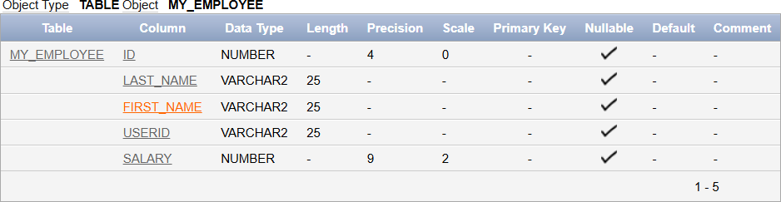

1. Add the first row and second rows data to MY_EMPLOYEE table fromthe sample table

Insert  MY_EMPLOYEE(&ID,&LAST_NAME,&FIRST_NAME,&USERID,&SALARY

)

values(1,”Patel”,”Ralph”,”rpatel”,895 2,”Dancs”,”Betty”,”bdancs”,860);

1. Display the table with values

Select * from MY_EMPLOYEE;

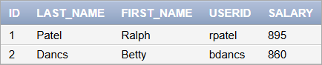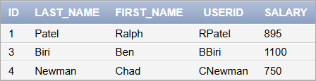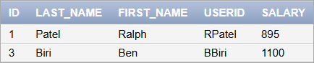

1. populate the next two rows of data from the sample data. Concatenate the first letter of the first_NAME with first seven letters of the last_name to produce Userid

Update MY_EMPLOYEES

Set Userid = substr(first_name,1,1) || substr(last_name,1,7)Where ID in (3,4);

1. delete Betty dancs from my_employee table`1 Delete from MY_EMPLOYEE

Where FIRST_NAME = „Betty‟ and LAST_NAME = „Dancs‟;

1. Empty the fourth row of the emp table Delete from MY_EMPLOYEE

Where ID = 5;

1. Make the data additions permanent

Commit

1. Change the last name of employee 3 to Drexler

Update MY_EMPLOYEE Set LAST_NAME = “Drexler” Where ID = 3;

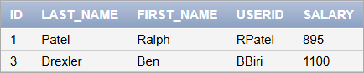

1. Change the salary to 1000 for all the employees with a salary less than900.

Update MY_EMPLOYEE Set salary = 1000

Where salary<900;

