Exp-2

Name: Pranaav kumar roll.no:230701233

|  |  |  |
| --- | --- | --- |
| **Ex.No.: 2** | | **DATA MANIPULATIONS** |
| **Date:** | 08/08/2024 |

1. Find out the employee id, names, salaries of all the employeesselect Employee_id, First_Name, Salary from EMPLOYEES;
2. List out the employees who works under manager 100

select First_Name || ' ' || Last_Name as name from EMPLOYEES where manager_id

=100;

1. Find the names of the employees who have a salary greater than or equal to 4800 select First_Name || ' ' || Last_Name as name from EMPLOYEES

Where salary >= 4800;

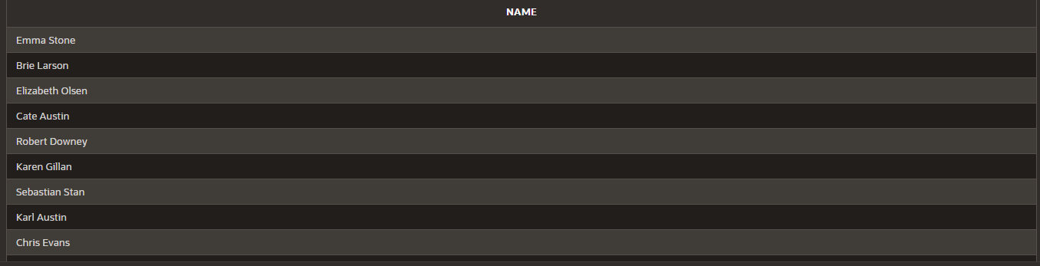

1. List out the employees whose last name is AUSTIN

select First_Name || ' ' || Last_Name as name from EMPLOYEES where Last_Name = 'Austin';

1. Find the names of the employees who works in departments 60,70 and 80

select First_Name || ' ' || Last_Name as name from EMPLOYEES where Department_id in (60,70,80);

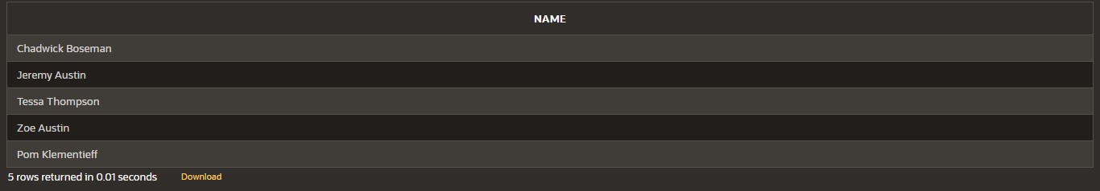

1. Display the unique Manager_Id.

select DISTINCT(manager_id) from EMPLOYEES;



1. Insert Five Records and calculate GrossPay and NetPay.

INSERT INTO Emp (EmpNo, EmpName, Job, Basic, DA, HRA, PF, GrossPay, NetPay) VALUES (

101, 'John Doe', 'Manager', 50000, 15000, 20000, 6000,0,0 ,

102, 'Jane Smith', 'Developer', 40000, 12000, 16000, 4800,0,0 ,

103, 'Alice Johnson', 'Analyst', 35000, 10500, 14000, 4200,0,0 ,

104, 'Bob Brown', 'Designer', 30000, 9000, 12000, 3600,0,0 ,

105, 'Charlie Davis', 'Tester', 25000, 7500, 10000, 3000,0,0

)

update emp

set GrossPay = Basic+DA+HRA where Grosspay = 0;

update emp

set NetPay = Grosspay - PF where Netpay = 0;

1. Display the employees whose Basic is lowest in each department.select job,min(basic) from Emp

group by Job;

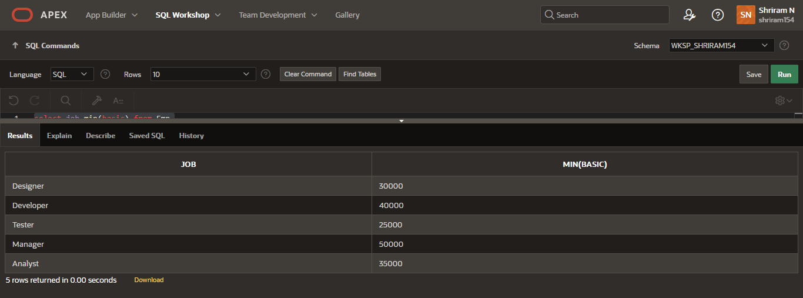

1. Create the DEPT table based on the DEPARTMENT following the table instancechart below. Confirm that the table is created.

Create table DEPT(

ID Number(7), Name varchar(25)

);

Desc DEPT;

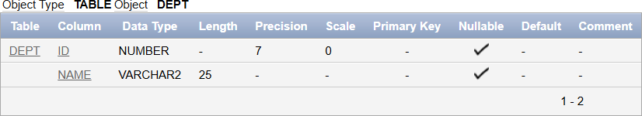

1. Create the EMP1 table based on the following instance chart. Confirm that the tableis created.

create table EMP1( ID Number(7),

First_name varchar(25), Last_name varchar(25), Dept_id Number(7)

);

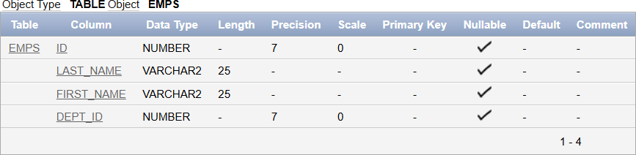Desc EMP1;

1. Modify the EMP1 table to allow for longer employee last names. Confirm the modification.(Hint: Increase the size to 50)

# ALTER TABLE EMP1

modify Last_name varchar(50);

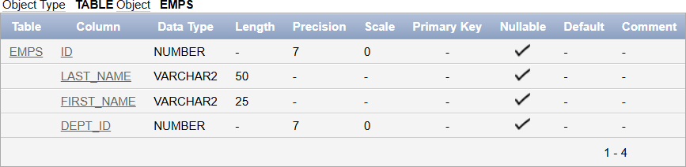

1. Create the EMPLOYEES2 table based on the structure of EMPLOYEES table. Include Only the Employee_id, First_name, Last_name, Salary and Dept_id coloumns.Name the columns Id, First_name, Last_name, salary and Dept_id respectively.

create table EMPLOYEES2(ID Number(10), First_name varchar(50), Last_name varchar(50), Salary Number(10), Dept_id Number(10)

);

1. Drop the EMP1 table. drop table EMP1;
2. Rename the EMPLOYEES2 table as EMP1.

# ALTER TABLE EMPLOYEES2 RENAME TO EMP1;

1. Add a comment on DEPT and EMP1 tables. Confirm the modification by describingthe table.

comment on TABLE DEPT IS 'this table contains the fields ID and NAME..'; SELECT TABLE_NAME, COMMENTS

# FROM USER_TAB_COMMENTS

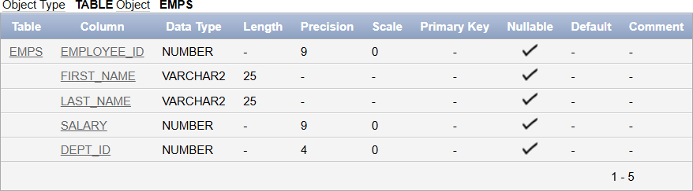

WHERE TABLE_NAME = 'DEPT';

comment on TABLE EMP1 IS 'this table contains the fields ID,first name,lastname,salary,DEPT_id..';

# SELECT TABLE_NAME, COMMENTS FROM USER_TAB_COMMENTS WHERE TABLE_NAME = 'EMP1';

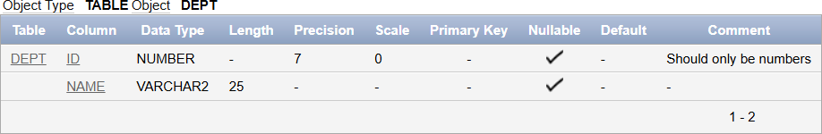

1. Drop the First_name column from the EMP table and confirm it.

# ALTER TABLE EMP1

drop column First_name;

