Exp-10



Name: Pranaav kumar roll.no:230701233

|  |  |  |
| --- | --- | --- |
| **Ex.No.: 10** | | **AGGREGATING DATA USING GROUP FUNCTIONS** |
| **Date:** | 12/09/2024 |

Find the Solution for the following:

Determine the validity of the following three statements. Circle either True or False.

1. Group functions work across many rows to produce one resultper group. True/False - TRUE
2. Group functions include nulls in calculations. True/False - FALSE
3. The WHERE clause restricts rows prior to inclusion in a group calculation. True/False - FALSE
4. Find the highest, lowest, sum, and average salary of all employees. Label the columns Maximum, Minimum, Sum, and Average, respectively. Round your results tothe nearest whole number

SELECT ROUND(MAX(salary)) AS Maximum, ROUND(MIN(salary)) AS Minimum, ROUND(SUM(salary)) AS Sum, ROUND(AVG(salary)) AS Average

FROM employees;

1. Modify the above query to display the minimum, maximum, sum, and average salaryfor each job type.

SELECT ROUND(MAX(salary)) AS Maximum, ROUND(MIN(salary)) AS Minimum, ROUND(SUM(salary)) AS Sum, ROUND(AVG(salary)) AS Average

FROM employees join department

on department.dept_id = employees.department_idgroup by dept_name;

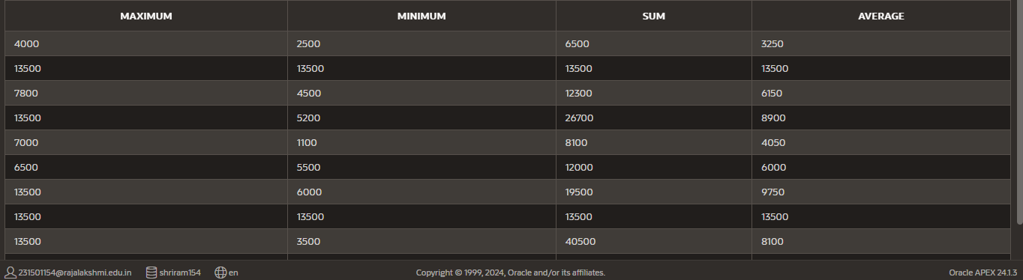

1. Write a query to display the number of people with the same job. Generalize thequery so that

the user in the HR department is prompted for a job title.

SELECT d.dept_name , COUNT(*) AS NumberOfEmployeesFROM Employees e

join department d on e.department_id = d.dept_idgroup by d.dept_name;

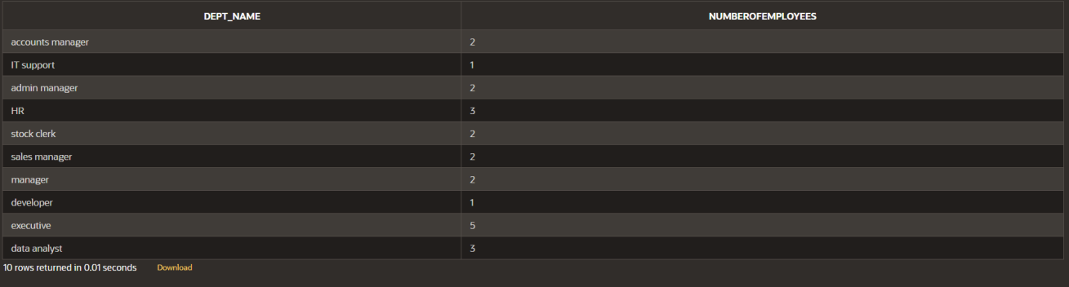

1. Determine the number of managers without listing them. Label the column Numberof Managers

SELECT COUNT(DISTINCT MANAGER_ID) AS "Number of Managers"

FROM Employees

WHERE MANAGER_ID IS NOT NULL;



1. Find the difference between the highest and lowest salaries. Label the column DIFFERENCE.

select max(salary) - min(salary) as "DIFFERENCE"from employees;



1. Create a report to display the manager number and the salary of the lowest-paid employee for that manager. Exclude anyone whose manager is not known. Exclude anygroups where the minimum salary is $6,000 or less. Sort the output in descending orderof salary.

SELECT MANAGER_ID, MIN(SALARY) AS "Lowest Salary"

FROM Employees

WHERE MANAGER_ID IS NOT NULL GROUP BY MANAGER_ID

HAVING MIN(SALARY) > 6000

ORDER BY "Lowest Salary" DESC;



1. Create a query to display the total number of employees and, of that total, thenumber of employees hired in 1995, 1996, 1997, and 1998. Create appropriate

column headings.

SELECT EXTRACT(YEAR FROM hire_date) AS "yearly wise employment", COUNT(*) FROM employees

GROUP BY EXTRACT(YEAR FROM hire_date)

HAVING EXTRACT(YEAR FROM hire_date) IN (1995, 1996, 1997, 1998);



1. Create a matrix query to display the job, the salary for that job based on departmentnumber, and the total salary for that job, for departments 20, 50, 80, and 90, giving each column an appropriate heading.

select d.dept_name , sum(e.salary) from employees e

join department d on e.department_id = d.dept_idwhere department_id in (20,50,80,90)

group by d.dept_name;



1. Write a query to display each department‘s name, location, number of employees,and the average salary for all the employees in that department. Label the column name-Location, Number of people, and salary respectively. Round the average salary to two decimalplaces.

SELECT d.dept_name AS "Name", d.Location_id AS "Location", COUNT(e.department_id) AS "Number of People", ROUND(AVG(e.Salary), 2) AS"Salary"

FROM department d

JOIN employees e ON d.dept_id = e.department_id

GROUP BY d.dept_name, d.location_id;

