Exp-11

Name: Pranaav kumar roll.no:230701233

|  |  |  |
| --- | --- | --- |
| **Ex.No.: 11** | | **PL SQL PROGRAMS** |
| **Date:** | 13/09/2024 |

# PROGRAM 1

Write a PL/SQL block to calculate the incentive of an employee whose ID is 110.

DECLARE

pl_emp_id employees.employee_id%TYPE := 110; pl_salary employees.salary%TYPE;

pl_incentive NUMBER; BEGIN

SELECT salary INTO pl_salary FROM employees

WHERE employee_id = pl_emp_id; pl_incentive := pl_salary * 0.10;

UPDATE employees

SET incentive = pl_incentive WHERE employee_id = pl_emp_id;

DBMS_OUTPUT.PUT_LINE('Incentive for employee ID ' || pl_emp_id || ' is ' || pl_incentive);

COMMIT; END;

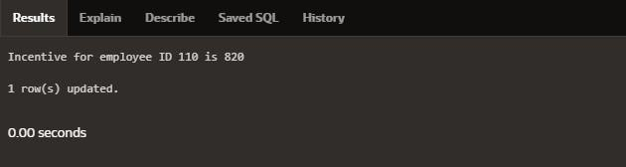

# PROGRAM 2

Write a PL/SQL block to show an invalid case-insensitive reference to a quotedand without quoted user-defined identifier.

DECLARE

employeeName VARCHAR2(100); "EmployeeID" NUMBER;

BEGIN

employeeName := 'John Doe'; "EmployeeID" := 40;

DBMS_OUTPUT.PUT_LINE('Employee Name: ' || employeeName); DBMS_OUTPUT.PUT_LINE('Employee ID: ' || "EmployeeID");

END;

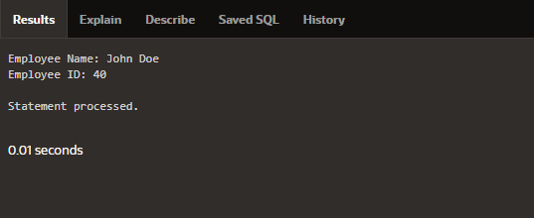

Write a PL/SQL block to adjust the salary of the employee whose ID 122.Sample table: employees

# DECLARE

v_employee_id NUMBER := 122; v_salary NUMBER; v_new_salary NUMBER;

v_increase_percentage NUMBER := 0.40; BEGIN

SELECT salary INTO v_salary FROM employees

WHERE employee_id = v_employee_id;

v_new_salary := v_salary + (v_salary * v_increase_percentage / 100); UPDATE employees

SET salary = v_new_salary

WHERE employee_id = v_employee_id;

DBMS_OUTPUT.PUT_LINE('Employee ID ' || v_employee_id || ' new salary: ' || v_new_salary);

# END;

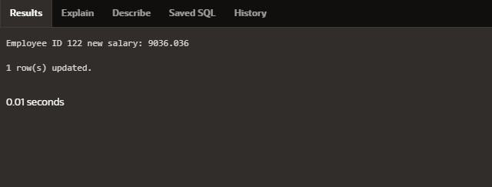

Write a PL/SQL block to create a procedure using the "IS [NOT] NULL Operator" andshow AND operator returns TRUE if and only if both operands are TRUE.

create or replace procedure check_nullis value1 number := 10;

value2 number := null; begin

if value1 is not null and value2 is null then

dbms_output.put_line('Both values are not null!!'); else

dbms_output.put_line('Null value found');end

if; end;

# BEGIN

check_null; END;

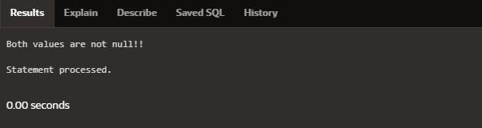

Write a PL/SQL block to describe the usage of LIKE operator including wildcard characters and

escape character.

declare

v_employeename employees.first_name%type; v_employeeid NUMBER := 122;

begin

select first_name into v_employeenamefrom employees

where first_name like '%e%' and employee_id = v_employeeid; DBMS_OUTPUT.PUT_LINE(v_employeename);

# END;

Write a PL/SQL program to arrange the number of two variable in such a way that the small number will store in num_small variable and large number will store in num_largevariable.

declare

ab number :=10;

cd number :=20; num_small number; num_large number; begin

if ab>cd then num_small :=cd; num_large :=ab; else

num_small :=ab; num_large :=cd; end if;

dbms_output.put_line('small number = '||num_small); dbms_output.put_line('large number = '||num_large); End;

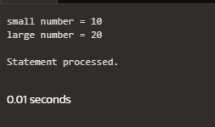

Write a PL/SQL procedure to calculate the incentive on a target achieved and display themessage either the record updated or not.

create or replace procedure calculate_incentive(p_emp_id employees.employee_id%type, p_target number)

is

v_incentive number(7,2); v_salary employees.salary%type;

begin

select salary into v_salary from employees

where employee_id = p_emp_id;

if p_target >= 100000 then v_incentive := v_salary * 0.1;

dbms_output.put_line('Incentive of ' || v_incentive || ' calculated for employee ID ' || p_emp_id);

else

dbms_output.put_line('No incentive for employee ID ' || p_emp_id);end if;

End;

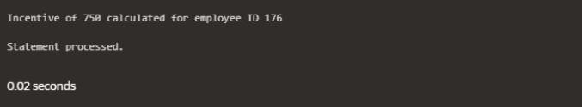

Write a PL/SQL procedure to calculate incentive achieved according to the specific salelimit.

create or replace procedure incentive_sale(p_emp_id employees.employee_id%type,p_sales number)

is

v_incentive number(7,2); begin

if p_sales > 100000 then v_incentive := p_sales * 0.1;

elsif p_sales between 50000 and 100000 then v_incentive := p_sales * 0.05;

else

v_incentive := 0; end if;

dbms_output.put_line('Incentive for employee ID ' || p_emp_id || ' is: ' || v_incentive);End;

begin

incentive_sale(122,500000); end;

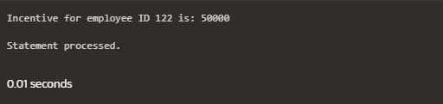

Write a PL/SQL program to count number of employees in department 50 and checkwhether this department have any vacancies or not. There are 45 vacancies in this department.

declare

no_of_emp number; vacancies number:=45; begin

select count(*) into no_of_emp from employees where department_id=50;if no_of_emp<vacancies then

dbms_output.put_line('vacancies are available');else dbms_output.put_line('vacancies are not available');end if;

end;

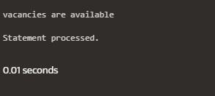

# PROGRAM 10

Write a PL/SQL program to count number of employees in a specific department and check whether this department have any vacancies or not. If any vacancies, how manyvacancies are in that department.

declare

v_department_id number := 55; v_emp_count number; v_vacancies number := 50;

begin

select count(*) into v_emp_count from employees

where department_id = v_department_id;

if v_emp_count < v_vacancies then

dbms_output.put_line('Vacancies available: ' || (v_vacancies - v_emp_count));else dbms_output.put_line('No vacancies available.');end

if; end;

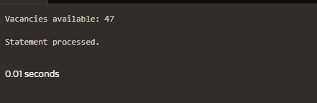

Write a PL/SQL program to display the employee IDs, names, job titles, hire dates, andsalaries of all employees.

begin

for i in (select employee_id, first_name || ' ' || last_name as name, job_id, hire_date,salary from employees)

loop

dbms_output.put_line('ID: ' || i.employee_id || ', Name: ' || i.name || ', Job: ' || i.job_id

|| ', Hire Date: ' || i.hire_date || ', Salary: ' || i.salary);end loop;

end;

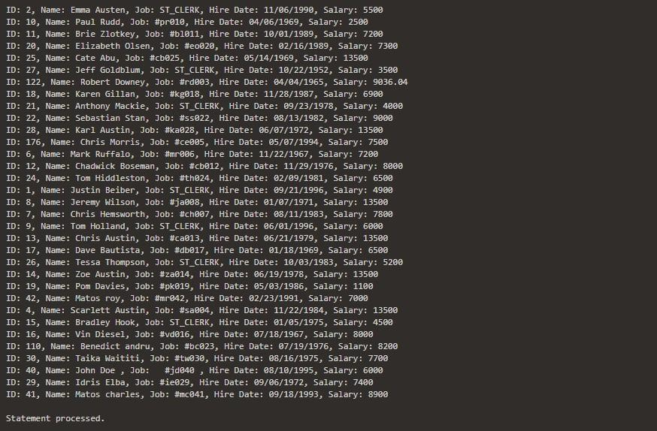

Write a PL/SQL program to display the employee IDs, names, and department names ofall employees.

begin

for i in (select e.employee_id, e.first_name || ' ' || e.last_name as name, d.dept_namefrom employees e

join department d on e.employee_id = d.dept_id) loop dbms_output.put_line('ID: ' || i.employee_id || ', Name: ' || i.name || ', Department: ' ||

i.dept_name); end loop;

End;

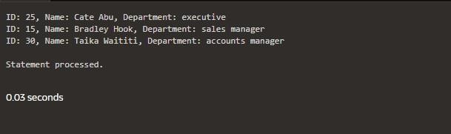

Write a PL/SQL program to display the job IDs, titles, and minimum salaries of all jobs.

begin

for rec in (select e.employee_id, d.dept_name, min(salary) as min_salary from employees

e join department d

on e.employee_ID = d.dept_id

group by e.employee_id , d.dept_name)loop

dbms_output.put_line('Job ID: ' || rec.employee_id || ', Title: ' || rec.dept_name || ',Min Salary: ' || rec.min_salary);

end loop; End;

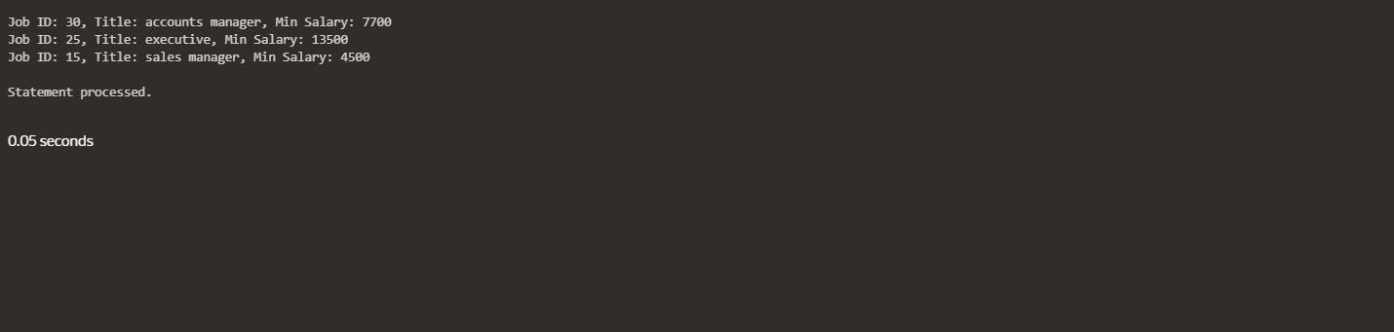

begin

for rec in (select e.employee_id, d.dept_name, min(salary) as min_salary from employees

e join department d

on e.employee_ID = d.dept_id

group by e.employee_id , d.dept_name)loop

dbms_output.put_line('Job ID: ' || rec.employee_id || ', Title: ' || rec.dept_name || ',Min Salary: ' || rec.min_salary);

end loop; End;



# PROGRAM 14

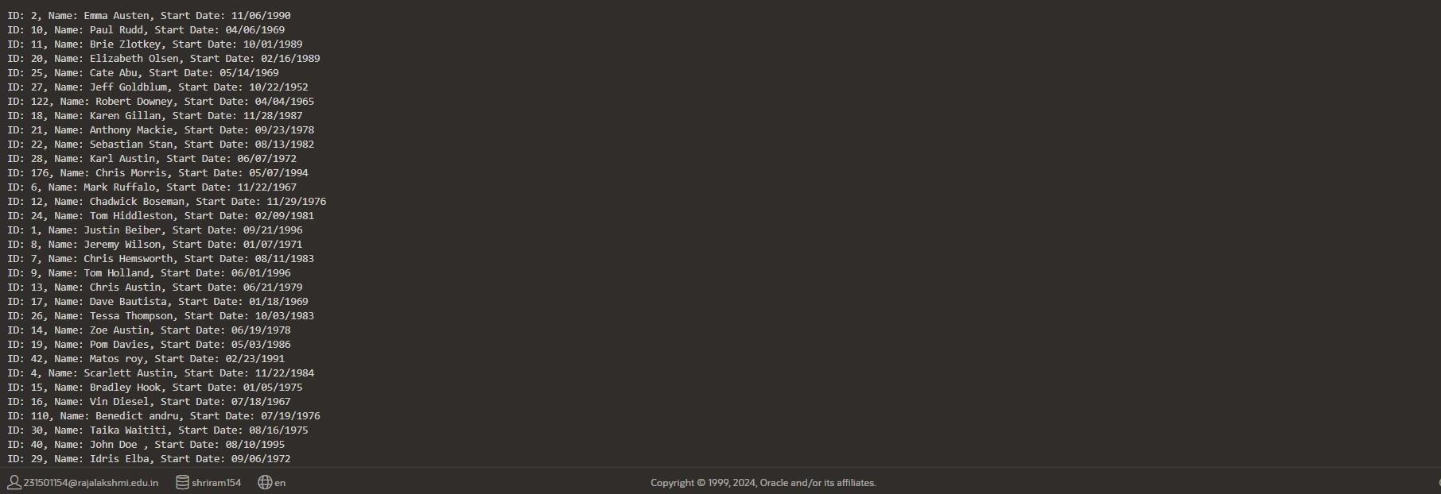

Write a PL/SQL program to display the employee IDs, names, and job history start datesof all Employees.

Begin

for rec in (select employee_id, first_name || ' ' || last_name as name, hire_datefrom employees) loop

dbms_output.put_line('ID: ' || rec.employee_id || ', Name: ' || rec.name || ', Start Date: '

|| rec.hire_date); end loop;

end;

# PROGRAM 15

**BEGIN**

FOR rec IN (SELECT employee_id, first_name || ' ' || last_name AS name, end_dateFROM employees)

# LOOP

dbms_output.put_line('ID: ' || rec.employee_id ||',

Name: ' || rec.name || ', End Date: ' ||

NVL(TO_CHAR(rec.end_date, 'YYYY-MM-DD'), 'Still Active'));

**END LOOP; END;**

