Exp-12

Name: pranaav kumar roll.no:230701233

|  |  |  |
| --- | --- | --- |
| **Ex.No.: 12** | | **PL SQL PROGRAMS** |
| **Date:** | 19/09/2024 |

Program 1

FACTORIAL OF A NUMBER USING FUNCTION

DECLARE

n NUMBER := 10;

result NUMBER;

FUNCTION itfact(num NUMBER) RETURN NUMBER IS fact NUMBER := 1;

BEGIN

FOR i IN 1..num LOOP

fact := fact * i; END LOOP;

RETURN fact; END;

BEGIN

result := itfact(n);

DBMS_OUTPUT.PUT_LINE('The factorial of ' || n || ' is ' || result); END;

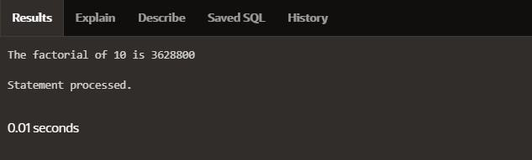

Program 2

Write a PL/SQL program using Procedures IN,INOUT,OUT parameters to retrieve the corresponding book information in library

CREATE OR REPLACE PROCEDURE book_info(

p_book_id IN NUMBER, p_author OUT VARCHAR2, p_title OUT VARCHAR2, p_published_date OUT DATE

) AS BEGIN

SELECT author, title, published_date INTO p_author, p_title, p_published_dateFROM books

WHERE book_id = p_book_id;

EXCEPTION

WHEN NO_DATA_FOUND THEN

p_author := NULL; p_title := NULL;

p_published_date := NULL; WHEN OTHERS THEN

RAISE;

END book_info;

DECLARE

v_author VARCHAR2(100); v_title VARCHAR2(100); v_published_date DATE; v_book_id NUMBER := 1;

BEGIN

book_info(v_book_id, v_author, v_title, v_published_date);

IF v_author IS NOT NULL THEN DBMS_OUTPUT.PUT_LINE('Book ID: ' || v_book_id); DBMS_OUTPUT.PUT_LINE('Author: ' || v_author); DBMS_OUTPUT.PUT_LINE('Title: ' || v_title);

DBMS_OUTPUT.PUT_LINE('Published Date: ' || TO_CHAR(v_published_date, 'YYYY- MM-DD'));

ELSE

DBMS_OUTPUT.PUT_LINE('No book found with ID: ' || v_book_id); END IF;

END;

