Exp-14

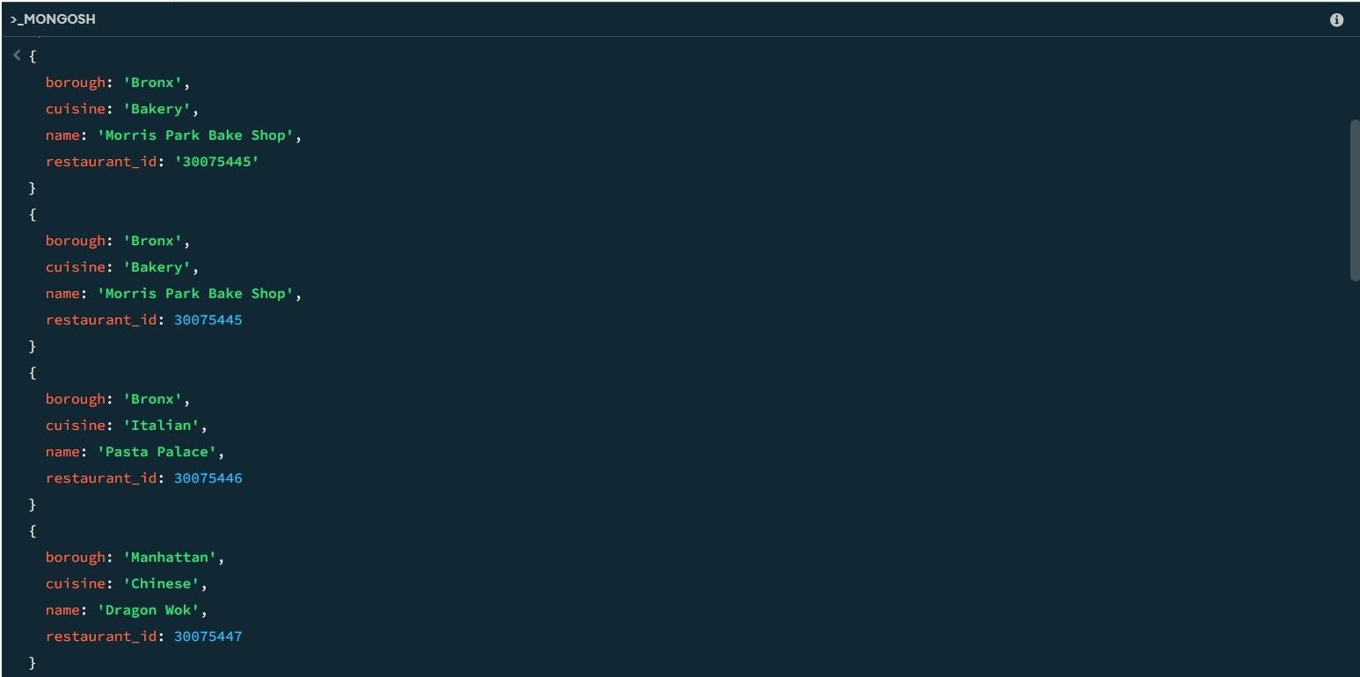

Name: pranaav kumar roll.no:230701233

|  |  |  |
| --- | --- | --- |
| **Ex.No.: 14** | | **MONGO DB** |
| **Date:** | 26/09/2024 |

1. **Write a MongoDB query to find the restaurant Id, name, borough and cuisine for those restaurants which prepared dish except 'American' and 'Chinees' or restaurant's name begins with letter 'Wil'.**

db.restaurants.find(

**{**

$or: [

{ cuisine: { $nin: ["American", "Chinees"] } },

{ name: { $regex: /^Wil/i } }

**]**

**},**

**{**

restaurant_id: 1,

name: 1,

borough: 1,

cuisine: 1,

_id: 0

**}**

**);**

1. **Write a MongoDB query to find the restaurant Id, name, and grades for those restaurants which achieved a grade of "A" and scored 11 on an ISODate "2014-08- 11T00:00:00Z" among many of survey dates..**

db.restaurants.find(

**{**

grades: {

$elemMatch: { grade: "A", score: 11

**}**

**}**

**},**

**{**

restaurant_id: 1,

name: 1,

grades: 1,

_id: 0

**}**

**);**

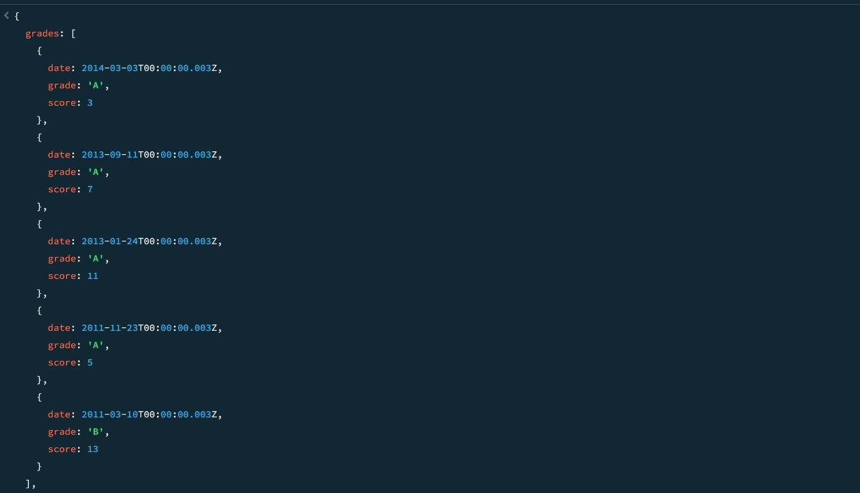

1. **Write a MongoDB query to find the restaurant Id, name and grades for those restaurants where the 2nd element of grades array contains a grade of "A" and score 9on an ISODate "2014-08-11T00:00:00Z".**

db.restaurants.find(

**{**

"grades.1": {

$elemMatch: { grade: "A", score: 9

**}**

**}**

**},**

**{**

restaurant_id: 1,

name: 1,

grades: 1,

_id: 0

**}**

**);**

1. **Write a MongoDB query to find the restaurant Id, name, address and geographical location for those restaurants where 2nd element of coord array contains a value whichis more than 42 and upto 52..**

db.restaurants.find(

**{**

"address.coord.1": { $gt: 42, $lte: 52 }

**},**

**{**

restaurant_id: 1,

name: 1,

address: 1,

_id: 0

**}**

**);**

1. **Write a MongoDB query to arrange the name of the restaurants in ascending orderalong with all the columns.**

db.restaurants.find().sort({ name: 1 }); SAMPLE OUTPUT:-

**{**

_id: ObjectId('671b5e6d56ec9972ca8f5dc4'), address: {

building: 5566, coord: [

-73.867377,

40.854047

**],**

street: '28th Avenue', zipcode: 10490

**},**

borough: 'Bronx', cuisine: 'BBQ', grades: [

**{**

date: 2014-03-03T00:00:00.028Z,

grade: 'A', score: 10

**},**

**{**

date: 2013-09-11T00:00:00.028Z,

grade: 'A', score: 7

**},**

**{**

date: 2013-01-24T00:00:00.028Z,

grade: 'A', score: 11

**},**

**{**

date: 2011-11-23T00:00:00.028Z,

grade: 'A', score: 9

**},**

**{**

date: 2011-03-10T00:00:00.028Z,

grade: 'B',

score: 15

**}**

**],**

name: 'BBQ Haven', restaurant_id: 30075473

**}**

**{**

_id: ObjectId('671b5dab56ec9972ca8f5db0'), address: {

building: 5566, coord: [

-73.859377,

40.850047

**],**

street: '8th Avenue', zipcode: 10470

**},**

borough: 'Manhattan', cuisine: 'French', grades: [

**{**

date: 2014-03-03T00:00:00.008Z,

grade: 'A', score: 7

**},**

**{**

date: 2013-09-11T00:00:00.008Z,

grade: 'A', score: 9

**},**

**{**

date: 2013-01-24T00:00:00.008Z,

grade: 'A', score: 10

**},**

**{**

date: 2011-11-23T00:00:00.008Z,

grade: 'B', score: 15

**},**

**{**

date: 2011-03-10T00:00:00.008Z,

grade: 'A', score: 6

**}**

**],**

name: 'Bistro Belle', restaurant_id: 30075453

**}**

1. **Write a MongoDB query to arrange the name of the restaurants in descending alongwith all the columns.**

db.restaurants.find().sort({ name: -1 });

SAMPLE OUTPUT

**{**

_id: ObjectId('671b5e9456ec9972ca8f5dc8'), address: {

building: 9900, coord: [

-73.868977,

40.854847

**],**

street: '32nd Avenue', zipcode: 10494

**},**

borough: 'Manhattan', cuisine: 'Russian', grades: [

**{**

date: 2014-03-03T00:00:00.032Z,

grade: 'A', score: 10

**},**

**{**

date: 2013-09-11T00:00:00.032Z,

grade: 'B', score: 5

**},**

**{**

date: 2013-01-24T00:00:00.032Z,

grade: 'A', score: 9

**},**

**{**

date: 2011-11-23T00:00:00.032Z,

grade: 'A', score: 8

**},**

**{**

date: 2011-03-10T00:00:00.032Z,

grade: 'A', score: 11

**}**

**],**

name: "Tsar's Table", restaurant_id: 30075477

**}**

**{**

_id: ObjectId('671b5e6d56ec9972ca8f5dbe'), address: {

building: 9900, coord: [

-73.864977,

40.852847

**],**

street: '22nd Avenue', zipcode: 10484

**},**

borough: 'Bronx', cuisine: 'Italian', grades: [

**{**

date: 2014-03-03T00:00:00.022Z,

grade: 'A', score: 8

**},**

**{**

date: 2013-09-11T00:00:00.022Z,

grade: 'B', score: 5

**},**

**{**

date: 2013-01-24T00:00:00.022Z,

grade: 'A', score: 12

**},**

**{**

date: 2011-11-23T00:00:00.022Z,

grade: 'A', score: 9

**},**

**{**

date: 2011-03-10T00:00:00.022Z,

grade: 'A', score: 14

**}**

**],**

name: 'Trattoria Bella', restaurant_id: 30075467

**}**

1. **Write a MongoDB query to arrange the name of the cuisine in ascending order and forthat same cuisine borough should be in descending order.**

db.restaurants.find().sort({ cuisine: 1, borough: -1 }); SAMPLE OUTPUT:-

**{**

_id: ObjectId('671b5d549d3d63480e0a64e9'), address: {

building: 2233, coord: [

-73.858177,

40.849447

**],**

street: '5th Avenue', zipcode: 10467

**},**

borough: 'Bronx', cuisine: 'American',

grades: [

**{**

date: 2014-03-03T00:00:00.005Z,

grade: 'A', score: 10

**},**

**{**

date: 2013-09-11T00:00:00.005Z,

grade: 'A', score: 6

**},**

**{**

date: 2013-01-24T00:00:00.005Z,

grade: 'B', score: 12

**},**

**{**

date: 2011-11-23T00:00:00.005Z,

grade: 'A', score: 9

**},**

**{**

date: 2011-03-10T00:00:00.005Z,

grade: 'A', score: 14

**}**

**],**

name: 'Burger Bistro', restaurant_id: 30075450

**}**

**{**

_id: ObjectId('671b5e6d56ec9972ca8f5dc4'), address: {

building: 5566, coord: [

-73.867377,

40.854047

**],**

street: '28th Avenue', zipcode: 10490

**},**

borough: 'Bronx', cuisine: 'BBQ',

grades: [

**{**

date: 2014-03-03T00:00:00.028Z,

grade: 'A', score: 10

**},**

**{**

date: 2013-09-11T00:00:00.028Z,

grade: 'A', score: 7

**},**

**{**

date: 2013-01-24T00:00:00.028Z,

grade: 'A', score: 11

**},**

**{**

date: 2011-11-23T00:00:00.028Z,

grade: 'A', score: 9

**},**

**{**

date: 2011-03-10T00:00:00.028Z,

grade: 'B', score: 15

**}**

**],**

name: 'BBQ Haven', restaurant_id: 30075473

**}**

1. **Write a MongoDB query to know whether all the addresses contains the street or not.**

db.restaurants.find(

**{**

"address.street": { $exists: false }

**}**

**);**

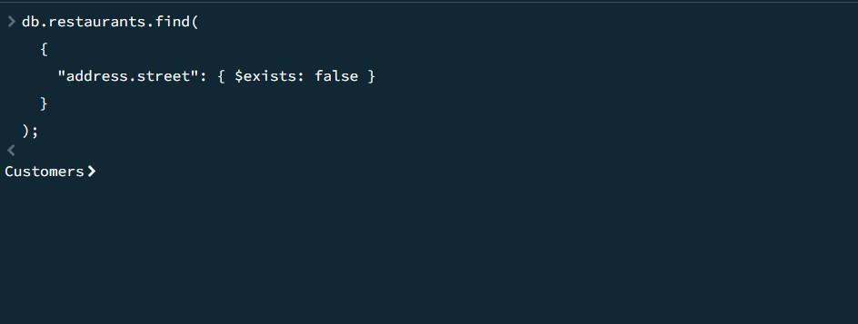

1. **Write a MongoDB query which will select all documents in the restaurants collectionwhere the coord field value is Double.**

db.restaurants.find(

**{**

"address.coord": { $type: "double" }

**}**

**);**

SAMPLE OUTPUT:-

**{**

_id: ObjectId('671b92d339ec8a9bc8b6588b'), address: {

building: '1007', coord: [

-73.856077,

40.848447

**],**

street: 'Morris Park Ave', zipcode: '10462'

**},**

borough: 'Bronx', cuisine: 'Bakery', grades: [

**{**

date: 2014-03-03T00:00:00.000Z,

grade: 'A', score: 2

**},**

**{**

date: 2013-09-11T00:00:00.000Z,

grade: 'A', score: 6

**},**

**{**

date: 2013-01-24T00:00:00.000Z,

grade: 'A', score: 10

**},**

**{**

date: 2011-11-23T00:00:00.000Z,

grade: 'A', score: 9

**},**

**{**

date: 2011-03-10T00:00:00.000Z,

grade: 'B', score: 14

**}**

**],**

name: 'Morris Park Bake Shop', restaurant_id: '30075445'

**}**

**{**

_id: ObjectId('671b5d549d3d63480e0a64e5'), address: {

building: 1234, coord: [

-73.856577,

40.848647

**],**

street: '1st Avenue', zipcode: 10463

**},**

borough: 'Bronx', cuisine: 'Italian', grades: [

**{**

date: 2014-03-03T00:00:00.001Z,

grade: 'A', score: 5

**},**

**{**

date: 2013-09-11T00:00:00.001Z,

grade: 'A', score: 8

**},**

**{**

date: 2013-01-24T00:00:00.001Z,

grade: 'B', score: 12

**},**

**{**

date: 2011-11-23T00:00:00.001Z,

grade: 'A', score: 7

**},**

**{**

date: 2011-03-10T00:00:00.001Z,

grade: 'A', score: 15

**}**

**],**

name: 'Pasta Palace', restaurant_id: 30075446

**}**

1. **Write a MongoDB query which will select the restaurant Id, name and grades forthose restaurants which returns 0 as a remainder after dividing the score by 7.**

db.restaurants.find(

**{**

"grades.score": { $mod: [7, 0] }

**},**

**{**

restaurant_id: 1,

name: 1,

grades: 1,

_id: 0

**}**

**);**

SAMPLE OUTPUT:-

**{**

grades: [

**{**

date: 2014-03-03T00:00:00.000Z,

grade: 'A', score: 2

**},**

**{**

date: 2013-09-11T00:00:00.000Z,

grade: 'A', score: 6

**},**

**{**

date: 2013-01-24T00:00:00.000Z,

grade: 'A', score: 10

**},**

**{**

date: 2011-11-23T00:00:00.000Z,

grade: 'A', score: 9

**},**

**{**

date: 2011-03-10T00:00:00.000Z,

grade: 'B', score: 14

**}**

**],**

name: 'Morris Park Bake Shop', restaurant_id: '30075445'

**}**

**{**

grades: [

**{**

date: 2014-03-03T00:00:00.001Z,

grade: 'A', score: 5

**},**

**{**

date: 2013-09-11T00:00:00.001Z,

grade: 'A', score: 8

**},**

**{**

date: 2013-01-24T00:00:00.001Z,

grade: 'B', score: 12

**},**

**{**

date: 2011-11-23T00:00:00.001Z,

grade: 'A', score: 7

**},**

**{**

date: 2011-03-10T00:00:00.001Z,

grade: 'A', score: 15

**}**

**],**

name: 'Pasta Palace', restaurant_id: 30075446

**}**

1. **Write a MongoDB query to find the restaurant name, borough, longitude and attitude and cuisine for those restaurants which contains 'mon' as three letters somewhere in itsname.**

db.restaurants.find(

**{**

name: { $regex: /mon/i }

**},**

**{**

name: 1,

borough: 1,

"address.coord.0": 1, // Longitude "address.coord.1": 1, // Latitude cuisine: 1,

_id: 0

**}**

**);**

1. **Write a MongoDB query to find the restaurant name, borough, longitude and latitudeand cuisine for those restaurants which contain 'Mad' as first three letters of its name.**

db.restaurants.find(

**{**

name: { $regex: /^Mad/i }

**},**

**{**

name: 1,

borough: 1,

"address.coord.0": 1, // Longitude "address.coord.1": 1, // Latitude cuisine: 1,

_id: 0

**}**

**);**

1. **Write a MongoDB query to find the restaurants that have at least one grade with ascore of less than 5.**

db.restaurants.find(

**{**

"grades.score": { $lt: 5 }

**}**

**);**

SAMPLE OUTPUT:-

**{**

_id: ObjectId('671b92d339ec8a9bc8b6588b'), address: {

building: '1007',

coord: [

-73.856077,

40.848447

**],**

street: 'Morris Park Ave', zipcode: '10462'

**},**

borough: 'Bronx', cuisine: 'Bakery', grades: [

**{**

date: 2014-03-03T00:00:00.000Z,

grade: 'A', score: 2

**},**

**{**

date: 2013-09-11T00:00:00.000Z,

grade: 'A', score: 6

**},**

**{**

date: 2013-01-24T00:00:00.000Z,

grade: 'A', score: 10

**},**

**{**

date: 2011-11-23T00:00:00.000Z,

grade: 'A', score: 9

**},**

**{**

date: 2011-03-10T00:00:00.000Z,

grade: 'B', score: 14

**}**

**],**

name: 'Morris Park Bake Shop', restaurant_id: '30075445'

**}**

**{**

_id: ObjectId('671b5d549d3d63480e0a64e6'), address: {

building: 5678, coord: [

-73.856977,

40.848847

**],**

street: '2nd Avenue', zipcode: 10464

**},**

borough: 'Manhattan', cuisine: 'Chinese', grades: [

**{**

date: 2014-03-03T00:00:00.002Z,

grade: 'B', score: 4

**},**

**{**

date: 2013-09-11T00:00:00.002Z,

grade: 'A', score: 9

**},**

**{**

date: 2013-01-24T00:00:00.002Z,

grade: 'A', score: 10

**},**

**{**

date: 2011-11-23T00:00:00.002Z,

grade: 'A', score: 8

**},**

**{**

date: 2011-03-10T00:00:00.002Z,

grade: 'B', score: 16

**}**

**],**

name: 'Dragon Wok', restaurant_id: 30075447

**}**

1. **Write a MongoDB query to find the restaurants that have at least one grade with ascore of less than 5 and that are located in the borough of Manhattan.**

db.restaurants.find(

**{**

"grades.score": { $lt: 5 }, borough: "Manhattan"

**}**

**);**

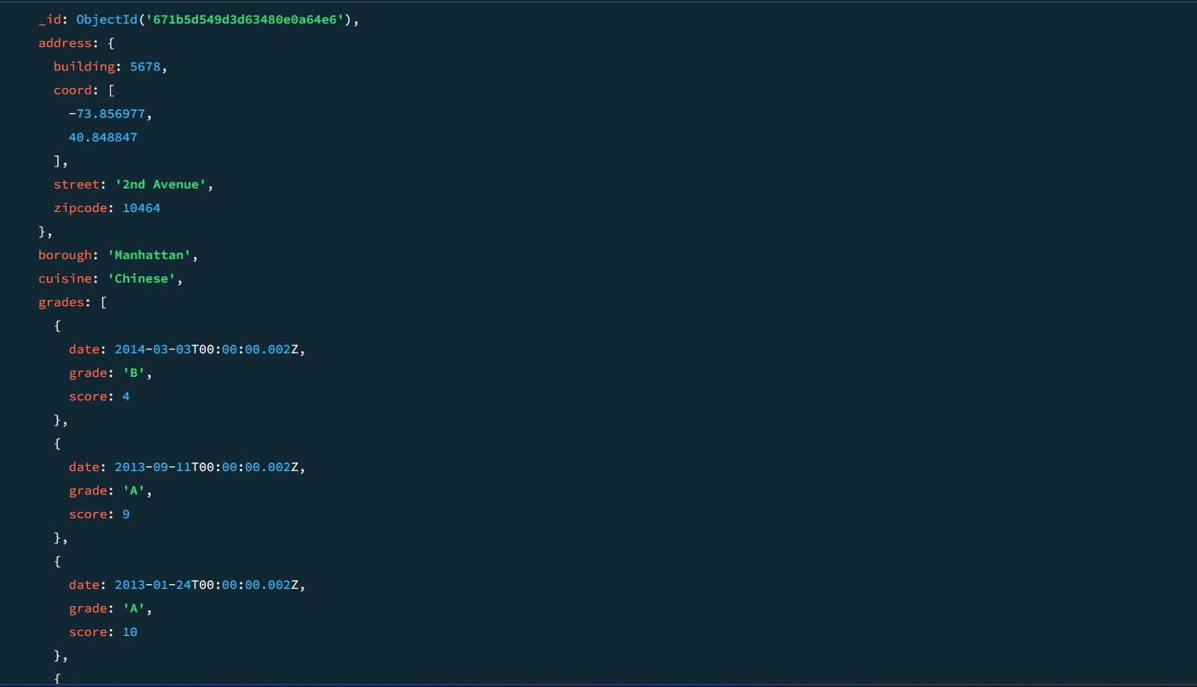

1. **Write a MongoDB query to find the restaurants that have at least one grade with ascore of less than 5 and that are located in the borough of Manhattan or Brooklyn.**

db.restaurants.find(

**{**

"grades.score": { $lt: 5 },

borough: { $in: ["Manhattan", "Brooklyn"] }

**}**

**);**

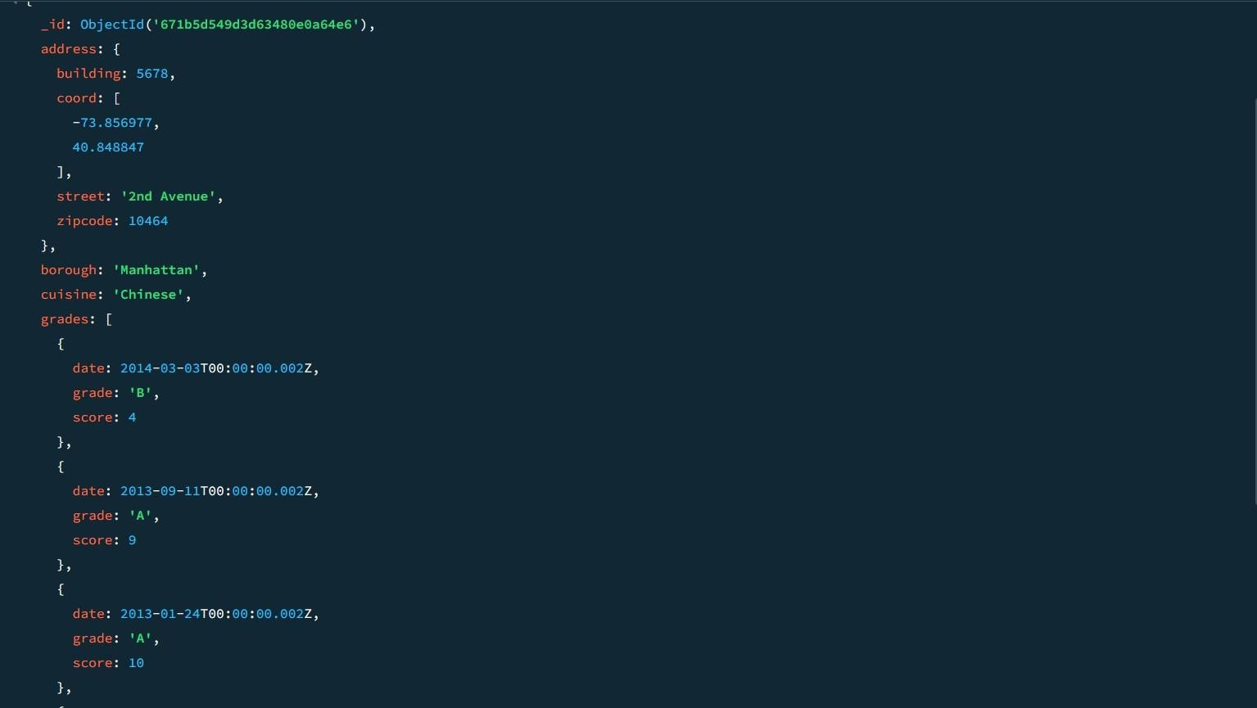

1. **Write a MongoDB query to find the restaurants that have at least one grade with a score of less than 5 and that are located in the borough of Manhattan or Brooklyn, andtheir cuisine is not American.**

db.restaurants.find(

**{**

"grades.score": { $lt: 5 },

borough: { $in: ["Manhattan", "Brooklyn"] }, cuisine: { $ne: "American" }

**}**

**);**

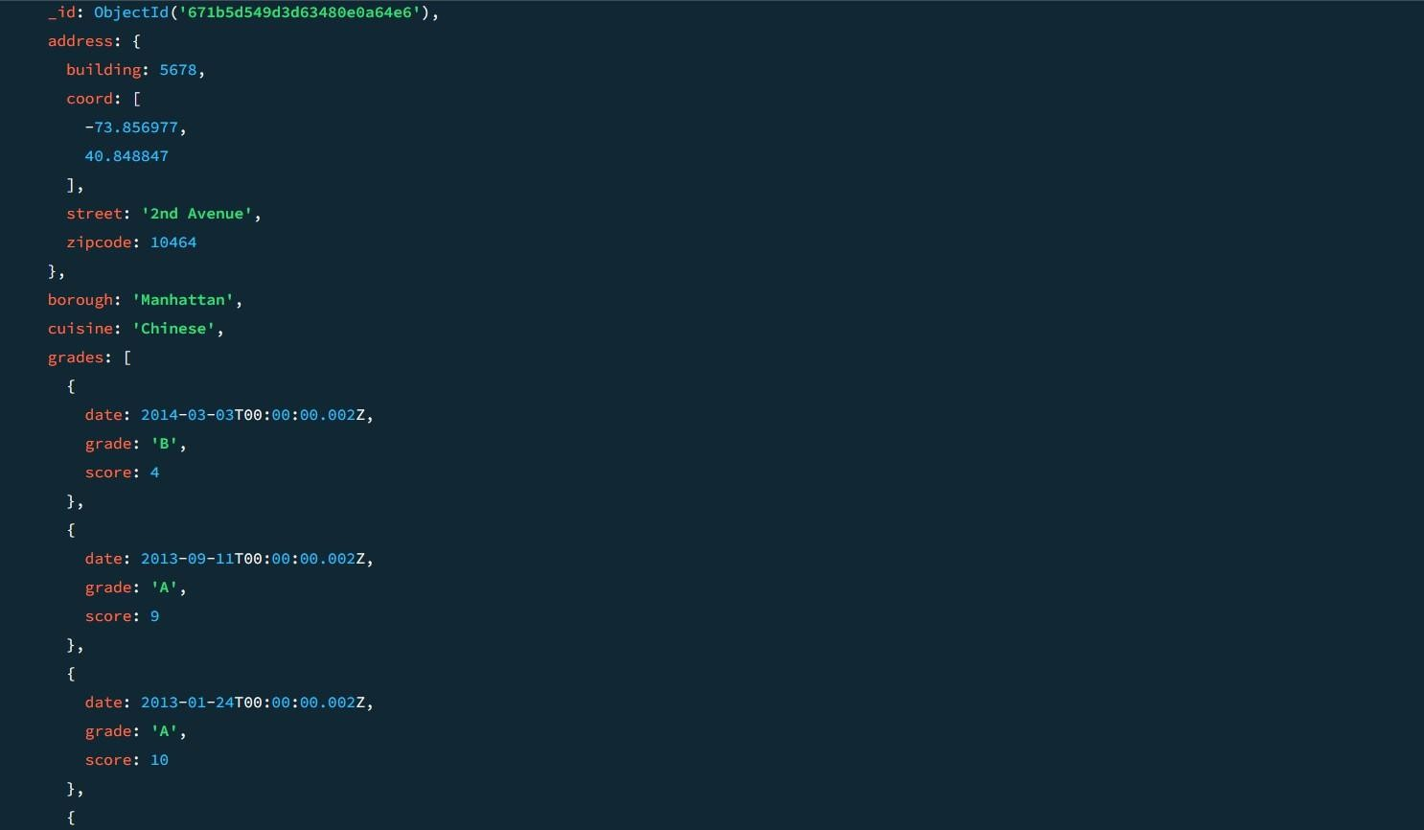

1. **Write a MongoDB query to find the restaurants that have at least one grade with a score of less than 5 and that are located in the borough of Manhattan or Brooklyn, andtheir cuisine is not American or Chinese.**

db.restaurants.find(

**{**

"grades.score": { $lt: 5 },

borough: { $in: ["Manhattan", "Brooklyn"] }, cuisine: { $nin: ["American", "Chinese"] }

**}**

**);**

1. **Write a MongoDB query to find the restaurants that have a grade with a score of 2 anda grade with a score of 6.**

db.restaurants.find(

**{**

grades: {

$all: [

{ $elemMatch: { score: 2 } },

{ $elemMatch: { score: 6 } }

**]**

**}**

**}**

**);**

SAMPLE OUTPUT:-

**{**

_id: ObjectId('671b92d339ec8a9bc8b6588b'), address: {

building: '1007', coord: [

-73.856077,

40.848447

**],**

street: 'Morris Park Ave', zipcode: '10462'

**},**

borough: 'Bronx', cuisine: 'Bakery', grades: [

**{**

date: 2014-03-03T00:00:00.000Z,

grade: 'A', score: 2

**},**

**{**

date: 2013-09-11T00:00:00.000Z,

grade: 'A', score: 6

**},**

**{**

date: 2013-01-24T00:00:00.000Z,

grade: 'A', score: 10

**},**

**{**

date: 2011-11-23T00:00:00.000Z,

grade: 'A', score: 9

**},**

**{**

date: 2011-03-10T00:00:00.000Z,

grade: 'B', score: 14

**}**

**],**

name: 'Morris Park Bake Shop', restaurant_id: '30075445'

**}**

**{**

_id: ObjectId('671b5c5f9d3d63480e0a64e4'), address: {

building: 1007, coord: [

-73.856077,

40.848447

**],**

street: 'Morris Park Ave', zipcode: 10462

**},**

borough: 'Bronx', cuisine: 'Bakery', grades: [

**{**

date: 2014-03-03T00:00:00.000Z,

grade: 'A', score: 2

**},**

**{**

date: 2013-09-11T00:00:00.000Z,

grade: 'A', score: 6

**},**

**{**

date: 2013-01-24T00:00:00.000Z,

grade: 'A', score: 10

**},**

**{**

date: 2011-11-23T00:00:00.000Z,

grade: 'A', score: 9

**},**

**{**

date: 2011-03-10T00:00:00.000Z,

grade: 'B', score: 14

**}**

**],**

name: 'Morris Park Bake Shop', restaurant_id: 30075445

**}**

1. **Write a MongoDB query to find the restaurants that have a grade with a score of 2 anda grade with a score of 6 and are located in the borough of Manhattan.**

db.restaurants.find(

**{**

borough: "Manhattan", grades: {

$all: [

{ $elemMatch: { score: 2 } },

{ $elemMatch: { score: 6 } }

**]**

**}**

**}**

**);**

1. **Write a MongoDB query to find the restaurants that have a grade with a score of 2 anda grade with a score of 6 and are located in the borough of Manhattan or Brooklyn.**

db.restaurants.find(

**{**

borough: { $in: ["Manhattan", "Brooklyn"] }, grades: {

$all: [

{ $elemMatch: { score: 2 } },

{ $elemMatch: { score: 6 } }

**]**

**}**

**}**

**);**

1. **Write a MongoDB query to find the restaurants that have a grade with a score of 2 anda grade with a score of 6 and are located in the borough of Manhattan or Brooklyn, and their cuisine is not American.**

db.restaurants.find(

**{**

borough: { $in: ["Manhattan", "Brooklyn"] }, grades: {

$all: [

{ $elemMatch: { score: 2 } },

{ $elemMatch: { score: 6 } }

**]**

**},**

cuisine: { $ne: "American" }

**}**

**);**

1. **Write a MongoDB query to find the restaurants that have a grade with a score of 2 anda grade with a score of 6 and are located in the borough of Manhattan or Brooklyn, and their cuisine is not American or Chinese.**

db.restaurants.find(

**{**

borough: { $in: ["Manhattan", "Brooklyn"] }, grades: {

$all: [

{ $elemMatch: { score: 2 } },

{ $elemMatch: { score: 6 } }

**]**

**},**

cuisine: { $nin: ["American", "Chinese"] }

**}**

**);**

1. **Write a MongoDB query to find the restaurants that have a grade with a score of 2 ora grade with a score of 6.**

db.restaurants.find(

**{**

$or: [

{ "grades.score": 2 },

{ "grades.score": 6 }

**]**

**}**

**);**

SAMPLE OUTPUT:-

**{**

_id: ObjectId('671b5d549d3d63480e0a64e9'), address: {

building: 2233, coord: [

-73.858177,

40.849447

**],**

street: '5th Avenue', zipcode: 10467

**},**

borough: 'Bronx', cuisine: 'American', grades: [

**{**

date: 2014-03-03T00:00:00.005Z,

grade: 'A', score: 10

**},**

**{**

date: 2013-09-11T00:00:00.005Z,

grade: 'A', score: 6

**},**

**{**

date: 2013-01-24T00:00:00.005Z,

grade: 'B', score: 12

**},**

**{**

date: 2011-11-23T00:00:00.005Z,

grade: 'A', score: 9

**},**

**{**

date: 2011-03-10T00:00:00.005Z,

grade: 'A', score: 14

**}**

**],**

name: 'Burger Bistro', restaurant_id: 30075450

**}**

**{**

_id: ObjectId('671b5dab56ec9972ca8f5daf'), address: {

building: 4455, coord: [

-73.858977,

40.849847

**],**

street: '7th Avenue', zipcode: 10469

**},**

borough: 'Bronx', cuisine: 'Thai', grades: [

**{**

date: 2014-03-03T00:00:00.007Z,

grade: 'A', score: 9

**},**

**{**

date: 2013-09-11T00:00:00.007Z,

grade: 'B', score: 6

**},**

**{**

date: 2013-01-24T00:00:00.007Z,

grade: 'A', score: 12

**},**

**{**

date: 2011-11-23T00:00:00.007Z,

grade: 'A', score: 8

**},**

**{**

date: 2011-03-10T00:00:00.007Z,

grade: 'B', score: 14

**}**

**],**

name: 'Thai Delight', restaurant_id: 30075452

**}**

**MOVIES COLLECTION**

1. **Find all movies with full information from the 'movies' collection that released in the year**

**1893.**

**db.movies.find({ year: 1893 });**

1. **Find all movies with full information from the 'movies' collectionthat have a runtime greater**

**than 120 minutes.**

**db.movies.find({ runtime: { $gt: 120 } }); SAMPLE OUTPUT:-**

**{**

**_id: ObjectId('573a1390f29313caabcd42ec'),**

**plot: 'An astronaut stranded on Mars must survive alone.',genres: [**

**'Sci-Fi', 'Drama'**

**],**

**runtime: 135, cast: [**

**'Matt Damon', 'Jessica Chastain'**

**],**

**poster: 'https://m.media-amazon.com/images/poster4.jpg',title: 'Mars Alone',**

**fullplot: 'An astronaut, left alone on Mars, struggles to survive with limited resources while awaiting rescue.',**

**languages: [**

**'English'**

**],**

**released: 2015-10-02T00:00:00.000Z,**

**directors: [ 'Ridley Scott'**

**],**

**rated: 'PG-13', awards: { wins:**

**8,**

**nominations: 6,**

**text: '8 wins & 6 nominations.'**

**},**

**lastupdated: '2021-08-09 17:22:30.000000000',**

**year: 2015, imdb: { rating: 8,**

**votes: 25650,**

**id: 443**

**},**

**countries: [ 'USA'**

**],**

**type: 'movie', tomatoes: { viewer: {**

**rating: 4.5,**

**numReviews: 2201,**

**meter: 93**

**},**

**fresh: 18, critic: { rating: 8.5,**

**numReviews: 25,**

**meter: 96**

**},**

**rotten: 1,**

**lastUpdated: 2021-07-19T21:20:55.000Z**

**}**

**}**

1. **Find all movies with full information from the 'movies' collectionthat have "Short" genre.**

**db.movies.find({ genres: "Short" }); SAMPLE OUTPUT:-**

**{**

**_id: ObjectId('573a1390f29313caabcd42e8'),**

**plot: 'A group of bandits stage a brazen train hold-up, only to find a**

**determined posse hot on their heels.', genres: [**

**'Short', 'Western'**

**],**

**runtime: 11, cast: [**

**'A.C. Abadie',**

**"Gilbert M. 'Broncho Billy' Anderson", 'George Barnes',**

**'Justus D. Barnes'**

**],**

**poster: 'https://m.media- amazon.com/images/M/MV5BMTU3NjE5NzYtYTYyNS00MDVmLWIwYjg tMmYwYWIxZDYyNzU2XkEyXkFqcGdeQXVyNzQzNzQxNzI@._V1_SY1 000_SX677_AL_.jpg',**

**title: 'The Great Train Robbery',**

**fullplot: "Among the earliest existing films in American cinema - notable as the first film that presented a narrative story to tell - it depicts a group of cowboy outlaws who hold up a train and rob the**

**passengers. They are then pursued by a Sheriff's posse. Severalscenes have color included - all hand tinted.",**

**languages: [ 'English'**

**],**

**released: 1903-12-01T00:00:00.000Z,**

**directors: [ 'Edwin**

**S. Porter'**

**],**

**rated: 'TV-G', awards: { wins: 1,**

**nominations: 0,**

**text: '1 win.'**

**},**

**lastupdated: '2015-08-13 00:27:59.177000000',**

**year: 1903, imdb: { rating: 7.4,**

**votes: 9847,**

**id: 439**

**},**

**countries: [ 'USA'**

**],**

**type: 'movie', tomatoes: { viewer: {**

**rating: 3.7,**

**numReviews: 2559,**

**meter: 75**

**},**

**fresh: 6, critic: { rating: 7.6,**

**numReviews: 6,**

**meter: 100**

**},**

**rotten: 0,**

**lastUpdated: 2015-08-08T19:16:10.000Z**

**}**

**}**

1. **Retrieve all movies from the 'movies' collection that were directed by "William K.L. Dickson" and include complete information for eachmovie.**

**db.movies.find({ directors: "William K.L. Dickson" });**

1. **Retrieve all movies from the 'movies' collection that were releasedin the USA and include complete information for each movie.**

**db.movies.find({ countries: "USA" });**

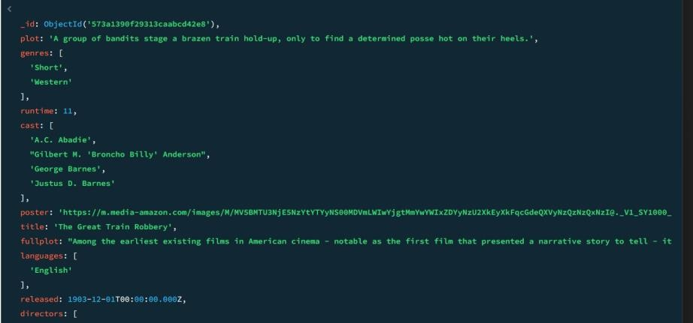

1. **Retrieve all movies from the 'movies' collection that have complete information and are rated**

**as "UNRATED".**

**db.movies.find({ rated: "UNRATED" });**

1. **Retrieve all movies from the 'movies' collection that have complete information and have received more than 1000 votes on IMDb.**

**db.movies.find({ "imdb.votes": { $gt: 1000 } });**

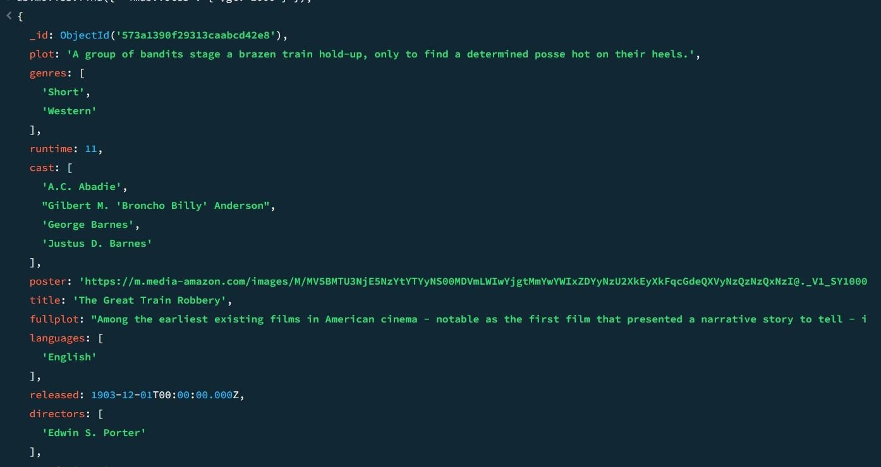

1. **Retrieve all movies from the 'movies' collection that have complete information and have an IMDb rating higher than 7.**

**db.movies.find({ "imdb.rating": { $gt: 7 } });**

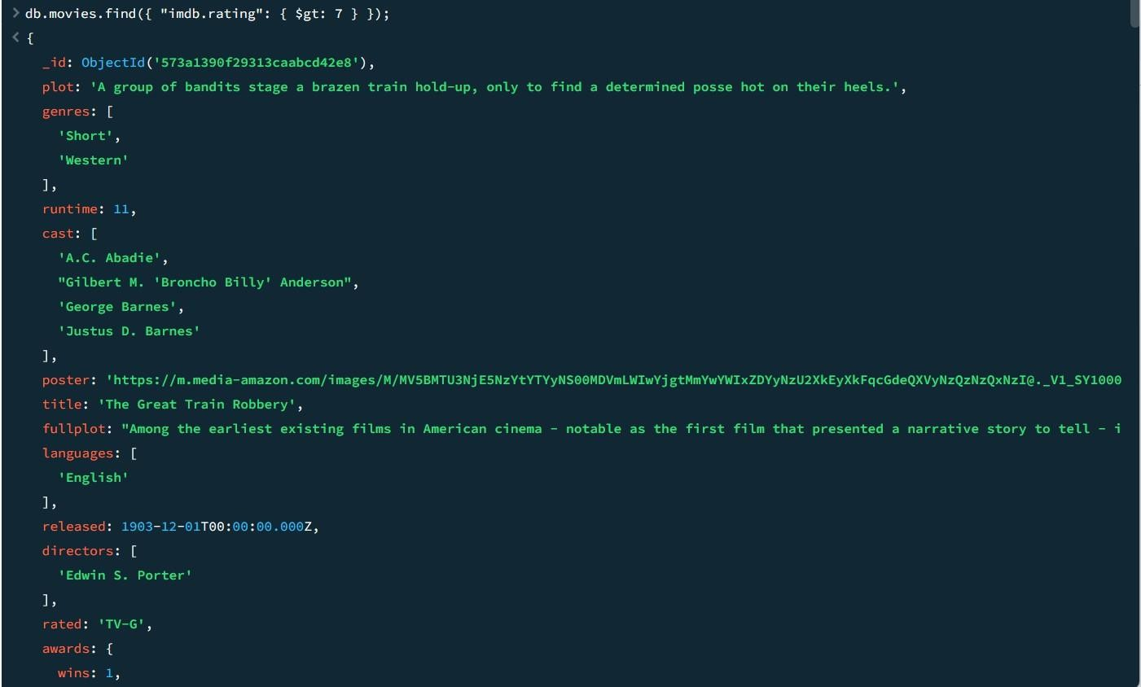

1. **Retrieve all movies from the 'movies' collection that have complete information and have a viewer rating higher than 4 onTomatoes.**

**db.movies.find({ "tomatoes.viewer.rating": { $gt: 4 } });**

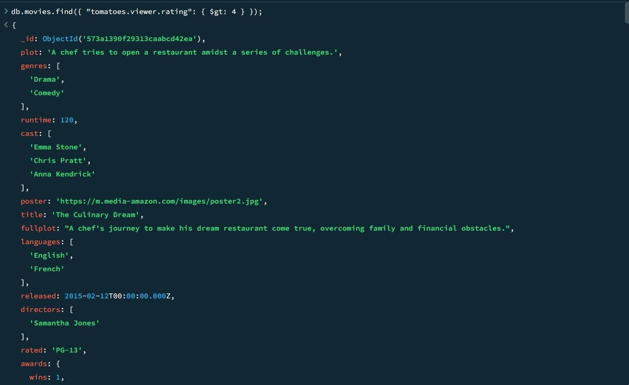

1. **Retrieve all movies from the 'movies' collection that have receivedan award.**

**db.movies.find({ "awards.wins": { $gt: 0 } });**

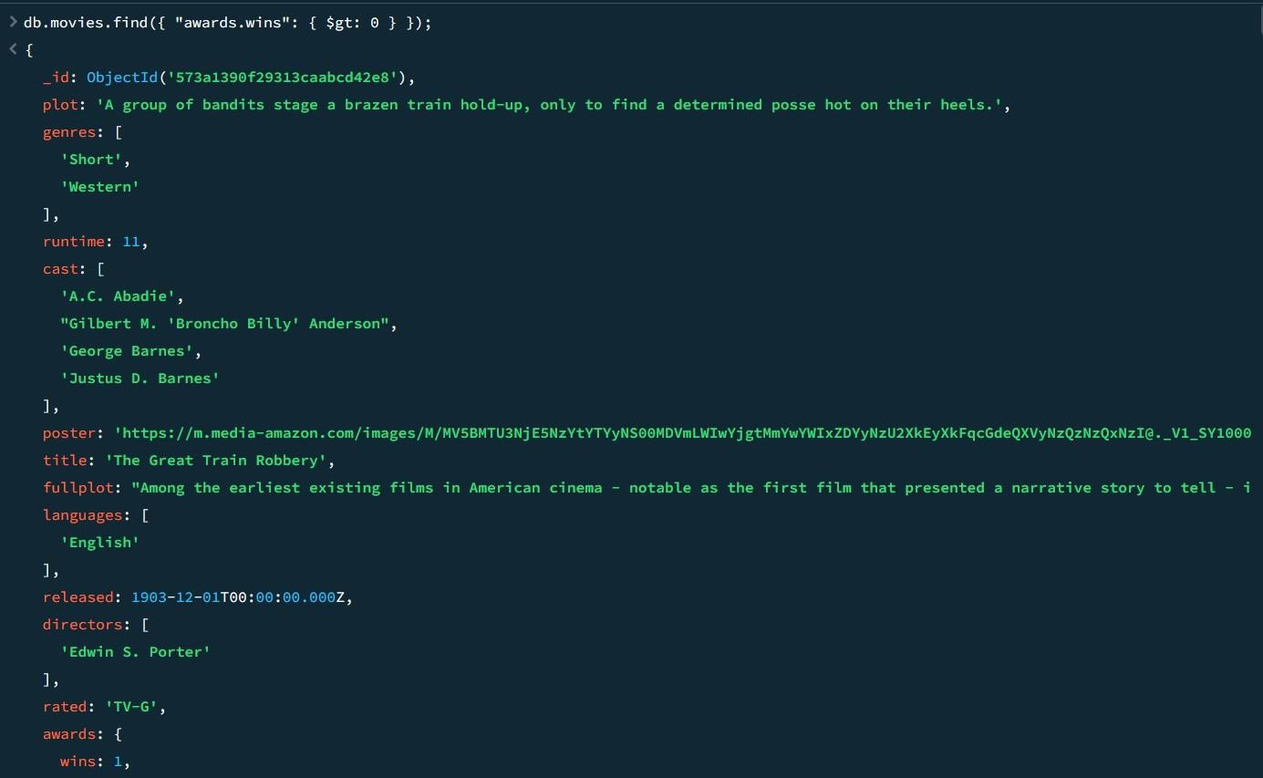

1. **Find all movies with title, languages, released, directors, writers, awards, year, genres, runtime, cast, countries from the 'movies' collection in MongoDB that have at least one nomination.**

**db.movies.find(**

**{ "awards.nominations": { $gt: 0 } },**

**{**

**title: 1,**

**languages: 1,**

**released: 1,**

**directors: 1,**

**writers: 1,**

**awards: 1,**

**year: 1,**

**genres: 1,**

**runtime: 1,**

**cast: 1,**

**countries: 1**

**}**

**);**

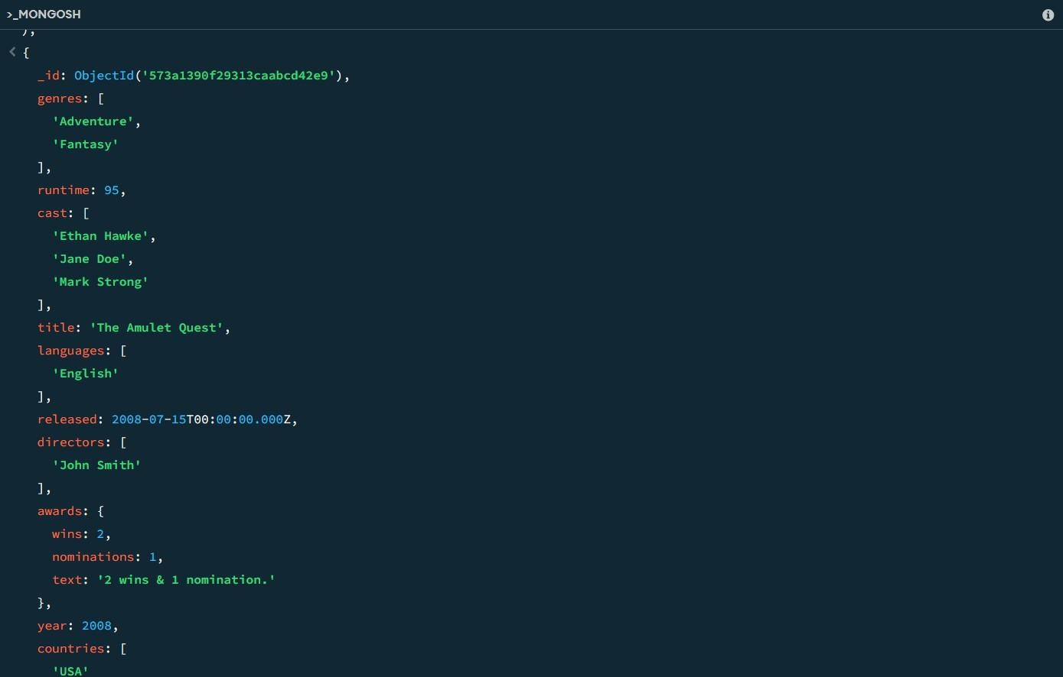

1. **Find all movies with title, languages, released, directors, writers, awards, year, genres, runtime, cast, countries from the 'movies' collection in MongoDB with cast including "Charles Kayser".**

**db.movies.find(**

**{ cast: "Charles Kayser" },**

**{**

**title: 1,**

**languages: 1,**

**released: 1,**

**directors: 1,**

**writers: 1,**

**awards: 1,**

**year: 1,**

**genres: 1,**

**runtime: 1,**

**cast: 1,**

**countries: 1**

**}**

**);**

1. **Retrieve all movies with title, languages, released, directors, writers, countries from the 'movies' collection in MongoDB that released on May 9, 1893.**

**db.movies.find(**

**{ released: ISODate("1893-05-09T00:00:00Z") },**

**{**

**title: 1,**

**languages: 1,**

**released: 1,**

**directors: 1,**

**writers: 1,**

**countries: 1**

**}**

**);**

**14. Retrieve all movies with title, languages, released, directors, writers, countries from the 'movies' collection in MongoDB that have aword "scene" in the title.**

**db.movies.find(**

**{ title: { $regex: /scene/i } },**

**{**

**title: 1,**

**languages: 1,**

**released: 1,**

**directors: 1,**

**writers: 1,**

**countries: 1**

**}**

**);**