Exp-15

Name: Pranaav kumar roll.no:230701233

|  |  |  |
| --- | --- | --- |
| **Ex.No.: 15** | | **OTHER DATABASE OBJECTS** |
| **Date:** | 27/09/2024 |

1) Create a sequence to be used with the primary key column of the DEPT table. The sequence should start at 200 and have a maximum value of 1000. Have your sequence increment by ten numbers. Name the sequence DEPT_ID_SEQ.

**CREATE SEQUENCE DEPT_ID_SEQ START WITH 200**

**INCREMENT BY 10**

**MAXVALUE 1000 NOCACHE NOCYCLE;**

2. Write a query in a script to display the following information about your sequences:sequence name, maximum value, increment size, and last number

**SELECT SEQUENCE_NAME, MAX_VALUE, INCREMENT_BY, LAST_NUMBER**

**FROM USER_SEQUENCES;**

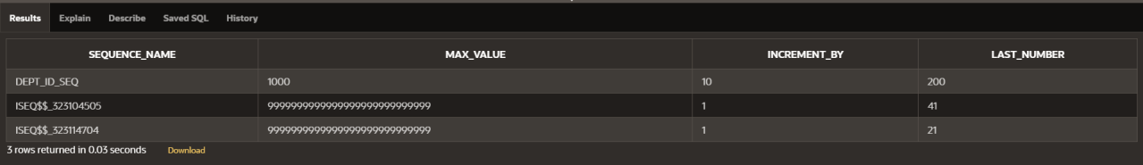

3 Write a script to insert two rows into the DEPT table. Name your script lab12_3.sql. Besure to use the sequence that you created for the ID column. Add two departments named Education And Administration. Confirm your additions. Run the commands in your script.

INSERT INTO DEPT (DEPT_ID, DEPT_NAME) VALUES (DEPT_ID_SEQ.NEXTVAL, 'Education');

**INSERT INTO DEPT (DEPT_ID, DEPT_NAME)**

VALUES (DEPT_ID_SEQ.NEXTVAL, 'Administration');

**SELECT * FROM DEPT**

WHERE DEPT_NAME IN ('Education', 'Administration');



1. **Create a non unique index on the foreign key column (DEPARTMENT_ID) in the EMPLOYEES table.**

CREATE INDEX employees_department_id_idx ON EMPLOYEES (DEPARTMENT_ID);

1. **Display the indexes and uniqueness that exist in the data dictionary for the EMP table.**

**SELECT INDEX_NAME, UNIQUENESS FROM USER_INDEXES**

**WHERE TABLE_NAME = 'EMPLOYEES';**

