Exp-16

Name: Pranaav kumar roll.no:230701233

|  |  |  |
| --- | --- | --- |
| **Ex.No.: 16** | | **CONTROLLING USER ACCESS** |
| **Date:** | 03/10/2024 |

1. **What privilege should a user be given to log on to the Oracle Server? Is this a systemor an object privilege?**

The privilege a user should be given to log on to the Oracle Server is the CREATESESSION privilege.

Type of Privilege: This is a system privilege. GRANT CREATE SESSION TO username;

1. **What privilege should a user be given to create tables?**

the user needs the CREATE TABLE privilege.

The CREATE TABLE privilege allows the user to create new tables in their own schema.

GRANT CREATE TABLE TO username;

1. **If you create a table, who can pass along privileges to other users on your table?**

When you create a table, only you as the table owner (or a user with the ADMIN OPTION or GRANT ANY PRIVILEGE system privilege) can grant privileges on your table to otherusers.

GRANT SELECT ON your_table TO other_user;

1. **You are the DBA. You are creating many users who require the same system privileges. What should you use to make your job easier?**

As a DBA, to simplify the process of granting the same system privileges to multipleusers, you should use roles.

CREATE ROLE my_role;

GRANT CREATE SESSION TO my_role; GRANT CREATE TABLE TO my_role;

GRANT my_role TO user1; GRANT my_role TO user2;

1. **What command do you use to change your password?**

ALTER USER username IDENTIFIED BY new_password;

1. **Grant another user access to your DEPARTMENTS table. Have the user grant youquery Access to his or her DEPARTMENTS table.**

Grant Access to Your DEPARTMENTSTable

GRANT SELECT ON your_username.DEPARTMENTS TO other_user;

Grant Query Access to Other User's DEPARTMENTSTable

GRANT SELECT ON other_user.DEPARTMENTS TO your_username;

1. **Query all the rows in your DEPARTMENTS table.**

SELECT * FROM DEPARTMENT;

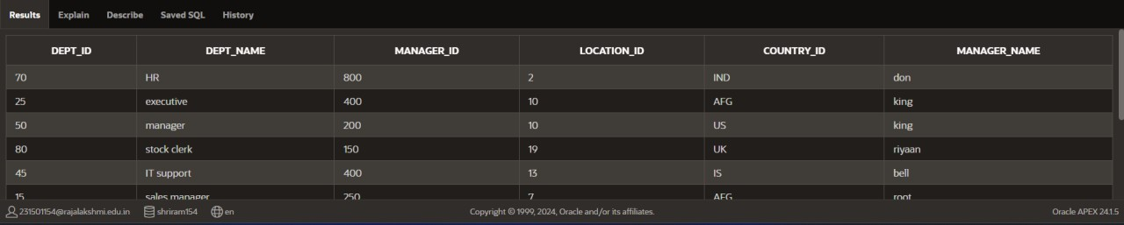

1. **Add a new row to your DEPARTMENTS table. Team 1 should add Education as department number 500. Team 2 should add Human Resources department number 510.Query the other team‘s table.**

INSERT INTO DEPARTMENT(dept_id,

DEPT_NAME,manager_id,location_id,country_id,manager_name) VALUES (500, 'Education',300,12,'BAN','ball');

INSERT INTO DEPARTMENT(dept_id,

DEPT_NAME,manager_id,location_id,country_id,manager_name) VALUES (510, 'Human Resources',150,10,'AUS','john');

SELECT * FROM DEPARTMENT;



1. **Query the USER_TABLES data dictionary to see information about the tables that youown.**

SELECT * FROM USER_TABLES;

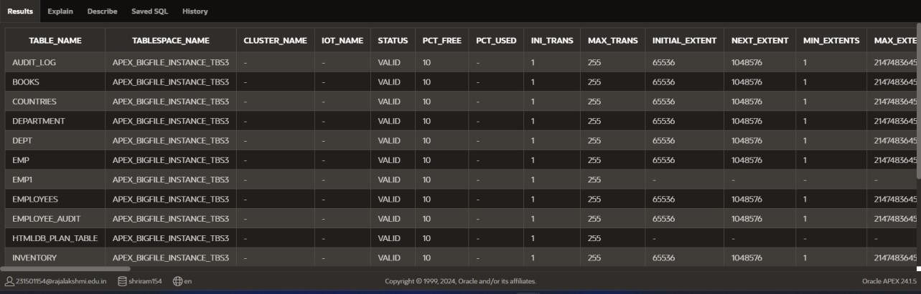

1. **Revoke the SELECT privilege on your table from the other team.**

REVOKE SELECT ON team1_user.DEPARTMENTS FROM other_user;

1. **Remove the row you inserted into the DEPARTMENTS table in step 8 and save the changes.**

DELETE FROM DEPARTMENT WHERE DEPT_ID IN (500, 510);