Exp-3

Name: Pranaav kumar roll.no:230701233

|  |  |  |
| --- | --- | --- |
| **Ex.No.: 3** | | **WRITING BASIC SQL SELECT STATEMENTS** |
| **Date:** | 10/08/2024 |

Find the Solution for the following:

True OR False

1. The following statement executes successfully.

Identify the Errors

SELECT employee_id, last_name sal*12 ANNUAL SALARY

FROM employees; FALSE

The columns in select statement should be separated by commas and the column alias shouldbe given by using a keyword “as”

SELECT employee_id, last_name, salary*12 as "ANNUAL SALARY" FROM employees;

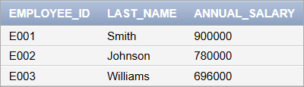

2) Show the structure of departments the table. Select all the data from it.

Desc employees;

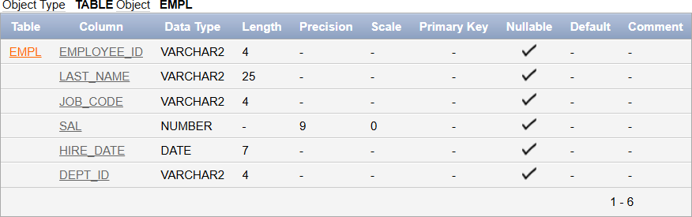

3. Create a query to display the last name, job code, hire date, and employee number foreach employee, with employee number appearing first.

select employee_id , job_id , last_name , hire_date from employees;

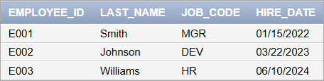

1. Provide an alias STARTDATE for the hire date. select hire_date as "STARTDATE" from employees;

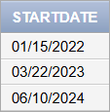

1. Create a query to display unique job codes from the employee table.select distinct(job_id) from employees;

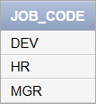

1. Display the last name concatenated with the job ID , separated by a comma and space,and name the column EMPLOYEE and TITLE.

select last_name || ' ' || ',' || ' ' || job_id as "EMPLOYEE AND TITLE" from employees;

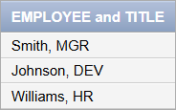

7. Create a query to display all the data from the employees table. Separate each column bya comma. Name the column THE_OUTPUT.

select employee_id || ' , ' || first_name || ' , ' || last_name || ' , ' || email || ' , ' || phone_number || ' ,' || hire_date

|| ' , ' || job_id || ' , ' || salary || ' , ' || commission_pct || ' , ' || manager_id || ' , ' || department_id as "THE_OUTPUT"

from employees;

