Exp-4

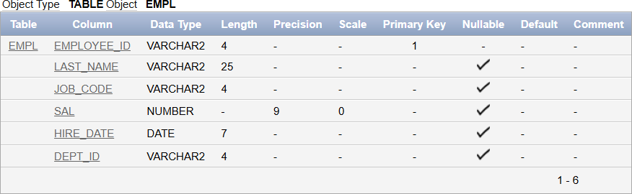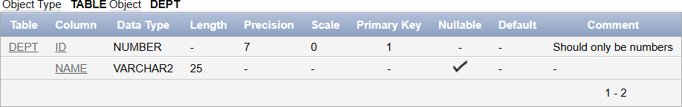

Name: Pranaav kumar roll.no:230701233

|  |  |  |
| --- | --- | --- |
| **Ex.No.: 4** | | **WORKING WITH CONSTRAINTS** |
| **Date:** | 16/08/2024 |

1. Add a table-level PRIMARY KEY constraint to the EMP table on the ID column.The constraint should be named at creation. Name the constraint my_emp_id_pk.

alter table EMP1

add constraint my_emp_id_pk PRIMARY KEY(ID);

1. Create a PRIMAY KEY constraint to the DEPT table using the ID colum. The constraintshould be named at creation. Name the constraint my_dept_id_pk.

alter table DEPT

add constraint my_dept_id_pk PRIMARY KEY(ID);

1. Add a column DEPT_ID to the EMP table. Add a foreign key reference on the EMP tablethat ensures that the employee is not assigned to nonexistent deparment. Name the constraint my_emp_dept_id_fk.

alter table emp

add DEPT_ID Numbe(10);

alter table emp

add constraint my_emp_dept_id_fk FOREIGN KEY(DEPT_ID) references dept(ID);

1. Modify the EMP table. Add a COMMISSION column of NUMBER data type, precision 2, scale 2. Add a constraint to the commission column that ensures that a commissionvalue is greater than zero.

alter table emp

add COMMISSION Number(2,2);

alter table emp

add CONSTRAINT commission_gt_zero CHECK(COMMISSION > 0);

