Exp-5

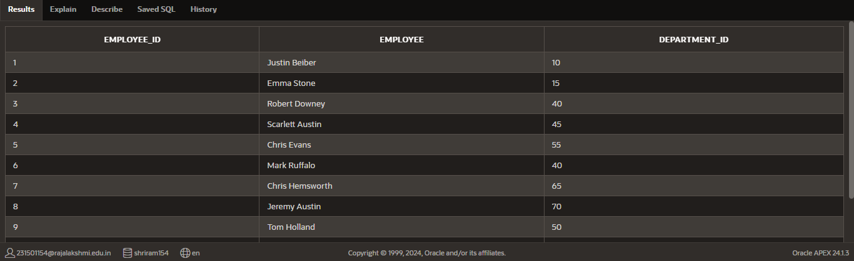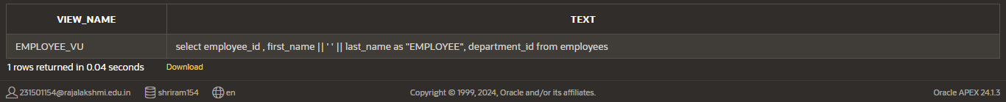

Name: pranaav kumar roll.no:230701233

|  |  |  |
| --- | --- | --- |
| **Ex.No.: 5** | | **CREATING VIEWS** |
| **Date:** | 23/08/2024 |

1. Create a view called EMPLOYEE_VU based on the employee numbers, employee names and department numbers from the EMPLOYEES table. Change the heading forthe employee name to EMPLOYEE.

create view EMPLOYEE_VU as

select employee_id , first_name || ' ' || last_name as "EMPLOYEE", department_idfrom employees;

1. Display the contents of the EMPLOYEES_VU view. select * from EMPLOYEE_VU;
2. Select the view name and text from the USER_VIEWS data dictionary views.select VIEW_NAME, TEXT

from USER_VIEWS

where VIEW_NAME = 'EMPLOYEE_VU';

1. Using your EMPLOYEES_VU view, enter a query to display all employees names and

Department.

SELECT employee, department_id

FROM EMPLOYEE_VU;

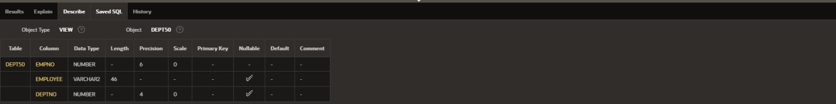

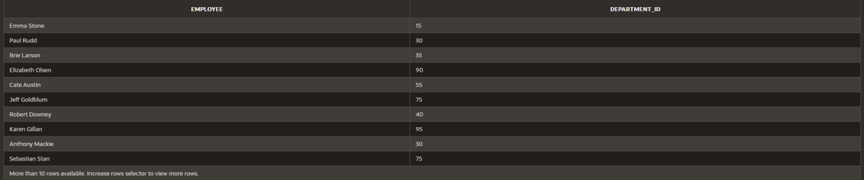

1. Create a view named DEPT50 that contains the employee number, employee last names and department numbers for all employees in department 50.Label the viewcolumns EMPNO, EMPLOYEE and DEPTNO. Do not allow an employee to be reassigned to another department through the view.

CREATE VIEW DEPT50 AS

SELECT employee_id AS EMPNO, employee AS EMPLOYEE, department_id AS DEPTNO

FROM EMPLOYEE_VU

WHERE department_id = 50 WITH READ ONLY;



1. Display the structure and contents of the DEPT50 view.

Desc dept50;

1. Attempt to reassign Matos to department 80.

UPDATE EMPLOYEES

SET department_id = 80 WHERE first_name = 'Matos';

1. Create a view called SALARY_VU based on the employee last names, department names, salaries, and salary grades for all employees. Use the Employees, DEPARTMENTS and JOB_GRADE tables. Label the column Employee, Department,salary, and Grade respectively.

CREATE VIEW SALARY_VU AS

SELECT e.last_name AS Employee, d.dept_name AS Department, e.salary AS Salary, j.grade_level AS Grade

FROM EMPLOYEES e JOIN DEPARTMENT d

ON e.department_id = d.dept_id JOIN JOB_GRADE j

ON e.salary BETWEEN j.lowest_sal AND j.highest_sal;

