Exp-7

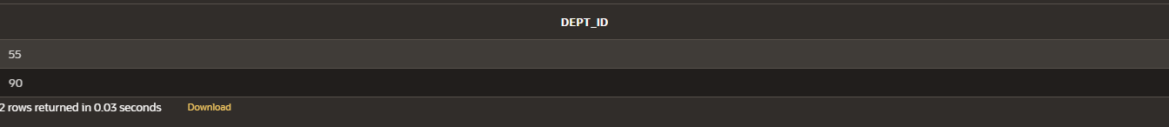

Name: pranaav kumar roll.no:230701233

|  |  |  |
| --- | --- | --- |
| **Ex.No.: 7** | | **USING SET OPERATORS** |
| **Date:** | 30/08/2024 |

1. The HR department needs a list of department IDs for departments that do not containthe job ID ST_CLERK. Use set operators to create this report.

select dept_id from department minus

select department_id from employees where job_id = 'ST_CLERK';

1. The HR department needs a list of countries that have no departments located in them.Display the country ID and the name of the countries. Use set operators to createthis report.

SELECT c.country_id, c.country_name FROM countries c

LEFT JOIN department d ON c.country_id = d.country_idWHERE d.country_id IS NULL;



1. Produce a list of jobs for departments 10, 50, and 20, in that order. Display job ID and department ID using set operators.

SELECT job_id, department_id FROM employees

WHERE department_id IN (10, 50, 20) ORDER BY department_id;

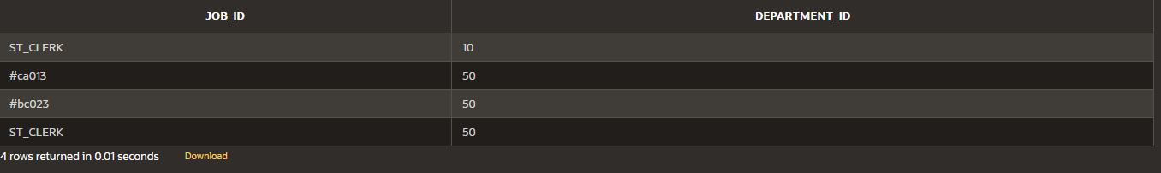

1. Create a report that lists the employee IDs and job IDs of those employees who currently have a job title that is the same as their job title when they were initially hired by the company (that is, they changed jobs but have now gone back to doingtheir original job).

SELECT employee_id, job_id FROM employees INTERSECT SELECT employee_id, job_id FROM job_history;



1. The HR department needs a report with the following specifications:
   * Last name and department ID of all the employees from the EMPLOYEES table, regardless of whether or not they belong to a department.
   * Department ID and department name of all the departments from the DEPARTMENTStable, regardless of whether or not they have employees working in them Write a compound query to accomplish this.

SELECT last_name, department_id FROM employees UNION

SELECT dept_name, dept_id FROM department;

