Exp-8

Name: Pranaav kumar roll.no:230701233

|  |  |  |
| --- | --- | --- |
| **Ex.No.: 8** | | **WORKING WITH MULTIPLE TABLES** |
| **Date:** | 05/09/2024 |

1. Write a query to display the last name, department number, and department name for all Employees.

select e.last_name , e.department_id , d.dept_namefrom employees e

join department d on e.department_id = d.dept_id;

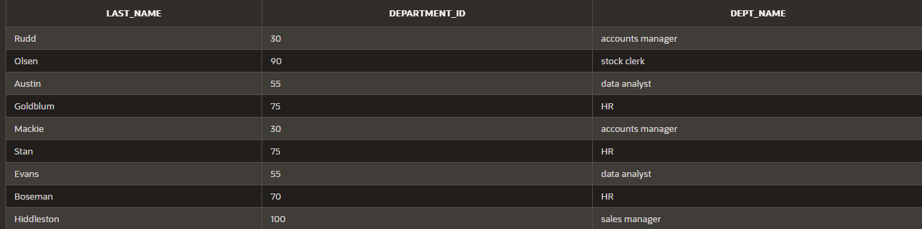

1. Create a unique listing of all jobs that are in department 80. Include the location of the department in the output.

select d.dept_name,d.location_id from department d

join employees e on d.dept_id = e.department_id where department_id = 80;

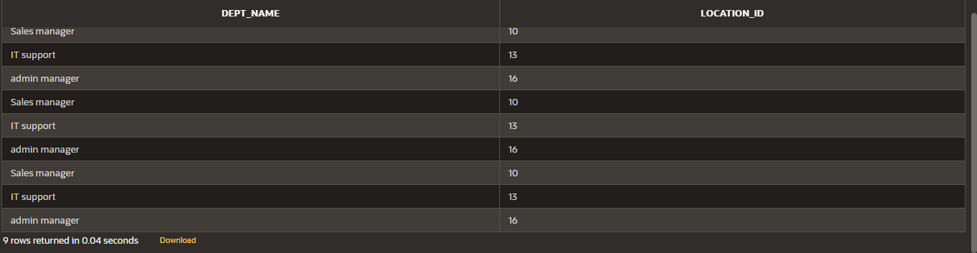

1. Write a query to display the employee last name, department name, location ID, and cityof all employees who earn a commission

select e.last_name,d.dept_name,d.location_id,l.cityfrom (department d

inner join employees e on d.dept_id = e.department_idinner join location l on d.location_id = l.location_id) where commission_pct is not null;

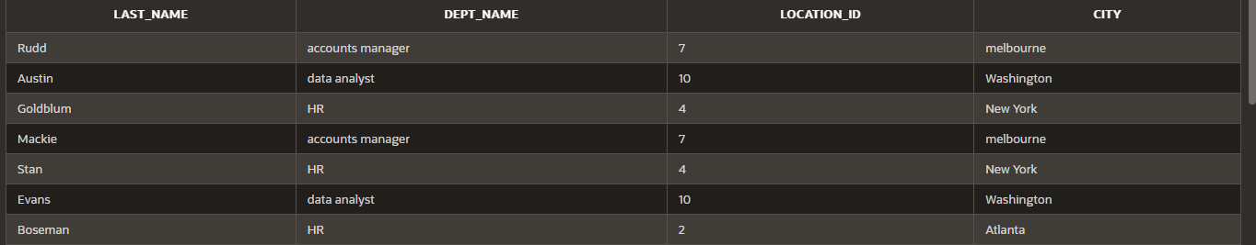

1. Display the employee last name and department name for all employees who have an a(lowercase) in their last names.

select e.last_name,d.dept_name from department d

inner join employees e on d.dept_id = e.department_id where last_name like '%a%';

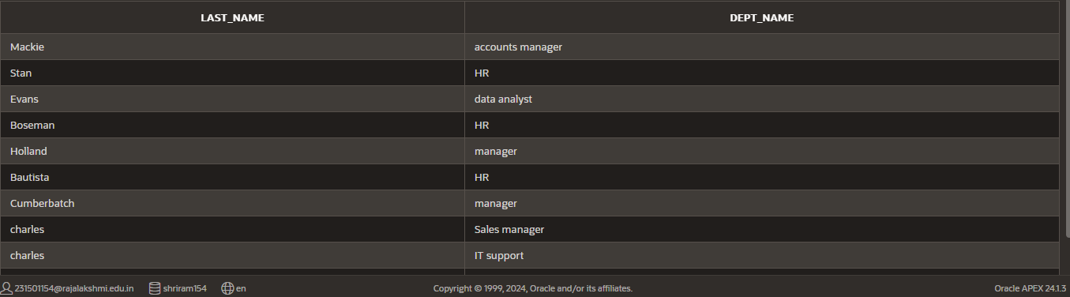

1. Write a query to display the last name, job, department number, and department namefor all employees who work in Toronto.

select e.last_name,d.dept_name,e.department_idfrom (department d

inner join employees e on d.dept_id = e.department_idinner join location l on l.location_id = d.location_id) where city = 'Toronto';

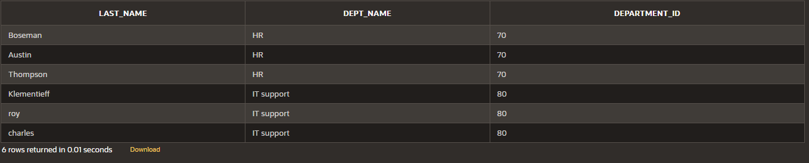

1. Display the employee last name and employee number along with their manager‘s last name and manager number. Label the columns Employee, Emp#, Manager, and Mgr#,

Respectively

select last_name as "Employee",employee_id as "Emp#",manager_id as "Mgr#" from employees;

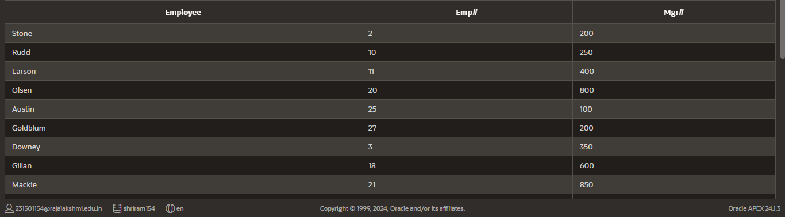

1. Modify lab4_6.sql to display all employees including King, who has no manager. Orderthe results by the employee number.

SELECT last_name AS "Employee",employee_id AS "Emp#",manager_id AS "Mgr#" FROM employees ORDER BY employee_id;

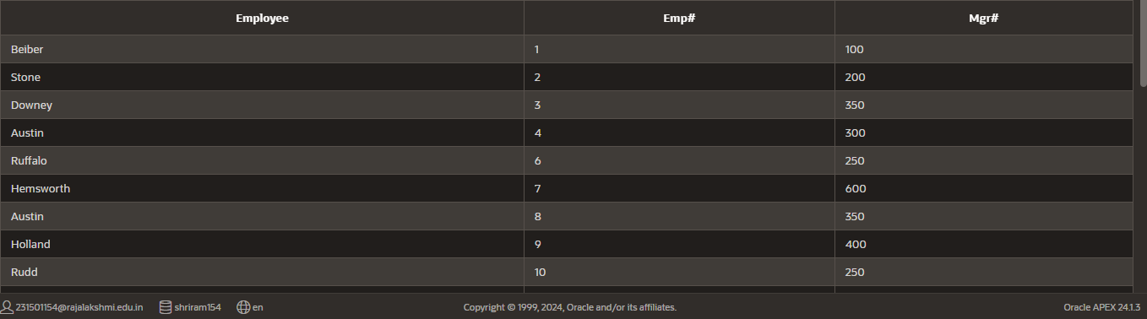

1. Create a query that displays employee last names, department numbers, and all the employees who work in the same department as a given employee. Give each column an appropriate label

select e.last_name as "Employee",d.dept_name as "department_name",e.department_idas "department_no" from employees e

inner join department d on e.department_id = d.dept_id;

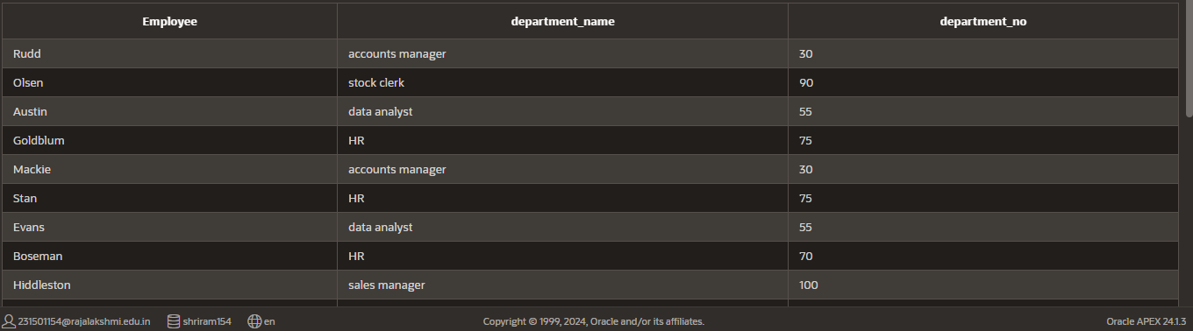

1. Show the structure of the JOB_GRADES table. Create a query that displays the name, job, department name, salary, and grade for all employees

desc job_grade;

SELECT e.first_name || ' ' || last_name AS "Employee",d.dept_name,e.salary,g.grade_level as "GRADE"

FROM (employees e

inner join department d on e.department_id = d.dept_id

inner join job_grade g on e.department_id = g.department_id);

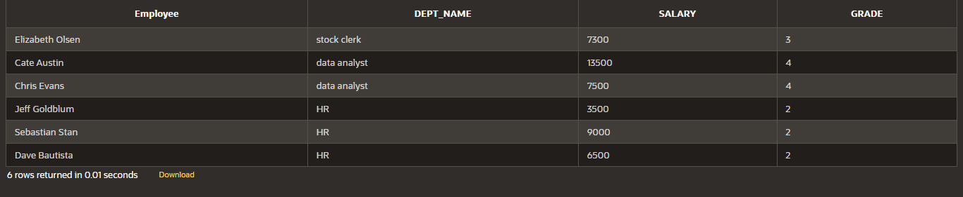

1. Create a query to display the name and hire date of any employee hired after employeeDavies.

SELECT last_name,hire_date FROM employees where hire_date > '05-03-1986';

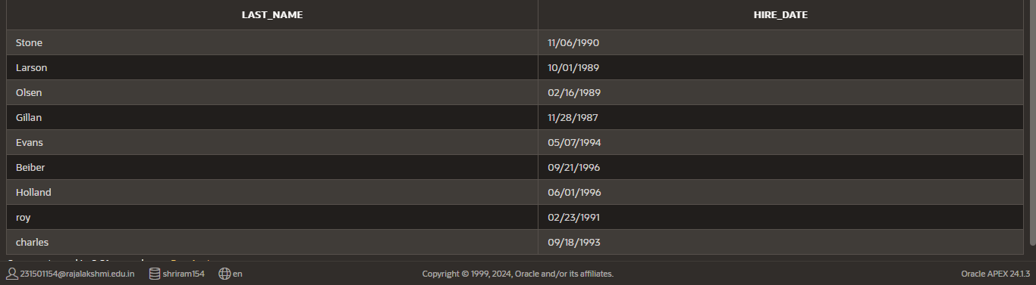

1. Display the names and hire dates for all employees who were hired before their managers,along with their manager‘s names and hire dates. Label the columns Employee, Emp Hired, Manager, and Mgr Hired, respectively.

SELECT last_name as "employee",hire_date as "employee hired" FROM employees;

