Exp-9

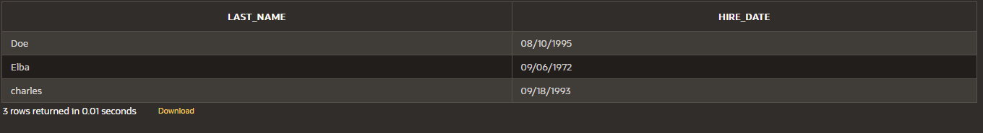

Name: Pranaav kumar roll.no:230701233

|  |  |  |
| --- | --- | --- |
| **Ex.No.: 9** | | **SUB QUERIES** |
| **Date:** | 06/09/2024 |

1. The HR department needs a query that prompts the user for an employee last name. The query then displays the last name and hire date of any employee in the same department as the employee whose name they supply (excluding that employee). For example, if the user enters Zlotkey, find all employees who work with Zlotkey (excludingZlotkey).

SELECT last_name, hire_date FROM employees

WHERE department_id = ALL( SELECT department_id FROM employees

WHERE last_name = 'Zlotkey'

)

AND last_name != 'Zlotkey';

1. Create a report that displays the employee number, last name, and salary of all employees who earn more than the average salary. Sort the results in order of ascending salary.

# SELECT EMPLOYEE_ID, LAST_NAME, SALARY

FROM employees WHERE SALARY > (

# SELECT AVG(SALARY)

FROM employees

)

# ORDER BY SALARY ASC;

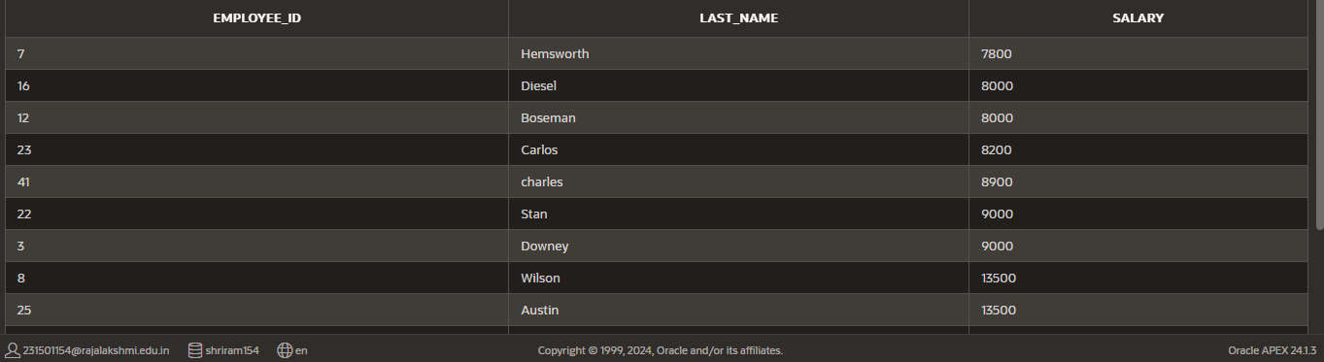

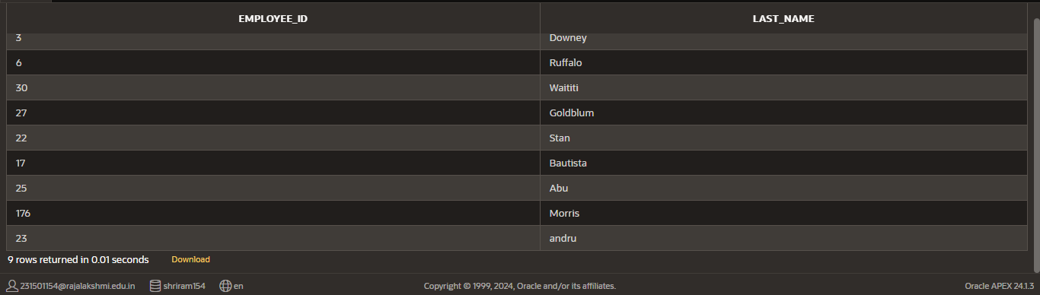

1. Write a query that displays the employee number and last name of all employees whowork in a department with any employee whose last name contains a u.

# SELECT EMPLOYEE_ID, LAST_NAME

FROM employees

# WHERE DEPARTMENT_ID IN ( SELECT DEPARTMENT_ID

FROM employees

WHERE LAST_NAME LIKE '%a%' and LAST_NAME LIKE '%u%');

1. The HR department needs a report that displays the last name, department number, andjob ID of all employees whose department location ID is 1700.

SELECT e.last_name, e.department_id, e.job_id

FROM employees e



INNER JOIN department d ON e.department_id = d.dept_id WHERE e.department_id IN (

SELECT dept_id FROM department

WHERE location_id = 1700);

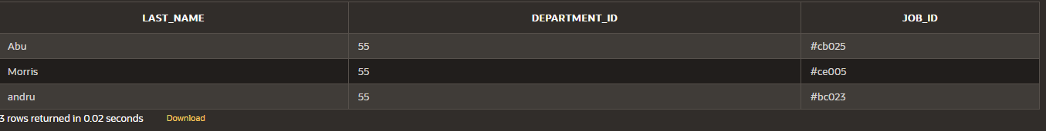

1. Create a report for HR that displays the last name and salary of every employee whoreports to King.

SELECT e.last_name, e.salary FROM employees e

WHERE e.manager_id IN ( SELECT d.manager_id FROM department d

WHERE d.manager_name = 'king');

1. Create a report for HR that displays the department number, last name, and job ID forevery employee in the Executive department.

SELECT e.department_id, e.last_name, e.job_id FROM employees e

JOIN department d on e.department_id = d.dept_id WHERE d.dept_name = 'executive';

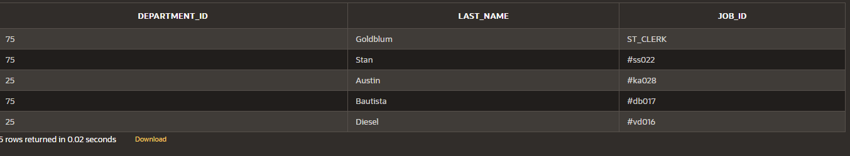

1. Modify the query 3 to display the employee number, last name, and salary of all employees who earn more than the average salary and who work in a department withany employee whose last name contains a u.

SELECT e.employee_id, e.last_name, e.salary FROM employees e

WHERE e.salary > ( SELECT AVG(salary) FROM employees

)

AND e.department_id IN ( SELECT x.department_id FROM employees x

WHERE x.last_name LIKE '%a%' AND x.last_name LIKE '%u%'

);

