# ***************************************LAB-1************************************* ROLL.NO:230701233

1)

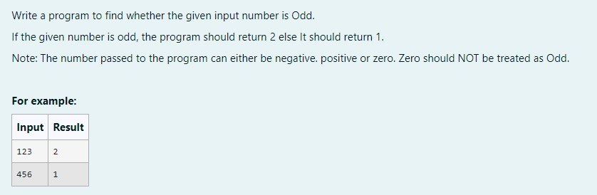

# CODE:

import java .util.*; public class main{

public static void main(String[] args){ int n;

Scanner s=new Scanner(System.in); n=s.nextInt();

if(n%2==0){

System.out.println(1);

}

else{

System.out.println(2);

}

}

}

# OUTPUT:

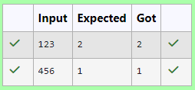

2)

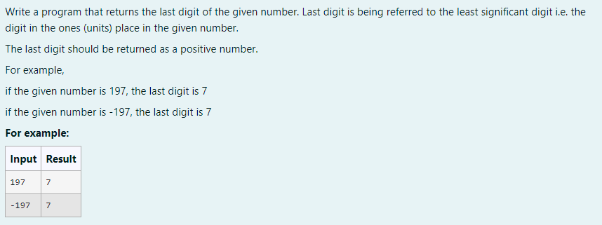

# CODE:

import java.util.*; public class main{

public static void main(String [] args){ int n;

Scanner s=new Scanner(System.in); n=s.nextInt();

if(n<0){ n=n*-1;

System.out.print(n%10);

}

else{

System.out.print(n%10);

}

}

# OUTPUT:

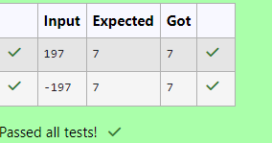

3)

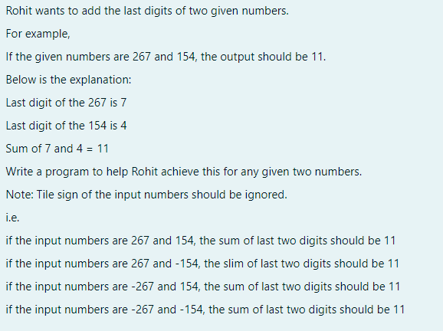

Code:

import java.util.*; public class main {

public static void main(String [] args){ int n1,n2;

Scanner s=new Scanner(System.in); n1=s.nextInt();

if(n1<0)

n1=n1*-1; n2=s.nextInt(); if(n2<0) n2=n2*-1;

System.out.println((n1%10)+(n2%10));

}

}

Output:

