# WEEK-10

ROLL NO:230701233

1. Given an ArrayList, the task is to get the first and last element of the ArrayList in Java. Input: ArrayList = [1, 2, 3, 4]

Output: First = 1, Last = 4

Input: ArrayList = [12, 23, 34, 45, 57, 67, 89]

Output: First = 12, Last = 89 CODE:

import java.util.ArrayList; import java.util.Scanner;

public class ArrayListExample {

public static void main(String[] args) {

Scanner scanner = new Scanner(System.in); ArrayList<Integer> list = new ArrayList<>(); int n = scanner.nextInt();

for (int i = 0; i < n; i++) {

int element = scanner.nextInt(); list.add(element);

}

int firstElement = list.get(0);

int lastElement = list.get(list.size() - 1); System.out.println("ArrayList: " + list);

System.out.printf("First : %d, Last : %d%n", firstElement, lastElement);

scanner.close();

}

}

# OUTPUT:

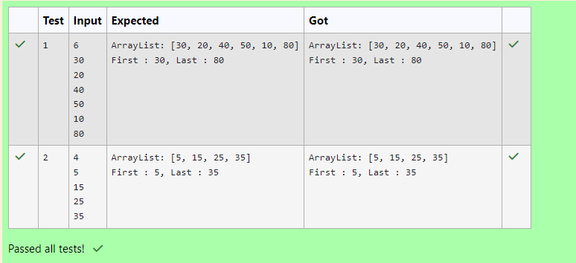

1. The given Java program is based on the ArrayList methods and its usage. The Java program is partially filled. Your task is to fill in the incomplete statements to get the desired output.

list.set();

list.indexOf());

list.lastIndexOf()) list.contains()

list.size());

list.add();

list.remove();

The above methods are used for the below Java program. CODE:

class Prog {

public static void main(String[] args)

{

Scanner sc= new Scanner(System.in); int n = sc.nextInt();

ArrayList<Integer> list = new ArrayList<Integer>();

for(int i = 0; i<n;i++)

list.add(sc.nextInt());

// printing initial value ArrayList

System.out.println("ArrayList: " + list);

//Replacing the element at index 1 with 100

//Getting the index of first occurrence of 100 System.out.println("Index of 100 = "+ );

//Getting the index of last occurrence of 100

System.out.println("LastIndex of 100 = "+ );

// Check whether 200 is in the list or not System.out.println( ); //Output : false

// Print ArrayList size

System.out.println("Size Of ArrayList = "+ );

//Inserting 500 at index 1

// code here

//Removing an element from position 3

// code here

System.out.print("ArrayList: " + list);

}

}

# OUTPUT:

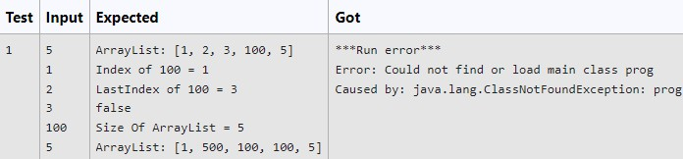

1. Write a Java program to reverse elements in an array list. Sample input and Output:

Red Green Orange White Black

**Sample output**

List before reversing :

[Red, Green, Orange, White, Black] List after reversing :

[Black, White, Orange, Green, Red]

# CODE:

import java.util.ArrayList; import java.util.Collections; import java.util.Scanner;

public class ReverseArrayList {

public static void main(String[] args) {

Scanner scanner = new Scanner(System.in); ArrayList<String> colors = new ArrayList<>();

System.out.println("List before reversing :"); int n = scanner.nextInt();

scanner.nextLine(); for (int i = 0; i < n; i++) {

String color = scanner.nextLine(); colors.add(color);

}

System.out.println( colors); Collections.reverse(colors);

System.out.println("List after reversing :"); System.out.println(colors);

scanner.close();

}

}

OUTPUT:

