WEEK-11

ROLL NO:230701233

1. **Java HashSet** class implements the Set interface, backed by a hash table which is actually a [HashMap](https://www.geeksforgeeks.org/java-util-hashmap-in-java/) instance.

No guarantee is made as to the iteration order of the hash sets which means that the class does not guarantee the constant order of elements over time.

This class permits the null element.

The class also offers constant time performance for the basic operations like add,

remove, contains, and size assuming the hash function disperses the elements properly among the buckets.

Java HashSet Features

A few important features of HashSet are mentioned below:

* Implements [Set Interface](https://www.geeksforgeeks.org/set-in-java/).
* The underlying data structure for HashSet is [Hashtable](https://www.geeksforgeeks.org/hashtable-in-java/).
* As it implements the Set Interface, duplicate values are not allowed.
* Objects that you insert in HashSet are not guaranteed to be inserted in the same order. Objects are inserted based on their hash code.
* NULL elements are allowed in HashSet.
* HashSet also implements **Serializable** and **Cloneable** interfaces.
* public class HashSet<E> extends AbstractSet<E> implements Set<E>, Cloneable, Serializable

Sample Input and Output: 5

90

56

45

78

25

78

Sample Output:

78 was found in the set. Sample Input and output: 3

2

CODE:

7

9

5

Sample Input and output: 5 was not found in the set.

import java.util.HashSet; import java.util.Scanner;

public class HashSetExample {

public static void main(String[] args) {

Scanner scanner = new Scanner(System.in);

HashSet<Integer> hashSet = new HashSet<>(); int n = scanner.nextInt();

for (int i = 0; i < n; i++) {

int element = scanner.nextInt(); hashSet.add(element);

}

int searchElement = scanner.nextInt(); if (hashSet.contains(searchElement)) {

System.out.println(searchElement + " was found in the set.");

} else {

System.out.println(searchElement + " was not found in the set.");

}

scanner.close();

}

}

OUTPUT:

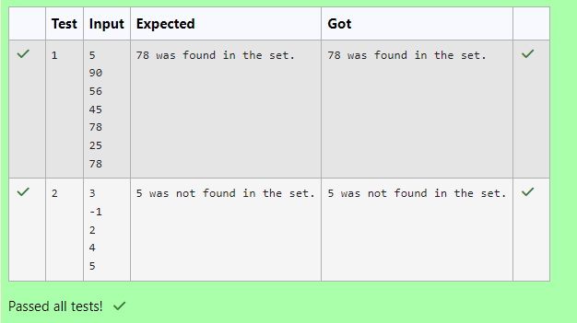

1. Write a Java program to compare two sets and retain elements that are the same.

# Sample Input and Output:

5

Football Hockey Cricket Volleyball Basketball

7 // **HashSet 2:**

Golf Cricket

Badminton Football

Hockey Volleyball Handball

# SAMPLE OUTPUT:

Football Hockey Cricket Volleyball Basketball

CODE:

import java.util.HashSet; import java.util.Scanner;

public class SetComparison {

public static void main(String[] args) {

Scanner scanner = new Scanner(System.in); int n1 = scanner.nextInt();

scanner.nextLine();

HashSet<String> set1 = new HashSet<>(); for (int i = 0; i < n1; i++) {

String element = scanner.nextLine(); set1.add(element);

}

int n2 = scanner.nextInt();

scanner.nextLine(); // Consume the newline character

HashSet<String> set2 = new HashSet<>(); for (int i = 0; i < n2; i++) {

String element = scanner.nextLine(); set2.add(element);

}

set1.retainAll(set2);

for (String element : set1) {

System.out.println(element);

}

scanner.close();

}

}

OUTPUT:

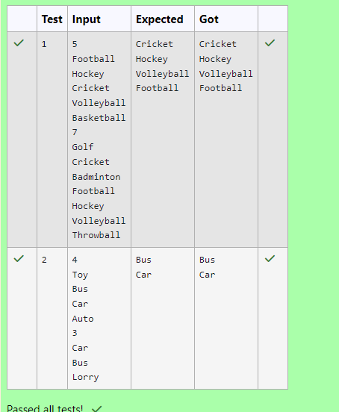

1. Java HashMap Methods

[containsKey()](https://www.w3schools.com/java/ref_hashmap_containskey.asp) Indicate if an entry with the specified key exists in the map [containsValue()](https://www.w3schools.com/java/ref_hashmap_containsvalue.asp) Indicate if an entry with the specified value exists in the map

[putIfAbsent()](https://www.w3schools.com/java/ref_hashmap_putifabsent.asp) Write an entry into the map but only if an entry with the same key does not already exist

[remove()](https://www.w3schools.com/java/ref_hashmap_remove.asp) Remove an entry from the map

[replace() Write to an entry in the map only if it exists](https://www.w3schools.com/java/ref_hashmap_replace.asp) [size()](https://www.w3schools.com/java/ref_hashmap_size.asp) Return the number of entries in the map

Your task is to fill the incomplete code to get desired output

CODE:

import java.util.HashMap; import java.util.Map.Entry; import java.util.Set; import java.util.Scanner;

class prog {

public static void main(String[] args) {

// Creating HashMap with default initial capacity and load factor

HashMap<String, Integer> map = new HashMap<String, Integer>();

String name; int num;

Scanner sc = new Scanner(System.in); int n = sc.nextInt();

for (int i = 0; i < n; i++) { name = sc.next(); num = sc.nextInt(); map.put(name, num);

}

// Printing key-value pairs

Set<Entry<String, Integer>> entrySet = map.entrySet(); for (Entry<String, Integer> entry : entrySet) {

System.out.println(entry.getKey() + " : " + entry.getValue());

}

System.out.println(" ");

// Creating another HashMap

HashMap<String, Integer> anotherMap = new HashMap<String, Integer>();

// Inserting key-value pairs to anotherMap using put() method anotherMap.put("SIX", 6);

anotherMap.put("SEVEN", 7);

// Inserting key-value pairs of map to anotherMap using putAll() method anotherMap.putAll(map); // Filling in the missing code here

entrySet = anotherMap.entrySet();

for (Entry<String, Integer> entry : entrySet) {

System.out.println(entry.getKey() + " : " + entry.getValue());

}

map.putIfAbsent("FIVE", 5);

// Retrieving a value associated with key 'TWO'

Integer value = map.get("TWO"); // Using Integer instead of int to handle null case System.out.println( (value != null ? value : "Key not found"));

// Checking whether key 'ONE' exists in map System.out.println( map.containsKey("ONE"));

// Checking whether value '3' exists in map System.out.println( map.containsValue(3));

// Retrieving the number of key-value pairs present in map System.out.println( map.size());

// Close the scanner sc.close();

}

}

OUTPUT:

