\*\*\*\*\*\*\*\*\*\*\*\*\*\*\*\*\*\*\*\*\*\*\*\*\*\*\*\*\*\*\*\*\*\*WEEK-2\*\*\*\*\*\*\*\*\*\*\*\*\*\*\*\*\*\*\*\*\*\*\*\*\*\*\*\*\*\*\*\*\*\*\*\*\*\*\*\*

ROLL NO:230701233

1. You and your friend are movie fans and want to predict if the movie is going to be a hit! The movie’s success formula depends on 2 parameters:

the acting power of the actor (range 0 to 10) the critic’s rating of the movie (range 0 to 10)

The movie is a hit if the acting power is excellent (more than 8) or the rating is excellent (more than 8). This holds true except if either the acting power is poor (less than 2) or rating is poor (less than 2), then the movie is a flop. Otherwise the movie is average.

Write a program that takes 2 integers:

the first integer is the acting power second integer is the critic’s rating.

You have to print Yes if the movie is a hit, Maybe if the movie is average and No if the movie is flop.

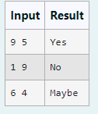

CODE:

import java.util.\*; public class main{

public static void main(String [] args){ int n[]=new int[2];

Scanner s=new Scanner(System.in); n[0]=s.nextInt();

n[1]=s.nextInt();

s.nextLine();

if(n[0]<2||n[1]<2){

System.out.print("No");

}

else if(n[0]>8 || n[1]>8){ System.out.print("Yes");

}

else{

System.out.print("Maybe");

}

}

}

OUTPUT:

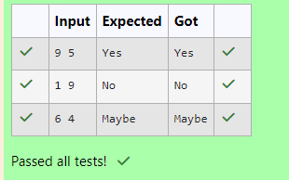

1. Write a program that takes as parameter an integer n.

You have to print the number of zeros at the end of the factorial of n.

For example, 3! = 6. The number of zeros are 0. 5! = 120. The number of zeros at the end are 1.

Note: n! < 10^5

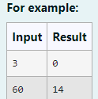

Code:

// Java program to count trailing 0s in n! import java.io.\*;

import java.util.Scanner; class prog {

// Function to return trailing

// 0s in factorial of n

static int findTrailingZeros(int n)

{

if (n < 0) // Negative Number Edge Case return -1;

// Initialize result int count =0;

// Keep dividing n by powers

// of 5 and update count

for (int i = 5; n / i >= 1;i\*=5 ) count += n / i;

return count;

}

// Driver Code

public static void main(String[] args)

{

int n ;

Scanner sc= new Scanner(System.in); n=sc.nextInt();

System.out.println(findTrailingZeros(n));

}

}

Output:

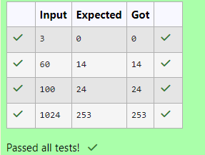

3)

Consider a sequence of the form 0, 1, 1, 2, 4, 7, 13, 24, 44, 81, 149…

Write a method program which takes as parameter an integer n and prints the nth term of the above sequence. The nth term will fit in an integer value.

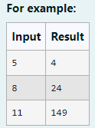

CODE:

import java.util.\*;

public class main{

public static int tribonacciTerm(int n){ if(n<3)

return n;

int a=0,b=1,c=1,d; while(n-->3){

d=a+b+c; a=b; b=c;

c=d;

}

return c;

}

public static void main(String [] args){ Scanner sc=new Scanner(System.in); int n=sc.nextInt();

int ans=tribonacciTerm(n); System.out.println(ans);

}

} OUTPUT:

