*******************************WEEK-4*******************************************

ROLL NO:230701233

1. Create a class called "Circle" with a radius attribute. You can access and modify this attribute using getter and setter methods. Calculate the area and circumference of the circle.

**Area of Circle = πr2**

**Circumference = 2πr Input:**

**2**

**Output:**

**Area = 12.57**

**Circumference = 12.57**

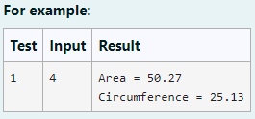

CODE:

import java.io.*;

import java.util.*; class Circle

{

private double radius; public Circle(double radius){

this.radius=radius;

// set the instance variable radius

}

public void setRadius(double radius){ this.radius=radius;

}

public double getRadius() { return radius;

// return the radius

}

public double calculateArea() { // complete the below statement return Math.PI*(Math.pow(radius,2));

}

public double calculateCircumference() {

// complete the statement return 2*Math.PI*radius;

}

}

class prog{

public static void main(String[] args) { int r;

Scanner s= new Scanner(System.in); r=s.nextInt();

Circle c= new Circle(r);

System.out.println("Area = "+String.format("%.2f", c.calculateArea()));

System.out.println("Circumference =

"+String.format("%.2f",c.calculateCircumference()));

}

}

OUTPUT:

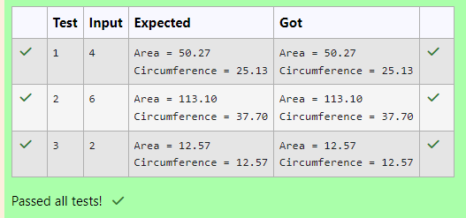

1. Create a class Student with two private attributes, name and roll number. Create three objects by invoking different constructors available in the class Student.

Student()

Student(String name)

Student(String name, int rollno)

**Input:**

No input

**Output:**

**No-arg constructor is invoked 1 arg constructor is invoked**

**2 arg constructor is invoked Name =null , Roll no = 0**

**Name =Rajalakshmi , Roll no = 0 Name =Lakshmi , Roll no = 101**

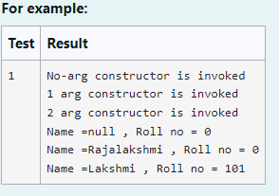

CODE:

public class Student{ private String name; private int rollno; public Student(){

this.name=null; this.rollno=0;

System.out.println("No-arg constructor is invoked");

}

public Student (String name){ this.name=name;

this.rollno=0;

System.out.println("1 arg constructor is invoked");

}

public Student (String name,int rollno){ this.name=name;

this.rollno=rollno;

System.out.println("2 arg constructor is invoked");

}

public void display(){

System.out.println("Name ="+ name + " , Roll no = "+ rollno);

}

public static void main( String [] a){ Student stu1=new Student();

Student stu2=new Student("Rajalakshmi"); Student stu3=new Student("Lakshmi",101); stu1.display();

stu2.display(); stu3.display();

}

}

OUTPUT:

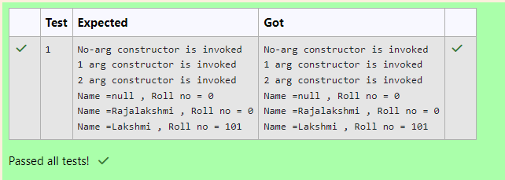

3)

Create a Class Mobile with the attributes listed below, private String manufacturer;

private String operating_system; public String color;

private int cost;

Define a Parameterized constructor to initialize the above instance variables. Define getter and setter methods for the attributes above.

for example : setter method for manufacturer is void setManufacturer(String manufacturer){

this.manufacturer= manufacturer;

}

String getManufacturer(){ return manufacturer;}

Display the object details by overriding the toString() method.

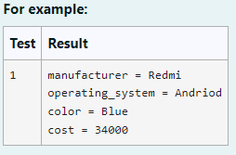

CODE:

public class Mobile{

private String manufacture;

private String operating_system; private String color;

private int cost;

public Mobile (String manufacture ,String operating_system,String color,int cost){ this.manufacture=manufacture;

this.operating_system=operating_system; this.color=color;

this.cost=cost;

}

public String getmanufacture(String manufacture){ return manufacture;

}

public void setmanufacture(String manufacture){ this.manufacture=manufacture;

}

public String getoperating_system(String operating_system){ return operating_system;

}

public void setoperating_system(String operating_system){ this.operating_system=operating_system;

}

public String getcolor(String color){ return color;

}

public void setcolor(String color){ this.color=color;

}

public int getcost(int cost){ return cost;

}

public void setcost(int cost){ this.cost=cost;

}

public String tostring(){

return "manufacturer = "+manufacture+"\noperating_system = "+operating_system+"\ncolor = "+color+"\ncost = "+cost;

}

public static void main(String [] args){

Mobile mymobile= new Mobile("Redmi","Andriod","Blue",34000); System.out.println(mymobile.tostring());

}

}

OUTPUT:

