************************************WEEK-7**************************************

ROLL NO:230701233

1. create an interface Playable with a method play() that takes no arguments and

returns void. Create three classes Football, Volleyball, and Basketball that implement the Playable interface and override the play() method to play the respective sports.

interface Playable { void play();

}

class Football implements Playable { String name;

public Football(String name){ this.name=name;

}

public void play() {

System.out.println(name+" is Playing football");

}

}

Similarly, create Volleyball and Basketball classes.

**Sample output:**

**Sadhvin is Playing football Sanjay is Playing volleyball Sruthi is Playing basketball**

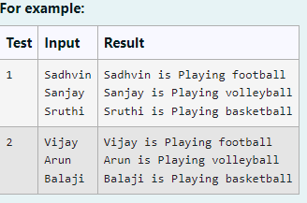

CODE:

import java.util.Scanner;

// Define the Playable interface interface Playable {

// Abstract method to play the respective sport void play();

}

// Football class implementing Playable interface class Football implements Playable {

String name;

// Constructor

public Football(String name) { this.name = name;

}

// Override the play method public void play() {

System.out.println(name + " is Playing football");

}

}

// Volleyball class implementing Playable interface class Volleyball implements Playable {

String name;

// Constructor

public Volleyball(String name) {

this.name = name;

}

// Override the play method public void play() {

System.out.println(name + " is Playing volleyball");

}

}

// Basketball class implementing Playable interface class Basketball implements Playable {

String name;

// Constructor

public Basketball(String name) { this.name = name;

}

// Override the play method public void play() {

System.out.println(name + " is Playing basketball");

}

}

// Main class to test the functionality public class Main {

public static void main(String[] args) {

Scanner scanner = new Scanner(System.in);

// Input for Football player

String footballPlayerName = scanner.nextLine();

Football footballPlayer = new Football(footballPlayerName);

// Input for Volleyball player

String volleyballPlayerName = scanner.nextLine();

Volleyball volleyballPlayer = new Volleyball(volleyballPlayerName);

// Input for Basketball player

String basketballPlayerName = scanner.nextLine();

Basketball basketballPlayer = new Basketball(basketballPlayerName);

// Call the play method for each player footballPlayer.play();

volleyballPlayer.play(); basketballPlayer.play();

scanner.close();

}

}

OUTPUT:

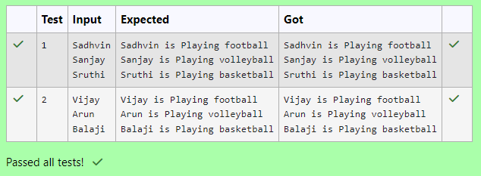

1. Create interfaces shown below.

interface Sports {

public void setHomeTeam(String name); public void setVisitingTeam(String name);

}

interface Football extends Sports { public void homeTeamScored(int points);

public void visitingTeamScored(int points);}

create a class College that implements the Football interface and provides the necessary functionality to the abstract methods.

sample Input:

Rajalakshmi Saveetha 22

21

Output:

Rajalakshmi 22 scored

Saveetha 21 scored Rajalakshmi is the Winner!

Code:

import java.util.Scanner;

interface Sports {

void setHomeTeam(String name);

void setVisitingTeam(String name);

}

interface Football extends Sports { void homeTeamScored(int points); void visitingTeamScored(int points);

}

class College implements Football { private String homeTeam;

private String visitingTeam;

private int homeTeamPoints = 0; private int visitingTeamPoints = 0;

public void setHomeTeam(String name) { this.homeTeam = name;

}

public void setVisitingTeam(String name) { this.visitingTeam = name;

}

public void homeTeamScored(int points) { homeTeamPoints += points;

System.out.println(homeTeam + " " + points + " scored");

}

public void visitingTeamScored(int points) {

visitingTeamPoints += points;

System.out.println(visitingTeam + " " + points + " scored");

}

public void winningTeam() {

if (homeTeamPoints > visitingTeamPoints) { System.out.println(homeTeam + " is the winner!");

} else if (homeTeamPoints < visitingTeamPoints) { System.out.println(visitingTeam + " is the winner!");

} else {

System.out.println("It's a tie match.");

}

}

}

public class Main {

public static void main(String[] args) { Scanner sc = new Scanner(System.in);

// Get home team name

String hname = sc.nextLine();

// Get visiting team name String vteam = sc.nextLine();

// Create College object College match = new College(); match.setHomeTeam(hname);

match.setVisitingTeam(vteam);

// Get points scored by home team int htpoints = sc.nextInt(); match.homeTeamScored(htpoints);

// Get points scored by visiting team int vtpoints = sc.nextInt(); match.visitingTeamScored(vtpoints);

// Determine and print the winning team match.winningTeam();

sc.close();

}

}

Output:

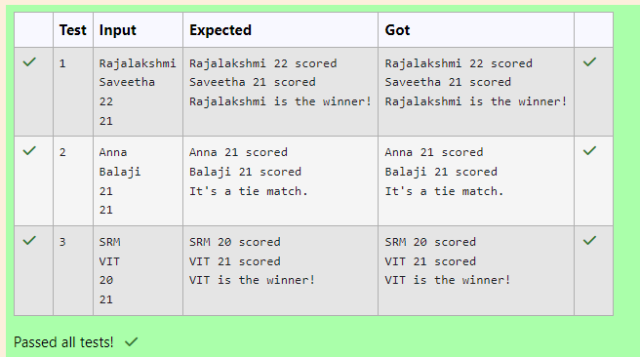

1. RBI issues all national banks to collect interest on all customer loans.

Create an RBI interface with a variable String parentBank="RBI" and abstract method rateOfInterest().

RBI interface has two more methods default and static method. default void policyNote() {

System.out.println("RBI has a new Policy issued in 2023.");

}

static void regulations(){

System.out.println("RBI has updated new regulations on 2024.");

}

Create two subclasses SBI and Karur which implements the RBI interface. Provide the necessary code for the abstract method in two sub-classes.

**Sample Input/Output:**

**RBI has a new Policy issued in 2023**

**RBI has updated new regulations in 2024. SBI rate of interest: 7.6 per annum.**

**Karur rate of interest: 7.4 per annum.**

Code:

interface RBI {

String parentBank = "RBI";

double rateOfInterest();

default void policyNote() {

System.out.println("RBI has a new Policy issued in 2023");

}

static void regulations() {

System.out.println("RBI has updated new regulations in 2024.");

}

}

class SBI implements RBI {

public double rateOfInterest() { return 7.6;

}

}

class Karur implements RBI { public double rateOfInterest() {

return 7.4;

}

}

public class Main {

public static void main(String[] args) { RBI rbi = new SBI();

rbi.policyNote(); RBI.regulations(); SBI sbi = new SBI();

System.out.println("SBI rate of interest: " + sbi.rateOfInterest() + " per annum.");

Karur karur = new Karur();

System.out.println("Karur rate of interest: " + karur.rateOfInterest() + " per annum.");

}

}

Output:

