WEEK-9

ROLL NO:230701233

1. In the following program, an array of integer data is to be initialized.

During the initialization, if a user enters a value other than an integer, it will throw an InputMismatchException exception.

On the occurrence of such an exception, your program should print “You entered bad data.”

If there is no such exception it will print the total sum of the array.

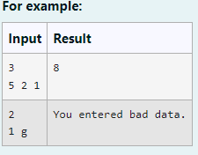

CODE:

import java.util.Scanner;

import java.util.InputMismatchException; class prog {

public static void main(String[] args) { Scanner sc = new Scanner(System.in); int length = sc.nextInt();

// create an array to save user input int[] name = new int[length];

int sum=0;//save the total sum of the array.

/\* Define try-catch block to save user input in the array "name" If there is an exception then catch the exception otherwise print the total sum of the array. \*/

try

{

for (int i=0;i<length;i++){ name[i]=sc.nextInt(); sum+=name[i];

}

System.out.println(sum);

}

catch(InputMismatchException e)

{

System.out.println("You entered bad data.");

}

}

OUTPUT:

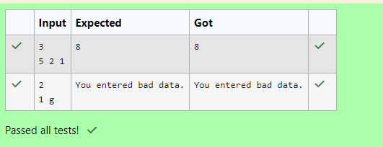

1. Write a Java program to create a method that takes an integer as a parameter and throws an exception if the number is odd.

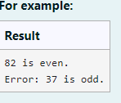

CODE:

class prog {

public static void main(String[] args) { int n = 82;

tryNumber(n); // Call the tryNumber method n = 37;

// Call the tryNumber method for the next number tryNumber(n);

}

public static void tryNumber(int n) { try {

// Call the checkEvenNumber method checkEvenNumber(n);

System.out.println(n + " is even.");

} catch (Exception e) {

// Handle any exceptions thrown

System.out.println("Error: " + e.getMessage());

}

}

public static void checkEvenNumber(int number) throws Exception { if (number % 2 != 0) {

// Throw an exception if the number is odd throw new Exception(number + " is odd.");

}

}

}

OUTPUT:

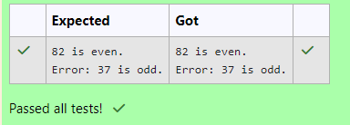

1. Write a Java program to handle ArithmeticException and ArrayIndexOutOfBoundsException.

Create an array, read the input from the user, and store it in the array. Divide the 0th index element by the 1st index element and store it.

if the 1st element is zero, it will throw an exception.

if you try to access an element beyond the array limit throws an exception.

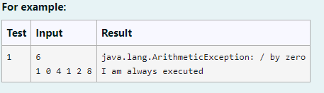\

CODE:

import java.util.Scanner;

public class ExceptionHandling { public static void main(String[] args) {

Scanner sc = new Scanner(System.in);

try {

// Read the size of the array int n = sc.nextInt();

int[] arr = new int[n];

// Read the array elements from the user

for (int i = 0; i < n; i++) { arr[i] = sc.nextInt();

}

// Attempt to divide the 0th element by the 1st element int result = arr[0] / arr[1];

// Attempt to access an element beyond the array limit (e.g., index 3) System.out.println("Accessing out of bound element: " + arr[3]);

} catch (ArithmeticException e) {

// Handle division by zero

System.out.println("java.lang.ArithmeticException: " + e.getMessage());

} catch (ArrayIndexOutOfBoundsException e) {

// Handle array index out of bounds

System.out.println("java.lang.ArrayIndexOutOfBoundsException: " + e.getMessage());

} finally {

// This block will always be executed System.out.println("I am always executed");

}

}

}

OUTPUT:

