1. Install python from [Download Python | Python.org](https://www.python.org/downloads/) press ctrl+click on this link
   1. Select custom install
   2. No need select any check box
   3. Change location from “C:” to “D:\Python” by making a folder named Python
2. Download “install_packages.txt” to desktop
3. Press “Win” type “cmd” press enter
4. Type “pip --version” and press enter you will see the pip location copy the path
5. Type “cd path” then install all packages one by one using “pip install” command
6. Note all the spellings of the packages must be exactly as in the install_packages.txt

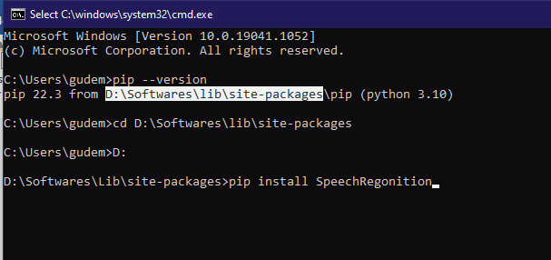

1. Then in the new cmd terminal (or) same terminal I.e., in the same path of pip, install some nltk libraries in python using the following commands one by one

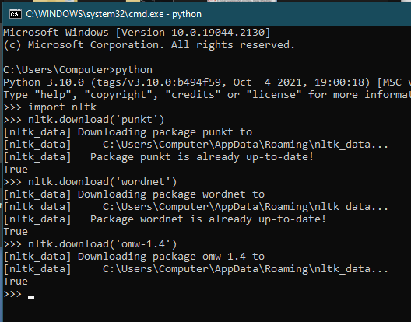

For installing “pyaudio” package

1. Open command prompt and type “python” and note the version

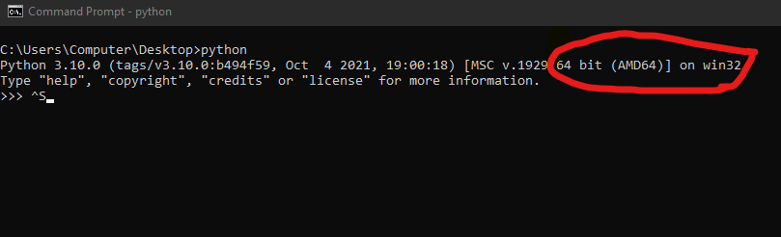

1. Now open [Python Extension Packages for Windows - Christoph Gohlke (uci.edu)](https://www.lfd.uci.edu/~gohlke/pythonlibs/#pyaudio) “ctrl+click”
2. Find your version pyaudio file and download on desktop
3. Mostly the first file should work for all

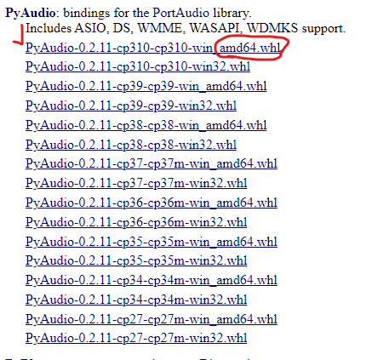

Installing pyaudio

1. Open cmd and type “cd desktop”
2. Then type “pip install PyAudio-0.2.11-cp38-cp38-win_amd64.whl” if you download this otherwise you have to type the name of the file to download don’t forget “.whl”

Now download tony_chatbot folder on desktop and run in cmd by

1. Open cmd from start and copy paste “cd \desktop\tony_chatbot”
2. Then copy paste “python tony_chatbot.py”
3. We can type or speak to give an input
4. If we type mic and press enter “mic is on” will appear then speak
5. Hi, hello to get random greetings
6. “current time” for time
7. “create note” to make a note
8. “add a new todo” to add a item to todo list
9. Say “open instagram” to open insta or any website “open site_name”
10. Say “what is programming wikipedia” to search in Wikipedia
11. It can wikipedia search for you. Use format wiki: your query
12. Ask “tell me a joke” it will read out a joke
13. Tell “take screenshot” it will take a screenshot and save it in same place wherethe code is saved
14. Say “play justin beiber” it’ll play justin beiber songs in youtube
15. If you wanna search say “search elephants” it’ll search elephants in google of your default browser
16. If you say other than these it’ll search for what you say in google and shows it in command prompt itself
17. It can get the present weather for any city. Use format weather: city name
18. It can get you the top 10 trending news in India. Use keywords 'Latest News'
19. It can get you the top 10 trending songs globally. Type 'songs'
20. It can set a timer for you. Enter 'set a timer: minutes to timer'
21. It can get the present Covid stats for any country. Use 'covid 19: world' or 'covid 19: country name'

Hope you find it useful.