King, Queen and Pawn Test

Syed Raza

Summary:

* King is still able to move into invalid positions ex. (5,-1),(4,-1),(3,-1)

Code used to test the movement of the pieces:

Code used to test the movement of the pieces:

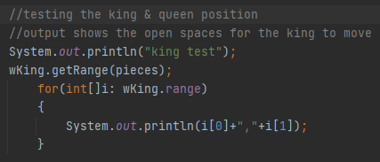

**King Test**

Starting Position: (4,0)



Adding to the pieces array list:



Output Given:

|  |  |  |  |  |  |  |  |  |
| --- | --- | --- | --- | --- | --- | --- | --- | --- |
| 7 |  |  |  |  |  |  |  |  |
| 6 |  |  |  |  |  |  |  |  |
| 5 |  |  |  |  |  |  |  |  |
| 4 |  |  |  |  |  |  |  |  |
| 3 |  |  |  |  |  |  |  |  |
| 2 |  |  |  |  |  |  |  |  |
| 1 |  |  |  |  |  |  |  |  |
| 0 |  |  |  |  | K |  |  |  |
|  | 0 | 1 | 2 | 3 | 4 | 5 | 6 | 7 |

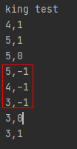

The same problem remains King is still able to move into invalid positions

**Queen Test**

Starting Position: (3,0)



Adding to the pieces array list:



Positions available to move:

Output Given:

|  |  |  |  |  |  |  |  |  |
| --- | --- | --- | --- | --- | --- | --- | --- | --- |
| 7 |  |  |  |  |  |  |  |  |
| 6 |  |  |  |  |  |  |  |  |
| 5 |  |  |  |  |  |  |  |  |
| 4 |  |  |  |  |  |  |  |  |
| 3 |  |  |  |  |  |  |  |  |
| 2 |  |  |  |  |  |  |  |  |
| 1 |  |  |  |  |  |  |  |  |
| 0 |  |  |  | Q |  |  |  |  |
|  | 0 | 1 | 2 | 3 | 4 | 5 | 6 | 7 |

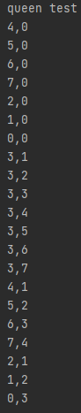

The Queen does not have the problem of error checking like the king does.

*Note: In the code provided the King and Queen cannot move into each other positions, which is correct

**Pawn Test**

Starting Position: (4,1)



Adding to the pieces array list:



Positions available to move:

|  |  |  |  |  |  |  |  |  |
| --- | --- | --- | --- | --- | --- | --- | --- | --- |
| 7 |  |  |  |  |  |  |  |  |
| 6 |  |  |  |  |  |  |  |  |
| 5 |  |  |  |  |  |  |  |  |
| 4 |  |  |  |  |  |  |  |  |
| 3 |  |  |  |  |  |  |  |  |
| 2 |  |  |  |  |  |  |  |  |
| 1 |  |  |  |  | P |  |  |  |
| 0 |  |  |  |  |  |  |  |  |
|  | 0 | 1 | 2 | 3 | 4 | 5 | 6 | 7 |

Output Given:

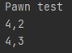

From the Pawns original position, it will be allowed to move either one or two spots forward

The output shown is correct

Testing Pawn after moving from its original position:

Moving the pawn



Positions available to move:

|  |  |  |  |  |  |  |  |  |
| --- | --- | --- | --- | --- | --- | --- | --- | --- |
| 7 |  |  |  |  |  |  |  |  |
| 6 |  |  |  |  |  |  |  |  |
| 5 |  |  |  |  |  |  |  |  |
| 4 |  |  |  |  |  |  |  |  |
| 3 |  |  |  |  |  |  |  |  |
| 2 |  |  |  |  | P |  |  |  |
| 1 |  |  |  |  |  |  |  |  |
| 0 |  |  |  |  |  |  |  |  |
|  | 0 | 1 | 2 | 3 | 4 | 5 | 6 | 7 |

Output Given:

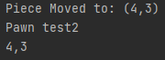

Pawn successfully moved from its original position and is now ONLY able to move one spot forward

Testing White Pawns Kill

First, creating a black pawn

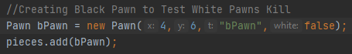

Moving Black Pawn:

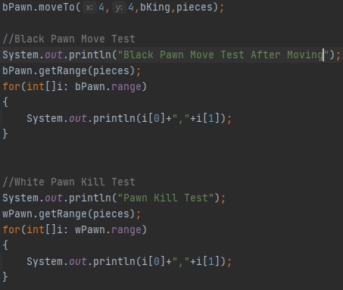

|  |  |  |  |  |  |  |  |  |
| --- | --- | --- | --- | --- | --- | --- | --- | --- |
| 7 |  |  |  |  |  |  |  |  |
| 6 |  |  |  |  |  |  |  |  |
| 5 |  |  |  |  |  |  |  |  |
| 4 |  |  |  |  | bP |  |  |  |
| 3 |  |  |  |  |  |  |  |  |
| 2 |  |  |  |  | wP |  |  |  |
| 1 |  |  |  |  |  |  |  |  |
| 0 |  |  |  |  |  |  |  |  |
|  | 0 | 1 | 2 | 3 | 4 | 5 | 6 | 7 |

**Other “Research”**

What started of for the sake of the project turned out to be really fun.

I first tried started off by thinking “in order for me to properly test the chess game I will need to learn how to play the game.” So obviously, I tried learning by watching YouTube videos and online blogs. Eventually, I kind of got the rules and thought “you know what? This actually seems like a lot of fun” so went and purchased a chess board.

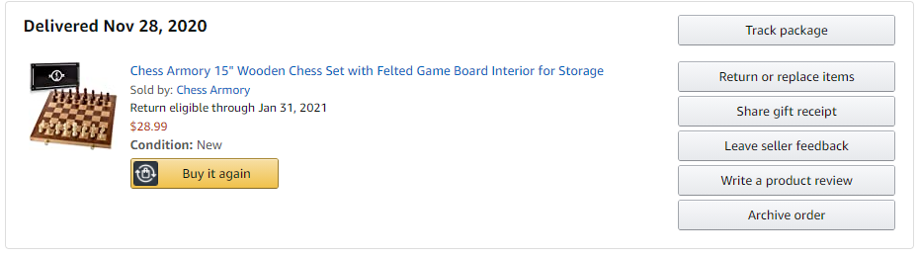

After this, its kind of went crazy. Me, my friends, brother all play and have even downloaded the chess.com app on our phones. It a lot of fun and we are just getting started learning. Also, none of us are good so it’s a good place to be.

Overall, I really enjoyed this project it reminded me A LOT of my internship over the summer and how the code would split and divided amongst different people.