King and Queen Test

Syed Raza

**King Test**

Starting Position: (4,0)



Positions available to move:

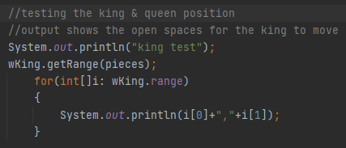

Output Given:

|  |  |  |  |  |  |  |  |  |
| --- | --- | --- | --- | --- | --- | --- | --- | --- |
| 7 |  |  |  |  |  |  |  |  |
| 6 |  |  |  |  |  |  |  |  |
| 5 |  |  |  |  |  |  |  |  |
| 4 |  |  |  |  |  |  |  |  |
| 3 |  |  |  |  |  |  |  |  |
| 2 |  |  |  |  |  |  |  |  |
| 1 |  |  |  |  |  |  |  |  |
| 0 |  |  |  |  | K |  |  |  |
|  | 0 | 1 | 2 | 3 | 4 | 5 | 6 | 7 |

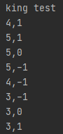

The King can move into invalid positions: (5, -1), (4, -1), etc

There does not seem to be any error checking at the moment.

**Queen Test**

Starting Position: (3,0)



Positions available to move:

Output Given:

|  |  |  |  |  |  |  |  |  |
| --- | --- | --- | --- | --- | --- | --- | --- | --- |
| 7 |  |  |  |  |  |  |  |  |
| 6 |  |  |  |  |  |  |  |  |
| 5 |  |  |  |  |  |  |  |  |
| 4 |  |  |  |  |  |  |  |  |
| 3 |  |  |  |  |  |  |  |  |
| 2 |  |  |  |  |  |  |  |  |
| 1 |  |  |  |  |  |  |  |  |
| 0 |  |  |  | Q |  |  |  |  |
|  | 0 | 1 | 2 | 3 | 4 | 5 | 6 | 7 |

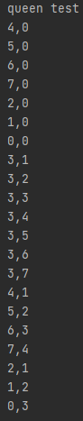

The Queen does not have the problem of error checking like the king does.

*Note: In the code provided the King and Queen cannot move into each other positions