***Assignment #1***

For Q1- Q4 you need to show your work

Q1: Find the Hexadecimal Representation for each of the following Binary numbers

1. **10101101**



1. **00100111**



Q2: Find the Decimal Representation for each of the following Hexadecimal numbers

1. **8EF**

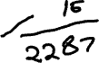

1. **5CE**

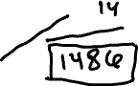

Q3: Find the Binary Representation for each of the following Decimal numbers

1. **53**



1. **885**



Q4: Find the answer for the following

Hexadecimal



1. 35 + AB



1. AA – 22

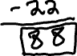

**Binary**



1. 11110 + 00111



1. 11001 – 11011



Q5: Write a C++ program to convert a binary number into hexadecimal.

Note: for this question you need to submit the source code and screen shot for the output