1. You can also double check which branch you are on by opening the panel, click View>Appearance>Show Panel. Then type the git command git status.

https://storage.googleapis.com/htmlandcss/code_snippet_git_status.png

And the output should show that you are on the github-assignment branch

https://storage.googleapis.com/htmlandcss/code_snippet_onbranch.png

1. Open the BasicHTML.html file.Add another paragraph tag within the body of the HTML document and the text “Added another paragraph.” Like this:

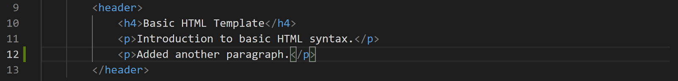 Save the BasicHTML.html file.

1. You will use the same git commands used in Git Bash in VS Code’s terminal in the Panel. Type the Git command to add the BasicHTML.html file to the staging area.

https://storage.googleapis.com/htmlandcss/code_snippet_git_add.png

1. Type the Git command to commit the file to your local repository.

https://storage.googleapis.com/htmlandcss/code_snippet_git_commit.png

If you get an error upon committing, make sure you spelled the file name exactly as it was saved. Reminder, git is case sensitive to file names.

1. Type the Git command to Push the file and your local branch to your remote repository.

https://storage.googleapis.com/htmlandcss/code_snippet_git_push.png