EVENTFORCE MANAGEMENT
SYSTEM
USING SALESFORCE
College Name: KSK College Of Engineering And Technology
College Code: 8210
Team ID: SWUID-2026-379743

S.No | Student  Name | Register  Number | NM ID
1 | Srinivasan J | 821023243305 | 6A69C98ACAB81EA80C84B517C469A482
2 | Harish V | 821023243010 | C69433C01C051D4AB0047213E3369A2C
3 | Subikshan C | 821023243306 | FB9A09B511FD0538E7E4F31AACE9E4F3

TABLE OF CONTENTS:
1. INTRODUCTION
1.1 Project overview
1.2 Purpose
1.3 Environment and boundaries
1.4 Project objectives
2. IDEATION PHASE
2.1 Problem statement
2.2 User personas
2.3 Empathy map
2.4 Brainstorming and idea selection
3. REQUIREMENT ANALYSIS PHASE
3.1 Customer journey
3.2 Functional requirements
3.3 Nonfunctional requirements
3.4 Data flow
4. PROJECT DESIGN PHASE
4.1 Problem and solution fit
4.2 Data model
4.3 Relationship diagram
4.4 Solution architecture
4.5 Technology stack
4.6 Implementation choices
5. PROJECT PLANNING AND SCHEDULING
5.1 Product backlog and priorities
5.2 Iteration sequence and tracking
5.3 Acceptance criteria

6. DEVELOPMENT PHASE
6.1 Requirement analysis and planning
6.2 Objects and fields
6.3 Booking Logic and Venue Availability
6.4 Cancellation Approval
6.5 Notification Flows
6.6 Scheduled Apex
6.7 User Interface and Analytics
6.8 Data Migration
6.9 Security Configuration
6.10 Deployment and Maintenance
7. FUNCTIONAL AND PERFORMANCE TESTING
7.1 Test strategy
7.2 Functional test cases
7.3 Regression and execution evidence
8. ADVANTAGES AND LIMITATIONS
8.1 Advantages
8.2 Limitations
9. CONCLUSION
10. FUTURE SCOPE
11. APPENDIX

1 Introduction

1.1 Project overview
EventForce centralizes the event lifecycle in Salesforce. Event records connect a client and venue; an Event Vendor junction records multiple vendor assignments. Feedback links the client to the relevant event. A Lightning app provides navigation, while reports and a dashboard summarize upcoming work.

1.2 Purpose
The project replaces scattered booking details with related records, automates reminders and cancellation processing, prevents conflicting venue bookings and controls access by responsibility. It demonstrates Salesforce configuration and Apex development within a dedicated educational playground.

1.3 Environment and boundaries
The implementation uses playful-unicorn-d2io9f-dev-ed.trailblaze.lightning.force.com. The earlier org is outside this project environment. Sample records are labelled demonstrations or samples. No production migration has been performed; the guide treats deployment as preparation in a standalone Developer Edition environment.

1.4 Project objectives
Objective | Acceptance evidence
Centralize event operations | Six related custom objects and EventForce app navigation
Prevent booking conflicts | Venue validation and passing service tests
Make cancellations traceable | Separate approval and rejection records with history
Automate routine follow-up | Active reminder flow, queued path and daily batch schedule
Control access | Profiles, roles, permission set and saved sharing configuration

2 Ideation Phase

2.1 Problem statement
User | Problem | Expected outcome
Event coordinator | Booking information is scattered across clients, venues and vendors. | One linked event record and a consistent workflow.
Vendor manager | Event assignments and vendor information are difficult to coordinate. | Vendor records and event visibility with limited editing.
Client | Reminders and cancellation updates can be missed. | Automated notification workflows and feedback collection.
Event administrator | Conflicting bookings and informal cancellations reduce reliability. | Validation, controlled approvals and reporting.

2.2 User personas
Event Admin maintains application configuration and oversight. Event Coordinator plans events and manages cancellations. Vendor Manager maintains vendor information and views shared events. Client users provide feedback within their permitted record access. These personas describe intended responsibilities rather than measured interview findings.

2.3 Empathy map
The coordinator thinks about avoiding missed commitments, hears changing client requirements, sees venue and vendor constraints, and spends time updating schedules. The principal pains are duplicate information and booking conflicts. The desired gains are clear ownership, timely reminders and visible approval outcomes. This persona is a design assumption, not a claim of a conducted customer interview.
Perspective | Event coordinator needs
Think and feel | Avoid booking conflicts and missed commitments.
See and hear | Changing client requests, venue constraints and vendor availability.
Say and do | Plan events, confirm resources and track cancellation decisions.
Pains and gains | Repeated updates are costly; linked records and visible approvals improve coordination.

2.4 Brainstorming and idea selection
Manual registers and spreadsheets are simple to start but require repeated coordination. A separate custom portal adds development and maintenance work. Salesforce was selected because its related data model, declarative automation, Apex, access controls and reporting support the project requirements within one platform.

3 Requirement Analysis Phase

3.1 Customer journey
Client enquiry and registration, event planning, venue selection, vendor assignment, confirmation and reminder scheduling, event execution, feedback and operational reporting. A cancellation request branches into approval or rejection with a recorded final status.
Stage | System support
Enquiry and planning | Create client and event records; select a venue.
Coordination | Link vendors and validate venue/date conflicts.
Confirmation | Reserve the venue and schedule the three-day reminder.
Cancellation branch | Submit approval; record Canceled or Rejected outcome.
Closure | Collect feedback and complete past events on the daily schedule.

3.2 Functional requirements
Requirement | Implementation
Manage core information | Event, Client, Vendor, Venue and Feedback custom objects.
Assign multiple vendors | EventVendor junction with two master detail relationships.
Prevent conflicting bookings | Apex validates venue and date before saving.
Manage cancellation | Approval process with Canceled and Rejected final status updates.
Notify clients | Cancellation notification flow and three-day reminder flow.
Complete past events | Scheduled BatchCompleteEvents at 8 PM daily.
Control access | Four role/profile combinations, Feedback Manager and sharing rules.
Monitor operations | Upcoming Events by Month report and Operations Dashboard.

3.3 Nonfunctional requirements
The solution must maintain related-record integrity, restrict record visibility, process bulk records, present understandable validation messages and remain maintainable through documented metadata and tests. No measured load benchmark or production availability guarantee is claimed.

3.4 Data flow
The coordinator enters client, venue and event details. Saving the event invokes booking validation and updates venue availability. Vendor assignments connect suppliers to the event through the junction object. A confirmed event schedules the reminder; a cancellation request enters approval and its decision updates status. The daily batch completes eligible past events. Feedback, reports and the dashboard use the related records for review.

4 Project Design Phase

4.1 Problem and solution fit
Problem | Implemented response
Scattered client and resource details | Linked Salesforce records and a dedicated Lightning app
Conflicting venue bookings | Apex checks event date and venue before saving
Informal cancellation decisions | Approval process and recorded final status
Repeated reminder work | Scheduled flow path three days before the event
Limited operational visibility | Monthly report and operations dashboard

4.2 Data model
Object | Purpose | Relationships
Event__c | Name, type, date, status and formula budget | Lookup to Client and Venue
Client__c | Contact and location information | Referenced by Event and Feedback
Vendor__c | Services, contact and availability | Master of EventVendor
Venue__c | Address, capacity, location and availability | Referenced by Event
Feedback__c | Autonumber, rating and comments | Lookup to Client and Event
EventVendor__c | Event to vendor assignment | Master detail to Event and Vendor

4.3 Relationship diagram
Related object | Relationship | Related object
Event | Lookup to | Client
Event | Lookup to | Venue
Feedback | Lookup to | Client
Feedback | Lookup to | Event
Event Vendor | Master-detail to | Event
Event Vendor | Master-detail to | Vendor

Event references Client and Venue through lookups. Feedback references Client and Event through lookups. Event Vendor joins Event and Vendor through two master-detail relationships. Lines indicate related objects; see the table for relationship direction and type.

4.4 Solution architecture
Salesforce Lightning provides the user interface. Custom objects store data. Formula fields and validation rules handle declarative calculations and checks. Record-triggered flows send notifications; the approval process controls cancellation decisions. Apex handles booking conflicts, venue synchronization and scheduled completion. Reports and dashboards summarize stored data.

4.5 Technology stack
Layer | EventForce components
Platform and interface | Salesforce Trailhead Playground, Lightning app and custom tabs
Data | Six custom objects, lookups, master-detail relationships and formula fields
Automation | Record-triggered flows, cancellation approval, Apex service and scheduled batch
Access and analytics | Profiles, roles, permission set, sharing rules, report and dashboard

4.6 Implementation choices
The app is named EventForce for the requested distinct presentation. The guide demonstrates separate helper and trigger examples; this implementation consolidates venue synchronization and booking validation in EventForceService and EventForceTrigger. The report uses the deployed names so that the source code and demonstration remain traceable.

5 Project Planning and Scheduling
The implementation was organized around the guide's five phases. The following sequence is a work breakdown, not a fabricated record of team sprint velocity or individual contributions.
Phase | Work package | Completion evidence
Requirements and planning | Identify objects, users, relationships and workflows | Requirements and data model in this report
Backend configuration | Fields, formula, validation, Apex, approval and flows | Setup screenshots and Apex tests
UI customization | Tabs, app, monthly report and dashboard | Application and analytics screenshots
Data testing and security | Sample imports, profiles, roles, permissions and sharing | Import results, saved settings and test results
Deployment and maintenance | Keep source, evidence, report and demo narration | Local project files and this report

5.1 Product backlog and priorities
Priority | Work item | Outcome
High | Data model and booking integrity | Objects, relationships and validation implemented
High | Cancellation workflow | Approval and rejection demonstrated
High | Access configuration | Profiles, roles and sharing saved; session checks pending
Medium | Notifications | Flows configured; actual inbox receipt pending
Medium | Analytics and migration | Report, dashboard and sample imports verified
High for submission | Documentation and demo | Report revised; live narrated video pending

5.2 Iteration sequence and tracking
Work was sequenced into data-model setup, automation, UI and sample data, security corrections, regression testing and submission preparation. The project log and saved screenshots record observed outcomes. This report does not invent sprint dates, velocity or individual task allocations.

5.3 Acceptance criteria
Booking correctness and related data come first; notification and cancellation behavior follow. Security is checked before user demonstrations. Documentation records the implemented behavior and any remaining acceptance checks. A final submission should include the report and a screen recording narrated by the student.

6 Development Phase

6.1 Requirement analysis and planning
The new playground separates this implementation from the earlier org. The project maps Client, Coordinator, Vendor Manager and Event Admin responsibilities to related data and controlled workflows.

6.2 Objects and fields
Six custom objects implement the data model. Event Type drives a Currency formula budget. Event Status tracks progression, cancellation and rejection. Client email validation and the Feedback event lookup filter protect data quality. Feedback uses an autonumber record name.
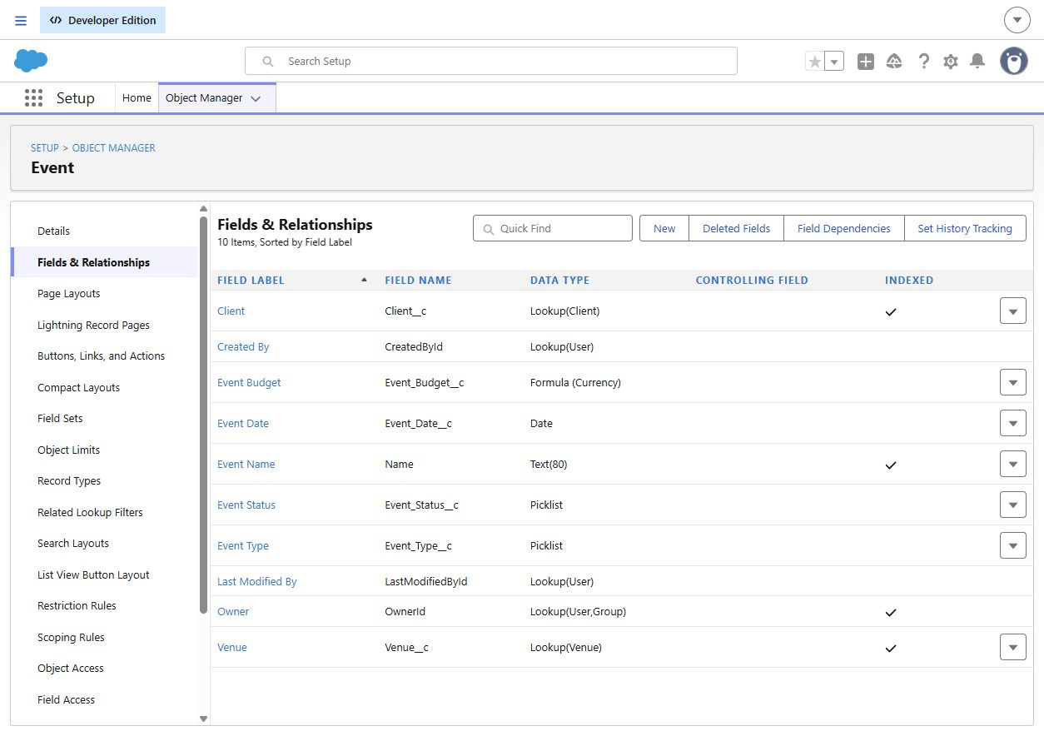
Figure 1. Event fields and relationships captured from the project playground.
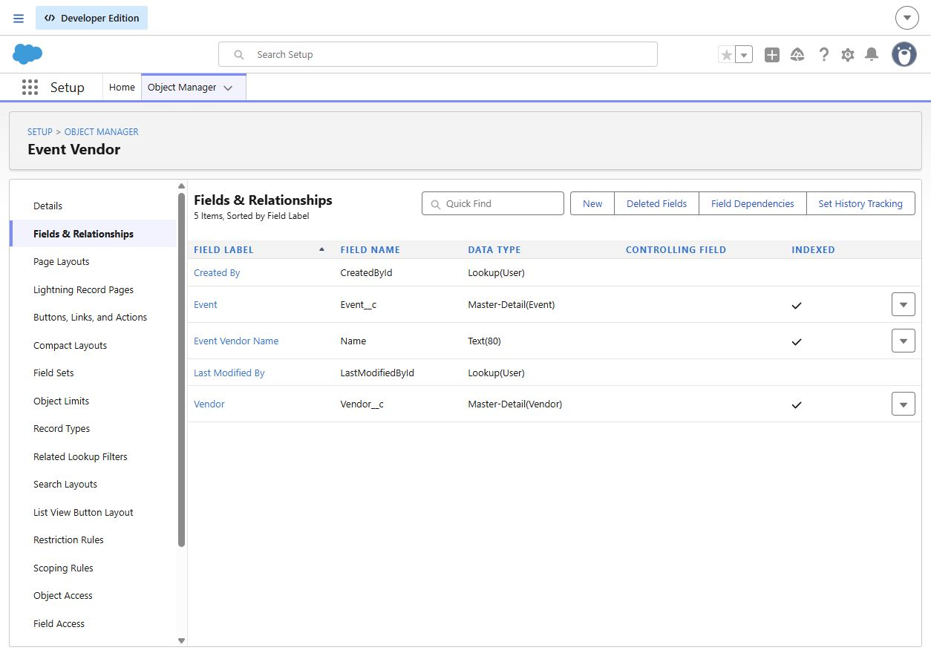
Figure 2. Event Vendor junction relationships.

6.3 Booking Logic and Venue Availability
EventForceTrigger delegates to EventForceService. The service checks venue/date conflicts across stored records and records in the same operation. Venue rows are locked during validation to serialize competing bookings. Confirmed and Pending Cancellation events require client, venue and event date.
Venue synchronization reserves venues referenced by Confirmed or Pending Cancellation events and releases them when no such event remains. Venues marked Not Available retain that state. Canceled, Rejected and Completed records do not block a new booking in this implementation.
These rules are more explicit than the guide's short example code. Planned events participate in conflict prevention, while reservation status is driven by Confirmed and Pending Cancellation events. This distinction should be explained during the demonstration.
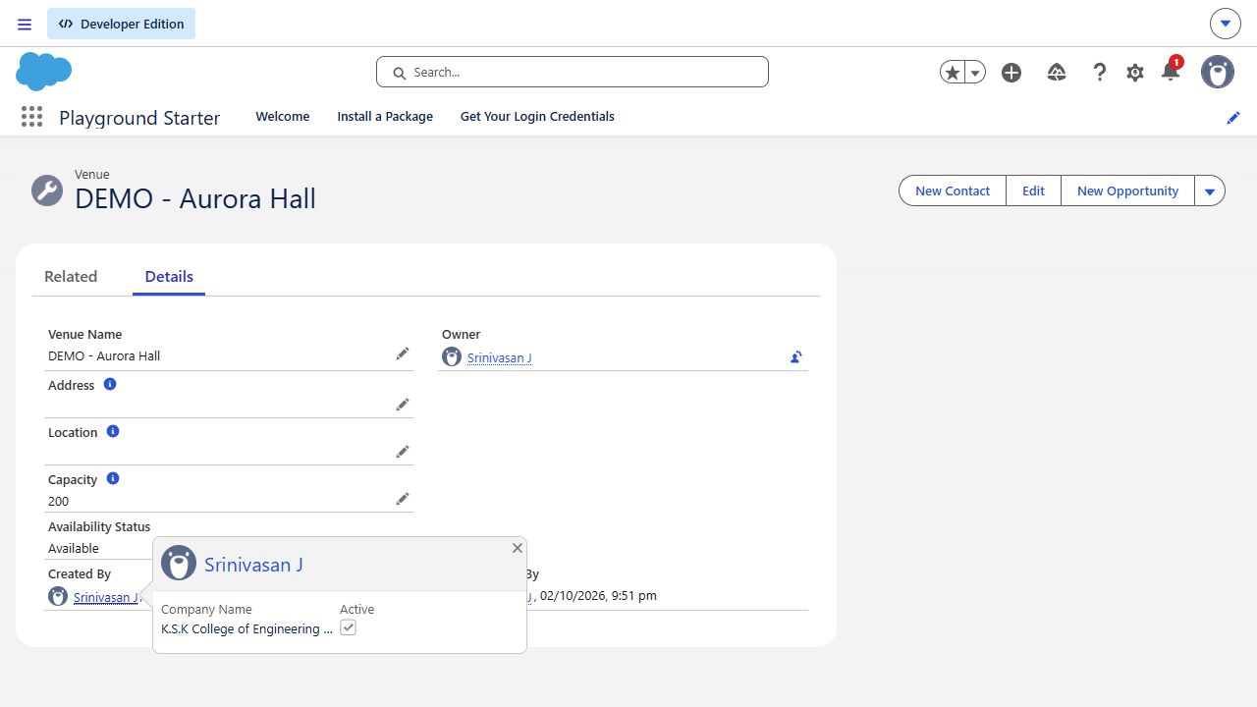
Figure 3. A venue is Available after the cancellation demonstration releases its reservation.

6.4 Cancellation Approval
The active Event Cancellation Process accepts events with Pending Cancellation status. The event owner submits the request and the configured current user acts as the demonstration approver. Submission sends an alert. Approval updates the status to Canceled; rejection updates it to Rejected, as required by the guide's field-update step.
Approval and rejection were exercised through separate demonstration records. Approval History provides the decision trail. The client cancellation flow is separate from the approval process and runs when a record changes to Canceled with a related client email.
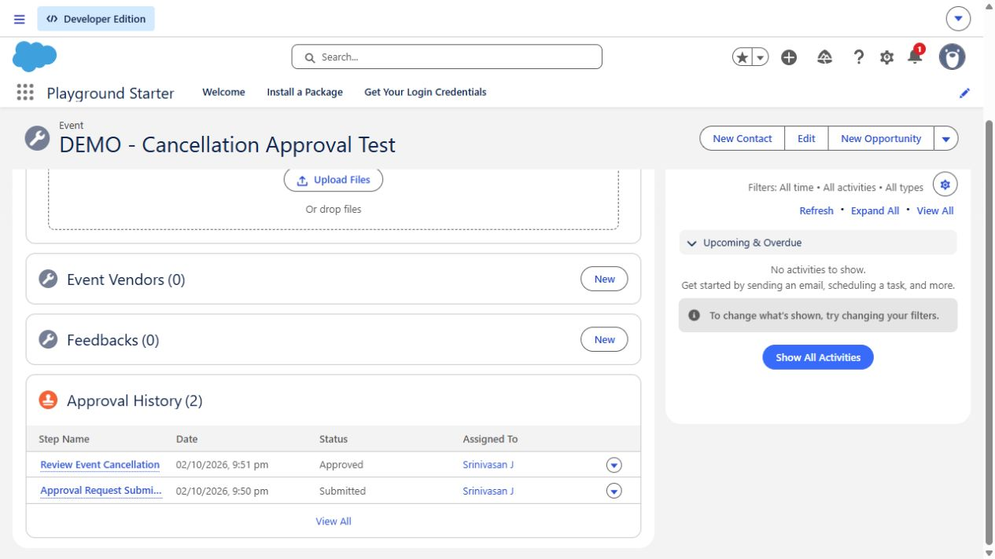
Figure 4. Completed approval history from the cancellation demonstration.
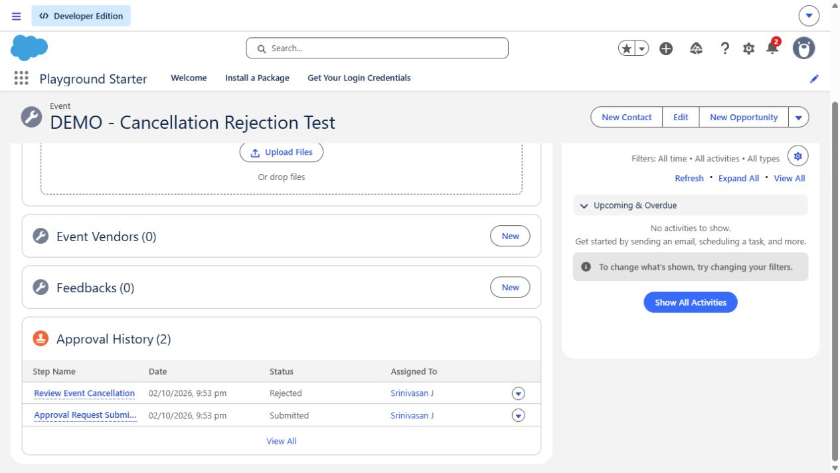
Figure 5. Completed rejection history from the rejection demonstration.

6.5 Notification Flows
Client Reminder - 3 Days Before is active. Confirmed events with date, client and email qualify. Its scheduled path uses Event Date with a three-day offset. The email goes to the client and copies the event owner. Debugging validated recipient resolution and merged event, client and venue information.
A separate cancellation notification flow sends the client an update when Event Status changes to Canceled. Entry checks avoid blank recipients and repeated notifications from unrelated edits.
The reminder demonstration for 20 October 2026 produced a scheduled path dated 17 October 2026. This verifies scheduling, not inbox delivery. Actual receipt remains a user acceptance check.
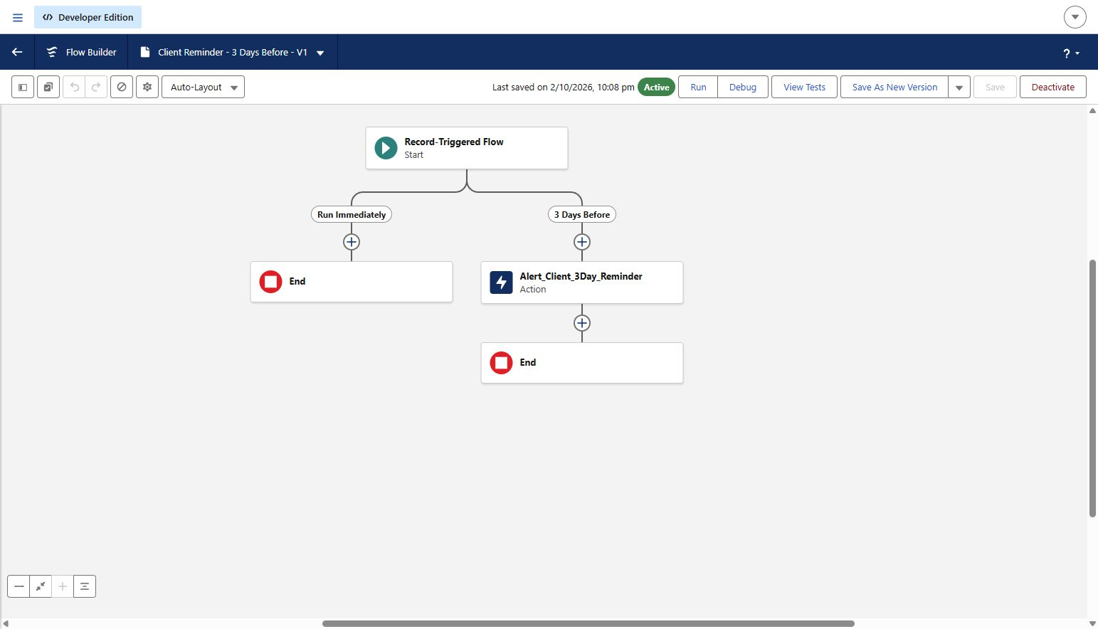
Figure 6. Active reminder flow.
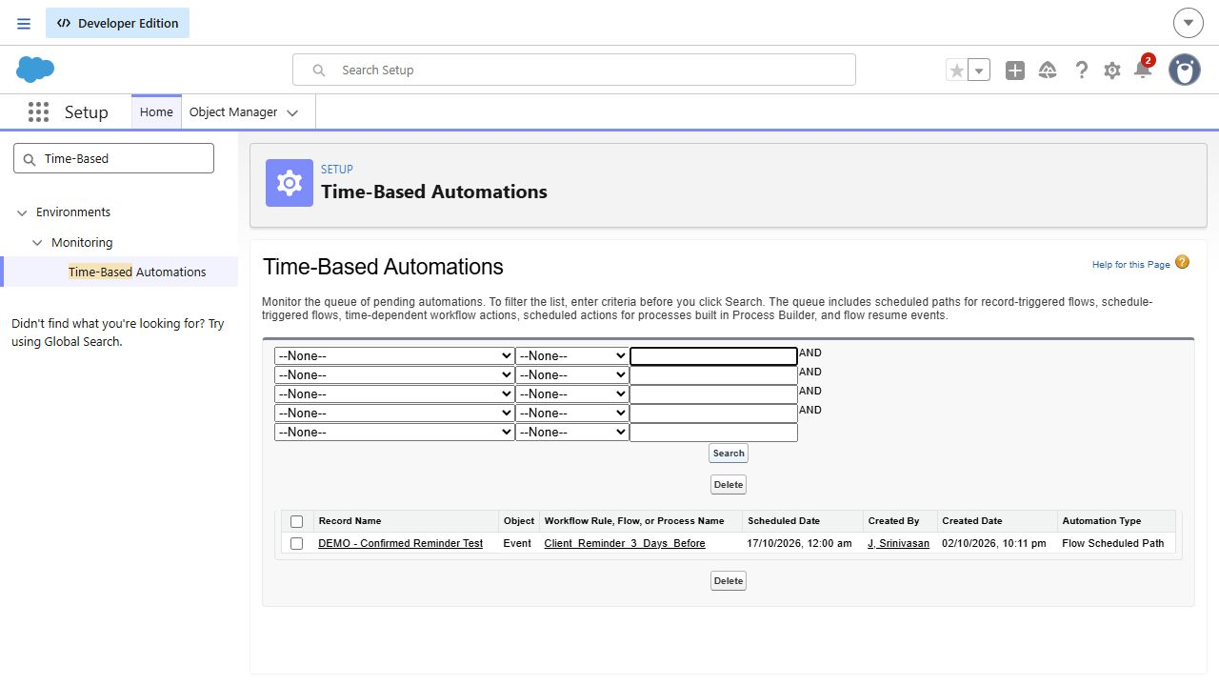
Figure 7. Scheduled path evidence showing the three-day offset.

6.6 Scheduled Apex
BatchCompleteEvents implements Database.Batchable and Schedulable. To follow the guide literally, it selects events where Event Date is earlier than today and status is not Completed, then sets status to Completed. The daily job uses cron 0 0 20 * * ?, corresponding to 8 PM in the scheduling user's configured time zone.
This rule includes past Planned, Canceled and Rejected events. Consequently, a canceled event's current status can later become Completed even though its approval history remains. This is the guide's specified batch behavior and should be considered before any real production adoption.
The schedule was replaced after Salesforce required removal of the pending job before editing its class. The replacement retained the original daily time. Earlier execution on 3 October completed with zero failures and no eligible batches; automated tests separately exercise eligible records.
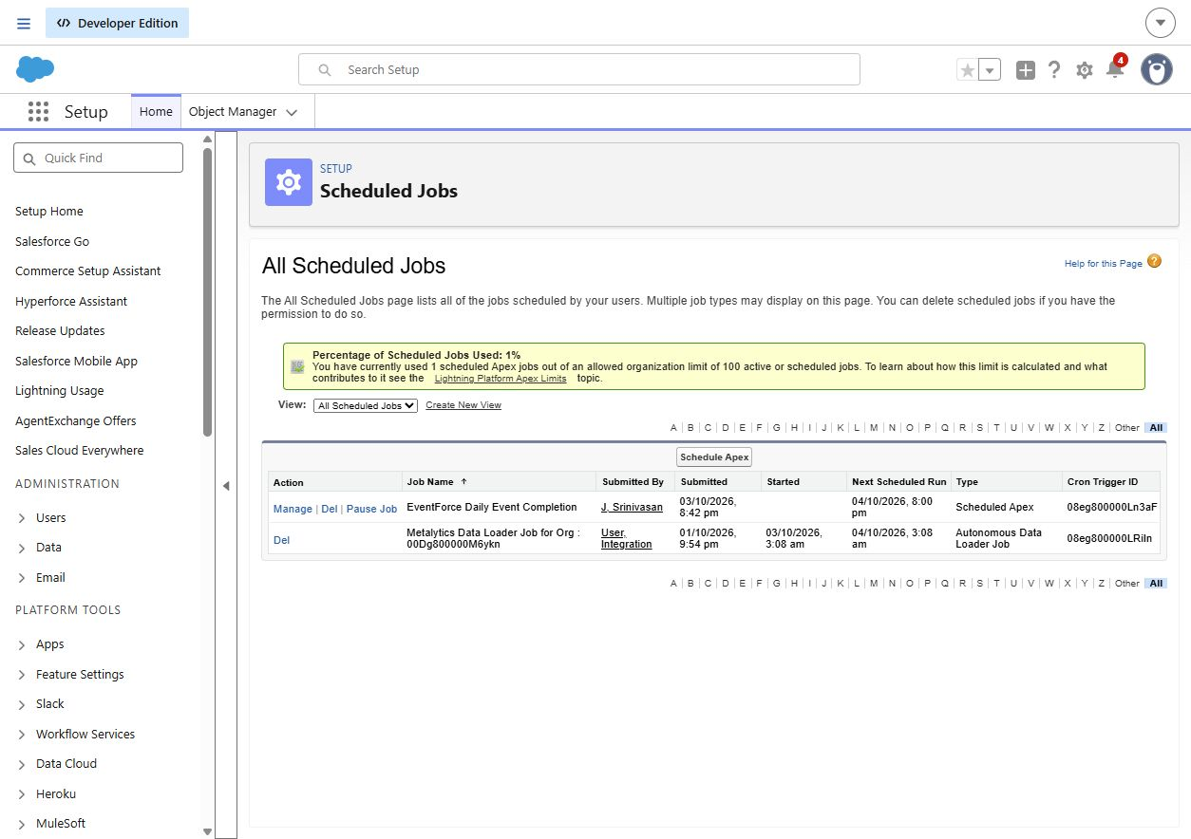
Figure 8. Restored daily schedule following the guide-aligned batch change.

6.7 User Interface and Analytics
The EventForce Lightning app includes Events, Clients, Vendors, Venues, Feedbacks, Reports and Dashboards. Five custom tabs use distinct icons. The monthly report selects all events in the next 30 days except Canceled records, groups Event Date by calendar month and summarizes record count and budget.
The EventForce Operations Dashboard uses the monthly report with a donut chart, six maximum displayed values, the subtitle Upcoming Events Overview and a light widget theme. Report results depend on the current date, so demonstration counts can change.
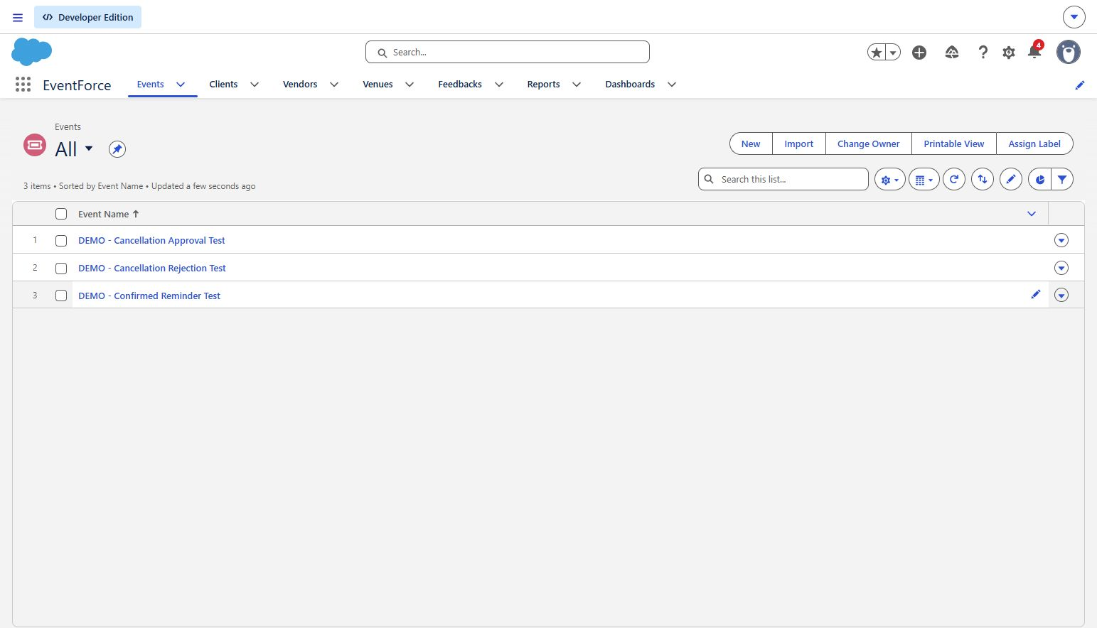
Figure 9. EventForce application and navigation.
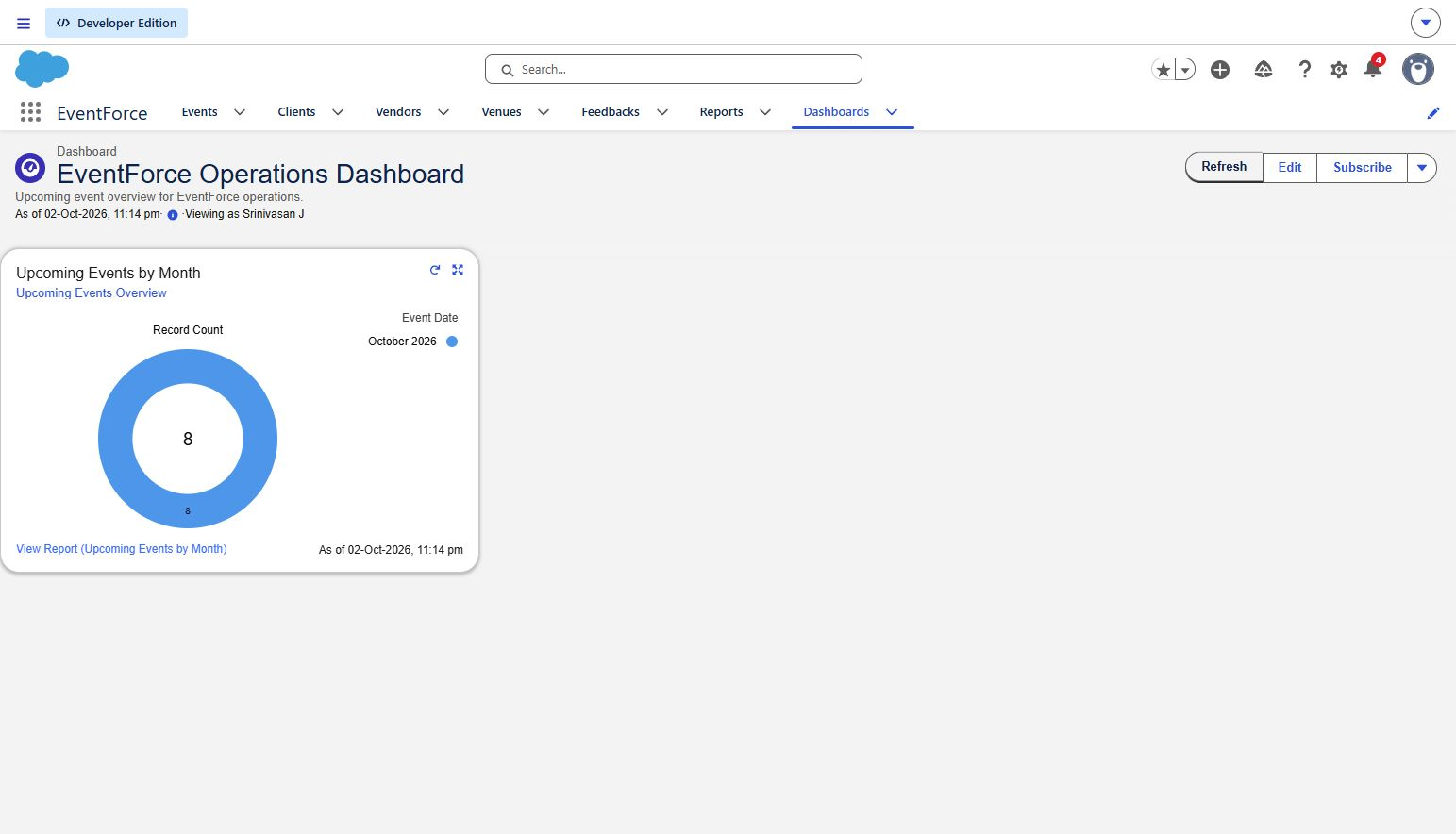
Figure 10. Operations dashboard captured during implementation.

6.8 Data Migration
Sample CSV files were prepared for all six objects. Parent records were imported before related records; relationships were matched by names. The Data Import Wizard results reported zero failed rows for all six imports. Fictional sample email addresses and labelled records distinguish demonstrations from real operational data.
Object | Records represented after import
Client | 10 including the existing demo client
Venue | 10 including the existing demo venue
Vendor | 10
Event | 13 including three demonstration events
Feedback | 10
EventVendor | 10

These counts describe the verified import checkpoint. Later intentional test activity may change totals. Feedback inserts should not be repeated casually because they do not have a matching duplicate key in the prepared import.
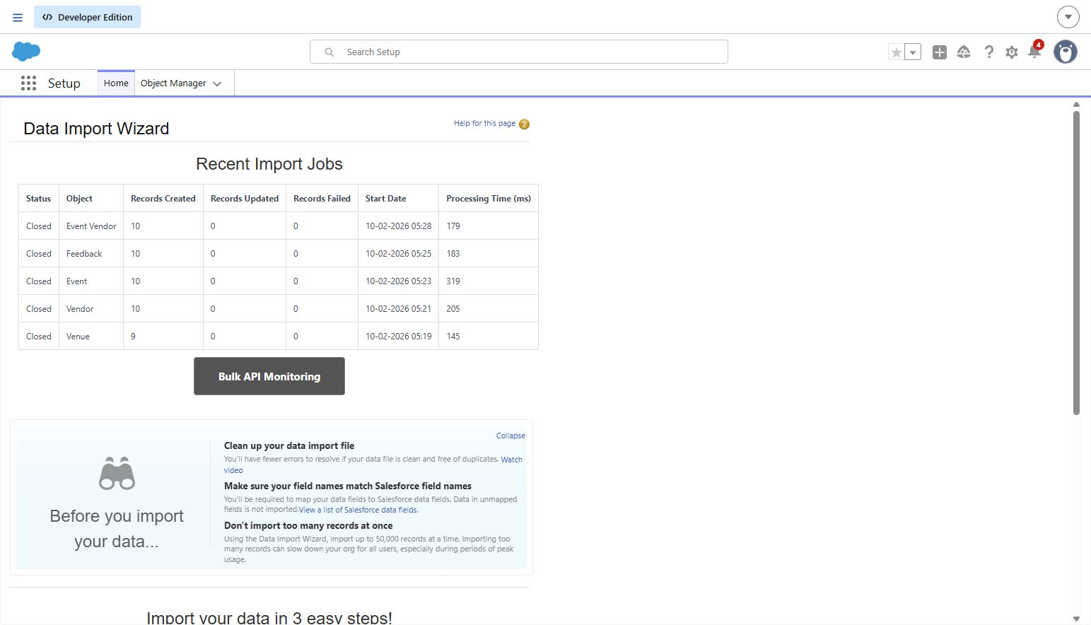
Figure 11. Data import evidence.

6.9 Security Configuration
Profile | Object permissions
Event Admin | Administrator profile clone
Event Coordinator | Event CRED; Client Read/Edit; Vendor and Venue Read; Feedback Create/Read
Vendor Manager | Vendor CRED; Event, Venue, Client and Feedback Read
Client Profile | Event Read; Feedback Create/Read; no Vendor or Venue access

CRED means Create, Read, Edit and Delete. Feedback Manager additionally grants these four Feedback permissions to the coordinator. The three operational profiles use the guide's eight-character minimum, two-hour inactivity setting and non-expiring password policy; actual role-session acceptance remains to be checked.
Event internal and external defaults are Private. Event_Sharing_For_Vendors gives the Vendor Manager role Read Only access to events owned by users in the Event Coordinator role. The report folder gives View access to those two roles. Event Admin reports to CEO; Coordinator, Vendor Manager and Client are below Event Admin.
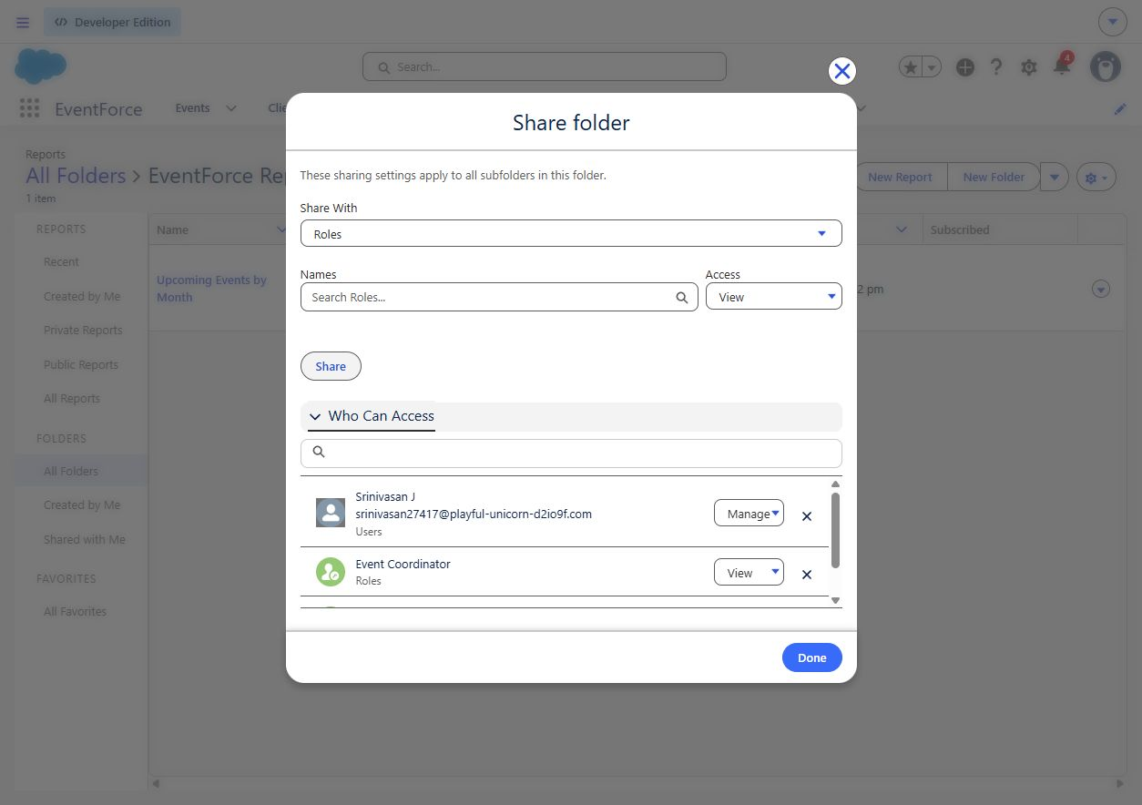
Figure 12. Saved report folder shares for the two required roles.

6.10 Deployment and Maintenance
The guide does not require deployment into a production org. The educational delivery remains in the new playground. Local metadata and sample CSVs accompany implementation evidence. They support review and future packaging, but are not represented as a fresh complete metadata export of every manually configured component.
Maintenance consists of monitoring Apex Jobs and scheduled paths, checking failed flow interviews and email delivery, reviewing access after user changes, and running regression tests after schema or Apex edits. Any future production release would require a separate environment, complete metadata retrieval and a deployment-specific test and security review.
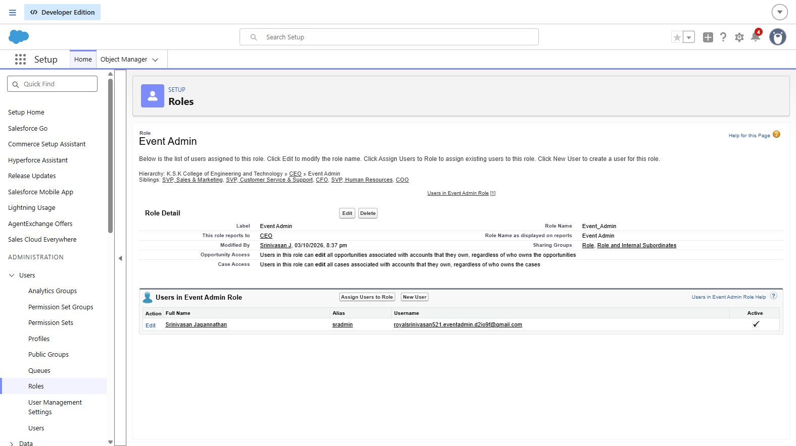
Figure 13. Saved Event Admin parent role is CEO.
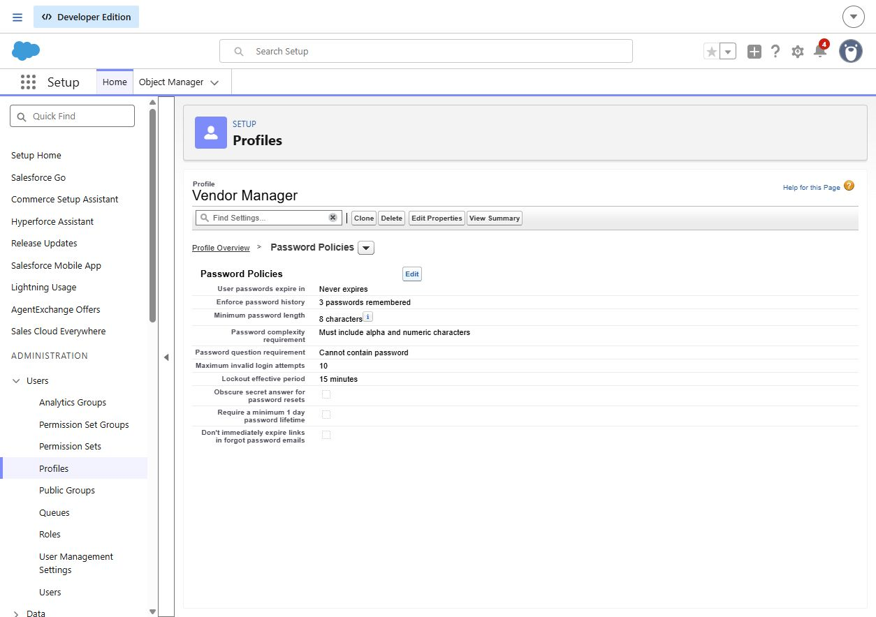
Figure 14. Vendor Manager password policy saved as specified by the guide.

7 Functional and Performance Testing

7.1 Test strategy
We used Apex tests for booking and batch behavior, separate records for approval and rejection, import-job outcomes for migration, and the scheduled-path queue for reminder timing. Configuration checks covered saved access settings. Inbox receipt, separate user sessions and load benchmarking are explicitly distinguished from the checks that passed.

7.2 Functional test cases
ID | Scenario | Expected result | Observed result
TC01 | Cancellation approved | Event becomes Canceled; decision is recorded | Canceled status and Approved history verified
TC02 | Cancellation rejected | Event becomes Rejected | Rejected status and history verified
TC03 | Reminder for 20 October | Scheduled for 17 October | Queue showed the three-day offset
TC04 | Six sample imports | No failed rows | All six jobs reported zero failures
TC05 | Project regression | All six methods pass | Four service and two batch methods passed
TC06 | Email receipt | Recipient receives correct message | Not verified
TC07 | Role sessions | Allowed and denied actions match access model | Not verified

7.3 Regression and execution evidence
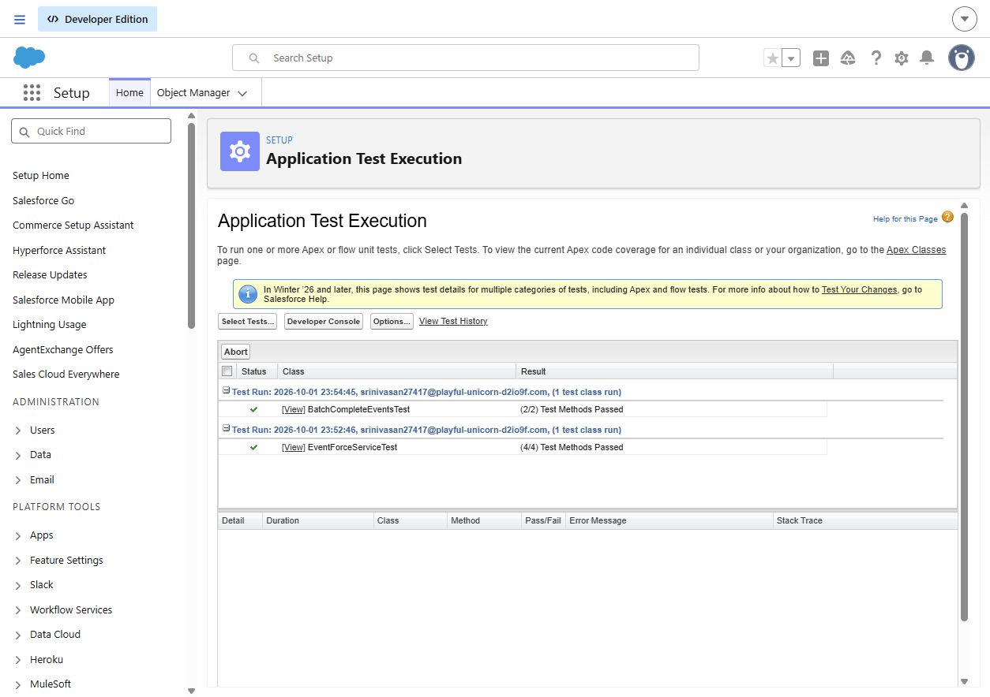
Figure 15. Earlier regression run on 1 October: four service methods and two batch methods passed. The final 3 October rerun is recorded in the project log.
Check | Observed result | Evidence or limit
Apex compilation | Successful | Invalid classes recompiled on 3 October
Booking and venue tests | 4 methods passed | EventForceServiceTest
Batch tests after guide scope edit | 2 methods passed | Updated regression on 3 October
Cancellation approval | Passed | Canceled status and approval history
Cancellation rejection | Passed | Rejected status and rejection history
Reminder scheduling | Passed | Three-day offset visible in queue
Sample imports | Passed | Zero failed rows in six import jobs
Scheduled execution | Completed with zero failures | No eligible records in that execution
Email inbox receipt | Not verified | A scheduled path or successful action does not prove receipt
Four user login and access checks | Not verified | Accounts and assignments verified; separate sessions not exercised
Load and concurrency benchmark | Not measured | No throughput claim

The test evidence supports the specific results shown. It is not a guarantee of zero defects. The updated batch regression passed after the guide-aligned query change.

8 Advantages and Limitations

8.1 Advantages
Related records reduce duplicate data entry and help users follow an event from client request to feedback. Automated booking checks reduce conflicting venue allocations. Approval History records cancellation decisions. Scheduled reminders and completion processing reduce repeated manual steps, while reporting makes upcoming work easier to inspect.

8.2 Limitations
The source snapshot is incomplete for clean-org deployment. Saved access configuration still requires separate user-session tests, and notification scheduling does not prove receipt. The guide-specific batch overwrites the status of past Canceled and Rejected events with Completed. The project has not been tested under production load, and no client self-service portal is claimed.

9 Conclusion
The playground implements the main EventForce workflow using Salesforce configuration and Apex. Security corrections, actual approval demonstrations, import results and regression evidence make the implementation reviewable. The remaining acceptance checks are actual email receipt and role-specific login behavior. These must not be presented as passed without observation.

10 Future Scope
Future work could add client self-service, richer vendor assignment notifications, calendar-based venue visibility, mobile-specific layouts and integrations. A production version should revisit the guide's non-expiring passwords and broad past-event completion rule. These are future improvements, not features claimed in this educational implementation.

11 APPENDIX

A. Custom Objects
Event__c
Client__c
Vendor__c
Venue__c
Feedback__c
EventVendor__c

B. Key Salesforce Records
• Events
• Clients
• Vendors
• Venues
• Feedback
• Event Vendor assignments
• Users

C. Flows
Client Reminder - 3 Days Before: record-triggered flow with a scheduled path three days before the event date.
Client Cancellation Notification: record-triggered flow for client notification when an event changes to Canceled.

D. Approval Process
Event Cancellation Process: processes cancellation requests and updates the event to Canceled on approval or Rejected on rejection.

E. Apex Components
• EventForceService - booking validation and venue availability logic
• EventForceTrigger - event trigger that invokes the service
• BatchCompleteEvents - scheduled batch for completing past events
• EventForceServiceTest and BatchCompleteEventsTest - project test classes

F. Visuals Included
• EventForce relationship diagram
• Event fields and Event Vendor relationship screenshots
• Venue availability and cancellation decision evidence
• Reminder flow and scheduled-path queue
• Daily Apex schedule
• EventForce Lightning app and operations dashboard
• Data import results
• Report sharing, role hierarchy and password-policy configuration
• Apex regression screen
THANK YOU

