Part F: Architecture & System Design
CS4241 — Introduction to Artificial Intelligence
Student: Nana Kwaku Owusu-Ansah | Index: 10012300016 | Lecturer: Godwin N. Danso

1. System Architecture
The system is built in three layers. The ingestion pipeline runs once to process the raw data and save it. The query pipeline runs every time a user asks a question. The feedback loop improves results over time based on user ratings.

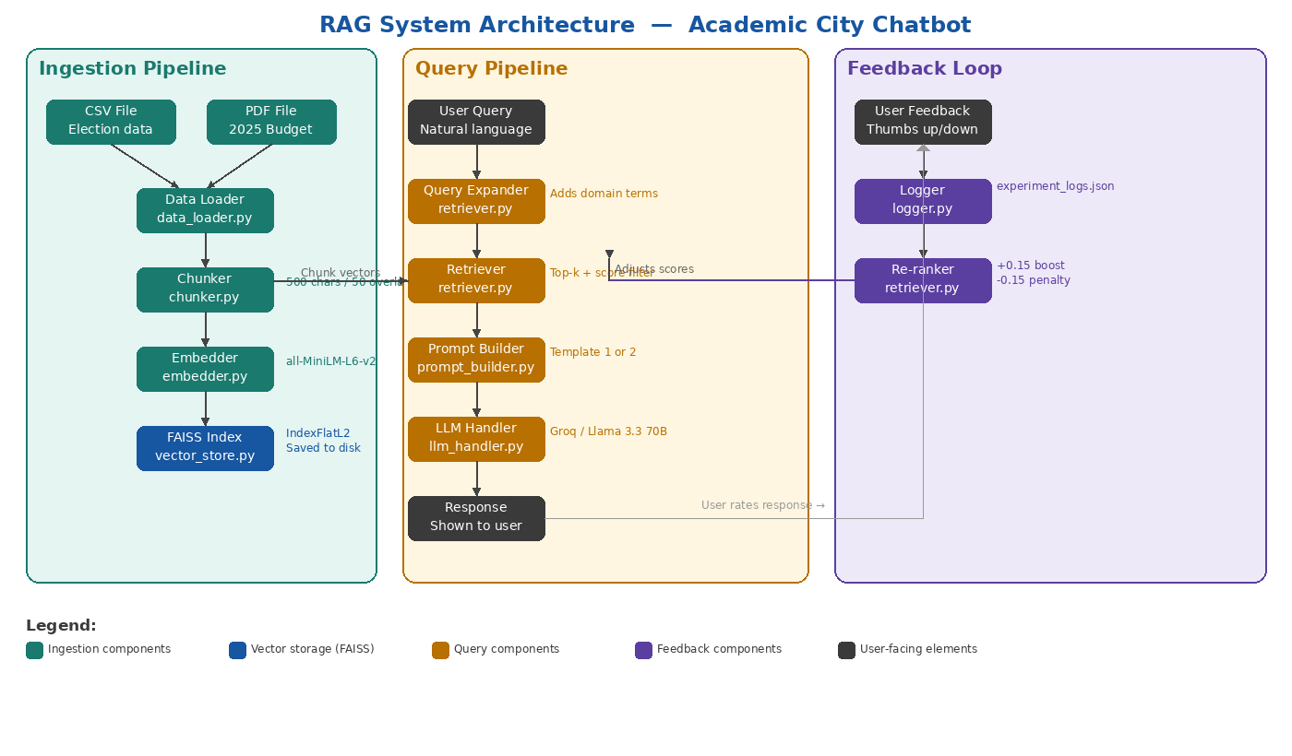

2. Data Flow

2.1 Ingestion Flow
This happens once when you first set up the system. The raw data is loaded, cleaned, split into chunks, turned into vectors, and saved to disk. Once this is done the system is ready to answer questions.

Step | What Happens | File
1 | Load the CSV and PDF files | data_loader.py
2 | Clean the data — remove empty rows, normalise spacing, convert CSV rows into readable sentences | data_loader.py
3 | Split all text into 500-character chunks with 50-character overlap | chunker.py
4 | Convert each chunk into a vector using the MiniLM embedding model | embedder.py
5 | Save all vectors into a FAISS index on disk with chunk text and metadata | vector_store.py

2.2 Query Flow
This happens every time a user types a question. The question passes through several steps before an answer is returned.

Step | What Happens | File
1 | User types a question into the chat interface | app.py
2 | Query expander adds related domain terms based on keywords detected in the question | retriever.py
3 | The expanded query is converted into a vector using the same embedding model | embedder.py
4 | Retriever searches the FAISS index and returns the top 5 most similar chunks with scores | retriever.py
5 | Re-ranker adjusts scores based on past user feedback before returning final results | retriever.py
6 | Prompt builder wraps the top chunks into a structured prompt | prompt_builder.py
7 | Prompt is sent to Llama 3.3 70B via the Groq API | llm_handler.py
8 | Response is shown to the user with source chunks displayed underneath | app.py

2.3 Feedback Flow
This happens after the user reads a response. Their rating is saved and used to improve future searches automatically.

Step | What Happens | File
1 | User clicks thumbs up or thumbs down below the response | app.py
2 | The rating is saved to the log file with the query and top retrieved chunk | logger.py
3 | On the next search the re-ranker reads the log and adjusts chunk scores | retriever.py
4 | Chunks rated positively are boosted by 0.15. Chunks rated negatively are penalised by 0.15 | retriever.py

3. Components Interaction
The table below shows how each part of the system connects to the others — what it receives and what it passes on.

Component | Receives From | Sends To
Data Loader | CSV and PDF files | Chunker
Chunker | Data Loader | Embedder
Embedder | Chunker (indexing) / Query Expander (queries) | FAISS Index / Retriever
FAISS Index | Embedder | Retriever
Query Expander | User query | Embedder
Retriever | FAISS Index and Re-ranker adjusted scores | Prompt Builder
Prompt Builder | Retriever results and original query | LLM Handler
LLM Handler | Prompt Builder | App (user interface)
Logger | User feedback from app | Re-ranker
Re-ranker | Logger feedback history | Retriever

4. Why This Design Suits the Domain

4.1 The Data Is Static
The 2024 election results and the 2025 budget are fixed documents that do not change after they are published. This makes a pre-built FAISS index the right choice — you build it once and it stays correct. There is no need for a live database or a streaming pipeline that would add complexity without any benefit for documents that never change.

4.2 Two Very Different Data Formats
The election data is structured — each row has a candidate, a party, a constituency, and a vote count. The budget is unstructured — it is dense government policy text across hundreds of pages. The data loader handles both by converting CSV rows into readable sentences and extracting PDF text page by page. The chunker then processes both formats the same way so they can be stored and searched in one index.

4.3 Users Will Not Use Formal Language
A student asking about the budget will not use the exact phrases that appear in the document. They might ask about 'money for schools' when the document says 'education sector allocation'. The query expander bridges this gap by adding related terms before searching. This makes the system more likely to find the right chunk even when the user's wording does not match the document exactly.

4.4 Accuracy Matters in an Academic Context
Students may act on the answers this tool gives them. If it invents a budget figure or makes up an election result it could mislead someone. The strict prompt template stops this from happening by telling the model to say it does not know rather than guess. This is especially important for a tool used in an academic setting where getting the facts right matters.

4.5 The System Gets Better With Use
Because the feedback loop adjusts chunk scores based on real user ratings, the system improves over time. A student who marks a response as helpful is teaching the system to surface that chunk again for similar questions in future. This is a useful property for a tool that will be used repeatedly by students asking similar questions about the same two documents.

4.6 Everything Runs for Free
Every component was chosen so the system runs at zero cost. Sentence-transformers handles embeddings locally with no API charges. FAISS runs entirely in memory with no hosting fees. Groq provides LLM access for free within generous daily limits. This makes the system practical to build, test, and demo as a student project without needing a paid account for any part of it.

