* Update Address Table from Master (SQL Server) to Community table (SQL Developer) Changes to Id’s were made from BigDecimal to regular integer.

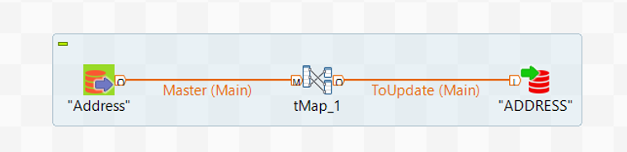

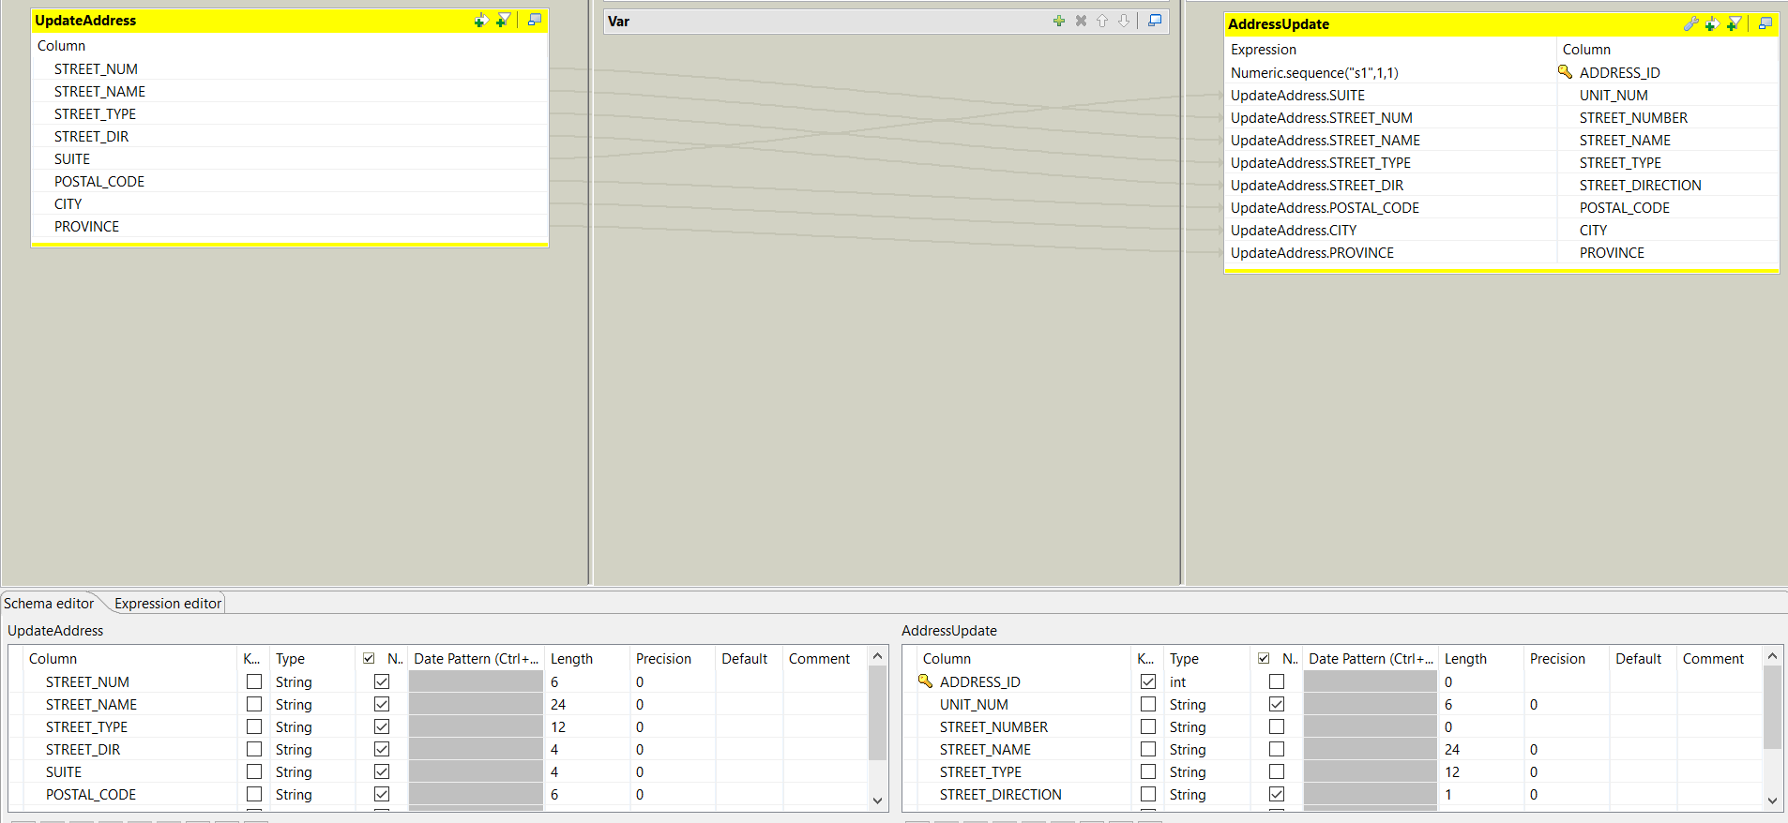

* Volunteer list integrated to Community database. Once again BigDecimal on GROUP_LEADER column was Change to integer and ID column was generated with increments of one, for uploading records into database.

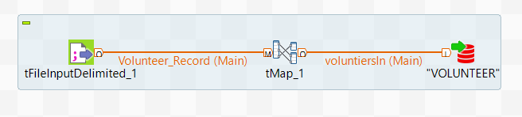

* Now that volunteer table has been updated, we proceeding to find the addresses id’s with help from the master database

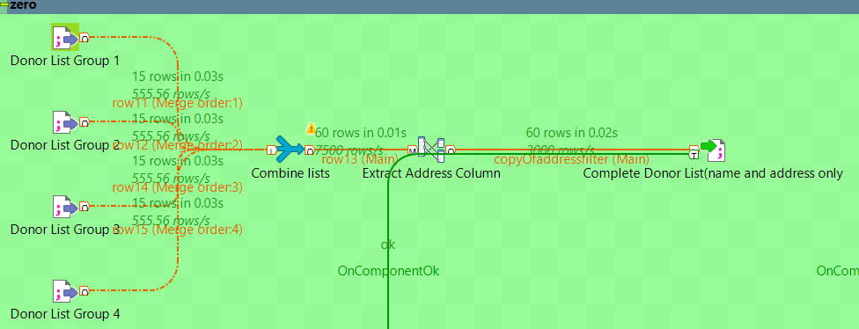

* Using a combine list we gather all the donors list together isolating the addresses.

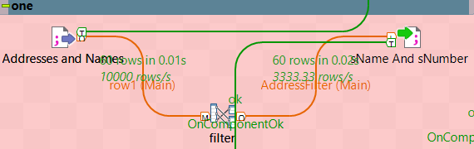

* Here, the number and the street name are filter

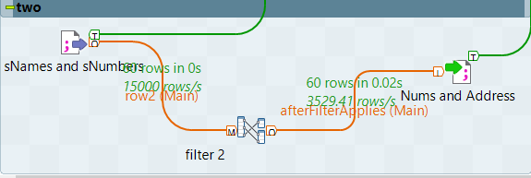

* After extracting the St. number and St. name to a file we proceed to given them their own columns for farther examination

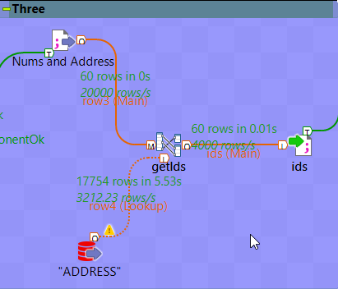

* By giving the street number and street name their own columns, we can now used them to find their ids by matching their contents with the content of the address table

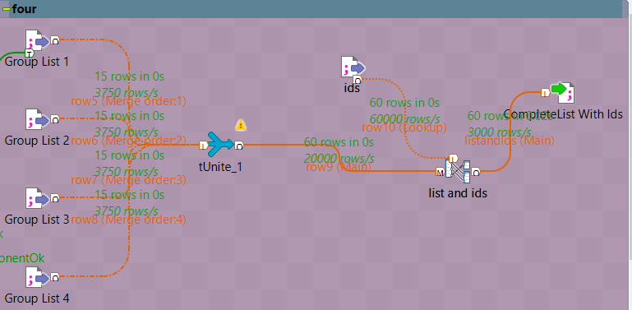

* Now the I got their ids. All I have to do is combined them with the original list forming a big blob for further procedures

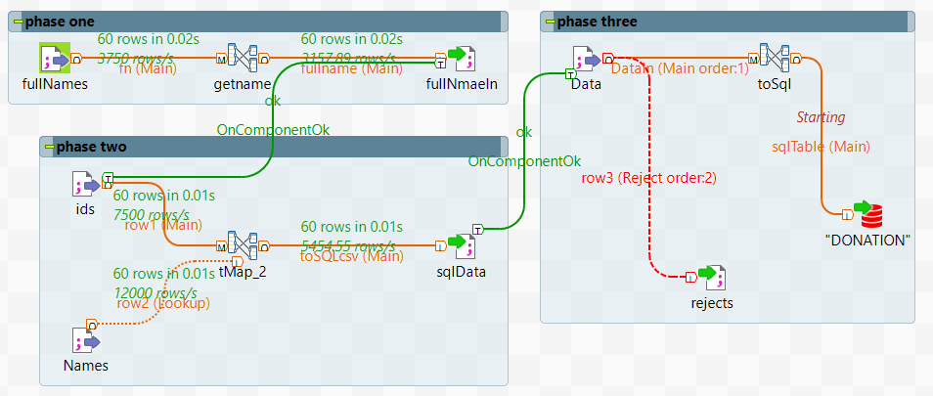

Phase one: takes the full name from the list of donors.

Phase two: takes the data from the donors list (the one with the address id’s) plus the file made by phase one and now we have all the data we need for our SQL entries.

Phase three: using the SQL entry file and creating a rejects option, Data is ready to go into the SQL table