**BASIC SECURITY**

Due to insufficient privileges on the class database, the security portion of the project was done on the local database created on week 11. The tables and views from the project does not exist in the local database so it must be copied from the class database. In order to do this, go to Tools and select ‘Database copy…’.

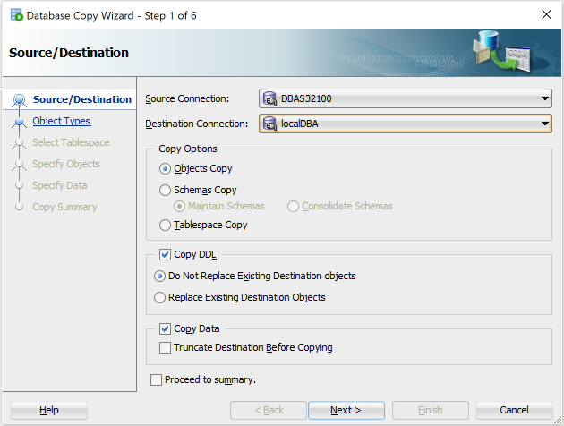

Set the Source Connection to the class database and Destination Connection to the local database. A database version warning window will pop up and click “Yes” to continue.

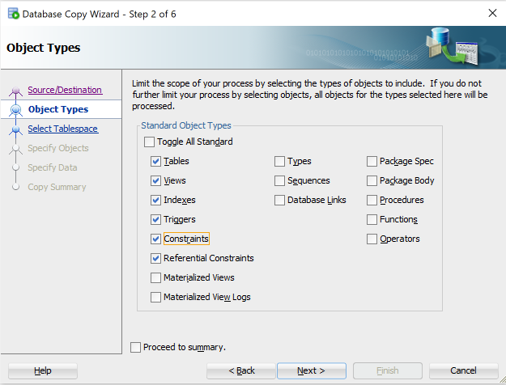

In the Object Types window, only select Tables, Views, Indexes, Triggers, Constraints, and Referential Constraints as shown above to limit the scope. In the next window, click on the “More…” button. Select “Table” from the drop down field of “Type” to filter the selection as shown in the image below.

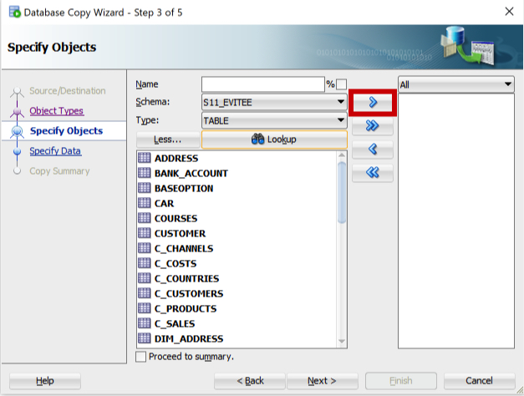

Select ADDRESS and click on the first arrow button (with red border) to move it to the adjacent text field. Do this again for DIM_ADDRESS, DIM_DATE, DIM_VOLUNTEER, DONATION, FACT_DON, and VOLUNTEER.

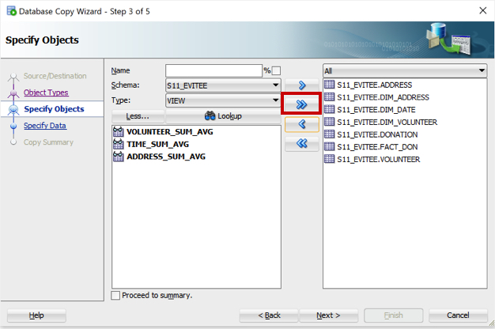

To transfer the views, set the Type drop-down field to “View” and click on the Lookup button. The three views will show up and to move them, click on the second arrow button (with red border) and then hit the “Next >” button.

In the next window (Specify Data), just click “Next >” and select “Finish” in the Copy Summary window to begin the process.

**Create users source code**

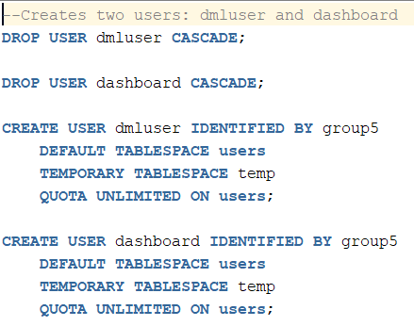

The first two lines of script drops any existing users named dmluser and dashboard. The word CASCADE was included to ensure even all of the objects are dropped. The next two statements creates new users: dmluser and dashboard with a password of “group5” for simplicity. A default tablespace for users and a temporary tablespace was created as well.

**Grant privileges to DMLUser and Dashboard source code**

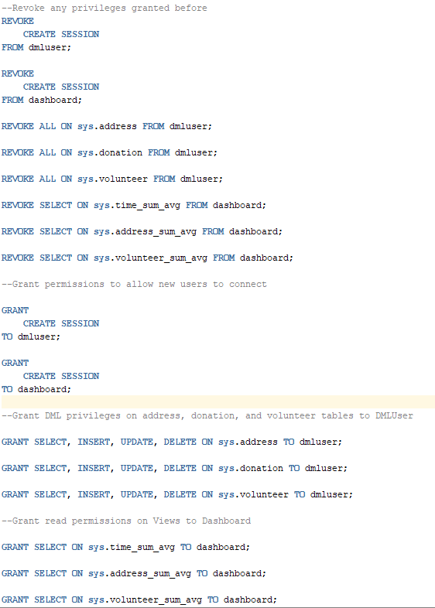

Revoke statements

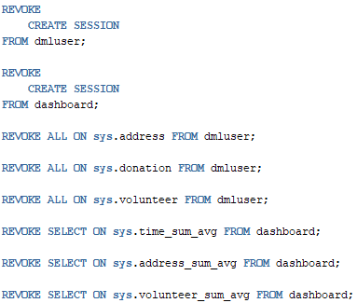

These statements were included in the script to ensure any existing privileges were revoked before running the next statements.

Grant create session

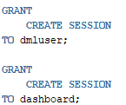

This system privilege must be granted to the new users so that they can connect to the database.

Grant DML privileges to DMLUser

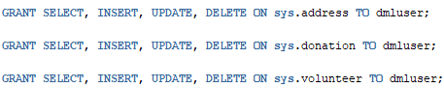

The object privileges were specified instead of using “all” to make sure only DML operations are granted to the address, donation, and volunteer tables.

Grant read permissions for Dashboard

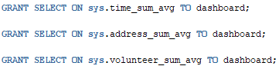

By granting the select object privilege on the views, Dashboard user can only read the views.