**The average and sum of the donation by day, month, year**

Source code of the view

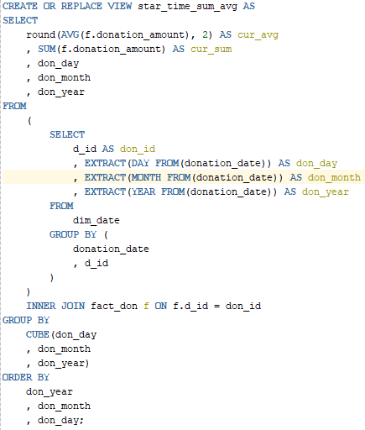

Fields Required

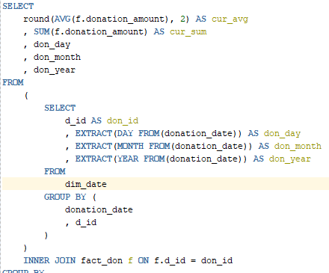

The sum and average of the donation amount is included as required. A subquery is made to get the day, month and year from the donation_date field which included all those values in one field, these field are separated so that the query results can be calculated by daily, monthly and yearly totals. d_id is included so that the subquery results (date results) can be connected to the fact_don table allowing access to the donation_amount

Group by Cube

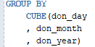Cube was used to calculate the subtotals by the donation day, month and year. The order of the cube sets the query to get subtotals first by the day, then calculate a monthly total and finally calculate a yearly total.

Order by

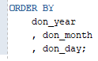The order by formats the output to sort by day, then month and finally year; all ascending (ex. 1, 1, 1990 – 12,2,2020)

**The average and sum of the donations by address, postal code**

Source code of the view

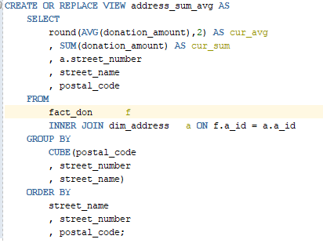

Fields Needed

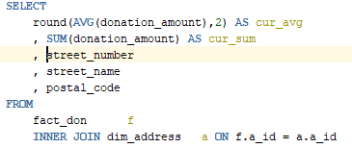

The average and sum of the donation amount is required for the view. Fact_don is joined to dim_address so that the fields of street_number, street_name and postal_code can be accessed.

Group by Cube

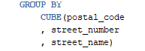Cube was used to calculate the subtotals by postal codes, street numbers, and street names. The order of the cube sets the query to get subtotals by postal code, by a street name and then the individual street houses / numbers.

Order by

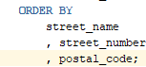 The order by is used to format the output, it will display divided by the street name, list the houses in order and then order them by postal codes

**The average and sum of the donations by volunteer and volunteer group leader**

Source code of the view

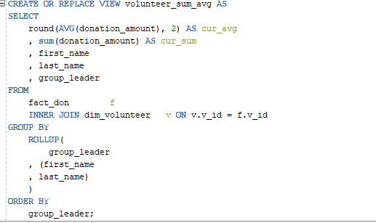

Fields needed

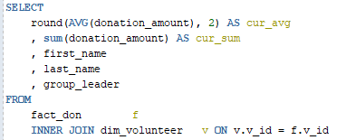

The sum and average of the donation amount is required, this is gathered from the fact_don table. The volunteer table is joined to fact_don so that first and last names and the group leader ID can be included

Group by Rollup

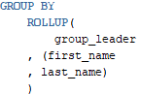Rollup was used to calculate the subtotal donations received by individuals (i.e. John Smith) and the subtotal of their group. Cube wasn’t used here since only the individual and group subtotals were required whereas cube would’ve produced tabulated data that isn’t needed here.

The order of the rollup sets the query to divide by volunteer groups (gets the group subtotal), then divide by volunteer name (individual subtotals)