Sample Data

Campus

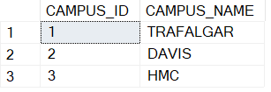

Wing - Trafalgar

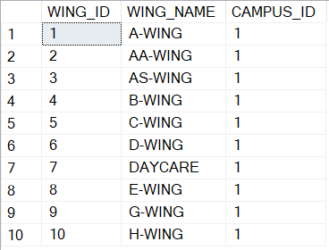

Floor_Level (floors specific to a school wing) – S-Wing

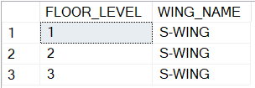

Rooms – partial of S-Wing, 2nd floor