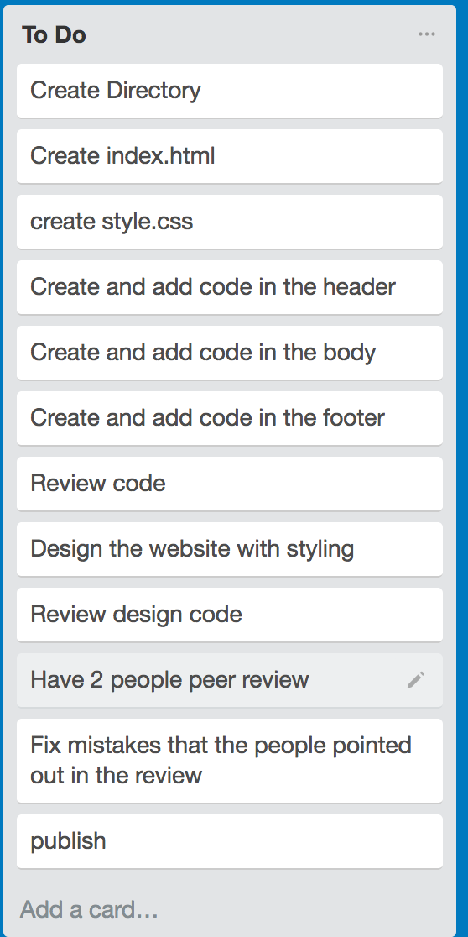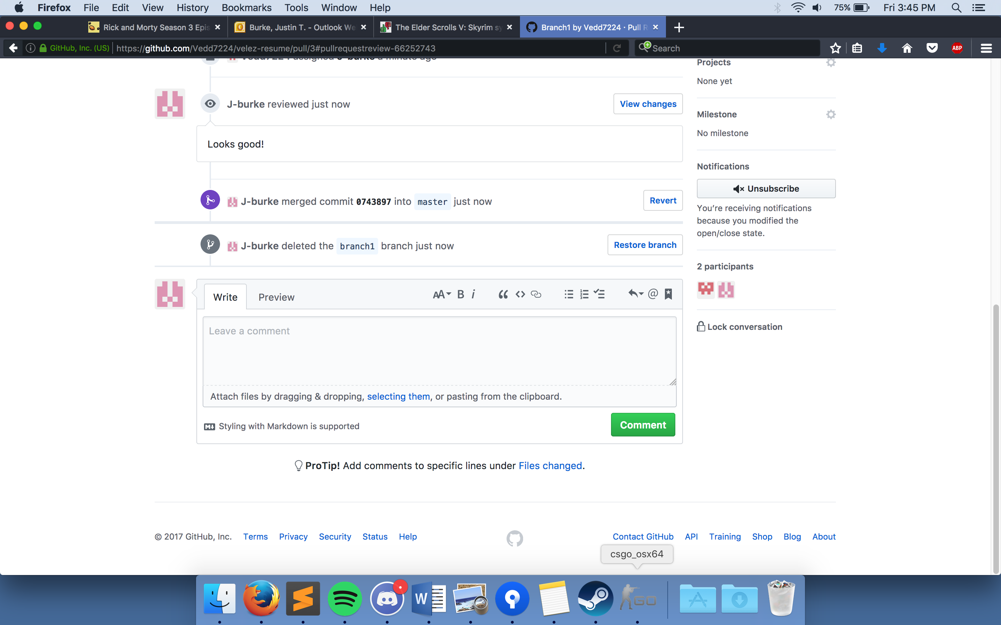

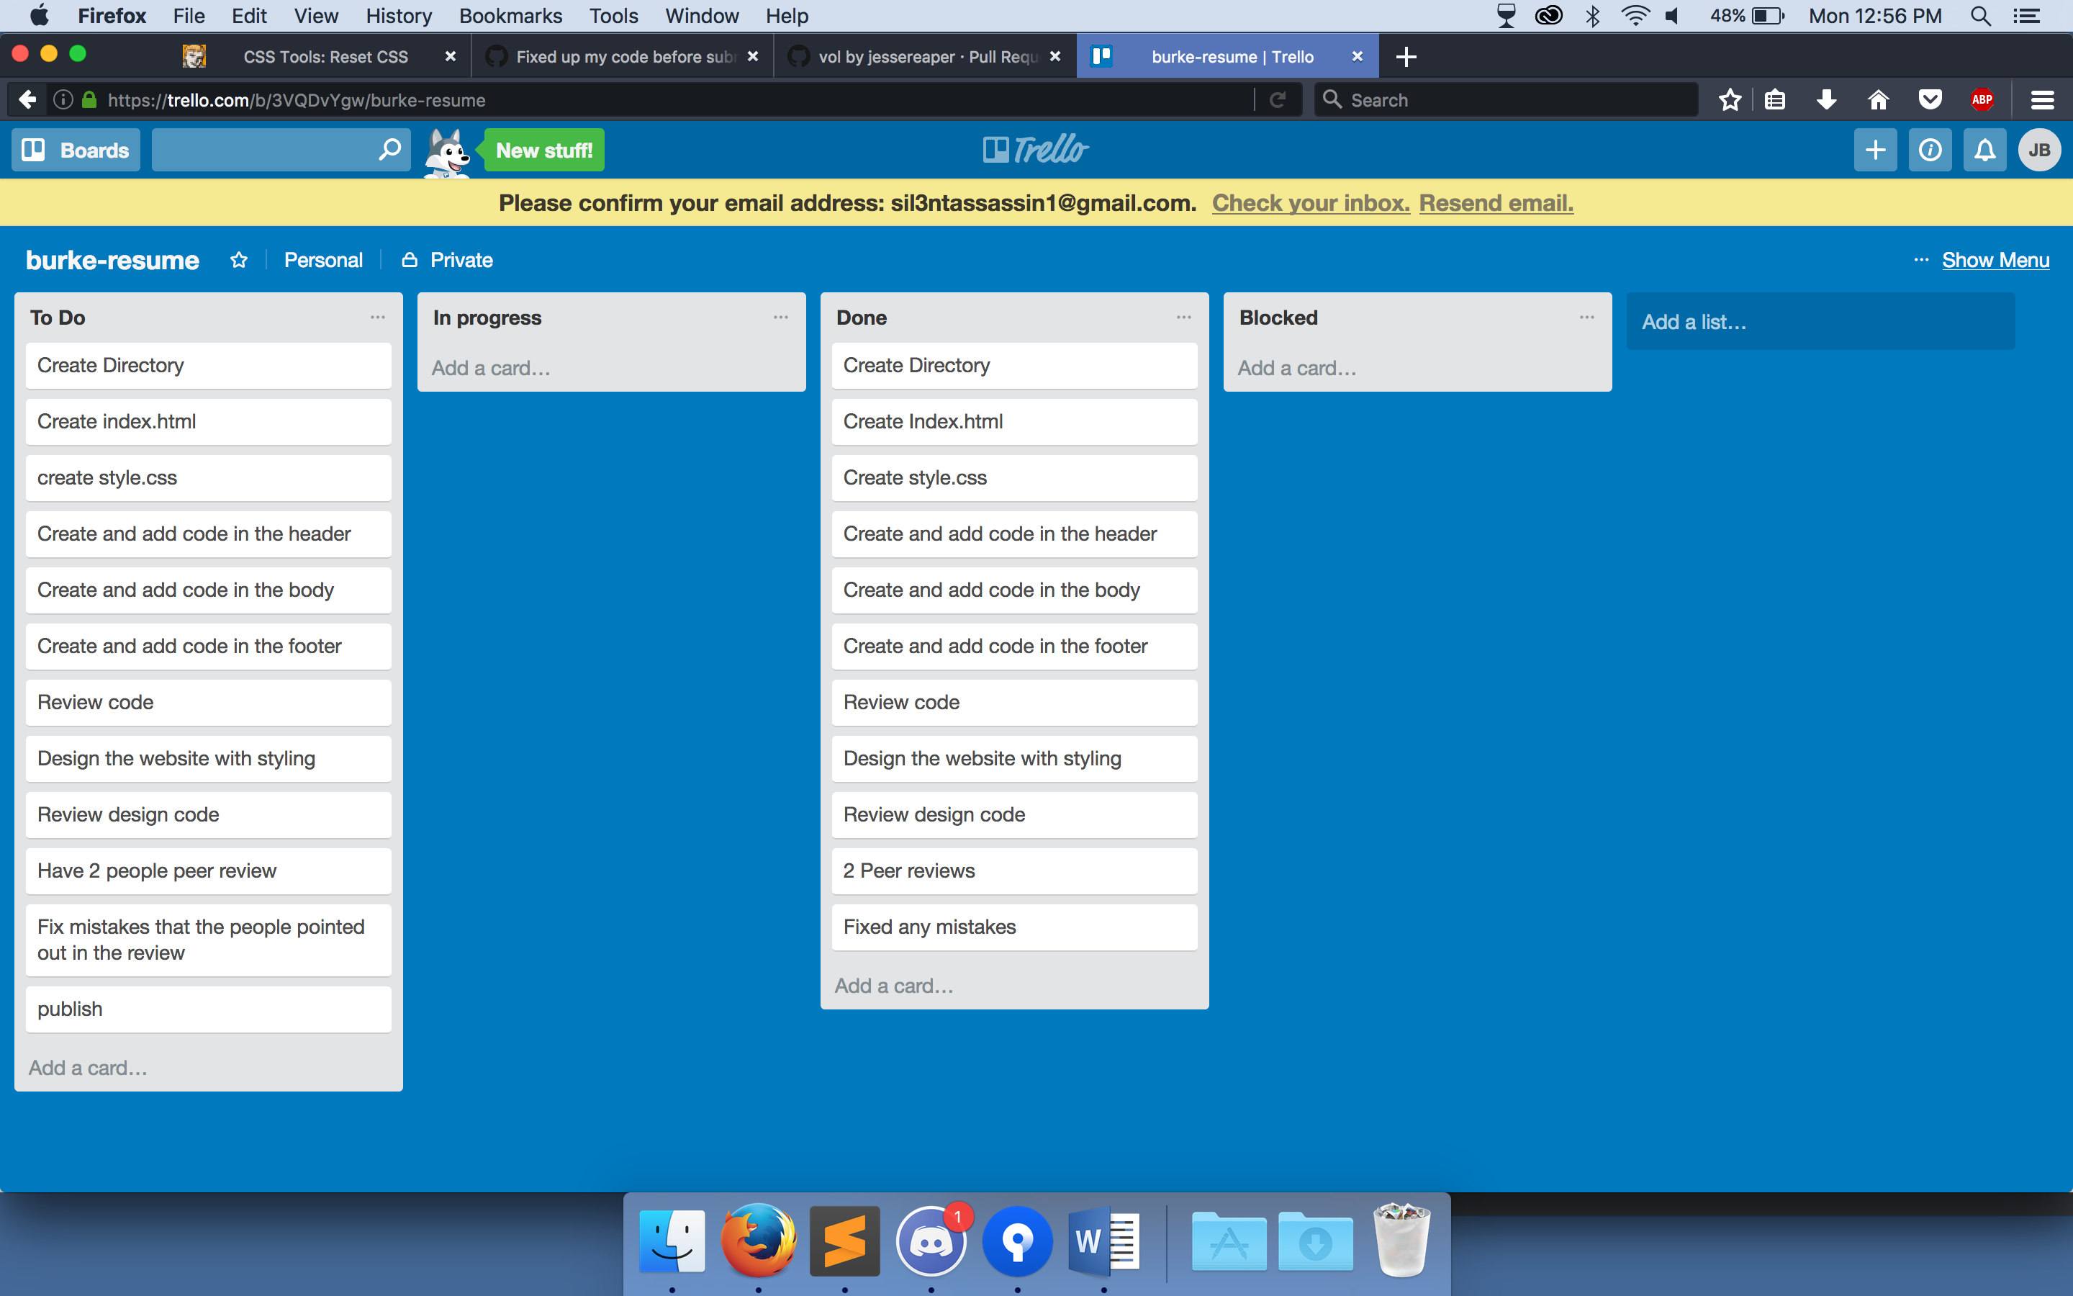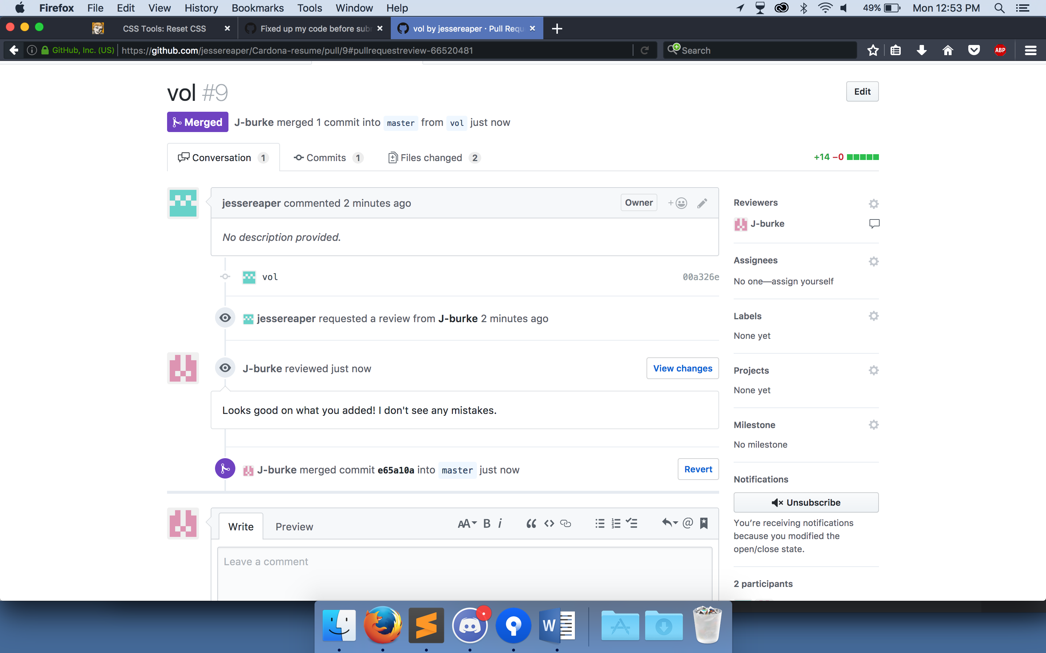

Reflect: Working in a team like this was not too bad everyone did there own thing and would only talk to each other when they needed a preview or help in there code. The downside would be not talking as much as I think we should. A lot of the people on the team waited till the day before it was due to start on it causing them to rush through the project. I did make the mistake of doing my own merge requests at 1am due to no one in my team being up at that time.