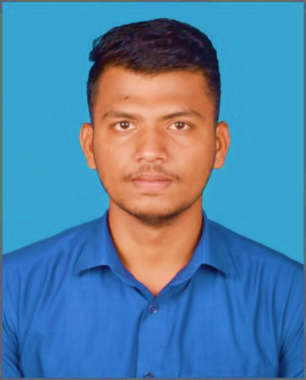62

**Trainings:**

* **Google Analytics for Advanced**

Google

* **Responsive Web Designing**

Freecodecamp.org

* **Microsoft AI AzureFundamentals**

Microsoft

* **Process mining**

Celonis

* **Cyber Security Essentials**

Cisco

* **Network Virtualization Concepts**

VMcare

* **Image Processing Onramp**

Matlab

**LinkedIn:**

[**https://www.linkedin.com/in/deena-dhayalan-a3bbab189**](https://www.linkedin.com/in/deena-dhayalan-a3bbab189)

**E-mail :** dhayalandeena0050@gmail.com

**Educational Background:**

**SRI KALISWARI COLLEGE (**AUTONOMOUS**)**

**Bachelor of Computer Application**

2019-2022

**KCAD Chidambaram Gnana. HR&Sec, School**

High School studies, Class of 12th

2018-2019

**Deenadhayalan** J

**Address:** 460,Melagandhi Nagar

Sattur-626203

**Github :**  [**https://github.com/Deena0050**](https://github.com/Deena0050)

**Internships:**

**Campus Business Manager**

**At Prepbytes.co**

**Oct 2020-May2021**

**On Job Training (Billing Management)**

**At, The Saravana Textile’s**

**July2021-Aug2021**

To work proactively as a programmer in the company, with stable personality, good interpersonal relations, good communication and better coordination skills, strong sense of responsibility, good team spirit, not afraid of difficulties, dare to meet challenges, for new things to accept the ability to be strong, life and work attitude positive, hope to improve their own continuous progress.

**SELF-EVALUATION**

* DOT NET
* My sql
* JavaScript
* CSS
* C Programming
* C++ Programming
* Python
* PHP
* PHP

**Skills:**

**Phone:** 9344154552