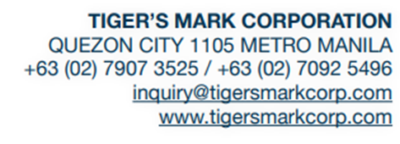

**MEMORANDUM**

DATE: February 7, 2023

TO: Prince Dave Hipolito

FROM: Tigers Mark Management

SUBJECT: Insubordination Warning

Dear Mr. Hipolito,

This letter is issued to notice to explain, it has been reported against you. These are the complaints against you;

* You do not submit a Daily Progress Report (DPR) and your last submission was on January 13, 2023, lack of coordination (your not sending daily progress like photos/videos of Site) – the Admin do the reporting instead of Project Site Engineer.
* You are inactive on Viber (it takes a long time before you response).
* You do not log-in and log-out on the Site - logbook.

Although serious measures could have been taken against you for your insubordination, you are being given a chance to notice to explain, and we hope you will be more cautious in the future. You have been issued a warning.

Sincerely yours,

Anabelle Carpio

HR Admin