PROJECT CHARTER

Da'atSNA Community Data Platform
Version 1.0 | 2026-01-01 – 2026-12-31

1. EXECUTIVE SUMMARY
Da'atSNA Community Data Platform is sponsored by Dr. James Okello, Project Sponsor — Min. of Health and managed by Sarah Nakato. Enable every community health worker in Uganda to access trusted, interoperable patient data through a secure national platform.

2. PROJECT OVERVIEW
Field | Value
Project Name | Da'atSNA Community Data Platform
Project Sponsor | Dr. James Okello, Project Sponsor — Min. of Health
Project Manager | Sarah Nakato
Department/Division | Digital Health Innovations
Start Date | 2026-01-01
End Date | 2026-12-31

3. VISION & OBJECTIVES

3.1 Vision Statement
Enable every community health worker in Uganda to access trusted, interoperable patient data through a secure national platform.

3.2 Mission Statement
Design, build, and deploy the Da'atSNA Community Data Platform connecting clinics, NHIS, and ministry systems within 12 months.

3.3 SMART Objectives
ID | Objective | Measurable Criteria
OBJ-01 | Deliver FHIR-compliant data exchange between 50 pilot clinics | 50 clinics live by Q4; 99% uptime SLA
OBJ-02 | Reduce patient record retrieval time for CHWs | Median query time under 2 seconds
OBJ-03 | Train 200 community health workers on the platform | 200 certified users; 80% adoption in pilot districts

4. SCOPE

4.1 In-Scope
- FHIR API gateway and patient demographics module
- Clinic onboarding portal and CHW mobile interface
- Integration with NHIS billing endpoints
- Training program and operational runbooks

4.2 Out-of-Scope
- Payroll and HR systems
- Legacy paper record digitization backlog
- National e-prescription rollout (Phase 2)

4.3 Boundaries
Platform terminates at approved ministry firewall endpoints; clinics connect via VPN or approved cloud links.

4.4 Scope Diagram
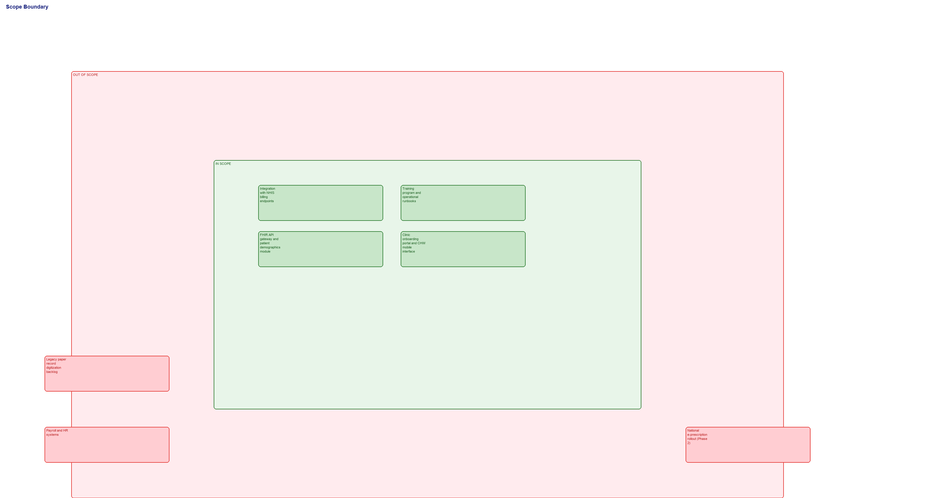
Figure 1: Scope Boundaries

5. STAKEHOLDERS

5.1 Stakeholder Register
ID | Name | Role | Organization | Power | Interest
SH-01 | Dr. James Okello | Project Sponsor | Min. of Health | High | High
SH-02 | Dr. Sarah Nambi | Policy Maker | Min. of Health | High | Low
SH-03 | NHIS Leadership | Insurance Partner | NHIS | High | High
SH-04 | District Health Officers | Regional Coordinators | Regional Health Offices | Low | High
SH-05 | Community Health Workers | End Users | Pilot Clinics | Low | High

5.2 Stakeholder Matrix
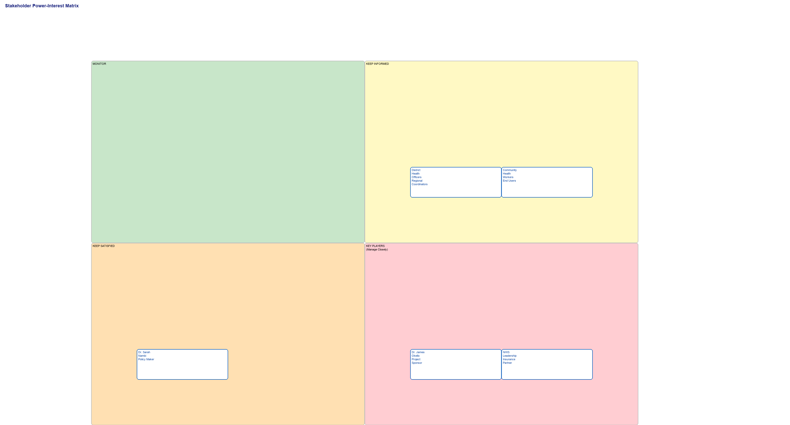
Figure 2: Power-Interest Matrix

6. SYSTEM CONTEXT
System context diagram (when provided).

7. PROJECT ORGANIZATION

7.1 Team Structure
ID | Name | Role | Reports To
SPONSOR | Dr. James Okello | Project Sponsor | —
PM | Sarah Nakato | Project Manager | SPONSOR
TL-TECH | David Mukasa | Technical Lead | PM
TL-QA | Grace Achieng | QA Lead | PM
BA-01 | Peter Okello | Business Analyst | PM

7.2 Org Chart
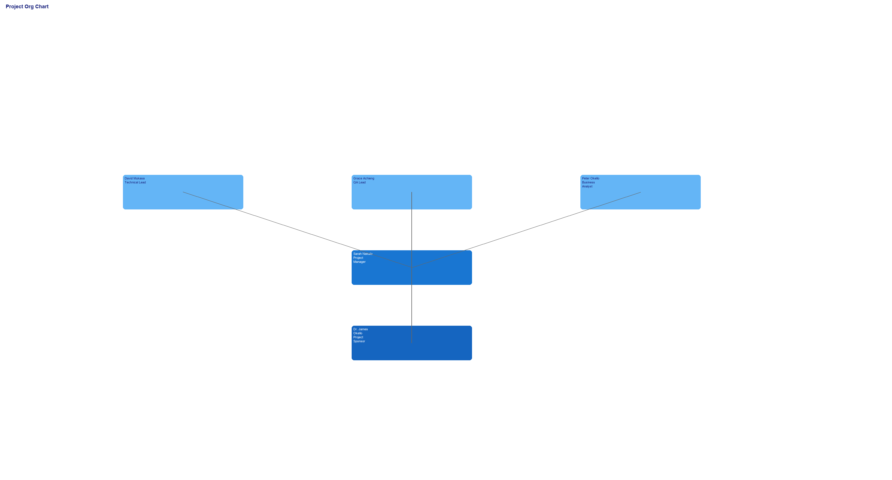
Figure 3: Project Organization

8. CONSTRAINTS & ASSUMPTIONS

8.1 Constraints
- Must comply with Uganda Data Protection and Health Information regulations
- Total budget capped at USD 59,400 for Phase 1
- All production releases require sponsor sign-off

8.2 Assumptions
- Existing NHIS APIs remain stable through project duration
- Pilot clinics provide dedicated IT liaisons
- Cloud infrastructure procured within first 60 days
- Ministry security review completes before go-live

9. RISKS

9.1 Risk Register
ID | Risk | Likelihood | Impact | Mitigation
RSK-01 | NHIS API changes break billing integration | 3 | 4 | Maintain adapter layer; monthly API compatibility review with NHIS
RSK-02 | Clinic connectivity delays pilot rollout | 4 | 3 | Pre-site surveys; backup mobile hotspot kits for 10 clinics
RSK-03 | Security audit findings delay go-live | 2 | 5 | Early penetration test in Q2; remediate findings before UAT

9.2 Problem Tree Analysis
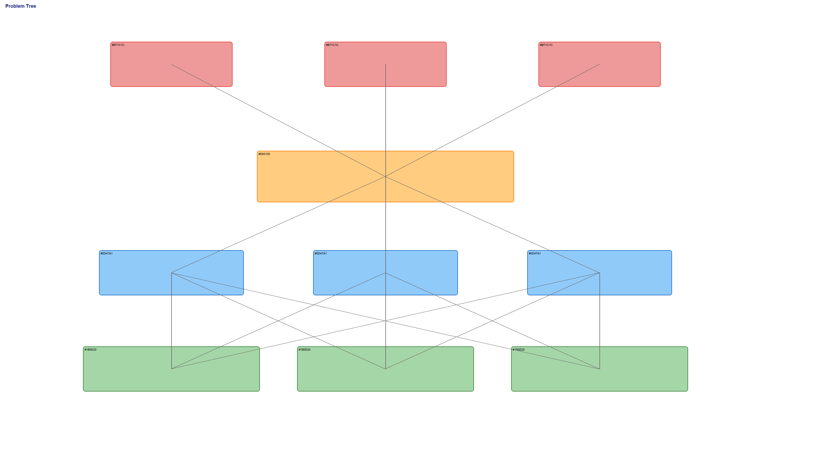
Figure 4: Problem Tree

9.3 Risk Matrix
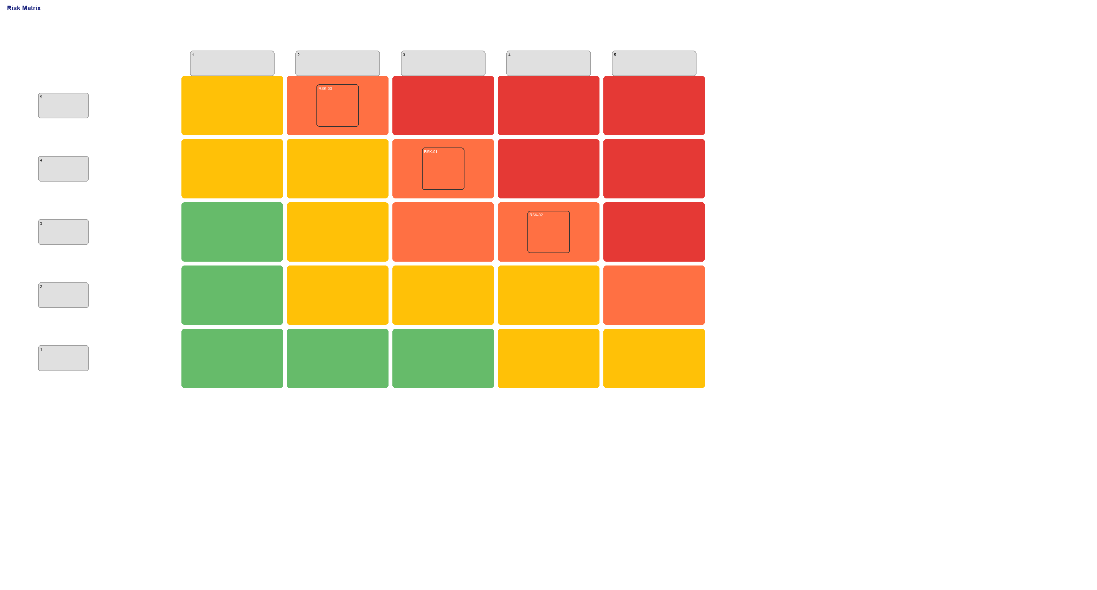
Figure 5: Risk Matrix

10. MILESTONES

10.1 Milestone Schedule
ID | Milestone | Date | Deliverable
M1 | Project Kickoff | 2026-01-01 | Charter approved; team mobilized
M2 | Architecture Sign-off | 2026-03-15 | Solution architecture and security baseline approved
M3 | Pilot Go-Live | 2026-09-01 | 10 clinics live on platform
M4 | Phase 1 Complete | 2026-12-15 | 50 clinics connected; training complete

10.2 Timeline
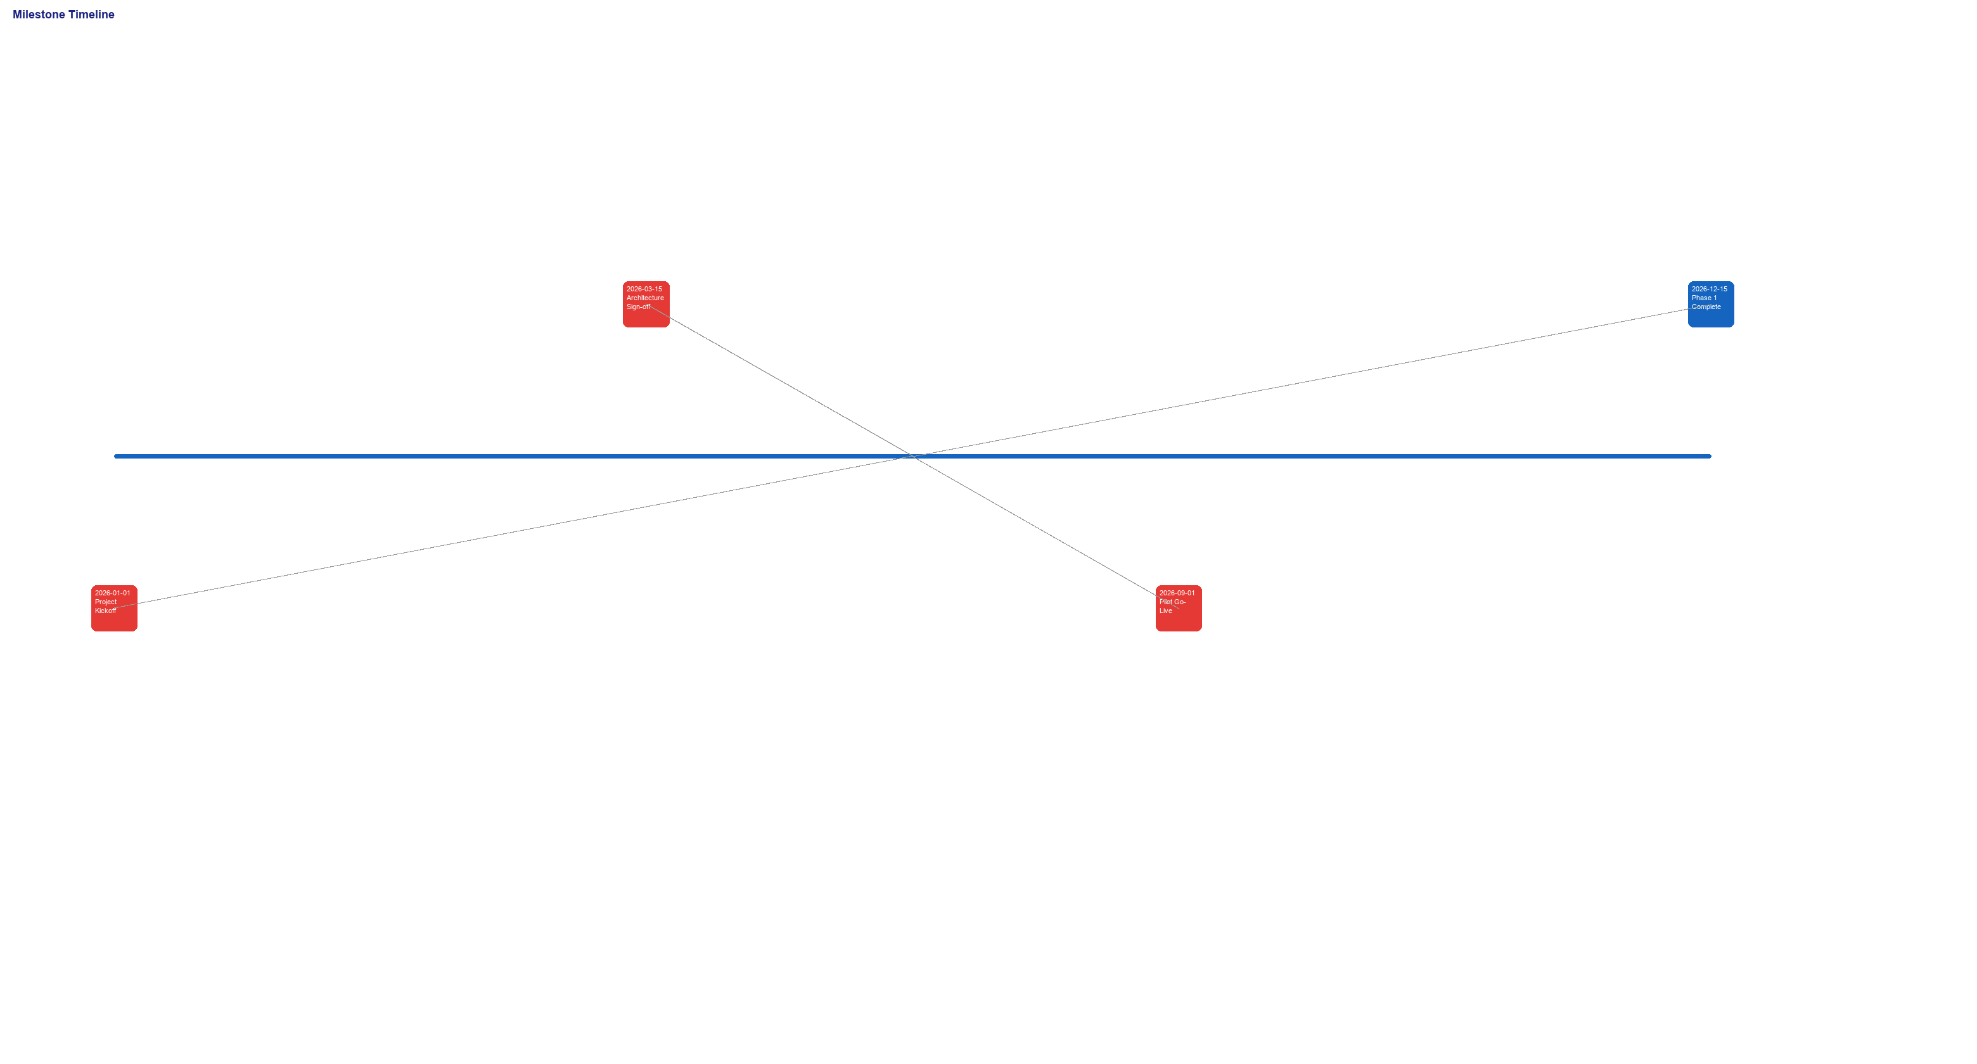
Figure 6: Milestone Timeline

11. BUDGET
Category | Amount (USD)
Personnel | 31,000
Hardware | 18,500
Software | 1,500
Training | 3,000
Contingency | 5,400
TOTAL | 59,400

12. SUCCESS CRITERIA
- 50 clinics connected with verified data exchange
- Median record retrieval under 2 seconds
- 200 CHWs trained and actively using the platform
- Zero critical security findings at go-live audit

13. APPROVALS
Role | Name | Signature | Date
Project Sponsor | Dr. James Okello |  | 2026-01-05
Project Manager | Sarah Nakato |  | 2026-01-05

