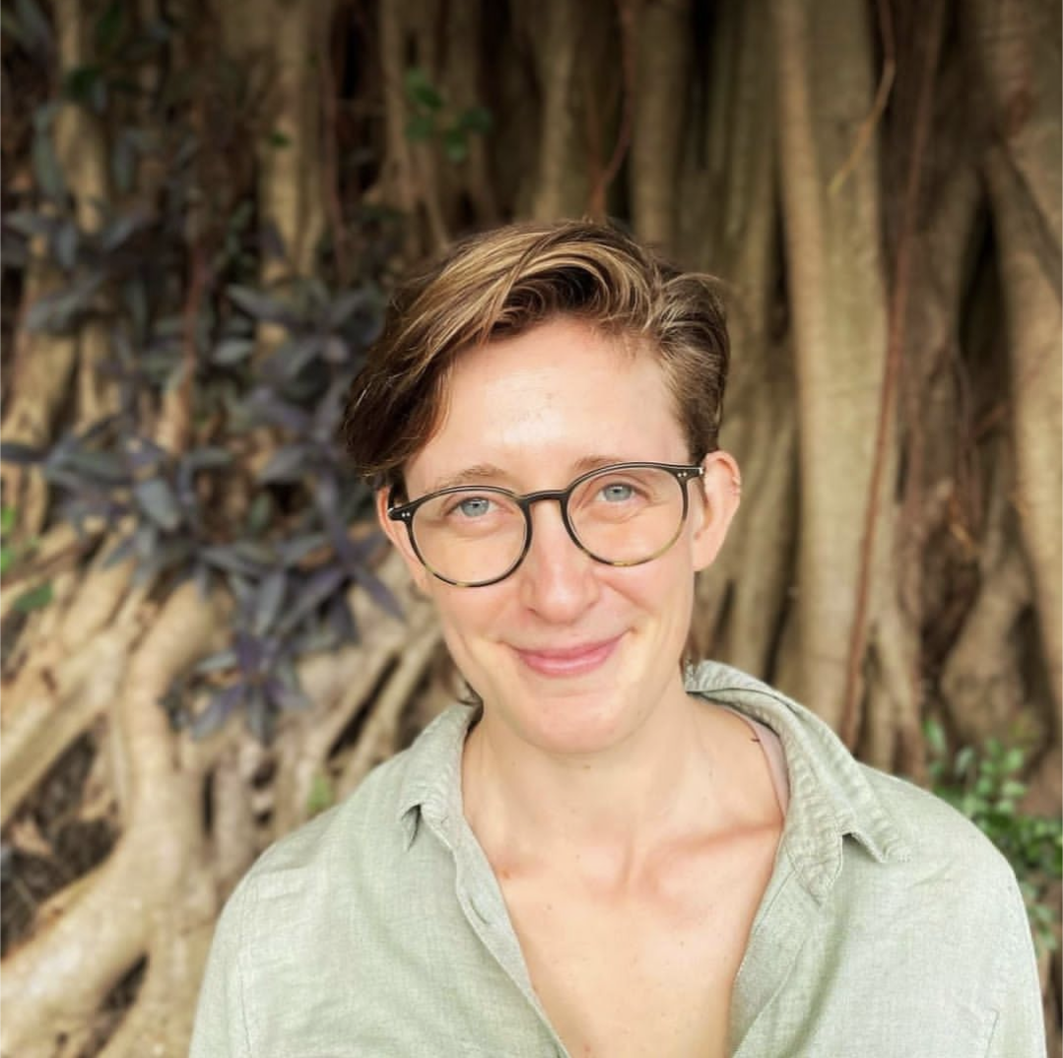

Cognitive Neuroscience/Sociolinguistics

**Jen Lewendon**

**DIPLOMAS Y HOBBIES**

**Formaciones :** Diplomados, Congresos, xxxxxxxxxx xxxxxx xxxxxxxxx xxxxxxxxxxxxxxxxx

**Hobbies:** xxxxxxxxxxxxxxxxxxxxxxxxxxxxxx



<https://j-lewen.github.io/>

**PROFILE**

**EDUCATION**

My research interests lie at the intersection of cognitive neuroscience, linguistics, and social psychology, with a specific focus on unraveling the intricacies of speech processing beyond the purely linguistic content. Moreover, I am deeply intrigued by the complexities of bi-/multilingualism and the cognitive mechanisms that underpin language activation and interaction in individuals proficient in multiple languages. Through my work, I am also dedicated to advancing our understanding of language-related ERP as a methodology, and improvements in research, reporting, and reliability in the field.

01/09/2016

10/01/2020

Bangor, Wales

**Cognitive Neuroscience – Bilingualism (PhD)**

Bangor University: Psychology Dept.

**Thesis:** *Two languages, one mind: How accent and lexical stress modulate bilingual language activation.* Supervised by Prof. Guillaume Thierry.

**Public Health – Epidemiology (PGDip)**

Warwick University: Warwick Medical School

**Grade:** Distinction.

**Education (PGCE)**

Wolverhampton University – Education Dept.

**Grade:** Good

**English Language & Linguistics (BA)**

Bangor University: Linguistics Dept.

**Grade:** First Class (Hons)

01/09/2015

01/09/2016

Warwick, UK

01/09/2014

01/09/2015

Wolves, UK

01/09/2011

01/09/2014

Bangor, Wales

**EMPLOYMENT**

**New York University (AD)**

Postdoctoral Fellow (2-year fellowship)

**Project:** *Social Cognition & its Electrophysiological Correlates.*

**Hong Kong University**

Temporary Lecturer

**Role:** Course creation, delivery & assessment for Research Methods & Statistics (Speech- Language Pathology BSc 2nd year).

**Hong Kong Polytechnic University**

Postdoctoral Fellow (2-year award)

**Project:** *The Phonological Mapping Negativity: Authenticity, & functional sensitivity.*

01/03/2023

To-date

Abu Dhabi, UAE

01/04/2021

01/03/2023

Hong Kong

01/10/2022

01/03/2023

Hong Kong



**RESEARCH GRANTS**

2023 Hong Kong Polytechnic General Research Fund

Co-I HKD ***$250,000***

2021 Hong Kong Polytechnic International Collaboration Fund

Co-I HKD ***$146,525***

2019 Santander Mobility Grant

PI GBP ***£1000***

2019 Economic & Social Research Council Fieldwork Grant

PI GBP ***£2270***

UK Citizen

Jal9590@nyu.edu

Abu Dhabi, UAE

+971 58585 2245

**Lewendon, J**., Lin, J., Politzer-Ahles, S.J. (Submitted) Unconscious categorisation of L2 concepts may be based on the native semantic network, *PNAS.*

**Lewendon, J**., Britton, J., Politzer-Ahles, S.J. (under review) The ‘Phonological?’ Mapping Negativity – language specificity of auditory ERP responses. *PLOS ONE.*

Vari, J., **Lewendon, J**. (under review) Studying implicit automatic language attitudes: Methodological challenges of the Affective Priming Paradigm. *Language & Communication.*

**Lewendon, J**., Egan, C., Politzer-Ahles, S.J. (under review) A systematic approach to ERP methodological quality assessment: the Event-Related Potential Quality Assessment List. *Psychophysiology.*

**Lewendon, J**. (2023). ERP Training Resources. https://j-lewen.github.io/erp/.

**Lewendon, J**., Britton, J., Poliltzer-Ahles, S.J. (2023) The MMN by another name? Exploring the assumed autonomy of the Phonological Mapping (Mismatch) Negativity. *Language Cognition and Neuroscience.*

**Lewendon, J**., Mortimore, L., & Egan, C. (2020). The phonological mapping (mismatch) negativity: History, inconsistency, and future direction. *Frontiers in Psychology*, *11*, 1967.

**Lewendon, J**., Foltz, A., & Thierry, G. (2020). Electrophysiological Differentiation of the Effects of Stress and Accent on Lexical Integration in Highly Fluent Bilinguals. *Brain Sciences*, *10*(2), 113.

**Lewendon, J**. Xu, C., & Yao, Y. (submitted) Processing gender-related stereotypical violations in spoken sentences of Mandarin Chinese. *Linguistic Society of America (LSA)*, New York.

**Lewendon, J**., Lin, J., Politzer-Ahles, S.J. (accepted) Unconscious categorisation of L2 concepts may be based on the native semantic network. *The European Society for Cognitive Psychology (ESCOP)*, Portugal.

**Lewendon, J**., Egan, C., & Politzer-Ahles, S.J. (2022). The Event-Related Potential Quality Assessment List (EQuAL): a framework for systematic review and meta-analyses. *Cognitive Neuroscience Annual Meeting (CNS), San Francisco.*

**Lewendon, J**., Egan, C., & Politzer-Ahles, S.J. (2021). Developing a tool for systematic review of ERP literature. *Language Neurobiology Group*, Hong Kong Polytechnic University.

Maquate, K., Schliewe, K., **Lewendon, J**., & Knoeferle, P. (2020) Lexical versus compositional World-Language Relations: Event-Related Brain Potential effects during Second Language Processing *33rd Annual CUNY Human Sentence Processing Conference.* Massachusetts, USA.

Maquate, K., Schliewe, K., **Lewendon, J**., & Knoeferle, P. (2020) *Event-related brain potent effects of actions and role relations during second language picture-sentence verification. Cognitive Neuroscience Society (CNS).* Boston, USA.

**Lewendon, J**., Foltz, A., & Thierry, G. (2019). *Accent and Bilingualism.* Language, Literatures & Linguistics Research Series. University of Bangor.

**Lewendon, J**., Foltz, A., & Thierry, G. (2019). The role of native accent in unconscious L1 access*.* Humboldt-Universität zu Berlin, Dept. of German Studies and Linguistics, Berlin.

**Lewendon, J**., Foltz, A., & Thierry, G. (2018). Does stress close the language gate? Inhibition of unconscious L1 activation. *24th Annual AMLaP Conference*, Berlin, Germany.

**Lewendon, J**., Foltz, A., & Thierry, G. (2018). Lexical stress and unconscious L1 activation. *Cognitive Neuroscience of Second and Artificial Language Learning*, Bangor, UK.

**Lewendon, J**., Foltz, A., & Thierry, G. (2018) Stress & accent within an integrated lexicon: Influences on implicit priming. *Phonetics Group & Laboratory.* University of Zurich, Switzerland.

Manuscript available on request

**PUBLICATIONS**

In prep1

Under review

Published

**CONFERENCES & TALKS**

**Lewendon, J**., Egan, C., & Politzer-Ahles, S.J. (in prep ) The Phonological Mapping Negativity: A Systematic Review. Pre-registration available: [here](https://osf.io/u35xk/?view_only=76c57b6198f5477b9a9fd5c780cb374b).

**Lewendon, J**., Britton, J., Yao, Y., Politzer-Ahles, S.J. (in prep) Neurotypical integration of speaker characteristics: how does the timeline of pragmatic mapping unfold? Targeted journal: Psychophysiology.



`

First supervision –Wang Masie – MA Linguistics – Bangor University - 2019-2020

Joint supervision – Jonathan Culkin – MA Linguistics – Bangor University - 2019-2020

Joint supervision – Xu Chenxi – BA Language and Speech Sciences – PolyU - 2022-2023

Journal of Language & Conflict

Journal of Psychology & Sexuality

Social Psychological Bulletin. Special Issue: *The gendered language (r)evolution: new insights into the interaction between gender and language*.

Moving laboratory: Science during the pandemic. (2022). Nature Careers. https:// [www.nature.com/articles/d41586-022-04396-8](http://www.nature.com/articles/d41586-022-04396-8)

Lewendon, J. (2021) Trapped in a hotel room: my scientific life in the pandemic. Nature, 600(7889), 559-560.

Cognitive Neuroscience of Second and Artificial Language Learning Conference (2019). Bangor University, UK.

3rd bi-annual Second Language Prosody Workshop (2017). Bangor University, UK.

**Postgraduate**

**Undergraduate**

**Ad-hoc Reviewing**

**Editorial Board**

**Podcasts & Articles**

**Conference Organization Committee**

**STUDENT SUPERVISION**

* Joint supervisor – Xu Chenxi – BA Language and Speech Sciences – 2022-to-date
* First supervisor –Wang Masie – MA Linguistics – 2019-2020
* Joint supervisor – Jonathan Culkin – MA Linguistics – 2019-2020
* Joint supervisor – Nicky Jones – RA internship – 2019-2020
* Joint supervisor – Xu Chenxi – BA Language and Speech Sciences – 2022-to-date
* First supervisor –Wang Masie – MA Linguistics – 2019-2020
* Joint supervisor – Jonathan Culkin – MA Linguistics – 2019-2020
* Joint supervisor – Nicky Jones – RA internship – 2019-2020

* Joint supervisor – Xu Chenxi – BA Language and Speech Sciences – 2022-to-date
* First supervisor –Wang Masie – MA Linguistics – 2019-2020
* Joint supervisor – Jonathan Culkin – MA Linguistics – 2019-2020
* Joint supervisor – Nicky Jones – RA internship – 2019-2020
* Joint supervisor – Xu Chenxi – BA Language and Speech Sciences – 2022-to-date
* First supervisor –Wang Masie – MA Linguistics – 2019-2020
* Joint supervisor – Jonathan Culkin – MA Linguistics – 2019-2020
* Joint supervisor – Nicky Jones – RA internship – 2019-2020

**SERVICES TO THE ACADEMIC COMMUNITY**

01/10/2022

01/03/2023

Hong Kong University

01/09/2020

01/01/2021

Bangor University

01/09/2020

01/02/2021

Bangor University

01/01/2019

01/05/2019

Bangor University

01/09/2018

01/01/2018

Bangor University

01/01/2017

01/05/2017

Bangor University

01/01/2016

01/05/2016

Bangor University

**Research Methods & Statistics**

Speech-Language pathology BSc (2nd year)

**Role:** Course creation, delivery & assessment

**Brain & Language**

Psychology BSc (3rd year)

**Role:** Course delivery

**Language Impartments & Bilingualism**

Linguistics MA/MSc

**Role:** Course creation, delivery & assessment

**Sounds & Sound systems**

Linguistics BA (2nd year)

**Role:** seminar/tutorial delivery

**Brain & Mind**

Psychology BSc (1nd year)

**Role:** Practical anatomy lead

**Meaning & Mind**

Linguistics BA (2nd year)

**Role:** Course co-creation, delivery & assessment

**Introduction to Linguistics**

Linguistics BA (1st year)

**Role:** Course co-delivery & assessment

**TEACHING ACTIVITIES**