

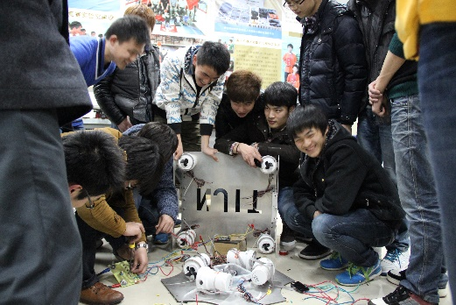Our company is called Deep-Sea Explorer. We are from Nanjing Institute of Technology, a famo­­us university in Nanjing, Jiangsu Province, China. It is a really long way from Nanjing to Seattle; about 13417km. Actually, it is our first time to participate in such a large international competition like this. Our team members’ grade level is very wide, ranging from freshman to senior.

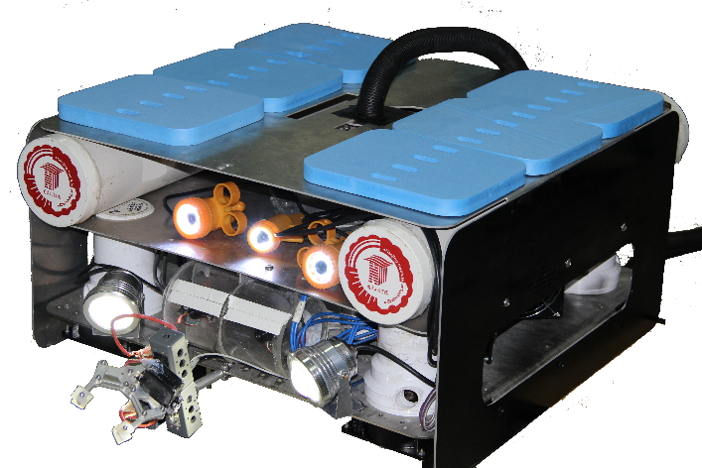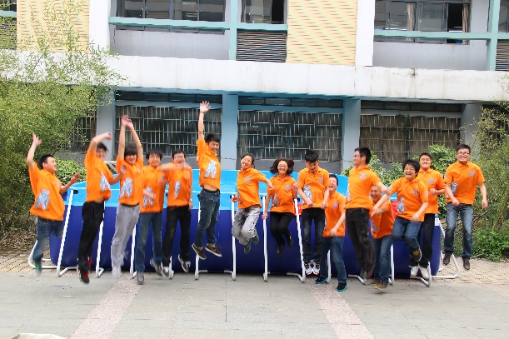Our ROV has a very inspiring name---Pioneer, whose total expense is about fifty thousand Yuan (US﹩6250) with the size of 0.6m\*0.6m\*0.32m. He is mostly made of aluminum, a kind of good design materials with the properties of lightness, durability and cost efficiency, which can best meet the needs of the design. We use steel to construct the bottom of our ROV to make his gravity lower for better self-balance. Besides, we use PVC as keg floats to keep Pioneer move freely. At the same time, we use acrylic at some certain places for waterproof the camera. The design of safety features are that each electric circuit includes fuses and we have warning sign in the dangerous places (such as: high voltage line and low voltage line). Our main feature of design is self-balance. In order to meet the balanced design of the robot, the equilibrium structure design and algorithm design are its two complementary aspects. This can do greater help to make the gravity relatively stable during the completion of the tasks.