

JAVA 3

Portfolio



June 23, 2021

Sang Joon Lee

30024165

# Java 3Project

## Introduction

This final project is to make Music Player that allows the ability to sort and search the songs stored in a binary tree, the GUI should display the sorted list. And this player should save and load the track list to/from a CSV file using a 3rd party library.

## design specification document

### UML

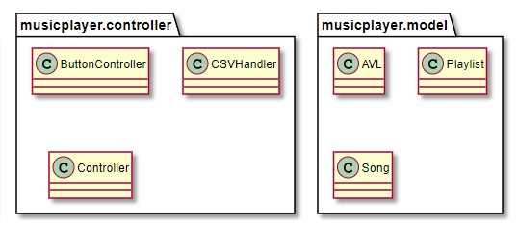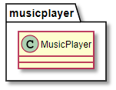

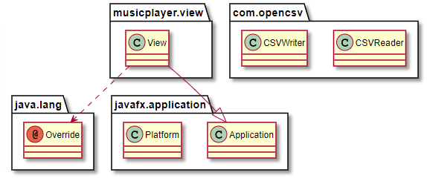

### User Interface

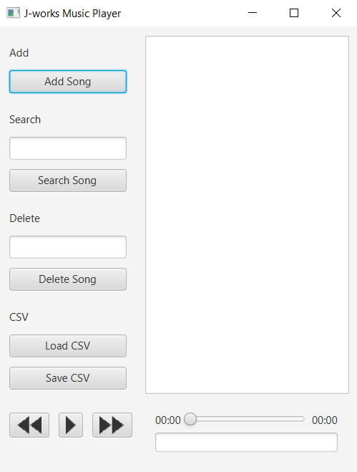

← Add song Button

← Search Button

← Delete Button

← Load and Save CSV Button

← Player Controller

### Functionality

* Sort Playlist
* Search a song
* Delete a song
* Load and Save Playlist from/to CSV
* General Music Player functionalities

## Version Control System

### GitHub

I used GitHub for my version control system. I tried to commit every single changes happens and it save as git and pushed to GitHub.



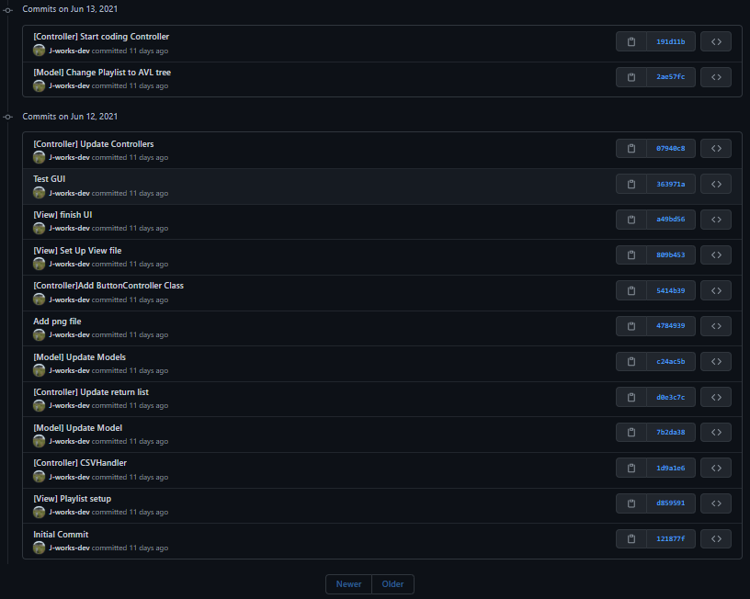

## Debugging and Test

### Debugging

Application was working properly. There were many issues during developing application. However, I missed capture screen shot for it.

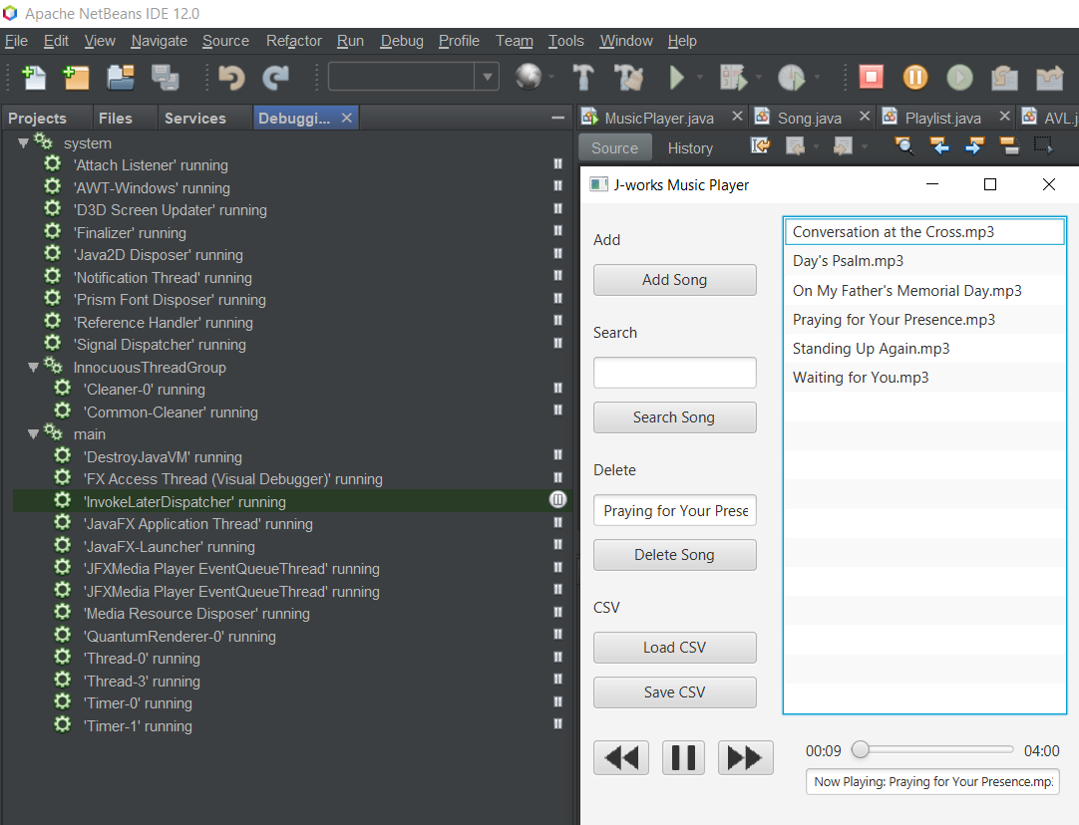

### Test Table

|  |  |  |  |  |
| --- | --- | --- | --- | --- |
| Case | Expected Result | Actual Result | Screen Shot | Verdict |
| Case 1 | Add a Song | Song Added | Figure 1 | Pass |
| Case 2 | Load Playlist | List loaded | Figure 2 | Pass |
| Case 3 | Delete a song | Song deleted | Figure 3 | Pass |
| Case 4 | Play music | Played | Figure 4 | Pass |
| Case 5 | Next song | Next song played | Figure 5 | Pass |
| Case 6 | Previous song | Previous song played | Figure 6 | Pass |
| Case 7 | Move slide | Song is delivered to changed position | Figure 7 | Pass |
| Case 8 | Search Song | Song Searched | Figure 8 | Pass |
| Case 9 | Save to CSV | File Created | Figure 9 | Pass |

Figure 1.

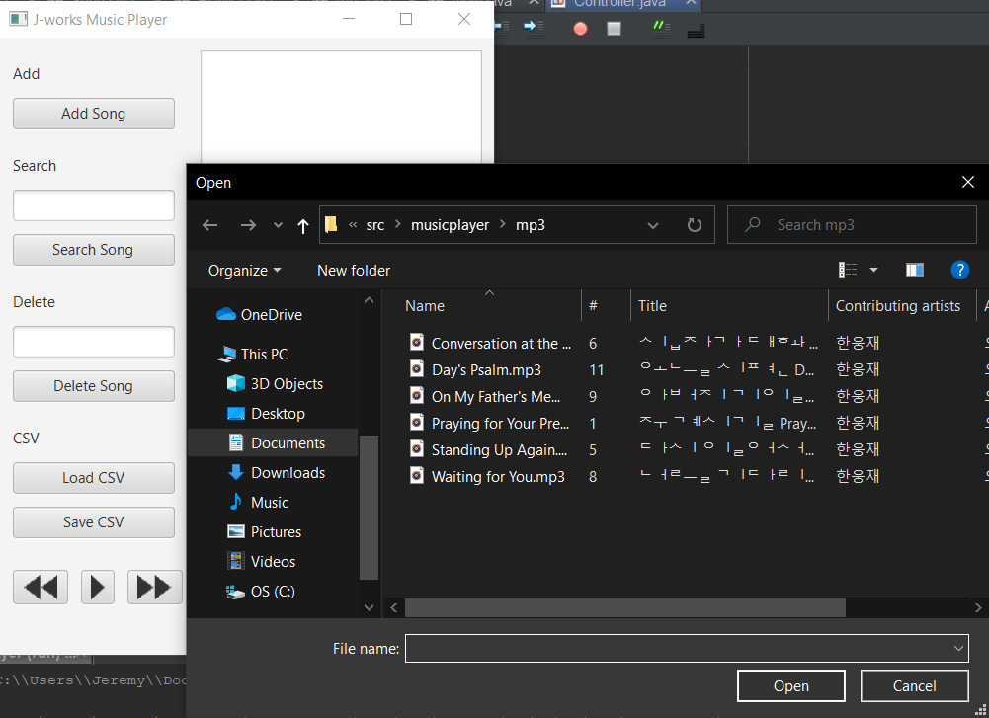 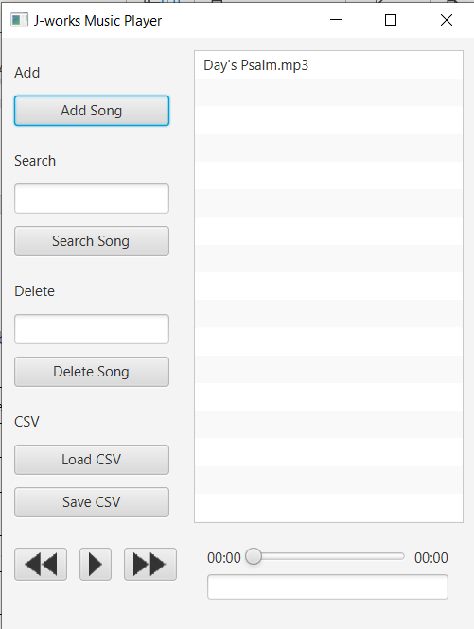

Figure 2.

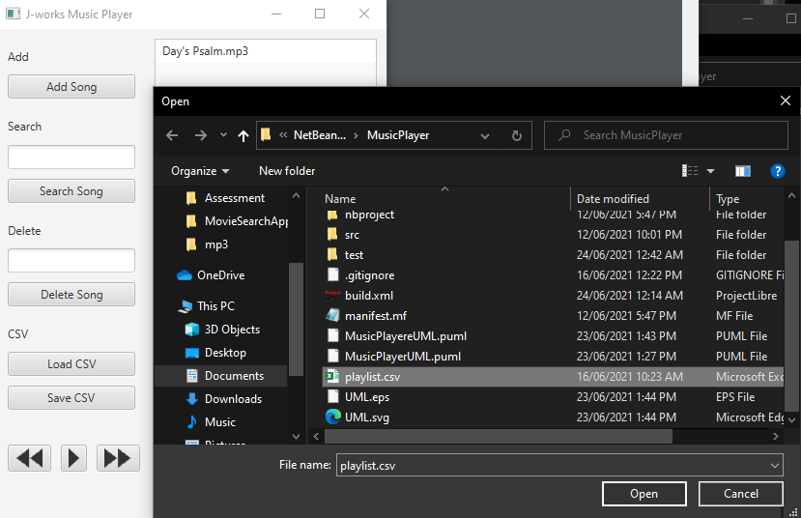 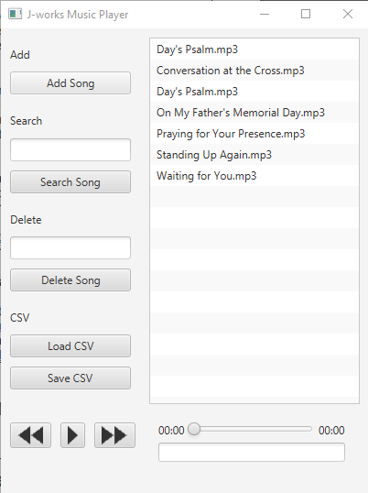

Figure 3.

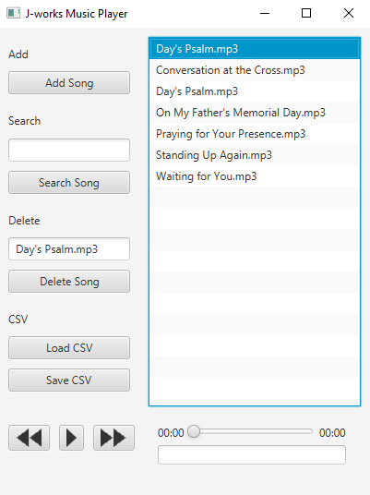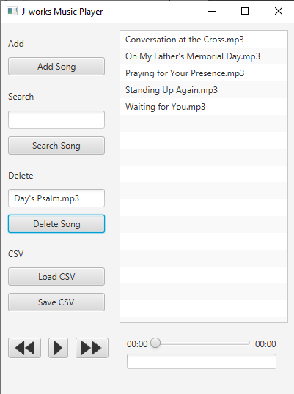

Figure 4.

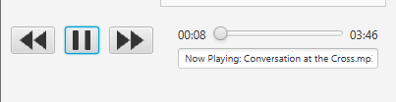

Figure 5.

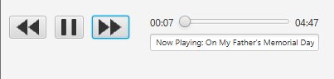

Figure 6. : clicked from Waiting for You.mp3

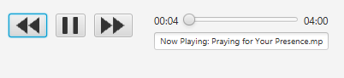

Figure 7.

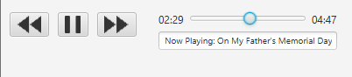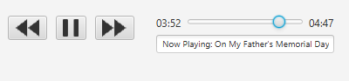

Figure 8.

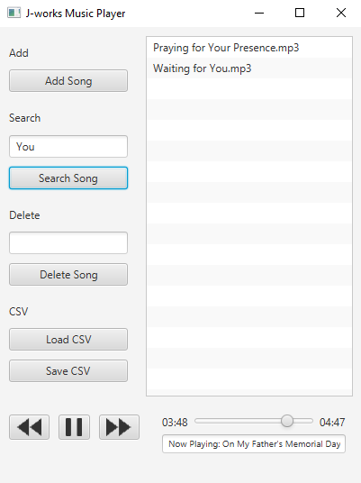

Figure 9.

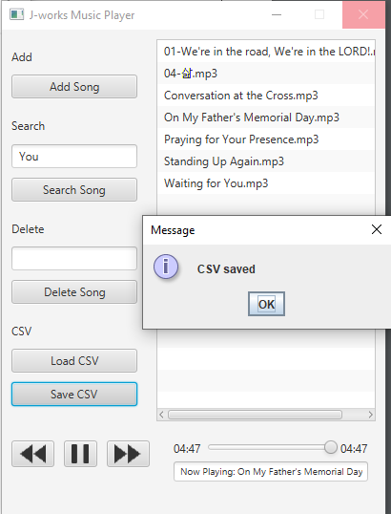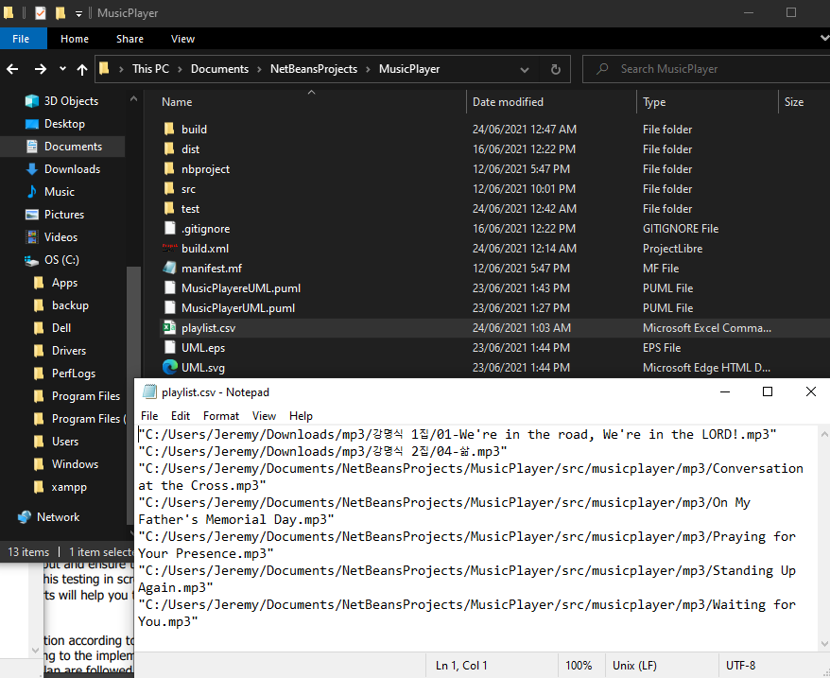

### Unit Test