Micro-Mouse GA Design Report

Detailed instructions related to this submission appear from page 8 onwards.
Please note that you are required to use the Microsoft form when preparing your report: it imposes strict formatting that must not be changed and enforces character limits for each section. Do not disable the “Protect Form” functionality in Microsoft Word. After completion you should convert the document to PDF for final submission.
If the form misbehaves then prepare your content in a separate application, then use copy and paste to populate it.

Student number: MCVJAR001

Brief Description of Design Task (max. 350 characters)
Provide a concise overview of the specific engineering problem you are solving and the subsystem you are designing (e.g., speed feedback control, sensor fusion, line sensor correction, safety wrapper, etc.). Explain how this fits into the broader system architecture of the autonomous mouse.
The design task was to develop a closed-loop controller that rotates the micromouse to a specified angle on the spot. This is a key part of autonomous movement: accurate rotation allows the robot to change direction predictably and follow a planned path. The subsystem combines sensor fusion, turning-speed control and wheel-speed balancing.

Visual Aids for this Report
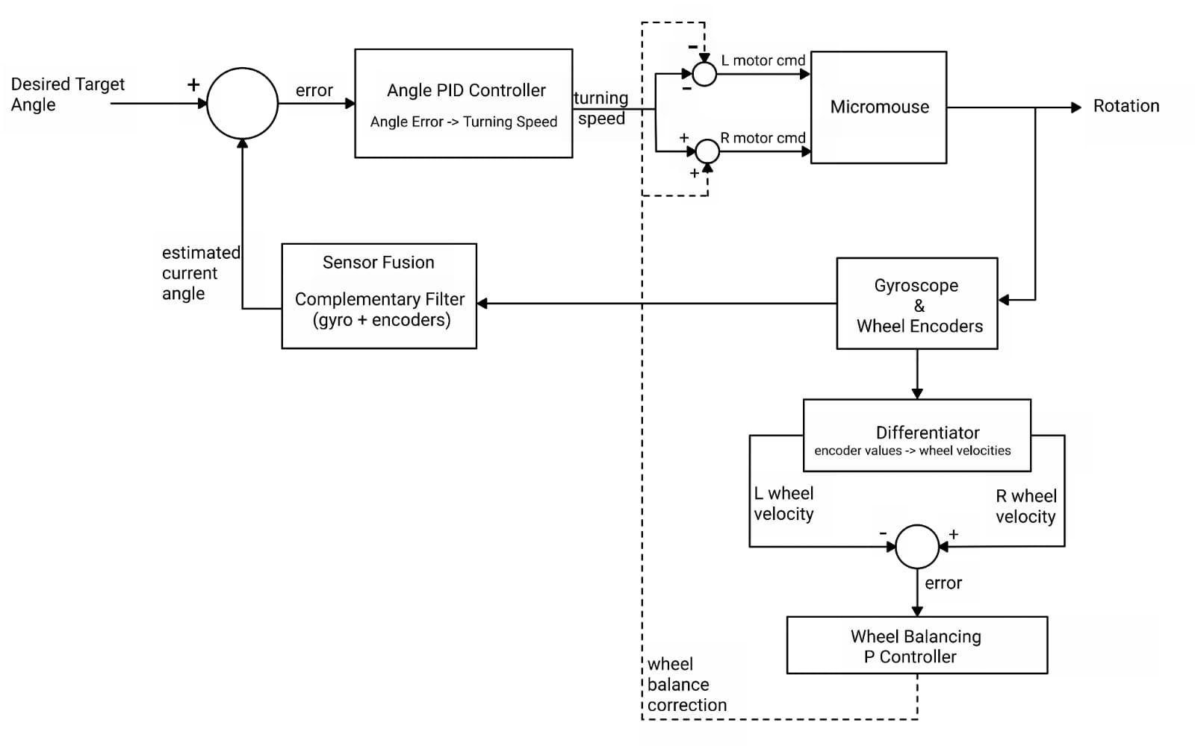
Insert all relevant figures, diagrams, flowcharts, or scope captures here. These must be referenced explicitly in the text below. Useful diagrams include: * Block diagrams showing system signal flow, interfaces, and inputs/outputs. * Stateflow logic charts or algorithmic flowcharts. * Simulink controller models or C-code software structure. * Oscilloscope wave captures or telemetry data plots.

Design Criteria & Constraints (max. 700 characters)
Formulate a clear design brief. Specify: * Quantitative Design Criteria: Desired performance standards (e.g., heading error $<2^{∘}$ after a 90° turn, speed regulation settling time $<100\text{ ms}$, line sensor response delay $<5\text{ ms}$). * Physical and Computational Constraints: Limits on hardware/software interfaces (e.g., STM32 CPU control execution time limits $<10\text{ ms}$, memory footprints, ADC sampling limits, power constraints, safety distances).
The primary criterion was to achieve a final angular error of less than 1° for each commanded 90° turn. The mouse must rotate on the spot, requiring the left and right wheels to have equal speed magnitude in opposite directions so that translational displacement is minimised. Constraints included noisy low-rate gyroscope measurements, possible wheel slip and motor asymmetry. Sensor readings were also only updated when the control loop called the required delay function, limiting the feedback update rate.

Main Design Assumptions with Justification (max. 700 characters)
State your engineering assumptions and justify them mathematically or physically. Examples include: * Assuming motor gains are linear within the operating region (with justification based on motor voltage ranges). * Assuming Gaussian white noise on sensor rails (with justification based on telemetry logs). * Assuming flat surfaces and perfect tire-floor traction (and how slip exceptions are handled).
The differential-drive model assumes fixed wheel spacing W and known distance per encoder tick used to calculate the displacement of each wheel. The change in heading in degrees is calculated by dividing the difference in displacement by the wheel spacing:
$$Δθ_{enc}=\frac{ΔR-ΔL}{W}\frac{180}{π}$$
The gyro provides a second estimate of the change in heading by:
$$Δθ_{gyro}=ω_{z}Δt$$
These are fused using the trust in the gyroscope G:
$$Δθ=GΔθ_{gyro}+\left(1-G\right)Δθ_{enc}$$
This method of calculating the change in angle assumes constant geometry, a known encoder scale and a fixed sampling period. Encoder estimates are affected by wheel slip, while gyro estimates accumulate noise and bias, so combining both provides a more reliable heading estimate.

Design Process & Alternative Solutions (max. 700 characters)
Describe the structured approach used to research, brainstorm, and select your solution. You must: * Identify Alternatives: Document at least two distinct engineering approaches or algorithms to solve the problem (e.g., a simple Proportional controller vs. a Proportional-Integral-Derivative controller, or a complementary filter vs. a Kalman filter). * Evaluate Alternatives: Evaluate them against your quantitative criteria and constraints (using a trade-off matrix or qualitative comparisons). * Select Preferred Solution: Justify why the selected approach is the optimal engineering choice.

For heading estimation, a complementary filter was selected over a Kalman filter because it was simpler to implement and less computationally expensive while still achieving the required angular accuracy. A Kalman filter would require additional modelling and tuning of system and sensor uncertainties. For turning control, open-loop timing, P-only and PID control were considered. Open-loop control cannot compensate for motor mismatch or disturbances. P control reduced the error but could leave a small residual error. PID was therefore selected, with D limiting rapid changes in correction and I removing persistent error. P-only control was selected for balancing the speed of the wheels.

Design Implementation & First-Principles Modeling (max. 700 characters)
Perform the detailed engineering design. Show the mathematical formulation and logical layout from first principles, including: * System equations (e.g., differential-drive kinematics, motor electrical and mechanical dynamic equations). * Control laws (e.g., discrete z-domain transfer functions, PID discretization). * Algorithm code schemas (e.g., C-caller interface logic or flowchart transitions).
The controller operates every 10 ms. The gyro yaw rate is integrated to determine its angular change, while encoder differences determine angular change from wheel motion. These are weighted and combined to update the estimated heading. The heading error is then calculated relative to the target angle. A PID controller converts this error into turning speed: P increases speed for large errors, D reduces rapid changes in speed, and I removes persistent error. The resulting speed is applied in opposite directions to both wheels. A separate P controller compares wheel-speed magnitudes and adjusts the two motor outputs to maintain equal and opposite rotation.

Design Evaluation, Testing & Discussion (max. 700 characters)
Evaluation and testing is crucial for ensuring a design meets its objectives and user needs. This process involves assessing a design's feasibility, desirability, and viability, and identifying areas for improvement before it gets deployed.
The completed controller was tested by repeatedly commanding 90° on-the-spot rotations and comparing the final measured angle with the 90° target. The micromouse consistently achieved the required final error of less than 1°, satisfying the design criterion. Equalising the wheel speeds also allowed rotation with negligible translational movement. Testing with differing wheel speeds and wheel slip showed that feedback compensated for motor asymmetry, while slip could still introduce heading error because encoder measurements are affected. The remaining deviation was mainly attributed to gyroscope noise and encoder-based errors under slip.

Appendix: ECSA Graduate Attribute 3 (Design) Rubric Mapping
To ensure your report provides bulletproof evidence for ECSA accreditation audits, use this table as a checklist to verify that your sections satisfy all GA3 assessment criteria:
ECSA GA3 Assessment Criterion | Report Section | What the Auditor Looks For
Criterion 3.1: Problem Definition & Constraints | Section 3: Design Criteria and Constraints  Section 4: Main Design Assumptions with Justification | A clear design brief outlining quantitative performance targets and physical/computational limits (e.g. CPU, memory, power).
Criterion 3.2: Generation & Evaluation of Alternative Solutions | Section 5: Design Process & Alternative Solutions | Documented generation of at least two alternative design concepts and a structured trade-off matrix/justification for the chosen concept.
Criterion 3.3: Detailed Design & Modeling (First-Principles) | Section 6: Design Implementation & First-Principles Modeling  Section 4: Main Design Assumptions | Detailed mathematical formulations (kinematics, transfer functions, discrete z-domain control laws) or logic models (state charts) from engineering science.
Criterion 3.4: Implementation & Experimental Verification | Section 7: Design Evaluation, Testing & Discussion | Successful implementation of the design and testing under realistic physical perturbations (motor asymmetry, traction loss/slip, and measurement noise).
Criterion 3.5: Design Evaluation & Discussion | Section 7: Design Evaluation, Testing & Discussion | Critical analysis of final experimental data against target criteria, analysis of model deviations, and discussion of design limits and failures.

Instructions

This report should document a structured design process that you conducted in relation to the micro-mouse project. You should explicitly be demonstrating use of methods presented to you in EEE3088F. The main purpose is to provide sufficient evidence for us to claim your proficiency in the ECSA Design Graduate Attribute (GA3), which is required to pass the course and complete your BSc(Eng) programme.
You can choose any design task for which you can confidently present evidence of design thinking. Without being prescriptive, some examples might be to design, build, and test:
- a more realistic and operationally useful Simulink model or Python simulation model of the micro-mouse motor drive system
- a realistic Simulink model or Python simulation class for time-of-flight distance measurements
- Simulink or Python model enhancements that accommodate a realistic perturbation such as friction, wheel slip, variable robot load (mass), operation on an inclined plane, or other
- processes for signal conditioning on measurements (e.g. improving IMU performance through calibration and noise modelling)
- a process for smoothing robot hardware motion (e.g. prediction and filtering of actuation signals)
- a Kalman filter-type algorithm for combining measurements and actuator signals in a structured manner
- a coordinated turn procedure that permits 90 degree turns of the robot even with significant forward velocity
- a method to acquire odometry by implementing rotary encoders on the wheels
- a method for making the robot follow a predetermined trajectory
- an overall improved micro-mouse simulator, or a visual block code generator (e.g. Blockly API), for in-the-loop algorithm development.
The task for which you provide evidence need not align with any submission milestone, and it does not have to be novel or earth shattering. However, the approach taken and the reporting thereof must follow formal design processes at the level required and must be objectively evaluated.
In essence, you should think of a micro-mouse related problem, approach it in a design-oriented manner, implement and test a proposed solution, and document the process you followed and the outcomes.
The format for this design report is very constrained. You are given limited space to present information relevant to each evaluation criterion, and each section will be evaluated for evidence it provides of your design thinking skills. A guide to the purpose of each section is as follows:
- Brief Description of Design Task: A short outline of the task identified and the problem it is intended to solve.
- Visual Aids for this Report: Any figures, images, or other graphics can be placed in this section and be referred to in the rest of the text. This can include excerpts of Stateflow or Simulink block diagrams.
- Design Criteria & Constraints: These are fundamental elements in the engineering design process. Criteria are the desired features, functions, and performance standards that a design must meet, while constraints are the limitations or restrictions that must be considered during the design process.
- Main Design Assumptions with Justification: Design assumptions are fundamental beliefs or statements about a system, its environment, or its users, that are taken as true without proof during the design process. Justification involves providing reasons and evidence to support these assumptions, explaining why they are reasonable and necessary for the design to proceed.
- Design Process & Alternative Solutions: The design process is a structured approach, often iterative, used to solve problems and develop solutions. It typically involves identifying a need, researching the problem, brainstorming ideas, creating prototypes, testing, and refining the design until it meets the desired outcome.
- Design Implementation & First-Principles Modeling: Design implementation describes the process of translating a design into a functional reality. It's the stage where the theoretical design is brought to life, whether it's a software application, a physical product, or a system.
- Design Evaluation, Testing & Discussion: Evaluation and testing is crucial for ensuring a design meets its objectives and user needs. This process involves assessing a design's feasibility, desirability, and viability, and identifying areas for improvement before it gets deployed.

The marking rubric for these reports is as follows:
Topic (weight) | Unacceptable (0) | Marginal (1) | Acceptable (2) | Exceptional (3)
Visual aids for this report (3) | Visual aids are unclear, confusing, or difficult to understand. Fails to effectively communicate design elements due to poor visual presentation | Visual aids are somewhat effective, but unclear or confusing in parts. May lead to misinterpretation of design elements due to poor visual presentation | Visual aids are clear and effectively communicate design elements. Meets minimum requirements for visual clarity and presentation | Visual aids are highly effective, clear, and engaging. Exceeds expectations for visual communication skills, creativity, and presentation
Design criteria and constraints (3) | Fails to identify or acknowledge critical design constraints. Ignores fundamental principles that limit design | Partially identifies some, but not all, critical constraints. Assumes factors without thorough consideration of limitations | Clearly identifies and justifies relevant design constraints. Demonstrates consideration of limitations or trade-offs in design decisions | Thoroughly identifies all critical constraints. Consistently considers design principles that account for limitations and trade-offs
Main design assumptions with justification (3) | Assumptions not identified or justified. Ignores critical variables and constraints | Lacks clear identification or justification of assumptions. Assumptions not thoroughly explored and considered | Assumptions clearly identified and justified. Consistently applied problem constraints with evidence to support | Assumptions rigorously identified and justified through thorough analysis. Assumptions explicitly made explicit and transparent
Design process description (3) | Lacks clear description of design process. Fails to demonstrate understanding of design methodology | Partially describes design process but lacks detail. Fails to identify key steps or decisions in the design process | Clearly describes main stages of the design process. Demonstrates understanding of key design concepts and principles | Comprehensive description of the entire design process. Clearly explains thought processes, decisions, and trade-offs
Design implementation (3) | Does not demonstrate successful implementation of design. Fails to demonstrate functional or effective design solution | Partially implements design, but with significant flaws. Fails to demonstrate clear and consistent implementation of design | Demonstrates successful implementation of basic design elements. Shows clear and consistent execution of design principles | Seamlessly implements design elements with attention to detail. Demonstrates exceptional execution of design principles
Design evaluation and testing (3) | Ignores or fails to evaluate design thoroughly. Fails to test and validate design assumptions | Partially evaluates design, but with significant limitations. Fails to test and validate design assumptions, or tests are not comprehensive | Consistently evaluates design for functionality and usability. Tests and validates design assumptions | Thoroughly evaluates design for all aspects. Validates design assumptions through rigorous testing and analysis

A discretionary further 2 points will be awarded for overall quality of the work and coherence of the report.
Note that to satisfy the GA assessment you will be required to get at least 1.5 marks out of 3 for every topic category in the rubric (i.e. no “Unacceptable” anywhere in the report, and “Marginal” is only permitted if an additional 0.5 marks is added via the rubric). This is separate from the mark that you receive, and a passing mark does not indicate that you’ve successfully attained the relevant GA.

