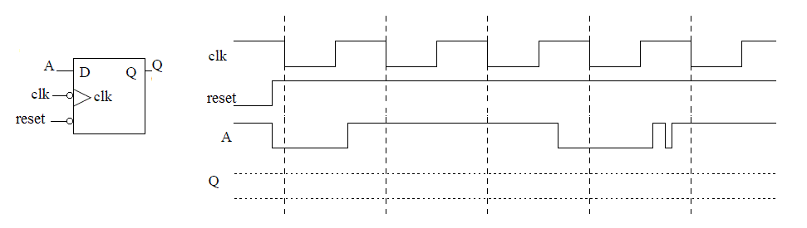

DAISY Inputs DAISY Outputs

|  |  |  |
| --- | --- | --- |
| RFID Scanner = r | Cow Present = c | Timer Status = t |
| 1 - Cow checked in | 1 - cow present | 1 - timer up |
| 0 - Cow not processed | 0 - no cow | 0 - timer running |

|  |  |  |  |
| --- | --- | --- | --- |
| Gate 1 | Gate 2 | Timer | Air Valve |
| 0 – gate closed | 0 – gate closed | 00 Stop timer | 0 closed |
| 1 - gate open | 1 – gate open | 01 Set to 30 sec | 1 open |
|  |  | 10 Set to 3 sec |  |
|  |  | 11 Run timer |  |

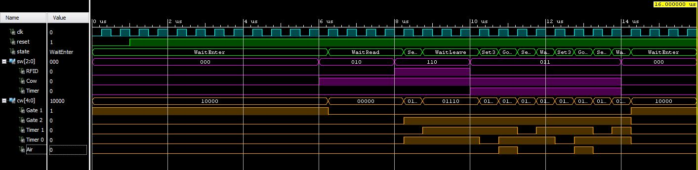

-------------------------------------------------------------------------

-- Name: Chris Coulston

-- Date: Jan 28, 2015

-- File: lec10.vhdl

-- Event: Lecture 10

-- Crs: CSCE 436

-------------------------------------------------------------------------

library IEEE;

use IEEE.STD_LOGIC_1164.ALL;

use IEEE.NUMERIC_STD.ALL;

entity lec09 is

Port( clk: in STD_LOGIC;

reset : in STD_LOGIC;

sw: in STD_LOGIC_VECTOR(2 downto 0);

cw: out STD_LOGIC_VECTOR(4 downto 0));

end lec09;

architecture behavior of lec09 is

type state_type is (WaitEnter, WaitRead, Set30, WaitLeave, Set3, Goose);

signal state: state_type;

constant rfid: integer := 2; -- helps keep status bits straight

constant cow: integer := 1;

constant timer: integer := 0;

begin

state_process: process(clk,reset)

begin

if (rising_edge(clk)) then

if (reset = '0') then

state <= WaitEnter;

else

case state is

when WaitEnter =>

if (sw(cow) = '1') then state <= WaitRead; end if;

when WaitRead =>

if (sw(rfid) = '1') then state <= Set30; end if;

when Set30 =>

state <= WaitLeave;

when WaitLeave =>

if (sw(cow) = '0') then state <= WaitEnter;

elsif (sw(timer) = '1' and sw(cow) = '1') then state <= Set3; end if;

when Set3 =>

state <= Goose;

when Goose =>

if (sw(timer) = '1') then state <= Set30; end if;

end case;

end if;

end if;

end process;

cw <= "10000" when state = WaitEnter else

"00000" when state = WaitRead else

"01010" when state = Set30 else

"01110" when state = WaitLeave else

"01100" when state = Set3 else

"01111"; -- when state = Goose;

end behavior;