-------------------------------------------------------------------------

-- File: lec19.vhdl

-- Ctrl: 00=Hold 01=Increment 10=Load 11=reset

-------------------------------------------------------------------------

entity lec11 is

generic( N : integer := 4);

port( clk : in STD_LOGIC;

reset_n : in STD_LOGIC;

ctrl : in std_logic_vector(1 downto 0);

D : in unsigned (N-1 downto 0);

Q : out unsigned (N-1 downto 0));

end lec11;

architecture behavior of lec11 is

signal processQ: __________________________________ ;

begin

process(clk)

begin

if (rising_edge(clk)) then

if (reset_n = '0') then

processQ <= ___________________ ;

elsif (ctrl = "01") then

processQ <= ___________________ ;

elsif (ctrl = "10") then

processQ <= ___________________ ;

elsif (crtl = "11") then

processQ <= ___________________ ;

end if;

end if;

end process;

Q <= processQ;

end behavior;

------------------------------------------------------------------------------

-- File: my_counter_ip_v1_0_S00_AXI.vhd

------------------------------------------------------------------------------

use ieee.numeric_std.all;

entity my_counter_ip_v1_0_S00_AXI is

generic (

-- Width of S_AXI data bus

C_S_AXI_DATA_WIDTH : integer := 32;

-- Width of S_AXI address bus

C_S_AXI_ADDR_WIDTH : integer := 7

);

port (

-- Users to add ports here

LED : out std_logic_vector(7 downto 0);

-- User ports ends

-- Do not modify the ports beyond this line

-- Global Clock Signal

S_AXI_ACLK : in std_logic;

-- Global Reset Signal. This Signal is Active LOW

S_AXI_ARESETN : in std_logic;

… lots of other stuff …);

architecture arch_imp of my_counter_ip_v1_0_S00_AXI is

------------------------------------------------

---- Signals for user logic register space example

--------------------------------------------------

component lec11 is

generic (N: integer := 4);

Port( clk: in STD_LOGIC;

reset_n : in STD_LOGIC;

ctrl: in std_logic_vector(1 downto 0);

D: in unsigned (N-1 downto 0);

Q: out unsigned (N-1 downto 0));

end component;

signal _________ : unsigned (7 downto 0);

begin

-- Address decoding for reading registers

loc_addr := axi_araddr(ADDR_LSB + OPT_MEM_ADDR_BITS downto ADDR_LSB);

case loc_addr is

when b"00000" =>

reg_data_out <= X"000000" & std_logic_vector(Q);

when b"00001" =>

reg_data_out <= slv_reg1;

when b"00010" =>

reg_data_out <= slv_reg2;

… lots more stuff here

end case;

-- Add user logic here

counter: ___________

generic map (____)

port map( clk => ___________________________,

reset_n => ___________________________,

ctrl => slv_reg1(1 downto 0),

D => unsigned(slv_reg0(7 downto 0)),

Q => ______________________________);

LED <= std_logic_vector(Q);

-- User logic ends

------------------------------------------------------------------------------

-- my_counter_ip_v1_0.vhd

------------------------------------------------------------------------------

use ieee.numeric_std.all;

entity my_counter_ip_v1_0 is

generic (

C_S00_AXI_DATA_WIDTH : integer := 32;

C_S00_AXI_ADDR_WIDTH : integer := 7

);

port (

-- Users to add ports here

LED : out std_logic_vector(7 downto 0);

-- User ports ends

-- Do not modify the ports beyond this line

-- Ports of Axi Slave Bus Interface S00_AXI

s00_axi_aclk : in std_logic;

s00_axi_aresetn : in std_logic;

… lots of other stuff …);

architecture arch_imp of my_counter_ip_v1_0 is

-- component declaration

component my_counter_ip_v1_0_S00_AXI is

generic (

C_S_AXI_DATA_WIDTH : integer := 32;

C_S_AXI_ADDR_WIDTH : integer := 7

);

port (

LED : out std_logic_vector(7 downto 0);

S_AXI_ACLK : in std_logic;-- Instantiation of Axi Bus Interface S00_AXI

… lots of other stuff …);

my_counter_ip_v1_0_S00_AXI_inst : my_counter_ip_v1_0_S00_AXI

port map( S_AXI_ACLK => S_AXI_ACLK,

S_AXI_ARESETN => S_AXI_ARESETN,

S_AXI_WDATA => S_AXI_WDATA,

… lots of other stuff …);my_counter_ip_v1_0_S00_AXI_inst : my_counter_ip_v1_0_S00_AXI

generic map (

C_S_AXI_DATA_WIDTH => C_S00_AXI_DATA_WIDTH,

C_S_AXI_ADDR_WIDTH => C_S00_AXI_ADDR_WIDTH )

port map (

LED => LED,

S_AXI_ACLK => s00_axi_aclk,

S_AXI_ARESETN => s00_axi_aresetn,

… lots of other stuff …);

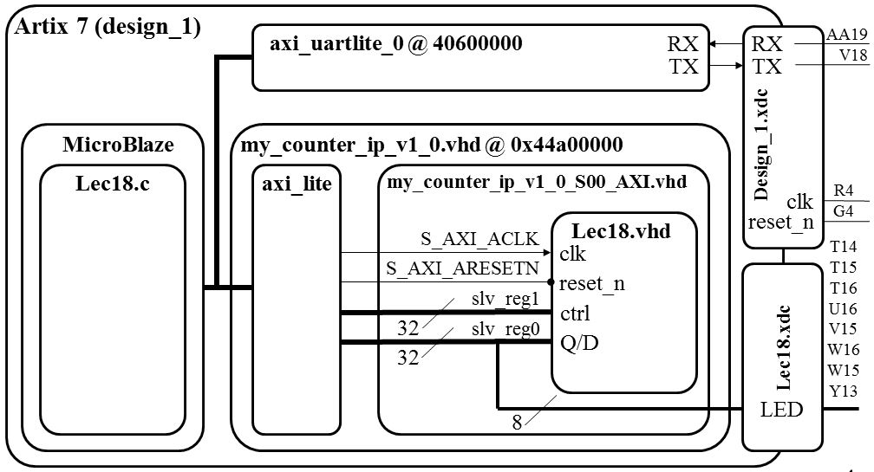

/*--------------------------------------------------------------------

-- Name: Prof Jeff Falkinburg

-- Date: Feb 16, 2017

-- File: lec19.c

-- Event: Lecture 19

-- Crs: CSCE 436

--

-- Purp: MicroBlaze Tutorial that implements a custom IP to microBlaze.

--

-- Documentation: MicroBlaze Tutorial

--

-- Academic Integrity Statement: I certify that, while others may have

-- assisted me in brain storming, debugging and validating this program,

-- the program itself is my own work. I understand that submitting code

-- which is the work of other individuals is a violation of the honor

-- code. I also understand that if I knowingly give my original work to

-- another individual is also a violation of the honor code.

-------------------------------------------------------------------------*/

/***************************** Include Files ********************************/

**#include** "xparameters.h"

**#include** "stdio.h"

**#include** "xstatus.h"

**#include** "platform.h"

**#include** "xil_printf.h" // Contains xil_printf

**#include** <xuartlite_l.h> // Contains XUartLite_RecvByte

**#include** <xil_io.h> // Contains Xil_Out8 and its variations

/************************** Constant Definitions ****************************/

/*

* The following constants define the slave registers used for our Counter PCORE

*/

**#define** countQReg 0x44a00000 // 8 LSBs of slv_reg0 read=Q, write=D

**#define** countCtrlReg 0x44a00004 // 2 LSBs of slv_reg1 are control

**#define** countRollReg 0x44a00008 // 1 LSBs of slv_reg2 for roll

/*

* The following constants define the Counter commands

*/

**#define** count_HOLD 0x00 // The control bits are defined in the VHDL

**#define** count_COUNT 0x01 // code contained in lec18.vhdl. They are

**#define** count_LOAD 0x02 // added here to centralize the bit values in

**#define** count_RESET 0x03 // a single place.

**#define** printf xil_printf /* A smaller footprint printf */

**#define** uartRegAddr 0x40600000 // read <= RX, write => TX

/************************** Function Prototypes ****************************/

/************************** Variable Definitions **************************/

/*

* The following are declared globally so they are zeroed and so they are

* easily accessible from a debugger

*/

**int** **main**()

{

**unsigned** **char** c;

init_platform();

print("Welcome to Lecture 19\n\r");

**while**(1) {

c=XUartLite_RecvByte(uartRegAddr);

**switch**(c) {

/*-------------------------------------------------

* Reply with the help menu

*-------------------------------------------------

*/

**case** '?':

printf("--------------------------\r\n");

printf(" count Q = %x\r\n",Xil_In16(countQReg));

printf("--------------------------\r\n");

printf("?: help menu\r\n");

printf("o: k\r\n");

printf("c: COUNTER count up LEDs (by x26)\r\n");

printf("s: COUNTER start counter\r\n");

printf("l: COUNTER load counter\r\n");

printf("r: COUNTER reset counter\r\n");

printf("f: flush terminal\r\n");

**break**;

/*-------------------------------------------------

* Basic I/O loopback

*-------------------------------------------------

*/

**case** 'o':

printf("k \r\n");

**break**;

/*-------------------------------------------------

* Tell the counter to count up

*-------------------------------------------------

*/

**case** 'c':

Xil_Out8(countCtrlReg,count_COUNT);

Xil_Out8(countCtrlReg,count_HOLD);

**break**;

/*-------------------------------------------------

* Start the counter to count up

*-------------------------------------------------

*/

**case** 's':

Xil_Out8(countCtrlReg,count_COUNT);

**break**;

/*-------------------------------------------------

* Stop the counter from counting

*-------------------------------------------------

*/

**case** 'S':

Xil_Out8(countCtrlReg,count_HOLD);

**break**;

/*-------------------------------------------------

* Tell the counter to load a value

*-------------------------------------------------

*/

**case** 'l':

printf("Enter a 0-9 value to store in the counter: ");

c=XUartLite_RecvByte(uartRegAddr) - 0x30;

Xil_Out8(countQReg,c); // put value into slv_reg1

Xil_Out8(countCtrlReg,count_LOAD); // load command

printf("%c\r\n",c+0x30);

**break**;

/*-------------------------------------------------

* Reset the counter

*-------------------------------------------------

*/

**case** 'r':

Xil_Out8(countCtrlReg,count_RESET); // reset command

**break**;

/*-------------------------------------------------

* Clear the terminal window

*-------------------------------------------------

*/

**case** 'f':

**for** (c=0; c<40; c++) printf("\r\n");

**break**;

/*-------------------------------------------------

* Unknown character was

*-------------------------------------------------

*/

**default**:

printf("unrecognized character: %c\r\n",c);

**break**;

} // end case

}

cleanup_platform();

**return** 0;

} // end main