--------------------------------------------------------------------

-- Name: Chris Coulston

-- Date: Jan 10, 2015

-- File: lec3.vhdl

-- HW: Lecture 3

-- Crs: CSCE 436

-- Purp: Illustrate difference between unsigned and signed operations

-- Documentation: No help, I based this off the class notes and readings.

-- Academic Integrity Statement: I certify that, while others may have

-- assisted me in brain storming, debugging and validating this program,

-- the program itself is my own work. I understand that submitting code

-- which is the work of other individuals is a violation of the honor

-- code. I also understand that if I knowingly give my original work to

-- another individual is also a violation of the honor code.

-------------------------------------------------------------------------

library IEEE;

use IEEE.std_logic_1164.all;

use IEEE.NUMERIC_STD.ALL;

entity lec3 is

port( au, bu: in unsigned(3 downto 0);

cu,du,su: out unsigned(3 downto 0);

as, bs: in signed(3 downto 0);

cs,ds,ss: out signed(3 downto 0));

end lec3;

architecture structure of lec3 is

begin

cu <= "1000" when (au > bu) else

"0110" when (au = bu) else

"0001";

su <= au + bu;

du <= au - bu;

cs <= "1000" when (as > bs) else

"0110" when (as = bs) else

"0001";

ss <= as + bs;

ds <= as - bs;

end structure;

Unsigned

|  |  |  |  |  |  |  |  |  |
| --- | --- | --- | --- | --- | --- | --- | --- | --- |
| A | B | Value A | Value B | A >? B | A =? B | A <? B | A + B | A - B |
| 0010 | 0100 |  |  |  |  |  |  |  |
| 1011 | 0001 |  |  |  |  |  |  |  |
| 0110 | 1010 |  |  |  |  |  |  |  |
| 0111 | 1000 |  |  |  |  |  |  |  |

Signed

|  |  |  |  |  |  |  |  |  |
| --- | --- | --- | --- | --- | --- | --- | --- | --- |
| A | B | Value A | Value B | A >? B | A =? B | A <? B | A + B | A - B |
| 0010 | 0100 |  |  |  |  |  |  |  |
| 1011 | 0001 |  |  |  |  |  |  |  |
| 0110 | 1010 |  |  |  |  |  |  |  |
| 0111 | 1000 |  |  |  |  |  |  |  |

Page 18-19 from: **Nexys Video™ Board Reference Manual**

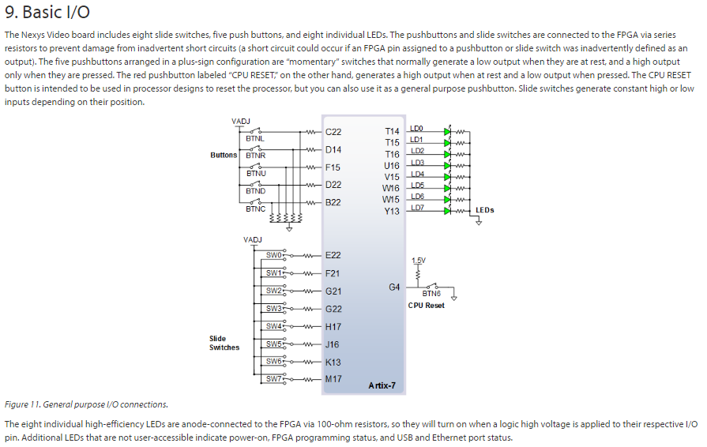

# This is slide switch SW0 #IO_L22P_T3_16 Sch=sw[0]

set_property -dict { PACKAGE_PIN E22 IOSTANDARD LVCMOS12 } [get_ports { a }];

# This is slide switch SW1 #IO_25_16 Sch=sw[1]

set_property -dict { PACKAGE_PIN F21 IOSTANDARD LVCMOS12 } [get_ports { b }];

# This is slide switch SW2 #IO_L24P_T3_16 Sch=sw[2]

set_property -dict { PACKAGE_PIN G21 IOSTANDARD LVCMOS12 } [get_ports { c }];

# This is LED Led(0) #IO_L15P_T2_DQS_13 Sch=led[0]

set_property -dict { PACKAGE_PIN T14 IOSTANDARD LVCMOS25 } [get_ports { f }];