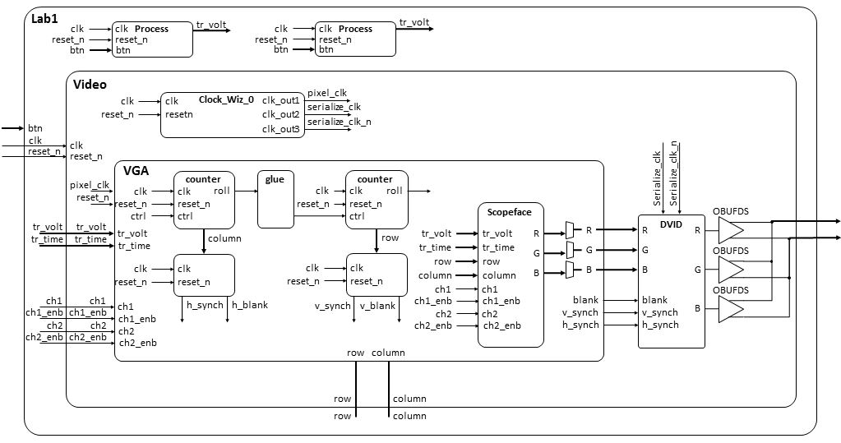

--------------------------------------------------------------------

-- Name: Prof Jeff Falkinburg

-- Date: Jan 12, 2017

-- File: lec5.vhdl

-- HW: Lecture 5

-- Crs: CSCE 436

-- Purp: This demonstrates some basic I/O as well as gated and ungated

-- outputs.

-- Documentation: No help, I based this off the class notes and readings.

-------------------------------------------------------------------------

library IEEE;

use IEEE.STD_LOGIC_1164.ALL;

use IEEE.NUMERIC_STD.ALL;

entity Lec5 is

Port ( clk : in STD_LOGIC;

reset : in STD_LOGIC;

btn : in STD_LOGIC_VECTOR (4 downto 0);

JB : out STD_LOGIC_VECTOR (7 downto 0));

end Lec5;

architecture Behavioral of Lec5 is

signal processQ: unsigned (7 downto 0);

constant L0: unsigned(7 downto 0) := "00101111";

constant L1: unsigned(7 downto 0) := "01011111";

constant L2: unsigned(7 downto 0) := "10111111";

begin

------------------------------------------------------------------------------

-- The buttons are all nominally 0 and equal to 1 when pressed.

-- btn(3) = '1' Right

-- btn(1) = '1' Left

-- btn(2) = '1' Down

-- btn(0) = '1' Up

-- btn(4) = '1' Center

------------------------------------------------------------------------------

process(clk)

begin

if (rising_edge(clk)) then

if (reset = '0') then

processQ <= (others => '0');

elsif (btn(4) = '0') then

processQ <= processQ + 1;

end if;

end if;

end process;

------------------------------------------------------------------------------------

-- The upper nibble of JB will tell us about the range of processQ using combo logic

------------------------------------------------------------------------------------

process(clk)

begin

if (rising_edge(clk)) then

if (reset = '0') then

JB(6 downto 4) <= "000";

elsif ((processQ >= 0) and (processQ < L0)) then

JB(6 downto 4) <= "001";

elsif ((processQ >= L0) and (processQ < L1)) then

JB(6 downto 4) <= "010";

elsif ((processQ >= L1) and (processQ < L2)) then

JB(6 downto 4) <= "100";

elsif (processQ >= L2) then

JB(6 downto 4) <= "111";

end if;

end if;

end process;

JB(7) <= clk;

------------------------------------------------------------------------------------

-- The lower nibble of JB will tell us about the range of processQ using gated logic

------------------------------------------------------------------------------------

JB(3 downto 0) <= "0001" when ((processQ >= 0) and (processQ < L0)) else

"0010" when ((processQ >= L0) and (processQ < L1)) else

"0100" when ((processQ >= L1) and (processQ < L2)) else

"1000";

end Behavioral;