(not finished)
- Background
In the last decade, directed functional (or effective) connectivity models and metrics from other research areas such as econometrics and physics have been adopted and customized to deal with neuroimaging data. Specifically, the theoretic framework of Granger causality (GC) based on prediction improvement (Granger, 1969) has gained popularity as a tool to search for causal networks in the brain with the GC index (GCI). Due to the rich spectral content of neuroimaging data like electroencephalography (EEG), frequency specific interactions are often a target of study. This motivated the use of Geweke’s spectral formulation for GC (GGC) (J. Geweke, 1982) and the development of frequency sensitive metrics like partial directed coherence (PDC) (Baccalá & Sameshima, 2001) and directed transfer function (DTF) (Kamiński, Ding, Truccolo, & Bressler, 2001) which use Fourier transformed (FT) autoregressive (AR) coefficients. Later on, these metrics have been reformulated and adapted to specific contexts and neuroimaging data. Although PDC is the most expressive example of alternative formulations - generalized PDC, row-wise PDC, spectrally weighted PDC and ortogonalized PDC - other advances occurred like GCI and GGC reformulations, extended multivariate AR (eMVAR) models for fMRI BOLD datasets and methods for conditioning the multivariate analysis on highly mutual informative variables. Non-parametric (NP) alternative methods (Barnett & Seth, 2014; Dhamala, Rangarajan, & Ding, 2008) came to light which eliminated the dependence on multivariate AR (MVAR) modeling and the necessity of optimal model order estimation by using the cross-spectral density matrix (CSDM) to compute the system’s transfer function and error covariance, thereby enabling the use of the wavelet transform (WT) to achieve improved frequency resolution and time-varying (TV) analysis of stationary and non-stationary data (Dhamala et al., 2008). TV-MVAR approaches have also been developed with the same purpose by estimating TV coefficients via sliding windows of stationarity (Ding, Bressler, Yang, & Liang, 2000), optimal window lengths (Luo et al., 2013), Kalman filtering (Havlicek, Jan, Brazdil, & Calhoun, 2010; a H. Omidvarnia et al., 2011), state space modeling (Sommerlade et al., 2012) or recursive least squares (Astolfi et al., 2008; Plomp, Quairiaux, Michel, & Astolfi, 2014).
Some of these techniques have been released in separate open source toolboxes however, we think that the interest and usefulness of this vast supply of methodologies demands a unified open source tool, where it is possible to choose, combine, edit and improve these methods or even add new functionalities. Therefore, we developed a versatile framework in Matlab®, aimed at causal analysis of neural data combining these techniques, that receives a multivariate time-series, returns the corresponding adjacency matrix and displays it in a user defined circular connectogram. There are four main functions user defined inputs that decide the how causality is estimated for example: choice of MVAR modeling, model order estimation, causal metric, spectral normalization, statistical validation, among others that are detailed in the later. In the rest of this manuscript we provide an overview to the toolbox workflow and available options, succinctly introduce the methodology behind each option, provide some examples of utilization with simulated and real datasets and discuss advantages and future work.
- Implementation
  - Definitions and computational aspects
In the following sections we present each metric’s procedure with a brief theoretical explanation and the necessary configuration parameters which are inputted in the fields of a structure – optStruct. Every analysis can be performed pairwise or pairwise-conditionally (there is one exception for partially conditioned analysis which is explained later). Table 1 shows the options common in all analysis; as we further detail each procedure, additional options are presented in the same fashion.
Table 1: Fields in optStruct present in all possible analysis.
Field name | Data type | Description | Options
type | string | Pairwise or pairwise-conditional analysis. When using the partially conditioned analysis function, this field is not necessary as analysis is always pairwise-conditional inside each subset. | ‘pwise’, ‘cond’
DOI | bool | Difference of influence (DOI) validation. Only values with positive DOI are kept in the adjacency matrix. | {0, 1}
Fs | int | Sampling rate | 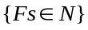

    - Time-invariant
Time-invariant analysis consists in finding an adjacency matrix that describes the causal relations in a given time interval. The function causalMatrix.m can be used for this purpose be sending the data as a multivariate time-series matrix, where observations reside in the columns, and a structure optStruct with the analysis parameters. This function can return an N*N, N*N*num_freqs or N*N*num_bands matrix, where N is the number of variables, num_freqs is the frequency resolution and num_bands is the number of frequency bands chosen.
      - Parametric modeling
Parametric modeling can be defined by the optStruct fields in Table 2.
Table 2: Fields in optStruct specific to time-invariant parametric modeling.
Field name | Data type | Description | Options
AR_mode | string | AR modeling choice. | ‘MVAR_OLS’, ‘eMVAR_OLS’, ‘MVAR_Burg’, ‘NTrials_MVAR_Burg’, ‘VARMA’
MINP | int | Minimum model order. Use the same as MAXP to force this value for model order. | 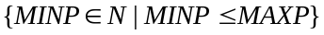
MAXP | int | Maximum model order. Use the same as MINP to force this value for model order. | 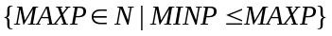
info_crit | string | Information criteria | ‘aic’, ‘bic’.
extended_AR | bool | Apply extension operation from (Faes & Nollo, 2010) to the AR model. Works for all parametric methods except eMVAR_OLS as these already have the j = 0 coefficients. | {0, 1}
VARMA2MVAR | bool | Convert VARMA to MVAR model using the Matlab® function vgxar available in the Econometrics Toolbox. | {0, 1}
Nr | int | Number of realizations. Use only if AR_mode is ‘NTrials_MVAR_Burg’ | 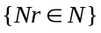
Nl | int | Length of every realization. Use only if AR_mode is ‘NTrials_MVAR_Burg’ | 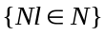

MVAR models can be estimated with the ordinary least-squares method (OLS), similar to the GCCA Toolbox (Seth, 2010) (AR_mode = ‘MVAR_OLS’ ) or with a Burg derived method from the Biosig Toolbox (Schlögl, 2006; Vidaurre, Sander, & Schlögl, 2011) (AR_mode = ‘ MVAR_Burg’ ) resulting in:
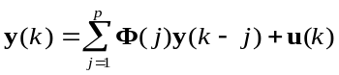 | (1)
where y(k) is a n-dimensional multivariate signal, Φ is the AR coefficient (n × n × p) matrix, u(k) are the residuals (white and uncorrelated noise) and the model order p can be estimated with the Bayesian (Schwarz, 1978) (info_crit = ‘bic’ ) or the Akaike Information Criteria (Akaike, 1974) (info_crit = ‘ aic’ ) (BIC and AIC respectively). The FT components of this MVAR model can be computed as:
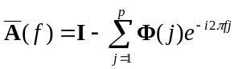 | (2)
The transfer matrix H is calculated by 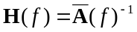 and the covariance matrix of the residuals by Σ=cov(u). The assumption of u being uncorrelated white noise and Σ diagonal is essential for causality measures based in spectral decomposition. The former MVAR model is strictly causal in that it only accounts for lagged effects. Zero-lag correlations that may exist between variables are not accounted by the model resulting in correlated residuals and non-diagonal Σ invalidating spectral decomposition formulations. Therefore, it is also possible to estimate an extended MVAR (eMVAR) model (j = 0,…,p) with a modified OLS procedure that accounts for the instantaneous correlations in the AR coefficients of j = 0 (AR_mode = ‘eMVAR_OLS’) or by transforming existing MVAR models as suggested in (Faes & Nollo, 2010) (extended_AR = 1). This way, it is possible to compute the purely lagged causality versions of GC metrics by accounting only for the lagged parameters (j = 1,…,p) of the eMVAR models (Deshpande, Sathian, & Hu, 2010; Faes & Nollo, 2010).
Multi-trial data can be fit by MVAR models estimated with a Burg derived method from the BSMART Toolbox (Cui, Xu, Bressler, Ding, & Liang, 2008) (AR_mode = ‘NTrials_MVAR_Burg’). Data must be prepared with concatenated multiple realizations with the same length (Nr = ...; Nl = ...).
VARMA models are estimated with the SSMMatlab toolbox (Peng & Aston, 2011) by a sequence of approximations starting with the Hannan-Riessanen method (Hannan & Rissanen, 1982), that can also establish the AR and MA orders following the BIC or AIC values, improved by a conditional and exact maximum likelihood (ML) methods (AR_mode = ‘VARMA’). The resulting VARMA (p, q) model:
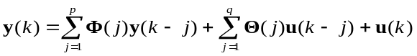, | (3)
where Θ is the MA coefficient (n × n × q) matrix. In case the subsequent causal analysis is defined for MVAR models solely, the VARMA model can be converted to a MVAR model using the Matlab® function vgxar available in the Econometrics Toolbox (VARMA2MVAR = 1). Notwithstanding, the frequency domain AR part is calculated as in (2) and the MA part by:
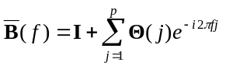 | (4)
In this case, for a stable and invertible process the transfer matrix 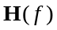 is calculated as 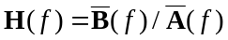 and the covariance matrix of the model’s residuals by Σ = cov(u).
The GC metrics used in these toolbox may require Φ, 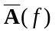, 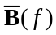, and Σ for their computation.
      - Non-parametric modeling
Table 3: Fields in optStruct specific to time-invariant non-parametric modeling.
Field name | Data type | description | options
AR_mode | string | AR model choice: parametric models or non-parametric methods. | ‘Wilson-Burg’, ‘autocov-seq’
spect_opt | string | Cross-spectrogram option for non-parametric time-varying analysis only. Choosing ‘syncWT’ enables squeezing operation on the causality matrix after it is computed.. | ‘ST’, ‘WT’, ‘Welch’, ‘mtm’

Autoregressive modeling is the original procedure to obtain the autoregressive parameters Φ or , transfer function H(f) and noise covariance Σ matrices necessary for the GC metrics. However, a nonparametric (NP) approach can also be used to compute these matrices. The key operation in this approach is the factorization of the cross spectral density matrix (CSDM) S(f) which can be computed with the Welch periodogram (spect_opt = ‘Welch’), the multitaper method (spect_opt = ‘mtm’), WT or the Stockwell transform (ST) (Stockwell, Mansinha, & Lowe, 1996) (spect_opt = ‘ST).
There are at least two proposed NP methods that use tne CSDM.
The first method, by Dhamala (Dhamala et al., 2008), uses the Wilson-Burg algorithm (Wilson, 1972) for spectral factorization (AR_mode = ‘Wilson-Burg’). Its basic principle is the factorization of a spectral density matrix S(f) = Ψ(f)Ψ*(f) into a unique set of minimum phase functions 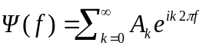 that have a Fourier series expansion in nonnegative powers of e^{i2πf}. By extracting A₀ from Ψ(f) the computation of the covariance matrix of the residuals and the transfer function translates into Σ=A₀A₀^{T} and H(f)= Ψ(f)A₀⁻¹ respectively.
Recently, Barnett and Seth proposed and implemented a more efficient and accurate spectral factorization technique in their Multivariate Granger causality toolbox (MVGC) (Barnett & Seth, 2014) that consists in obtaining an autocovariance sequence from a given CSDM S(f), computing the regression coefficients Φ and residual covariance matrix Σ from the autocovariance sequence by solving the Yule-Walker equations, and finally computing the transfer matrix H(f) (AR_mode = ‘autocov-seq'). From these values, and knowing that 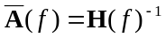, causality with GC metrics can be inferred in the same way as with the parametric formulation.

Table 4: Fields in optStruct specific to time-invariant TE analysis.
Field name | Data type | description | options
measure | string | Always ‘TE’. | ‘TE’
stats | string | Choice between knn statistics or Gaussian equivalence. | ‘knn’, ‘gaussian’
d | int | Embedding dimension (Lindner, Vicente, Priesemann, & Wibral, 2011). | 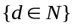  High values computationally demanding.
tau | int | Embedding lag (Lindner et al., 2011). | 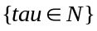
u | int | Prediction time (Lindner et al., 2011). | 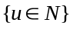

Transfer Entropy (TE) was proposed (T Schreiber, 2000) as a model-free, non-parametric measure of information transfer between two variables, within an information theoretic context. While its formulation is based on Shannon entropy, the TE from the source to destination can be interpreted as the average mutual information between the previous state of the source and a future state of the destination, conditioned on past states of the destination. These past states are constructed by delay embedding (Takens, 1981) with specific embedding delay and embedding dimension estimated by the Ragwitz criterion (Ragwitz & Kantz, 2002). The sensitivity of TE relies heavily on the correct estimation of the system’s interaction delay (Lindner et al., 2011). If the exact interaction delay is not known but can be estimated to be within a certain range, the average TE in that range can be computed. This toolbox does not offer the estimation functions for delay embedding dimension nor interaction delay; these can be found in TRENTOOL (Lindner et al., 2011).
The computation of TE is based on entropy estimates from k-nearest neighbor (knn) distances which provides minimal bias, adaptive resolution and data efficiency (Kraskov, Stögbauer, & Grassberger, 2004). TE can also be computed accounting for indirect influences (partial TE), by adding a conditional dependence on the past states from additional environmental variables (Vakorin, Krakovska, & McIntosh, 2009) (type = ‘cond).
In this toolbox TE measures can be computed with two mutual information (MI) estimators (Lizier, Heinzle, Horstmann, Haynes, & Prokopenko, 2011). In turn, MI can be computed either by using Kraskov’s knn (stats = ‘knn') distances with code adapted from the MILCA toolbox (Kraskov et al., 2004), or by following the Gaussian assumption (Barnett, 2009) (stats = ‘gaussian').

Table 5: Fields in optStruct specific to time-invariant PSI analysis.
Field name | Data type | Description | Options
measure | string | Always ‘PSI’. | ‘PSI’
freqs | array or string | Frequency bands for analysis or a string to get the mean value (‘mean’). Each frequency band is represented by a two column row with the delimiting frequencies. | ‘mean’,  [start_band1,end_band1;  start_band2,end_band2;…  start_bandN,end_bandN]
segleng | int | Segment length to compute the spectrum with the Welch periodogram (Nolte et al., 2008).
epleng | int | Length of each epoch for the jackknife and normalization procedure (Nolte et al., 2008).
thres | double | Threshold for considering normalized values significant. Usually 2 (Nolte et al., 2008) | 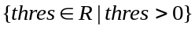

The Phase Slope Index (PSI) method (Nolte et al., 2008) is based on the phase coherency slope (averaged over a frequency band) between two variables, defined in a way that ensures robustness with respect to instantaneous mixtures of independent sources of arbitrary nature. PSI is based on the idea that interactions between variables are not instantaneous and take time to propagate. Considering two variables X and Y, and provided that the propagation speed is constant, the phase difference between X and Y increases with frequency and the phase spectrum is expected to have a positive slope if X drives Y and a negative slope if Y drives X.
In this toolbox PSI is computed with the software package for Matlab® provided by its author (Nolte et al., 2008). The underlying mathematical formulation is based on coherency C_{ij}(f) following 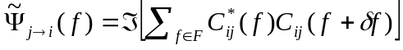, where, δf represents frequency resolution and F the frequency band of interest. This measure is then normalized by an estimate of the standard deviation using the jackknife method. Normalized absolute values above 2 are considered significant (Nolte et al., 2008).
    - Time-varying
Time- varying analysis consists in finding an adjacency matrix that describes the causal relations at each instant of a given time interval. The function TV_CausalMatrix.m can be used for this purpose by sending the data as a multivariate time-series matrix, where observations reside in the columns, and a structure optStruct with the analysis parameters. This function can return an N*N*num_points, N*N*num_freqs*num_points or N*N*num_bands*num_points matrix, where N is the number of variables, num_freqs is the frequency resolution, num_bands is the number of frequency bands chosen and num_points is the length of the multivariate time-series.
      - Parametric modeling
Table 6: Fields in optStruct specific to time-varying parametric analysis.
Field name | Data type | Description | Options
AR_mode | string | AR model choice: parametric models or non-parametric methods. | ‘MVAR’, ‘VARMA’
MINP | int | Minimum model order.
MAXP | int | Maximum model order.
scrit | string | Information criteria: ‘AIC’ or ‘BIC’. | ‘aic’, ‘bic’.
extended_AR | bool | Apply extension operation from (Faes & Nollo, 2010) to the AR model. | {0, 1}
VARMA2MVAR | bool | Convert TV-VARMA to TV-MVAR at each time instant model using the Matlab® function vgxar available in the Econometrics Toolbox. | {0, 1}

Time dependent regression coefficients provide a way to model non-stationary signals with intermittent interactions that would have been disregarded if time-invariant coefficients were used. Different paths can be taken to estimate time dependent coefficients and the corresponding time dependent covariance matrix of the residuals Σ(k), from sliding windows analysis to Kalman filters.
In this toolbox, the time varying parameters Φ(k) and Θ(k) and residual covariance matrix Σ(k) for TV-MVAR (AR_mode = ‘MVAR') and TV-VARMA (AR_mode = ‘VARMA’) are obtained by estimating their equivalent state space representations with time-varying Kalman filters and recasting these into TV-MVAR or TV-VARMA again. At each iteration k of the Kalman filter, Σ can be determined by the covariance matrix of the filter’s innovation process and Φ and Θ by recasting to the autoregressive representation. The generic implementation of the Kalman filter can be found in (Vaseghi, 2009) and the algorithms used by these toolbox for estimating the TV-MVAR and TV-VARMA can be found, respectively, in ( a H. Omidvarnia et al., 2011) (the code from this author is also used as it is freely available online) and (Yinfeng, Yingmin, Mingkui, & Ming, 2008).
With the resulting models, Φ, , , and Σ can be computed and used by GC metrics at each time instant.
Similarly to the time-invariant parametric modeling it is also possible to obtain a time-varying extended MVAR (TV-eMVAR) model (j = 0,…,p) that accounts for the instantaneous correlations in the AR coefficients of j = 0 by transforming existing TV-MVAR models, at each time instant, as suggested in (Faes & Nollo, 2010) (extended_AR = 1). In the same way as time-invariant, this allows the computation of purely lagged causality versions of GC metrics by accounting only for the lagged parameters (j = 1,…,p) of the tranformed TV-eMVAR models (Deshpande et al., 2010; Faes & Nollo, 2010).
      - Non-parametric modeling
Table 7: Fields in optStruct specific to time-varying non-parametric analysis.
Field name | Data type | Description | Options
AR_mode | string | AR model choice: parametric models or non-parametric methods. | ‘Wilson-Burg’, ‘autocov-seq’
spect_opt | string | Cross-spectrogram option for non-parametric time-varying analysis only. Choosing ‘syncWT’ enables squeezing operation on the causality matrix after it is computed.. | ‘ST’, ‘WT’, ‘syncWT’
spect_avg | int | Number CSDM past samples (from t-spect_avg to t) that are averaged to obtain S(f, t).

Time-varying NP (TV-NP) analysis requires a CSDM for each time point, S(f, t), that can be obtained from the cross-spectrogram resulting from cross multiplying the WT of each time-series as proposed in (Dhamala et al., 2008) (spect_opt = ‘WT’) or a similar method like the ST (spect_opt = ‘ST’). Additionally, the resulting time-frequency causality matrices can be squeezed by the synchrosqueezing transform's IFs map ω_{s} of the driving variable similarly to the operation proposed in (Daubechies, Lu, & Wu, 2011) for the WT energy squeezing (spect_opt = ‘syncWT').
    - Granger Causal Metrics
Table 8: Structure optStruct for the GC metrics analysis.
Field name | Data type | Description | Options
measure | string | Name of the GC metric to be used. | Abbreviations used throughout this section.
spect_norm_opt | string | Spectral weighting method. | Abbreviations used throughout this section. 'none' to avoid this step.
freqs | array or string | Frequency bands for analysis. | [start_band1,end_band1;  start_band2,end_band2;…  start_bandN,end_bandN]  Or a string to get all frequencies (‘all’) or the mean value (‘mean’)

      - Granger Causality Index
Granger Causality Index (GCI) (measure = ‘GCI') is a measure of directed inﬂuence between two time series, defined in the time domain. This concept was proposed by Wiener (Wiener, 1956) and it relies on the notion that if prediction of a certain time series variable X is improved by the knowledge of the past of a second time series Y, then Y has a causal influence in X. This dependence on temporal precedence was formalized by Granger (Granger, 1969) in the context of linear regression models, by quantifying prediction improvement in terms of variance decrease of the regression error terms when accounting for the past of Y.
GC can be generalized to the multivariate case (conditional GC) by testing the causality of two variables conditional on additional variables, in order to distinguish direct from indirect causality. The implementation of conditional GC is based on the variance reduction of the prediction error when accounting for Y and additional variables Z. Consists in testing for reduction in prediction error variance with an unrestricted AR model for X, Y and Z compared to a restricted AR model only for X and Z (J. F. Geweke, 1984).

      - Geweke’s Spectral GC
The spectral decomposition of time-domain GC was proposed by Geweke in 1982 (J. Geweke, 1982) and in this work it is referred as Geweke’s Granger Causality (GGC) (measure = ‘GGC'). In this formulation, the causal influence at a given frequency range depends on the ratio between the total and intrinsic power, which can only be computed if the total power is amenable to decomposition into an intrinsic and a causal part. In order to provide a proper decomposition, the AR model needs to be normalized by pre-multiplying its coefficient matrix and error terms with a specific transformation matrix that ensures that the normalized error terms are uncorrelated (J. Geweke, 1982). Similarly to GCI, frequency decomposition can also be performed conditionally, by estimating a restricted and an unrestricted model (J. F. Geweke, 1984) (type = ‘cond'). However, estimating two models may be undesired due to an increase in computational burden and eventual issues involving meaningless negative values of causality due to inconsistencies between restricted and unrestricted models. For this reason, if a conditional analysis is required the partition matrix improvement (pmGGC) (Chen, Bressler, & Ding, 2006) can be used (measure = ‘pmGGC') to avoid estimating the restricted model. For pairwise analysis (type = ‘pwise'), the classic formulation of GGC presented in (J. Geweke, 1982) is always used.

      - Directed Transfer Function
The directed transfer function (DTF) is based in the transfer matrix H and measures, for a specific frequency f, the causal influence, relative to all inflows (Kamiński et al., 2001) (measure = ‘DTF').
However, DTF does not distinguish direct from indirect causal effects; a modification is required for it to be sensitive to direct flows only. Korzeniewska et al. developed a full frequency DTF (ffDTF), similar to DTF but relative to all frequencies of the inflows, and multiplies it by the partial coherence (pCOH) resulting in the direct DTF (dDTF) (Korzeniewska, Mańczak, Kamiński, Blinowska, & Kasicki, 2003):
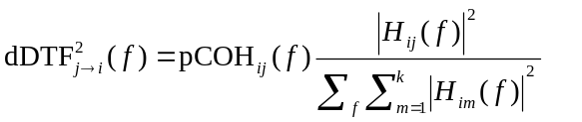 | (7)
This toolbox provides all former forms of DTF as well as Baccala’s directed coherence or generalized DTF (gDTF) (Baccala & Sameshima, 1998).

      - Generalized Partial Directed Coherence
The generalized partial directed coherence (gPDC) (measure = ‘gPDC') uses the FT AR coefficients matrix to measure, at each frequency, the outflow from channel j to channel i, relative to all the outflows at j (Baccalá & Sameshima, 2001; Baccalá, Sameshima, & Takahashi, 2007) gPDC is sensitive to direct flows only:
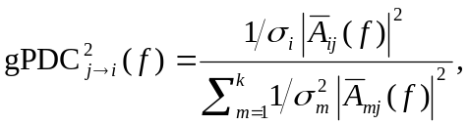 | (8)
Where 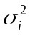is the variance of the residual i or the i-th element in the diagonal of Σ and k is the number of variables.
The gPDC metric is available in this toolbox along with three alternative formulations. Two were proposed by A. Omidvarnia (A. Omidvarnia et al., 2014) for increased resilience to volume conduction: the orthogonalized PDC (oPDC) and the generalized oPDC (goPDC). The remaining was introduced by G. Plomp and consists in the outflow from channel j to channel i, relative to all the inflows to i and is thus referred to as row-wise gPDC (rgPDC) (Plomp et al., 2014). All previous PDC metrics can be used row-wise and are identified by an ‘r’ prefix to their name.
      - Alternative definitions for GC
S. Hu et al. proposed alternative definitions for GC, both in time and frequency domain, that overcome some issues when causality is overly or insufficiently estimated (Hu, Dai, Worrell, Dai, & Liang, 2011; Hu & Liang, 2012). The authors show that these formulations differ from previous causality metrics as they consider the fraction of causal influence among all the causal influences to the target node and also because the spectral AR parameters are computed differently:
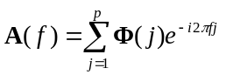 | (9)
Although similar in definition to rgPDC, the ensuing formulations differ from all the previous GC metrics. The time domain formulation follows (Hu et al., 2011) (measure = ‘newGCTime):
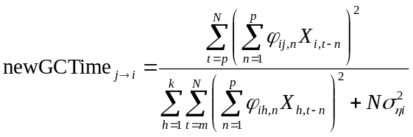 | (10)
Where N is the time-series length and p and k are, like in the previous formulas, the model order and number of variables respectively. The frequency domain resembles the former formula with FT coefficients (Hu & Liang, 2012) (measure = ‘newGCFreq'):
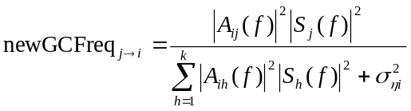 | (11)
Where S_{i} is the variable i’s FT. In time-varying, S_{i} is variable i’s ST at each time-instant.
      - Spectral weighting
Most GC metrics in the frequency domain are defined as ratios between the causal and total power or between the causal influence (measured by , 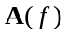 or ) and all the incoming influences at the target or all the outgoing influences from the source. Hence, frequencies with small spectral power can still have high estimated causal influence (Plomp et al., 2014; van Mierlo et al., 2013). Spectral weighting tackles this issue by multiplying the causal matrices, at each time and frequency bin, by the corresponding normalized (from 0 to 1) autospectrum of the source variable. This toolbox provides spectral weighting for both time-invariant and time-varying analysis. The autospectra can be computed with standard FT (spect_norm_opt = ‘FFT'), AR model’s spectrum (spect_norm_opt = ‘ARSpectrum'), tranfer matrix H(f) (spect_norm_opt = ‘TransfMatrix'), ST (Stockwell et al., 1996) (spect_norm_opt = ‘ST'), WT (spect_norm_opt = ‘WT'), Synchrosqueezing WT (syncWT) (spect_norm_opt = ‘FFT') or Hilbert Huang spectrum (HHS) (Huang et al., 1998) (spect_norm_opt = ‘HHT').
    - Statistical validation
Table 9: Fields in optStruct for statistical validation.
Field name | Data type | Description | Options
numSurrogates | int | Number of surrogates for the null population. | 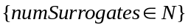. To avoid statistical validation choose 0.
nullPopMethod | string | Method for creating the surrogate dataset. | 'phaseran' or 'AAFT'
pval | double | Significance level. | 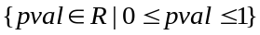

The GCI statistical validation for a causal relation j→i can be achieved with an F-test on the null hypothesis that all the values Φ_{ij}({1,…,p}) (where p is the model order) in the regression coefficient matrix Φ are zero. After applying Bonferroni correction for multiple observations to this test (in this case the model order p corresponds to the number of observations), causal influence is detected if all Φ_{ij}({1,…,p}) are jointly and significantly different from zero. Tests were performed with an initial p-value of 0.05 which was Bonferroni-corrected whenever the model order was higher than one.
Since the statistical distribution of the remaining causality measures is not defined, their significance has to be assessed using surrogate methods where the null hypothesis of lack of causal interaction between IMFs is tested (Seth, 2010). Hence, a null population must be free of causal relationships but preserve the time and spectral distributions of the original data. This null hypothesis is tested with a one-tailed test, the connection being deemed significant if the measure falls above a chosen percentile of the null distribution. The method for creating surrogates consists in phase randomization and correlation nullification (Baccalá, Takahashi, & Sameshima, 2006) using Fourier-transformed surrogates (Theiler, Eubank, & Longtin, 1992) (nullPopMethod = ‘phaseran') or amplitude-adjusted Fourier-transformed (AAFT) surrogates (Thomas Schreiber & Schmitz, 1996) (nullPopMethod = ‘AAFT'). As PSI already offers the jackknife normalization, surrogate testing is not used.
    - Partially conditioned analysis
In this toolbox causal analysis can be performed in a pairwise or in a pairwise conditional fashion. Pairwise analysis is done between pairs of variables whereas pairwise conditional is done between pairs of variables conditional on the remaining set of variables. However, an increased number of variables with reduced number of samples can lead to computational and numerical issues in the pairwise conditional analysis, a common concern with fMRI data for instance, (Bressler & Seth, 2011; Marinazzo, Pellicoro, & Stramaglia, 2012; Rodrigues & Andrade, 2014). Marinazzo et al. address this problem by partial conditioning the pairwise analysis to a limited subset of conditional variables that maximize the MI between them and the driver variable (Marinazzo et al., 2012). This toolbox can perform pairwise conditional analysis, with any of the previously presented options, between the causal pair conditional to the maximum MI subset found with the open source code developed by Marinazzo et al.. The functions causalMatrixPartiallyConditioned.m and TV_CausalMatrixPartiallyConditioned.m respectively replace causalMatrix.m and TV_CausalMatrix.m for these purpose. Their inputs remain the same.
  - Workflow

- Results and Discussion
A dataset generated with four known AR models, connected between each other, is analyzed with this toolbox.
  - Standard analysis
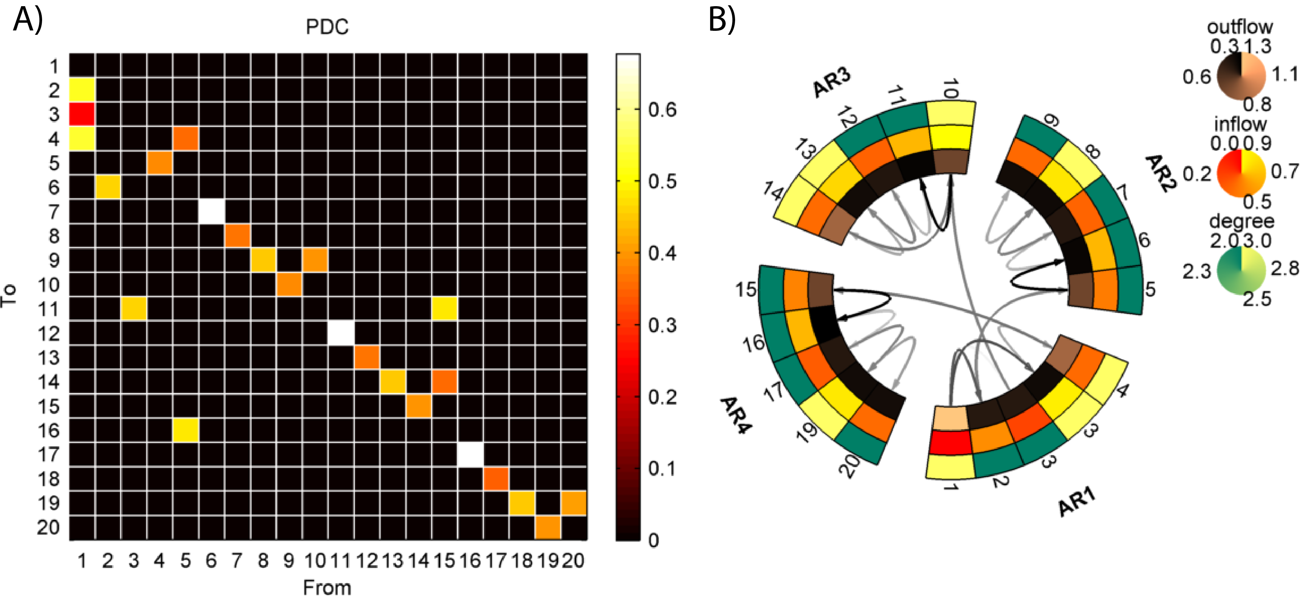
  - Partially conditioned analysis
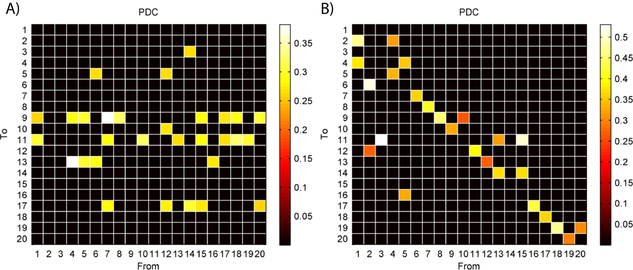
  - Time-varying analysis
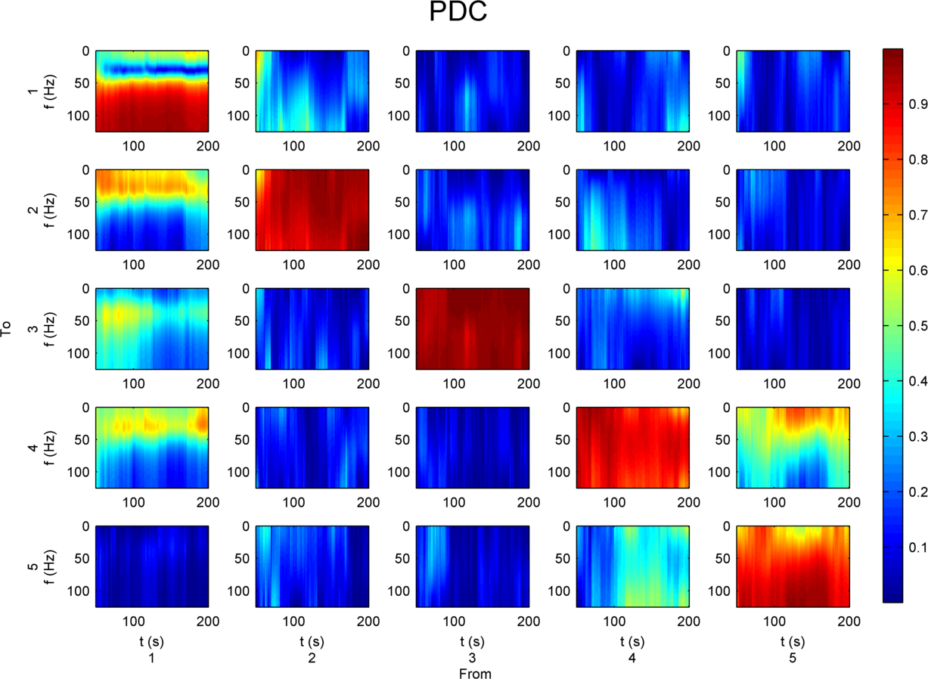

- Conclusions
References
Akaike, H. (1974). A new look at the statistical model identification. IEEE Transactions on Automatic Control, 19(6), 716–723. http://doi.org/10.1109/TAC.1974.1100705
Astolfi, L., Cincotti, F., Mattia, D., De Vico Fallani, F., Tocci, A., Colosimo, A., … Babiloni, F. (2008). Tracking the time-varying cortical connectivity patterns by adaptive multivariate estimators. IEEE Transactions on Bio-Medical Engineering, 55(3), 902–13. http://doi.org/10.1109/TBME.2007.905419
Baccalá, L. a, & Sameshima, K. (2001). Partial directed coherence: a new concept in neural structure determination. Biological Cybernetics, 84(6), 463–74. Retrieved from http://www.ncbi.nlm.nih.gov/pubmed/11417058
Baccala, L., & Sameshima, K. (1998). Studying the interaction between brain structures via directed coherence and Granger causality. Applied Signal …, 5, 40–48. Retrieved from http://www.lcs.poli.usp.br/~baccala/pdc/papers/asp.pdf
Baccalá, L., Sameshima, K., & Takahashi, D. Y. (2007). Generalized partial directed coherence. In 2007 15th International Conference on Digital Signal Processing (pp. 163 – 166). IEEE. http://doi.org/10.1109/ICDSP.2007.4288544
Baccalá, L., Takahashi, D., & Sameshima, K. (2006). Computer Intensive Testing for the Influence Between Time Series. In Handbook of Time Series Analysis (pp. 411–436). Wiley-VCH Verlag GmbH & Co. KGaA.
Barnett, L. (2009). Granger Causality and Transfer Entropy Are Equivalent for Gaussian Variables. Physical Review Letters, 103(23), 238701. http://doi.org/10.1103/PhysRevLett.103.238701
Barnett, L., & Seth, A. K. (2014). The MVGC multivariate Granger causality toolbox: a new approach to Granger-causal inference. Journal of Neuroscience Methods, 223, 50–68. http://doi.org/10.1016/j.jneumeth.2013.10.018
Bressler, S. L., & Seth, A. K. (2011). Wiener-Granger Causality: A well established methodology. NeuroImage, 58(2), 323–329. http://doi.org/10.1016/j.neuroimage.2010.02.059
Chen, Y., Bressler, S. L., & Ding, M. (2006). Frequency decomposition of conditional Granger causality and application to multivariate neural field potential data. Journal of Neuroscience Methods, 150(2), 228–37. http://doi.org/10.1016/j.jneumeth.2005.06.011
Cui, J., Xu, L., Bressler, S. L., Ding, M., & Liang, H. (2008). BSMART: a Matlab/C toolbox for analysis of multichannel neural time series. Neural Networks : The Official Journal of the International Neural Network Society, 21(8), 1094–104. http://doi.org/10.1016/j.neunet.2008.05.007
Daubechies, I., Lu, J., & Wu, H.-T. (2011). Synchrosqueezed wavelet transforms: An empirical mode decomposition-like tool. Applied and Computational Harmonic Analysis, 30(2), 243–261. http://doi.org/10.1016/j.acha.2010.08.002
Deshpande, G., Sathian, K., & Hu, X. (2010). Assessing and compensating for zero-lag correlation effects in time-lagged Granger causality analysis of FMRI. IEEE Transactions on Bio-Medical Engineering, 57(6), 1446–56. http://doi.org/10.1109/TBME.2009.2037808
Dhamala, M., Rangarajan, G., & Ding, M. (2008). Analyzing information flow in brain networks with nonparametric Granger causality. NeuroImage, 41(2), 354–62. http://doi.org/10.1016/j.neuroimage.2008.02.020
Ding, M., Bressler, S. L., Yang, W., & Liang, H. (2000). Short-window spectral analysis of cortical event-related potentials by adaptive multivariate autoregressive modeling: data preprocessing, model validation, and variability assessment. Biological Cybernetics, 83(1), 35–45. Retrieved from http://www.ncbi.nlm.nih.gov/pubmed/10933236
Faes, L., & Nollo, G. (2010). Extended causal modeling to assess Partial Directed Coherence in multiple time series with significant instantaneous interactions. Biological Cybernetics, 103(5), 387–400. http://doi.org/10.1007/s00422-010-0406-6
Geweke, J. (1982). Measurement of linear dependence and feedback between multiple time series. Journal of the American Statistical Association, 77, 304–313. Retrieved from http://www.tandfonline.com/doi/abs/10.1080/01621459.1982.10477803
Geweke, J. F. (1984). Measures of Conditional Linear Dependence and Feedback Between Time Series. Journal of the American Statistical Association, 79(388), 907–915. http://doi.org/10.2307/2288723
Granger, C. W. J. (1969). Investigating Causal Relations by Econometric Models and Cross-spectral Methods. Econometrica, 37(3), 424–438. http://doi.org/10.2307/1912791
Hannan, E., & Rissanen, J. (1982). Recursive estimation of mixed autoregressive-moving average order. Biometrika, 69(1), 81–94. Retrieved from http://biomet.oxfordjournals.org/content/69/1/81.short
Havlicek, M., Jan, J., Brazdil, M., & Calhoun, V. D. (2010). Dynamic Granger causality based on Kalman filter for evaluation of functional network connectivity in fMRI data. NeuroImage, 53(1), 65–77. http://doi.org/10.1016/j.neuroimage.2010.05.063
Hu, S., Dai, G., Worrell, G. a, Dai, Q., & Liang, H. (2011). Causality analysis of neural connectivity: critical examination of existing methods and advances of new methods. IEEE Transactions on Neural Networks / a Publication of the IEEE Neural Networks Council, 22(6), 829–44. http://doi.org/10.1109/TNN.2011.2123917
Hu, S., & Liang, H. (2012). Causality analysis of neural connectivity: New tool and limitations of spectral Granger causality. Neurocomputing, 76(1), 44–47. http://doi.org/10.1016/j.neucom.2010.10.017
Huang, N. E., Shen, Z., Long, S. R., Wu, M. C., Shih, H. H., Zheng, Q., … Liu, H. H. (1998). The empirical mode decomposition and the Hilbert spectrum for nonlinear and non-stationary time series analysis. Proceedings of the Royal Society A: Mathematical, Physical and Engineering Sciences, 454(1971), 903–995. http://doi.org/10.1098/rspa.1998.0193
Kamiński, M., Ding, M., Truccolo, W. a., & Bressler, S. L. (2001). Evaluating causal relations in neural systems: Granger causality, directed transfer function and statistical assessment of significance. Biological Cybernetics, 85(2), 145–157. http://doi.org/10.1007/s004220000235
Korzeniewska, A., Mańczak, M., Kamiński, M., Blinowska, K. J., & Kasicki, S. (2003). Determination of information flow direction among brain structures by a modified directed transfer function (dDTF) method. Journal of Neuroscience Methods, 125(1-2), 195–207. http://doi.org/10.1016/S0165-0270(03)00052-9
Kraskov, A., Stögbauer, H., & Grassberger, P. (2004). Estimating mutual information. Physical Review E, 69(6), 1–16. http://doi.org/10.1103/PhysRevE.69.066138
Lindner, M., Vicente, R., Priesemann, V., & Wibral, M. (2011). TRENTOOL: A Matlab open source toolbox to analyse information flow in time series data with transfer entropy. BMC Neuroscience, 12(1), 119. http://doi.org/10.1186/1471-2202-12-119
Lizier, J. T., Heinzle, J., Horstmann, A., Haynes, J.-D., & Prokopenko, M. (2011). Multivariate information-theoretic measures reveal directed information structure and task relevant changes in fMRI connectivity. Journal of Computational Neuroscience, 30(1), 85–107. http://doi.org/10.1007/s10827-010-0271-2
Luo, Q., Lu, W., Cheng, W., Valdes-Sosa, P. a, Wen, X., Ding, M., & Feng, J. (2013). Spatio-temporal Granger causality: a new framework. NeuroImage, 79, 241–63. http://doi.org/10.1016/j.neuroimage.2013.04.091
Marinazzo, D., Pellicoro, M., & Stramaglia, S. (2012). Causal information approach to partial conditioning in multivariate data sets. Computational and Mathematical Methods in Medicine, 2012, 303601. http://doi.org/10.1155/2012/303601
Nolte, G., Ziehe, A., Nikulin, V., Schlögl, A., Krämer, N., Brismar, T., & Müller, K.-R. (2008). Robustly Estimating the Flow Direction of Information in Complex Physical Systems. Physical Review Letters, 100(23), 1–4. http://doi.org/10.1103/PhysRevLett.100.234101
Omidvarnia, a H., Mesbah, M., Khlif, M. S., O’Toole, J. M., Colditz, P. B., & Boashash, B. (2011). Kalman filter-based time-varying cortical connectivity analysis of newborn EEG. Conference Proceedings : ... Annual International Conference of the IEEE Engineering in Medicine and Biology Society. IEEE Engineering in Medicine and Biology Society. Conference, 2011(2), 1423–6. http://doi.org/10.1109/IEMBS.2011.6090335
Omidvarnia, A., Azemi, G., Boashash, B., O’Toole, J. M., Colditz, P. B., & Vanhatalo, S. (2014). Measuring time-varying information flow in scalp EEG signals: orthogonalized partial directed coherence. IEEE Transactions on Bio-Medical Engineering, 61(3), 680–93. http://doi.org/10.1109/TBME.2013.2286394
Peng, J., & Aston, J. (2011). The state space models toolbox for MATLAB. Journal of Statistical Software, 41(6). Retrieved from http://onlinelibrary.wiley.com/doi/10.1002/wics.10/full
Plomp, G., Quairiaux, C., Michel, C. M., & Astolfi, L. (2014). The physiological plausibility of time-varying Granger-causal modeling: Normalization and weighting by spectral power. NeuroImage, 97, 206–216. http://doi.org/10.1016/j.neuroimage.2014.04.016
Ragwitz, M., & Kantz, H. (2002). Markov models from data by simple nonlinear time series predictors in delay embedding spaces. Physical Review E, 65(5), 1–12. http://doi.org/10.1103/PhysRevE.65.056201
Rodrigues, J., & Andrade, A. (2014). Lag-based effective connectivity applied to fMRI: a simulation study highlighting dependence on experimental parameters and formulation. NeuroImage, 89, 358–77. http://doi.org/10.1016/j.neuroimage.2013.10.029
Schlögl, A. (2006). A comparison of multivariate autoregressive estimators. Signal Processing, 86(9), 2426–2429. http://doi.org/10.1016/j.sigpro.2005.11.007
Schreiber, T. (2000). Measuring information transfer. Physical Review Letters, 85(2), 461–4. Retrieved from http://www.ncbi.nlm.nih.gov/pubmed/10991308
Schreiber, T., & Schmitz, A. (1996). Improved surrogate data for nonlinearity tests. Physical Review Letters, 635, 1–4. Retrieved from http://link.aps.org/doi/10.1103/PhysRevLett.77.635
Schwarz, G. (1978). Estimating the dimension of a model. The Annals of Statistics, 6(2), 461–464. Retrieved from http://projecteuclid.org/euclid.aos/1176344136
Seth, A. K. (2010). A MATLAB toolbox for Granger causal connectivity analysis. Journal of Neuroscience Methods, 186(2), 262–73. http://doi.org/10.1016/j.jneumeth.2009.11.020
Sommerlade, L., Thiel, M., Platt, B., Plano, A., Riedel, G., Grebogi, C., … Schelter, B. (2012). Inference of Granger causal time-dependent influences in noisy multivariate time series. Journal of Neuroscience Methods, 203(1), 173–85. http://doi.org/10.1016/j.jneumeth.2011.08.042
Stockwell, R. G., Mansinha, L., & Lowe, R. P. (1996). Localization of the complex spectrum: the S transform. IEEE Transactions on Signal Processing, 44(4), 998–1001. http://doi.org/10.1109/78.492555
Takens, F. (1981). Detecting strange attractors in turbulence. In D. A. R. and L.-S. Young (Ed.), Dynamical Systems and Turbulence, Lecture Notes in Mathematics (pp. 366–381). Springer-Verlag.
Theiler, J., Eubank, S., & Longtin, A. (1992). Testing for nonlinearity in time series: the method of surrogate data. Physica D, 58, 77–94. Retrieved from http://www.sciencedirect.com/science/article/pii/016727899290102S
Vakorin, V. a, Krakovska, O. a, & McIntosh, A. R. (2009). Confounding effects of indirect connections on causality estimation. Journal of Neuroscience Methods, 184(1), 152–60. Retrieved from http://www.ncbi.nlm.nih.gov/pubmed/19628006
van Mierlo, P., Carrette, E., Hallez, H., Raedt, R., Meurs, A., Vandenberghe, S., … Vonck, K. (2013). Ictal-onset localization through connectivity analysis of intracranial EEG signals in patients with refractory epilepsy. Epilepsia, 54(8), 1409–18. http://doi.org/10.1111/epi.12206
Vaseghi, S. V. (2009). Adaptive Filters: Kalman, RLS, LMS. In Advanced Digital Signal Processing and Noise Reduction (pp. 193–225). John Wiley & Sons, Ltd. http://doi.org/10.1002/9780470740156.ch7
Vidaurre, C., Sander, T. H., & Schlögl, A. (2011). BioSig: the free and open source software library for biomedical signal processing. Computational Intelligence and Neuroscience, 2011, 935364. http://doi.org/10.1155/2011/935364
Wiener, N. (1956). Modern mathematics for the engineer. (E. F. Beckenbach, Ed.)The theory of prediction. McGraw-Hill, New York.
Wilson, G. T. (1972). THE FACTORIZATION OF MATRICIAL SPECTRAL DENSITIES. SIAM Journal on Applied Mathematics, 23(4), 420–426.
Yinfeng, D., Yingmin, L., Mingkui, X., & Ming, L. (2008). Analysis of earthquake ground motions using an improved Hilbert–Huang transform. Soil Dynamics and Earthquake Engineering, 28(1), 7–19. http://doi.org/10.1016/j.soildyn.2007.05.002

