GitHub Link: https://github.com/J0SHUALU/holdfast-ar
APK / Build Link: Add APK link here
Built for Android (Android 11 or newer, ARM64, ARCore supported phone).
Video Demonstration (on device): Add video link here
Technical Explanation Video (Unity): Add video link here

Technical Documentation

1. Architecture overview
It all runs in one scene. GameManager runs a state machine: Main Menu, Placement, Playing, Game Over. Each state cleans up after itself, so leaving Playing wipes every enemy and bullet. Gameplay never touches the UI directly. It fires events through GameEvents and the HUD listens.
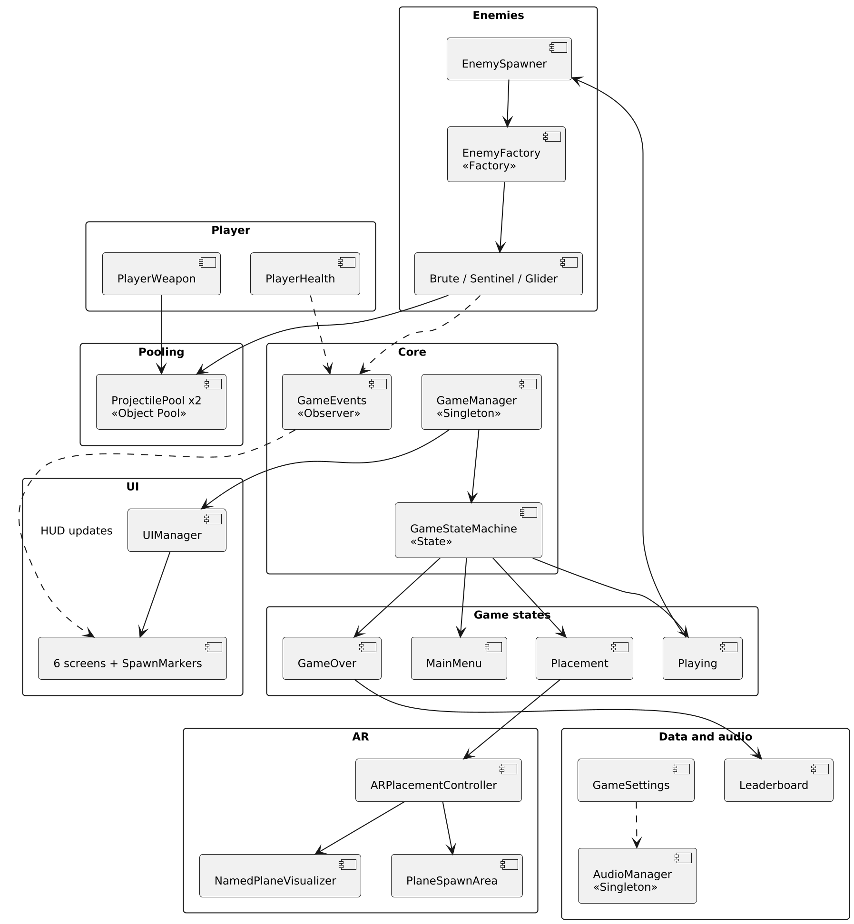

2. OOP structure
Encapsulation. Fields are private with read only properties. Score only changes through RegisterKill(), health only through TakeDamage().
Abstraction. IDamageable lets anything take a hit without the attacker knowing what it is. Enemy, GameState and UIPanel are abstract bases.
Inheritance. MeleeEnemy and ShooterEnemy extend Enemy, which already handles health, chasing, cooldowns, hit feedback and death. The four states extend GameState and the screens extend UIPanel.
Polymorphism. Enemy calls Attack() and StoppingDistance without knowing the type. The melee one punches up close, the shooter stops at 1.4 m and fires.

3. Design patterns used and why
Object Pool for bullets, so firing six shots a second doesn't cause garbage collection stutter.
State for the game flow, so each phase owns its setup and cleanup.
Singleton for GameManager and AudioManager, since there should only ever be one of each.
Factory (EnemyFactory) so one place turns an enemy type into the right prefab.
Observer (GameEvents) so health, score, time and kills reach the HUD without gameplay knowing the UI exists.

4. Object Pool implementation
On load, ProjectilePool makes 40 player bullets and 30 enemy bullets and switches them off. That's the only Instantiate. Firing takes one from the pool, and if it's empty the oldest bullet gets reused. When a bullet hits or lasts 3 seconds, it goes back. Its speed, damage, team and trail get reset, and it's switched off until next time.

5. Sound system structure and sources
AudioManager is the only thing with AudioSources. It has one 2D source for player and UI sounds, one for music, and six 3D sources it moves to wherever an enemy makes noise. So no enemy or bullet carries its own.
It covers player shoot, player death, enemy spawn, enemy shoot and the melee hit, plus hurt, hits, deaths, clicks, placement, victory and ambient music. I made all 12 sounds myself with a short Python script (Tools/make_audio.py) using basic waveforms and noise.

6. Performance metrics
In the Unity editor with six enemies on screen and fire held for 15 seconds: about 57 FPS, 56 draw calls, around 30,000 triangles, and zero garbage collections. The bullet count stayed at 70 the whole time. The APK is 45 MB.

