**RC Rover Instructions**

Yee Dai

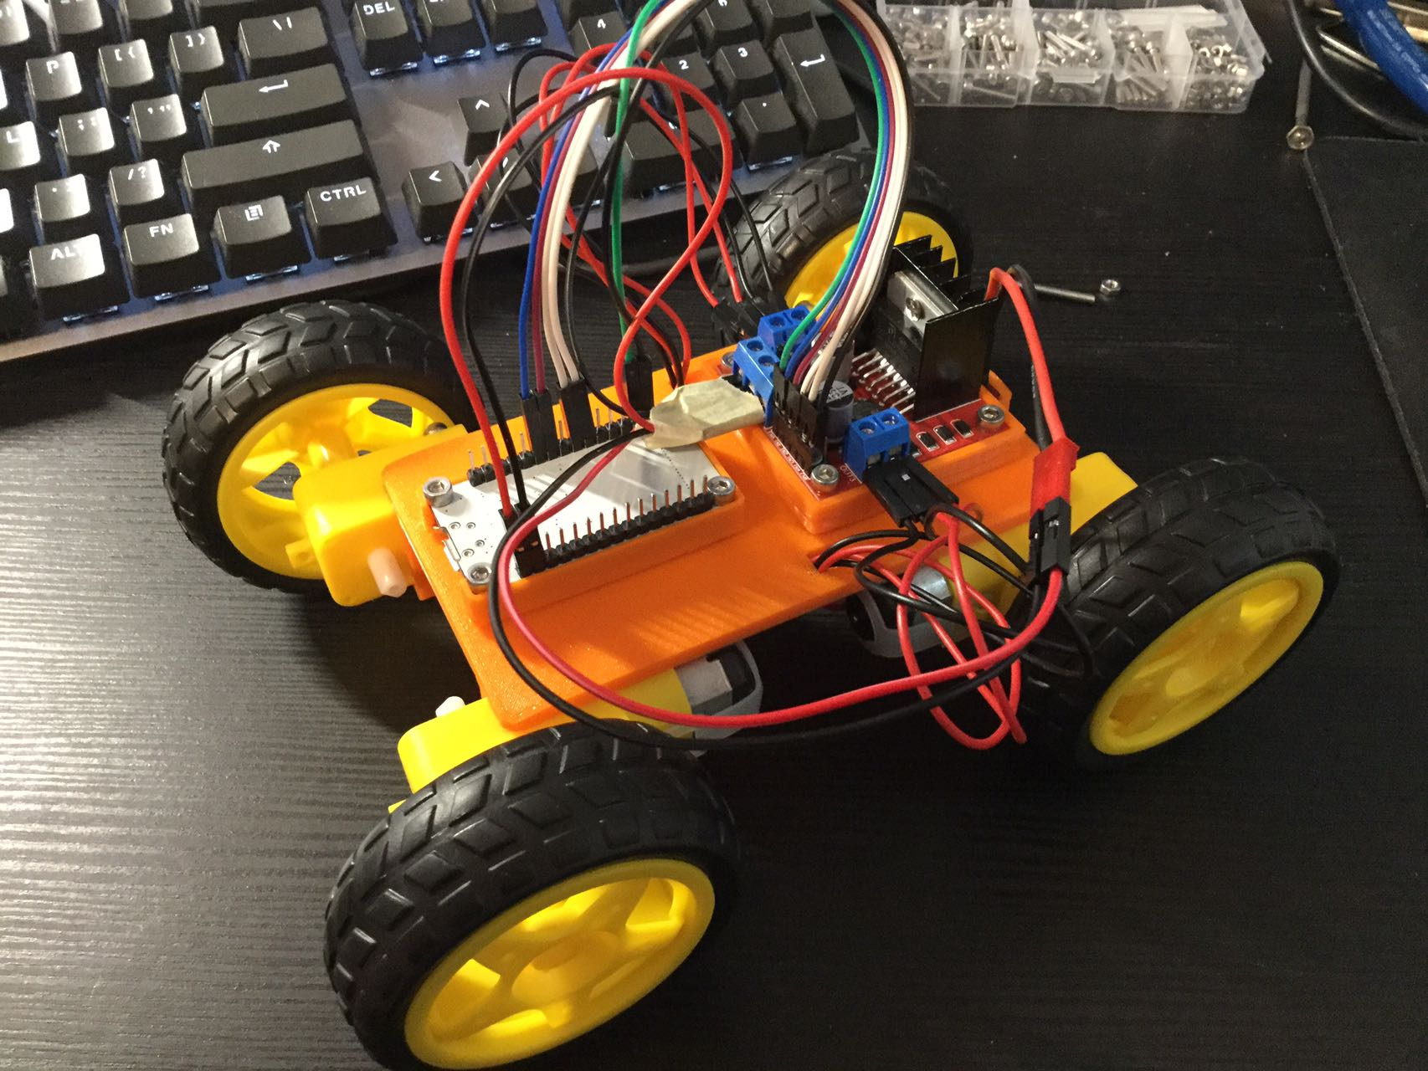

Part 1: Rover Assembly

Step 1:

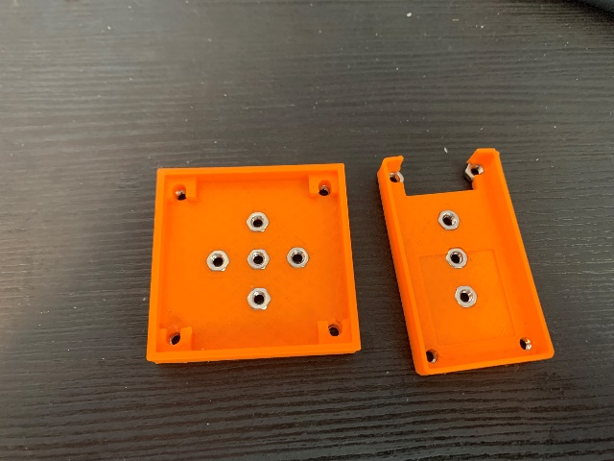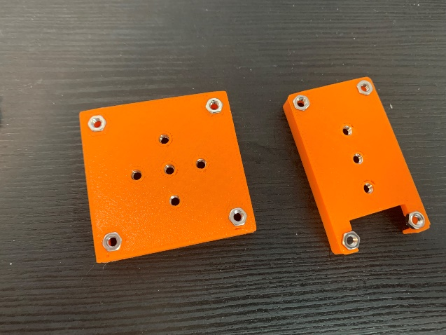Insert M3 Hex Nut into all of the hexagon shaped holes on the 2 holders.

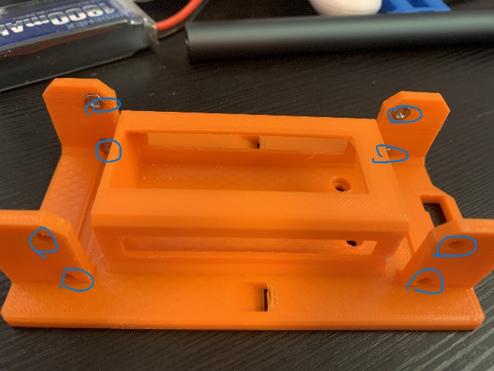Insert M3 Hex Nut into all of the hexagon shaped holes on the Frame

Step 2:

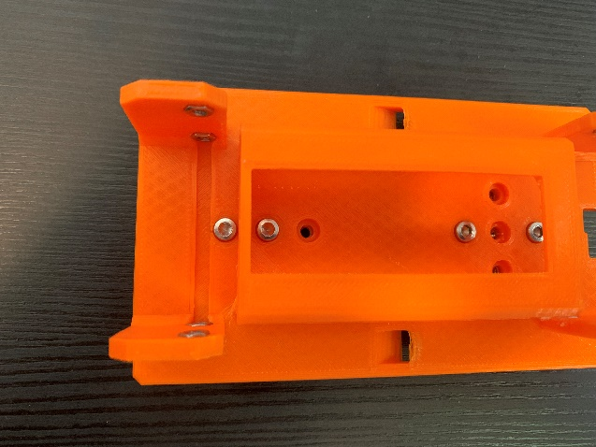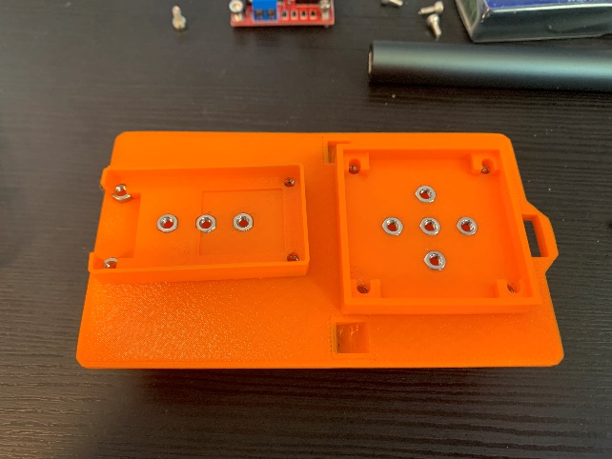Use 4 M3*6 mm bolts to secure the 2 holders onto the frame. Be aware of the orientation.

Step 3:

Mount the ESP32 and L293N using 8 M3*8 mm bolts. Be aware of the orientation.

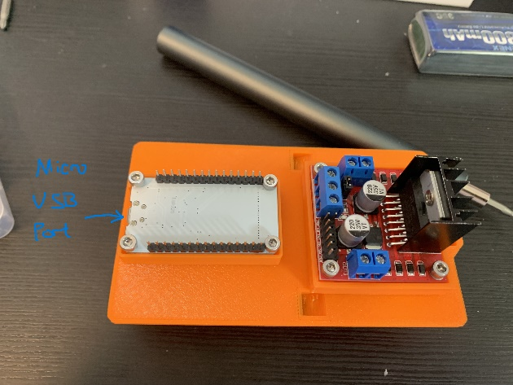

Slide in the Battery.

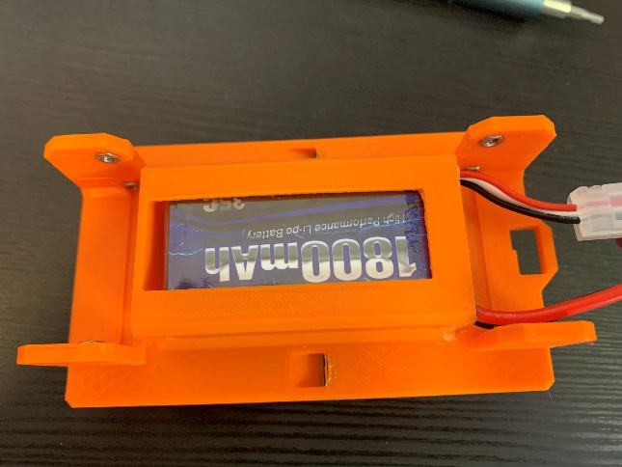

Step 4:

Connect the pins using Female to Female jumper wires as shown in the picture. This step is extremely important.

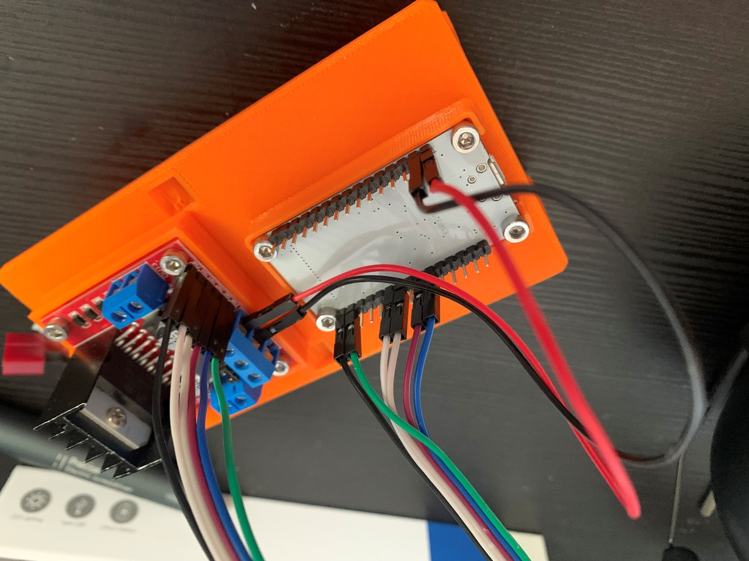

Step 5:

Connect the Deans T Plug wire to the L293N.

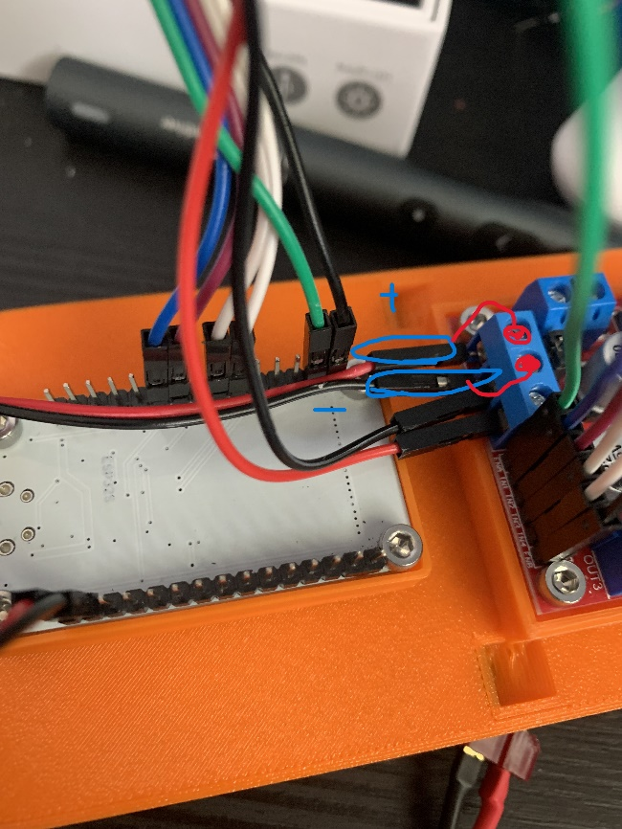

*FINAL WIRING SHOULD LOOK LIKE THIS:

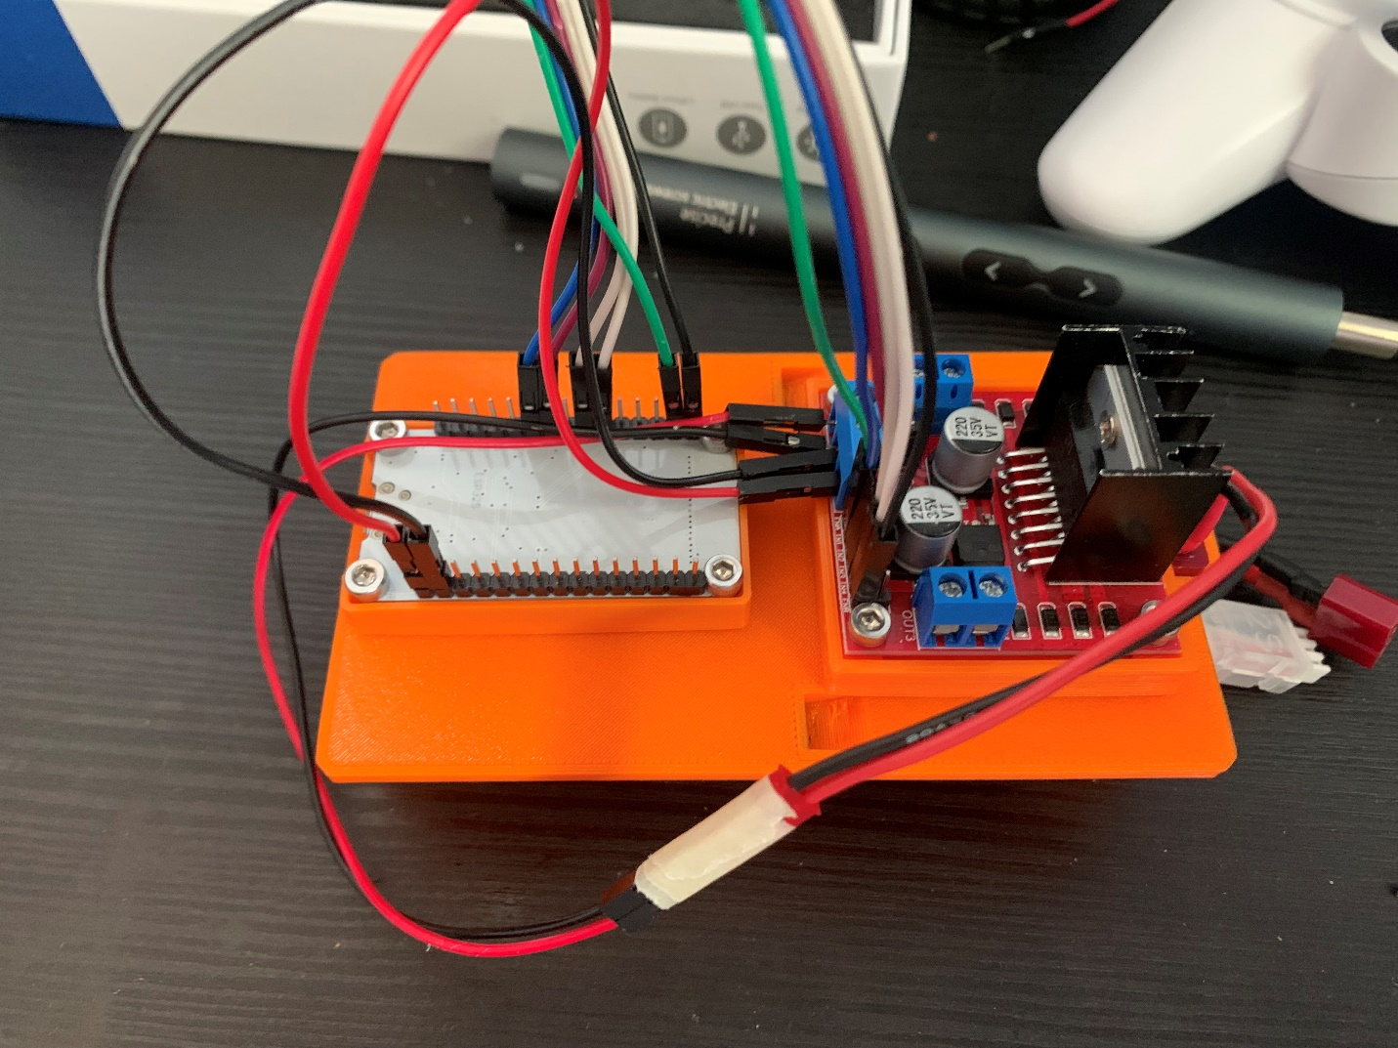

Step 6:

Use 8 M3 * 25 mm bolts to secure the driver motors to the frame. Make sure the soldered wiring part is pointed inside.

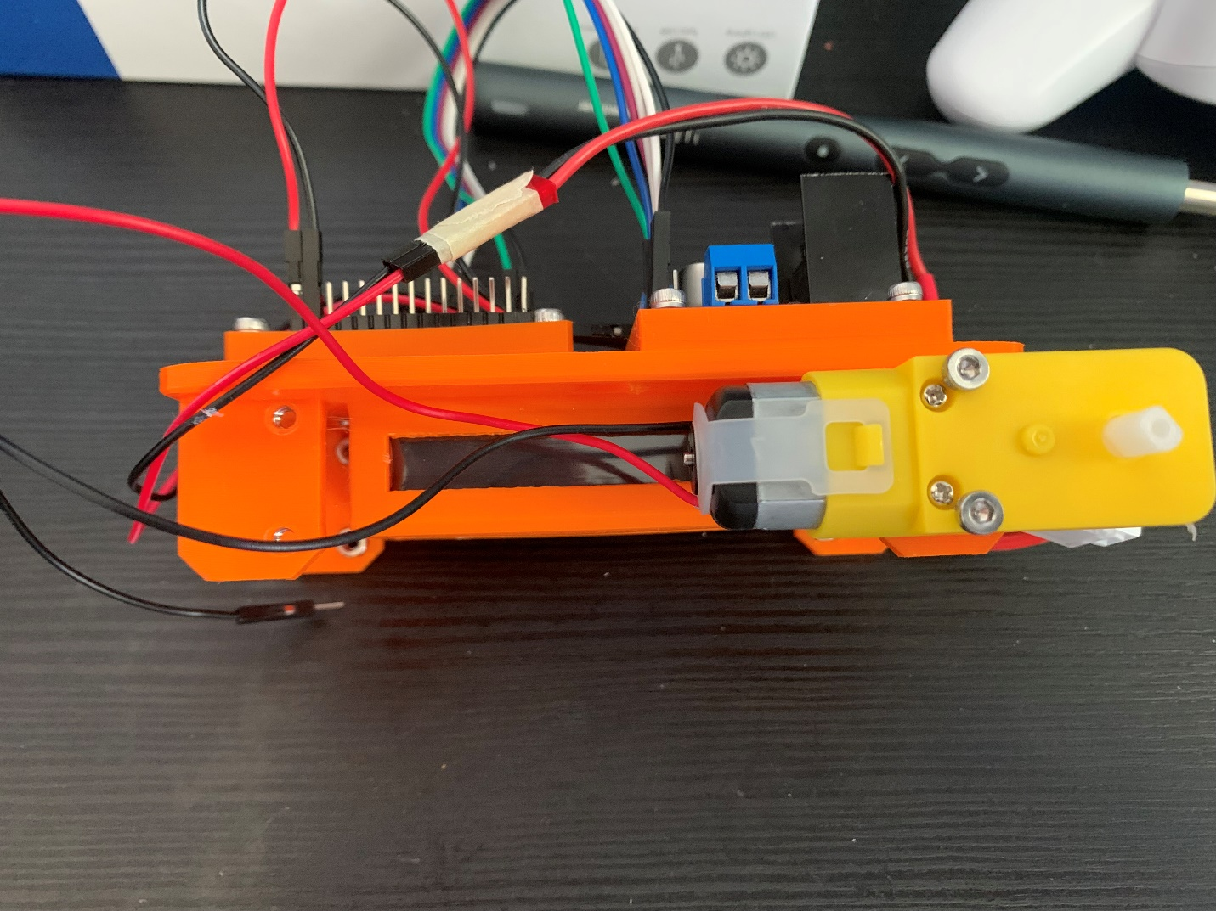

Step 7:

Feed the two power cables through the slanted hole on the side. Each hole should have 2 + and 2 – cables.

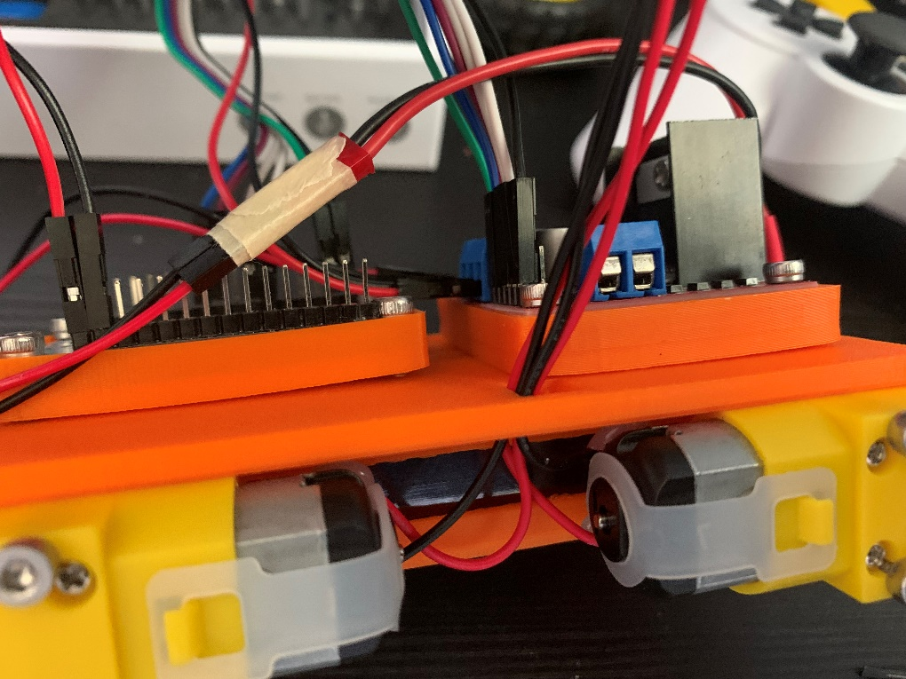

Step 8:

Connect the power cables as shown.

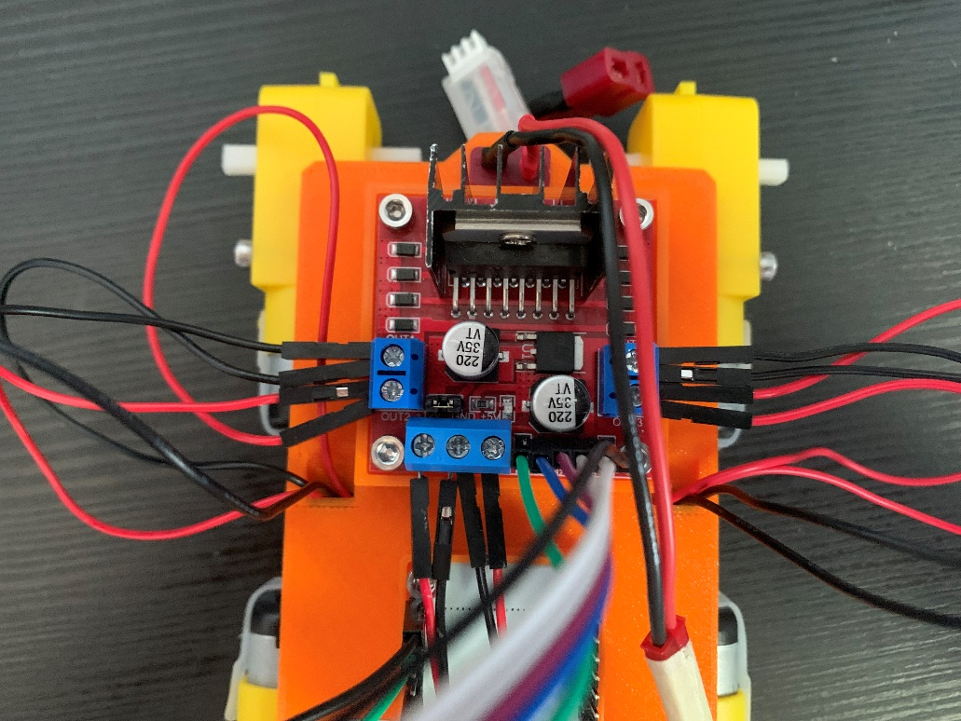

Step 9:

Connect the Power cables of the battery to the Deans T plug. Attach the wheels.

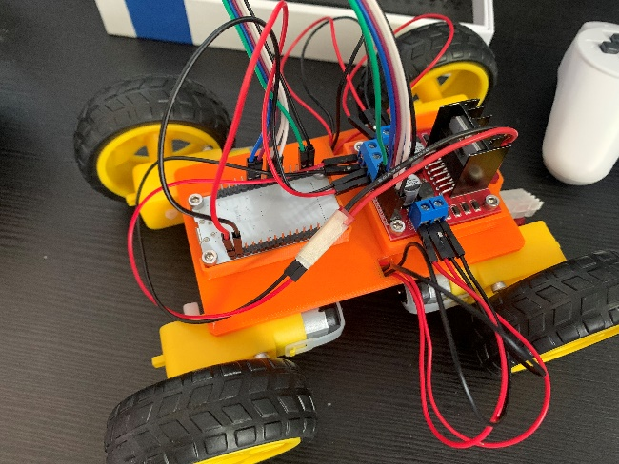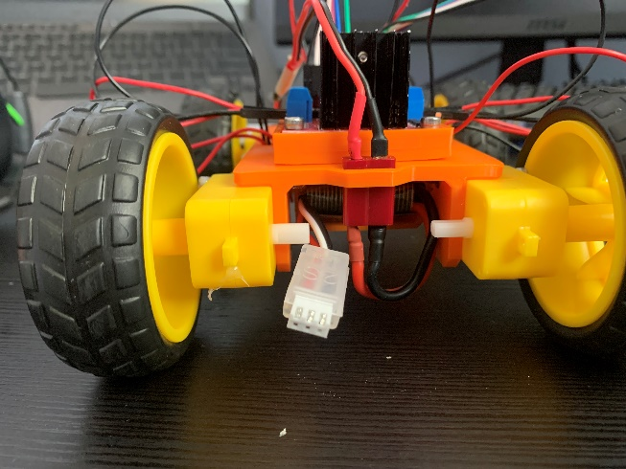

Part 2: Connect PS3 Controller

Follow this tutorial to connect PS3 Controller to ESP32:

<https://www.youtube.com/watch?v=nctYJaDNLU0&t=1000s>

if the above tutorial does not work, watch this one from 5:22 to 6:15:

<https://www.youtube.com/watch?v=FLNgkYBkLjA&t=196s>

Part 3: Upload Code:

Download AC_Car_OP.ino from Github. Make sure to insert your PS3 Controller MAC address between the quotation makes on line 114, and upload it onto your ESP32.

FINISHED