**Rules:**

* This is a two-player game.
* Both players take turns to open any two cards. If those two cards match, the player gains one point, and both cards will remain open until the end of the game. Otherwise, no point for the player, and both cards will be covered back up.
* For each turn, the player can only open two cards, no matter the cards match or not.
* There’s no time limit for each turn.
* For each turn, the first card will not be covered back until after the second card is flipped. If two cards don't match, both cards will remain open for one second and be flipped back after.
* A player may not skip a turn.
* The game is over when all the cards are revealed, or a player quits in the middle of the game.
* A player can only quit during his turn. He can quit after flipping the first card though.
* The player that gets the highest points wins.
* If both players have the same points, the one who gets the first point wins.
* If a player chooses to quit in the middle of the game, the other player wins regardless of the points that he gets.

**Usage:**

1. Server setup

* Save these three files 1) HandleGame.java, 2) MemoryGameConstants.java, 3) MemoryGameServer.java together at the same location.
* Compile and run “MemoryGameServer.java”
* A log window will pop with info of the server’s activity

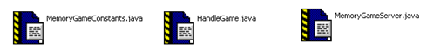

1. Player setup

* Save the files and those two folders 1) Card.java, 2) Sound.java, 3) Client.java, 4) MemoryGameConstants.java

and those two folders 5) images, 6) sounds together at the same location.

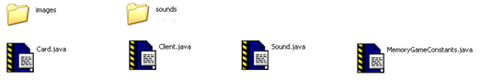

* Open the “Client.java” and run it with “-server [Server’s IP]”, and “-help” for usage guide.

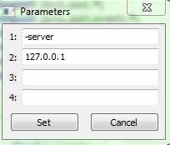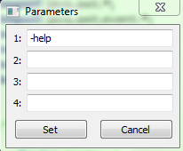

* Once the player window pops up, click on the Start button to start a game. Whoever presses Start first gets to move first.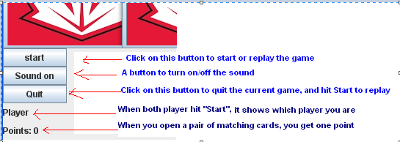

**UI design snapshot:**

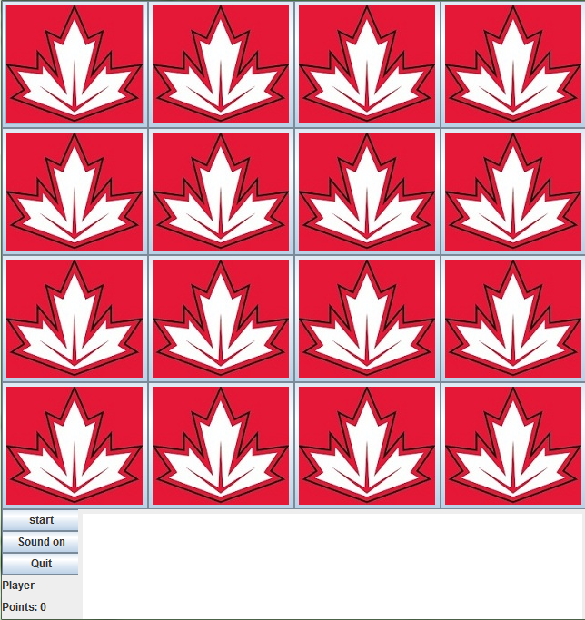

A server log:

